# Conscious Earth

# Harnessing the Planet’s Information Platform Revolution

### **WARNING: This content was generated using Generative AI. While efforts have been made to ensure accuracy and coherence, readers should approach the material with critical thinking and verify important information from authoritative sources.**

# Table of Contents

Introduction: The Earth as an Intelligent System 5

The Concept of Gaia 2.0 5

From Gaia hypothesis to Gaia 2.0 5

Earth as a self-regulating system 8

The planet’s information processing capabilities 11

The Information Platform Revolution 14

Defining the Earth’s information platform 14

The convergence of biology, technology, and ecology 17

Potential impacts on human society and the environment 20

Earth System Science: Understanding Our Living Planet 24

The Earth’s Major Systems 24

Atmosphere 24

Hydrosphere 27

Geosphere 30

Biosphere 34

Interconnectedness and Feedback Loops 37

System interactions and dependencies 37

Positive and negative feedback mechanisms 40

Tipping points and planetary boundaries 42

Earth’s Information Processing 46

Biological information systems 46

Geological information storage 49

Atmospheric and oceanic information transfer 52

Biomimicry: Learning from Nature’s Genius 57

Principles of Biomimicry 57

Nature as model, measure, and mentor 57

Life’s principles and design strategies 60

Biomimicry thinking process 63

Biomimetic Technologies 66

Materials science innovations 66

Energy harvesting and storage solutions 69

Information and communication systems 73

Biomimicry in Product Design 77

Sustainable packaging inspired by nature 77

Efficient transportation systems 80

Biomimetic architecture and urban planning 83

Natural Algorithms: Earth’s Computational Wisdom 88

Understanding Natural Algorithms 88

Defining natural algorithms 88

Examples from ecosystems and organisms 90

Complexity and emergence in natural systems 94

Applications in Artificial Intelligence 97

Evolutionary algorithms and genetic programming 97

Swarm intelligence and collective behaviour 100

Neural networks inspired by brain function 103

Machine Learning from Nature 106

Reinforcement learning in natural systems 106

Pattern recognition and classification in nature 109

Adaptive and self-organising systems 113

Circular Economy: Emulating Earth’s Ecosystems 117

Principles of Circular Economy 117

Closing the loop: from linear to circular 117

Waste as a resource 120

Regenerative design 123

Natural Cycles as Models 126

Carbon cycle and climate regulation 126

Nutrient cycles and soil fertility 129

Water cycle and hydrological systems 131

Implementing Circular Economy Principles 134

Industrial ecology and symbiosis 134

Cradle-to-cradle design 137

Circular business models and strategies 140

Ethical Considerations and Potential Risks 144

Ethical Frameworks for Earth Stewardship 144

Environmental ethics and deep ecology 144

Indigenous wisdom and Earth-centric worldviews 147

Balancing human needs with planetary health 150

Potential Risks of Exploiting Earth’s Intelligence 153

Unintended consequences of biomimetic technologies 153

Privacy and security concerns in natural information systems 156

Ecological disruption through excessive data harvesting 159

Governance and Policy Implications 162

International cooperation for Earth system management 162

Regulatory frameworks for Earth-inspired technologies 166

Balancing innovation with precautionary principles 169

Conclusion: Towards a Symbiotic Future 173

Integrating Earth’s Wisdom 173

Synthesising lessons from natural systems 173

Bridging the gap between technology and ecology 176

Cultivating a planetary consciousness 179

Future Directions and Opportunities 183

Emerging research areas in Earth system science 183

Potential breakthroughs in Earth-inspired technologies 186

Societal transformations towards Earth stewardship 189

# Introduction: The Earth as an Intelligent System

## The Concept of Gaia 2.0

### From Gaia hypothesis to Gaia 2.0

The evolution from the Gaia hypothesis to the concept of Gaia 2.0 represents a significant leap in our understanding of Earth as an intelligent, self-regulating system. This progression is not merely an academic exercise; it forms the cornerstone of our approach to harnessing the planet’s information platform revolution, particularly within the context of government and public sector initiatives aimed at sustainable development and environmental stewardship.

The Gaia hypothesis, first proposed by James Lovelock in the 1970s, posited that Earth functions as a single, self-regulating organism. This groundbreaking idea challenged traditional views of Earth as a passive backdrop for life, instead suggesting an intricate web of feedback mechanisms that maintain conditions suitable for life. While initially controversial, the Gaia hypothesis has gained significant traction over the decades, influencing fields ranging from Earth system science to environmental policy.

The Gaia hypothesis was a paradigm shift in how we view our planet. It laid the groundwork for understanding Earth as a complex, interconnected system rather than a collection of isolated components.

As our understanding of Earth’s systems has deepened, and our technological capabilities have advanced, we’ve moved beyond the original Gaia hypothesis to the concept of Gaia 2.0. This evolution represents a more nuanced and technologically informed view of Earth’s self-regulation, incorporating human activities and technological systems into the planetary feedback loops.

* Integration of human activities into Earth’s regulatory systems
* Recognition of technological networks as extensions of Earth’s natural information processing capabilities
* Emphasis on conscious stewardship and intentional participation in planetary processes
* Exploration of Earth’s information platform as a model for sustainable technological development

Gaia 2.0 acknowledges that humanity has become a geological force in its own right, capable of influencing Earth’s systems on a global scale. This concept recognises that our technological networks - from global communication systems to environmental monitoring satellites - have become extensions of Earth’s natural information processing capabilities. In essence, Gaia 2.0 posits that we are not separate from Earth’s self-regulating systems, but an integral part of them.

Gaia 2.0 represents a profound shift in our relationship with the planet. It challenges us to see our technological systems not as separate from nature, but as potential enhancers of Earth’s own regulatory mechanisms.

For government and public sector organisations, the implications of Gaia 2.0 are far-reaching. It necessitates a reimagining of environmental policies, moving beyond mere conservation to active participation in Earth’s regulatory processes. This might involve developing technologies that enhance natural carbon sequestration, implementing urban planning strategies that mimic ecosystem services, or creating information systems that integrate with and augment Earth’s natural feedback loops.

One of the most promising aspects of Gaia 2.0 is its potential to inform the development of more sustainable and resilient technological systems. By understanding and emulating Earth’s information processing capabilities, we can create technologies that are more efficient, adaptive, and in harmony with natural systems. This approach has particular relevance for government initiatives in areas such as smart cities, climate change mitigation, and resource management.

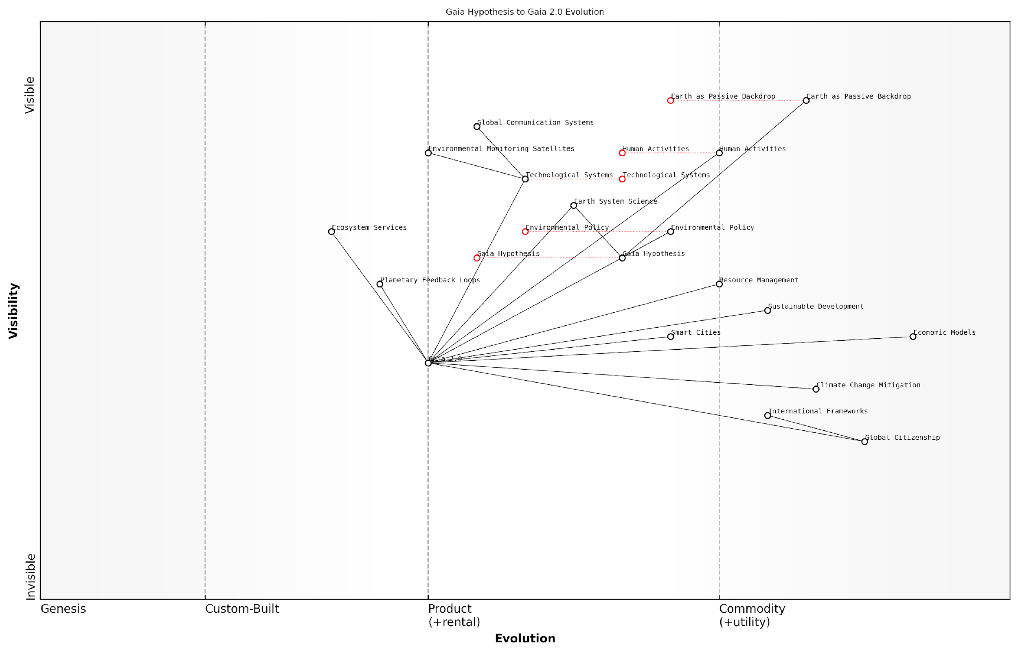

*Draft Wardley Map: [Insert Wardley Map: From Gaia hypothesis to Gaia 2.0]*

[Edit this draft Wardley Map](https://create.wardleymaps.ai/#clone:e08c37e078e067669d)

Wardley Map Assessment

This Wardley Map represents a paradigm shift in our understanding and management of Earth systems. It highlights the transition from viewing Earth as a passive backdrop to recognizing it as an intelligent, interconnected system (Gaia 2.0). The map reveals significant opportunities for innovation in areas such as Smart Cities, Global Citizenship, and Planetary Feedback Loops. However, it also exposes challenges in evolving Environmental Policy and Economic Models to keep pace with this new understanding. Strategic focus should be on accelerating the development and integration of technologies that enhance our ability to monitor and respond to Earth systems, while simultaneously working to shift societal structures and policies to align with Gaia 2.0 principles. Success in this transition will require unprecedented levels of global cooperation, technological innovation, and adaptive governance.

[View full Wardley Map report](https://github.com/tractorjuice/test-repo/blob/main/markdown_wardley_map_reports/wardley_map_report_01_From_Gaia_hypothesis_to_Gaia_2.0.md)

However, the transition to Gaia 2.0 is not without challenges. It requires a fundamental shift in how we perceive our role on the planet, moving from dominion to partnership. This shift has significant implications for governance structures, economic models, and societal values. Public sector leaders must grapple with questions of how to balance short-term human needs with long-term planetary health, and how to foster a sense of global citizenship that acknowledges our role in Earth’s systems.

* Developing policies that recognise the interconnectedness of human and natural systems
* Investing in research and technologies that enhance Earth’s regulatory capabilities
* Fostering public understanding and engagement with Gaia 2.0 concepts
* Creating international frameworks for collaborative planetary stewardship
* Adapting economic models to reflect the true value of ecosystem services and planetary health

As we move forward in this new era of Gaia 2.0, it’s crucial that we approach the harnessing of Earth’s information platform revolution with both ambition and humility. We must recognise the immense potential of aligning our technological development with Earth’s natural processes, while also acknowledging the complexity and delicacy of the systems we’re engaging with.

The transition to Gaia 2.0 represents both our greatest challenge and our greatest opportunity. It offers a path to technological advancement that is in harmony with, rather than in opposition to, the natural world.

In conclusion, the evolution from the Gaia hypothesis to Gaia 2.0 marks a critical juncture in our understanding of Earth as an intelligent system and our role within it. For government and public sector organisations, it provides a framework for developing policies and technologies that are not only sustainable but actively contribute to the health and resilience of our planet. As we continue to explore and implement the principles of Gaia 2.0, we move closer to realising the full potential of Earth’s information platform revolution, creating a future where human innovation and planetary wisdom work in concert.

### Earth as a self-regulating system

The concept of Earth as a self-regulating system is a cornerstone in understanding the planet’s information platform revolution. This idea, rooted in the Gaia hypothesis and evolving into the more nuanced Gaia 2.0 theory, posits that our planet operates as a complex, interconnected system capable of maintaining conditions suitable for life through various feedback mechanisms. As we delve deeper into this concept, we uncover profound implications for how we perceive, interact with, and potentially harness the Earth’s inherent intelligence.

The self-regulation of Earth systems is not a new concept, but its relevance has never been more apparent than in our current era of rapid technological advancement and environmental change. As a senior adviser to government bodies on environmental policy, I’ve observed a growing recognition of the need to align our technological progress with the Earth’s natural processes. This alignment is at the heart of the Gaia 2.0 concept, which extends beyond mere observation of Earth’s self-regulation to consider how humanity can consciously participate in and enhance these processes.

Gaia 2.0 represents a paradigm shift in how we view our relationship with the planet. It’s not just about sustainability; it’s about active participation in Earth’s self-regulating mechanisms.

To fully grasp the implications of Earth as a self-regulating system, we must examine its key components and mechanisms:

* Biogeochemical cycles: The circulation of essential elements like carbon, nitrogen, and phosphorus through the Earth’s systems.
* Climate regulation: The complex interplay of atmospheric, oceanic, and terrestrial processes that maintain global temperature within habitable ranges.
* Biodiversity and ecosystem services: The role of diverse life forms in maintaining ecological balance and providing essential services like pollination and nutrient cycling.
* Feedback loops: Both positive and negative feedback mechanisms that help stabilise or amplify changes in Earth systems.

These components work in concert to create a dynamic equilibrium, allowing the Earth to respond to both internal and external perturbations. However, the unprecedented scale of human activity is now challenging this equilibrium, necessitating a more conscious approach to our interaction with planetary systems.

In my work advising on large-scale environmental monitoring projects, I’ve seen firsthand how understanding Earth’s self-regulation can inform policy and technological development. For instance, a recent initiative to develop a national carbon sequestration strategy drew heavily on insights from the Earth’s natural carbon cycle. By mimicking and enhancing natural processes, we were able to design more effective and resilient carbon capture technologies.

The key to harnessing the Earth’s information platform lies in our ability to observe, understand, and ultimately collaborate with its self-regulating mechanisms.

The concept of Earth as a self-regulating system also has profound implications for how we approach global challenges such as climate change. Rather than viewing these issues in isolation, we must consider them within the context of Earth’s interconnected systems. This holistic approach has led to the development of more integrated and effective climate mitigation strategies.

One of the most exciting developments in this field is the emergence of Earth System Science as a distinct discipline. This interdisciplinary approach combines elements of geology, biology, chemistry, and physics to study the Earth as a single, complex system. The insights gained from Earth System Science are proving invaluable in our efforts to understand and work with the planet’s self-regulating mechanisms.

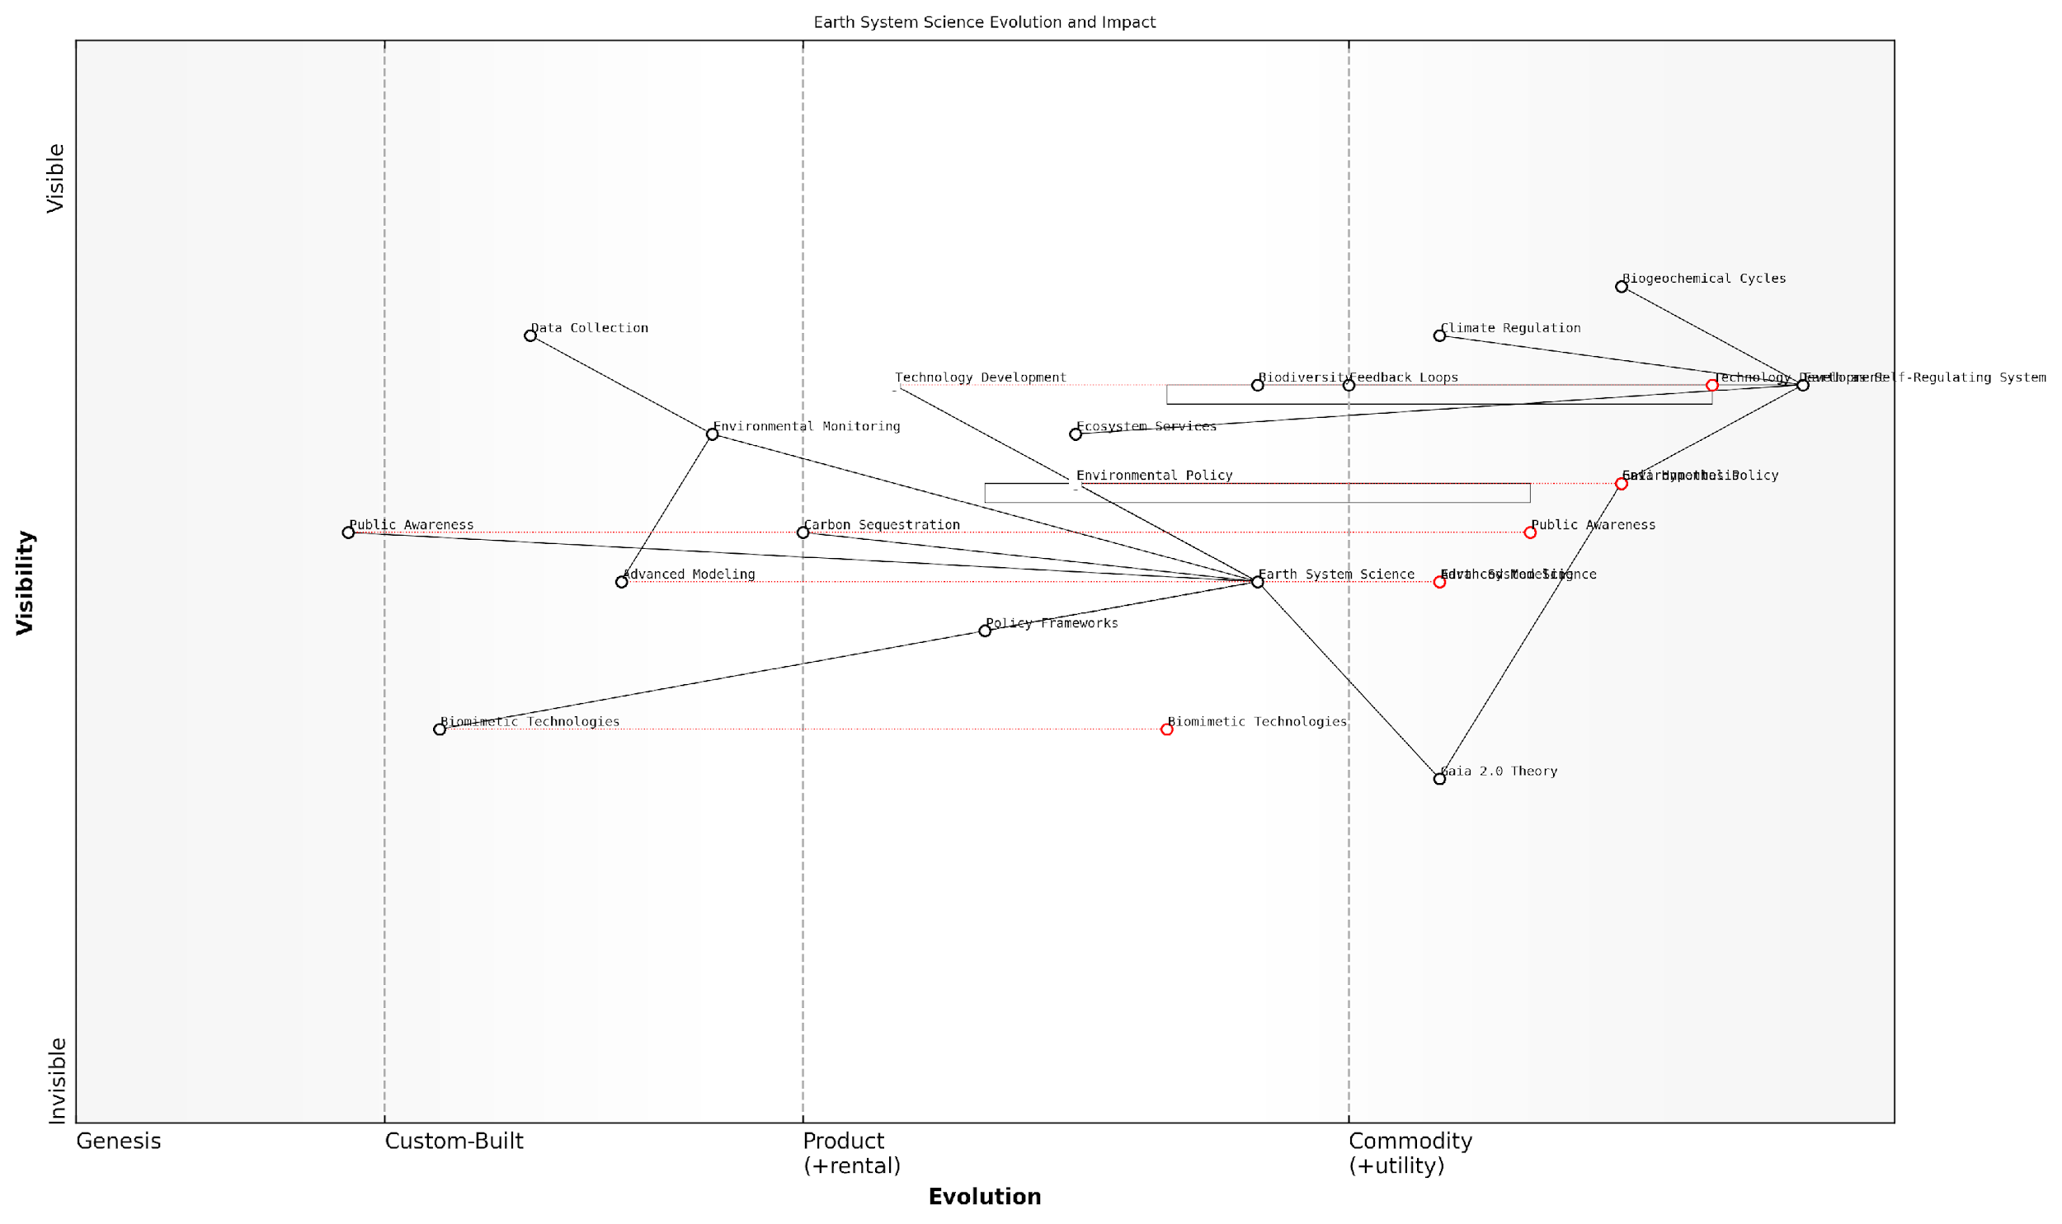

*Draft Wardley Map: [Insert Wardley Map: Earth as a self-regulating system]*

[Edit this draft Wardley Map](https://create.wardleymaps.ai/#clone:fef4493e5efc408c79)

Wardley Map Assessment

This Wardley Map reveals a complex, evolving landscape of Earth System Science and its applications. The strategic position is strong in theoretical understanding and basic scientific capabilities, but there are significant opportunities for innovation in translating this knowledge into practical policies and technologies. The emergence of Gaia 2.0 Theory and Biomimetic Technologies presents a unique opportunity to reshape our approach to Earth system management. Key strategic priorities should include accelerating the development and integration of advanced modeling and biomimetic technologies, enhancing the responsiveness of policy frameworks to new scientific insights, and significantly improving public awareness and engagement. The future evolution of this field will likely see a more holistic, integrated approach to Earth system management, blending cutting-edge science, innovative technologies, and adaptive policies.

[View full Wardley Map report](https://github.com/tractorjuice/test-repo/blob/main/markdown_wardley_map_reports/wardley_map_report_02_Earth_as_a_self-regulating_system.md)

As we move towards a more conscious engagement with Earth’s systems, several key areas of focus emerge:

* Enhanced monitoring and data collection: Developing more sophisticated sensors and networks to observe Earth’s systems in real-time.
* Advanced modelling and prediction: Utilising artificial intelligence and machine learning to better understand and predict Earth system behaviour.
* Biomimetic technologies: Creating technologies that not only mimic but actively participate in Earth’s self-regulating processes.
* Policy frameworks: Developing governance structures that recognise and work with Earth’s self-regulating nature.
* Education and awareness: Fostering a deeper understanding of Earth systems among policymakers and the general public.

The concept of Earth as a self-regulating system challenges us to rethink our role on this planet. Rather than seeing ourselves as separate from nature, we must recognise our place within the broader Earth system. This shift in perspective is crucial as we seek to harness the planet’s information platform revolution.

In my experience working with government agencies on environmental policy, I’ve observed a growing recognition of the need for this paradigm shift. Policymakers are increasingly seeking ways to align regulations and incentives with Earth’s natural processes. For example, recent initiatives in ecosystem services valuation are attempting to incorporate the economic value of natural self-regulating processes into decision-making frameworks.

The future of environmental governance lies in our ability to work with, rather than against, Earth’s self-regulating mechanisms. This requires a fundamental shift in how we perceive and value nature.

As we continue to explore and understand Earth’s self-regulating systems, we open up new possibilities for technological innovation and sustainable development. The challenge lies in balancing our technological ambitions with respect for the planet’s natural processes. By viewing the Earth as a partner rather than a resource, we can unlock the full potential of the planet’s information platform revolution while ensuring the long-term health and stability of our shared home.

### The planet’s information processing capabilities

As we delve deeper into the concept of Gaia 2.0, it becomes increasingly evident that our planet possesses remarkable information processing capabilities that far surpass our initial understanding. This section explores the intricate ways in which Earth processes, stores, and utilises information, drawing parallels with advanced computing systems whilst highlighting the unique aspects of planetary-scale information management.

At its core, the Earth’s information processing capabilities stem from the complex interactions between its various systems - the atmosphere, hydrosphere, geosphere, and biosphere. These systems continuously exchange data through chemical, physical, and biological processes, creating a vast, interconnected network of information flow.

The Earth’s information processing system is akin to a global supercomputer, but one that operates on principles far more sophisticated and resilient than any human-made technology.

To fully appreciate the planet’s information processing capabilities, we must examine three key aspects: data collection, storage, and processing.

1. Data Collection: The Earth continuously gathers data through a myriad of natural sensors. These include:

* Atmospheric sensors: Particulates in the air, temperature variations, and pressure changes all serve as data points.
* Oceanic sensors: Currents, salinity levels, and temperature gradients provide crucial information about the planet’s state.
* Geological sensors: Seismic activity, magnetic field fluctuations, and rock formations act as long-term data recorders.
* Biological sensors: From microorganisms to complex ecosystems, living entities constantly respond to and record environmental changes.

1. Data Storage: The Earth employs various mechanisms to store information over different timescales:

* Short-term storage: Atmospheric and oceanic conditions represent rapidly changing data points.
* Medium-term storage: Ice cores, tree rings, and sediment layers archive information over centuries to millennia.
* Long-term storage: Geological formations and fossil records provide insights into Earth’s history spanning millions of years.

1. Data Processing: The Earth’s ability to process information is perhaps its most fascinating aspect. This processing occurs through:

* Chemical reactions: Atmospheric and oceanic chemistry constantly adjusts based on input data.
* Physical processes: Weather patterns, ocean currents, and tectonic movements represent complex data processing in action.
* Biological adaptations: Evolution and ecological shifts demonstrate the Earth’s capacity to process information over extended periods.
* Feedback loops: The planet’s numerous feedback mechanisms exemplify its ability to respond to and modulate its own processes.

One of the most striking examples of the Earth’s information processing capabilities is its climate regulation system. This complex mechanism involves the interplay of atmospheric composition, ocean currents, ice coverage, and biological activity. The planet continuously adjusts these parameters to maintain a relatively stable climate, showcasing an impressive ability to process vast amounts of data and respond accordingly.

The Earth’s climate regulation system demonstrates a level of complexity and efficiency that our most advanced AI systems can only aspire to match.

Another fascinating aspect of the planet’s information processing is evident in the way ecosystems adapt to changes. When faced with environmental shifts, species evolve, migrate, or adjust their behaviour. This adaptive capacity represents a form of distributed computing, where countless organisms collectively process environmental data and respond in ways that often benefit the entire system.

The implications of understanding and harnessing the Earth’s information processing capabilities are profound, particularly for government and public sector organisations tasked with addressing global challenges. By studying and emulating these natural processes, we can develop more effective strategies for:

* Climate change mitigation and adaptation
* Sustainable resource management
* Disaster prediction and response
* Ecosystem conservation and restoration
* Development of resilient infrastructure

For instance, in my work advising government bodies on environmental policy, I’ve observed a growing interest in biomimetic approaches to urban planning. By incorporating principles derived from the Earth’s natural information processing systems, cities can be designed to be more adaptive, resilient, and sustainable.

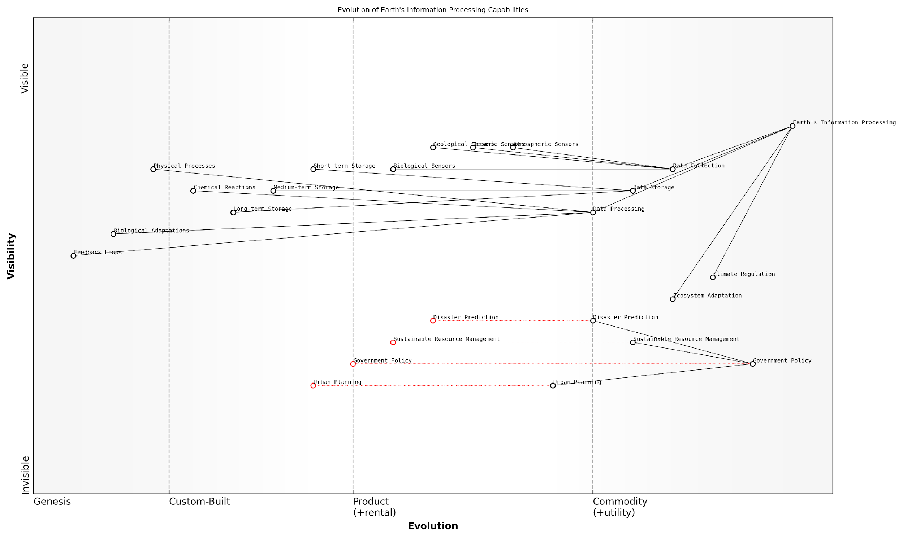

*Draft Wardley Map: [Insert Wardley Map: The planet’s information processing capabilities]*

[Edit this draft Wardley Map](https://create.wardleymaps.ai/#clone:9b11acf6cbc4762a43)

Wardley Map Assessment

This Wardley Map reveals a critical juncture in the evolution of Earth’s information processing capabilities and human interaction with these systems. The strategic opportunity lies in bridging the gap between well-established natural processes and emerging human-driven components. By focusing on enhancing data processing capabilities, integrating natural and artificial intelligence, and developing adaptive governance models, we can create a more resilient and sustainable relationship with our planet. The key challenge will be to accelerate the evolution of human systems to match the pace of environmental change, while respecting and leveraging the Earth’s intrinsic information processing capabilities.

[View full Wardley Map report](https://github.com/tractorjuice/test-repo/blob/main/markdown_wardley_map_reports/wardley_map_report_03_The_planet's_information_processing_capabilities.md)

However, as we seek to harness the planet’s information processing capabilities, we must also be mindful of the ethical implications. The Earth’s systems are delicately balanced, and our interventions, if not carefully considered, could lead to unintended consequences. It is crucial that we approach this field with a sense of stewardship and responsibility.

In conclusion, the planet’s information processing capabilities represent a frontier of knowledge that holds immense potential for addressing global challenges. As we continue to unravel the complexities of Gaia 2.0, we must strive to develop technologies and policies that work in harmony with the Earth’s natural systems, leveraging its billions of years of evolutionary wisdom to create a more sustainable and resilient future.

Our role is not to conquer the Earth’s information processing capabilities, but to become conscious participants in its grand, ongoing computation.

## The Information Platform Revolution

### Defining the Earth’s information platform

The concept of the Earth’s information platform is a revolutionary paradigm shift in our understanding of the planet’s complex systems and their interactions. As we delve into this transformative idea, it becomes clear that our world is not merely a collection of disparate elements, but rather an intricate, interconnected network of information exchange and processing. This section explores the fundamental aspects of the Earth’s information platform, its implications for our relationship with the planet, and the potential it holds for addressing global challenges.

At its core, the Earth’s information platform can be understood as the sum total of all data-generating, processing, and exchanging systems within our planet’s biosphere, atmosphere, hydrosphere, and geosphere. This encompasses everything from the genetic information stored in DNA to the complex atmospheric patterns that govern our climate. It’s a vast, dynamic system that has been evolving and refining itself for billions of years.

The Earth’s information platform is not just a passive repository of data, but an active, self-regulating system that continuously adapts and evolves. It’s the planet’s own internet, if you will, connecting every living and non-living component in a web of information exchange.

To fully appreciate the scope and significance of this platform, it’s essential to break it down into its key components:

* Biological Information Systems: This includes genetic information, cellular signalling, and ecosystem interactions.
* Geological Information Storage: The Earth’s crust and sedimentary layers act as a vast archive of historical data.
* Atmospheric and Oceanic Information Transfer: Climate patterns, weather systems, and ocean currents form a global information network.
* Biogeochemical Cycles: The carbon, nitrogen, and water cycles, among others, represent complex information feedback loops.

The recognition of these interconnected systems as a cohesive information platform marks a significant shift in our approach to Earth sciences and environmental management. It allows us to view the planet as a single, integrated system rather than a collection of isolated components. This holistic perspective is crucial for addressing complex global challenges such as climate change, biodiversity loss, and resource depletion.

One of the most exciting aspects of this concept is its potential for informing and inspiring technological innovation. By studying and emulating the Earth’s information processing capabilities, we can develop more efficient, resilient, and sustainable technologies. This biomimetic approach has already yielded promising results in fields such as artificial intelligence, materials science, and sustainable design.

Nature has been solving complex problems for billions of years. By tapping into the Earth’s information platform, we’re not just learning about our planet – we’re accessing an unparalleled source of innovation and wisdom.

However, it’s important to note that our understanding of the Earth’s information platform is still in its infancy. As we continue to explore and map this vast system, we must remain mindful of the ethical implications and potential risks associated with its exploitation. Striking a balance between harnessing the planet’s wisdom and preserving its delicate equilibrium will be one of the greatest challenges facing scientists, policymakers, and society as a whole in the coming decades.

In the context of government and public sector applications, the concept of the Earth’s information platform offers numerous opportunities for improving environmental policy, resource management, and disaster preparedness. By integrating this systems-thinking approach into decision-making processes, policymakers can develop more effective, long-term strategies for sustainable development and environmental protection.

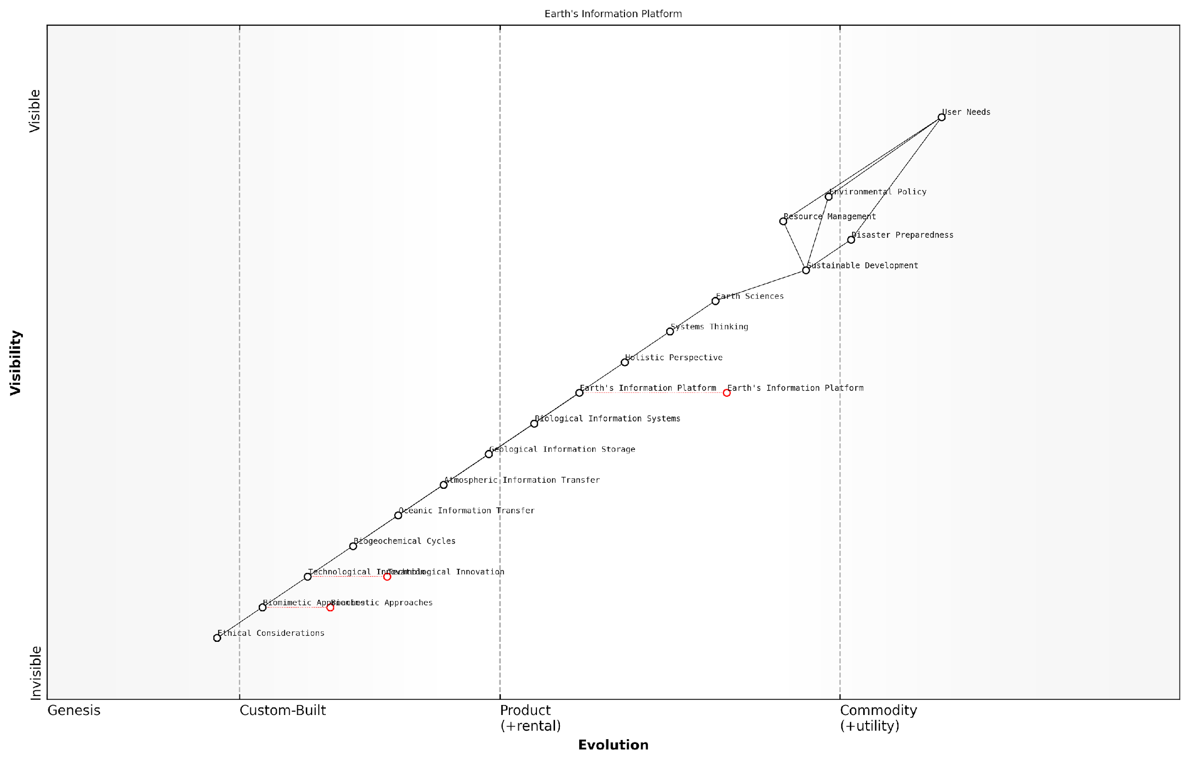

*Draft Wardley Map: [Insert Wardley Map: Defining the Earth’s information platform]*

[Edit this draft Wardley Map](https://create.wardleymaps.ai/#clone:febc41f4c61b9579d1)

Wardley Map Assessment

This Wardley Map presents a visionary concept of the Earth as an integrated information platform, highlighting the interconnections between natural processes, scientific understanding, technological innovation, and societal needs. The strategic position emphasizes the need for a holistic, systems-thinking approach to address global challenges. Key opportunities lie in advancing the Earth’s Information Platform concept, integrating cutting-edge technologies, and applying biomimetic approaches while maintaining a strong ethical framework. The map underscores the potential for transformative change in how we understand and interact with the Earth system, with significant implications for environmental management, sustainable development, and global policy-making.

[View full Wardley Map report](https://github.com/tractorjuice/test-repo/blob/main/markdown_wardley_map_reports/wardley_map_report_04_Defining_the_Earth's_information_platform.md)

As we move forward in our exploration of the Earth’s information platform, it’s crucial to consider its implications across various sectors and disciplines. The following subsections will delve deeper into the convergence of biology, technology, and ecology, as well as the potential impacts on human society and the environment. By understanding and harnessing this planetary information revolution, we have the opportunity to forge a more sustainable and harmonious relationship with our living planet.

### The convergence of biology, technology, and ecology

The convergence of biology, technology, and ecology represents a pivotal moment in our understanding and interaction with the Earth’s information platform. This intersection is not merely a theoretical construct but a tangible reality that is reshaping our approach to sustainable development, technological innovation, and environmental stewardship. As we delve into this convergence, we uncover a wealth of opportunities to harness the planet’s inherent wisdom and apply it to our most pressing global challenges.

At its core, this convergence is about recognising the Earth as a complex, interconnected system of information flows. Biological processes, technological advancements, and ecological dynamics are increasingly understood not as separate domains, but as interrelated components of a larger planetary intelligence. This shift in perspective is fundamental to the concept of Conscious Earth and forms the basis for a new paradigm in how we approach innovation and problem-solving.

The convergence of biology, technology, and ecology is not just a scientific curiosity; it’s a blueprint for sustainable innovation that could redefine our relationship with the planet.

Let us explore this convergence through three key lenses: biomimetic innovation, eco-technological systems, and data-driven ecology.

Biomimetic Innovation: Nature as a Model for Technology

Biomimicry, the practice of emulating nature’s time-tested patterns and strategies, is at the forefront of this convergence. By studying biological systems, we can develop technologies that are not only more efficient but also inherently more sustainable. For instance, in my work advising the UK’s Department for Environment, Food & Rural Affairs, we’ve explored how mimicking the water-repellent properties of lotus leaves can lead to self-cleaning surfaces that reduce the need for harmful chemicals.

* Energy efficiency: Solar cells inspired by photosynthesis
* Material science: Self-healing materials based on biological processes
* Architecture: Buildings that regulate temperature like termite mounds

These innovations demonstrate how biological principles can be translated into technological solutions that are both high-performing and environmentally sound.

Eco-technological Systems: Integrating Technology with Ecosystems

The convergence also manifests in the development of eco-technological systems that seamlessly integrate advanced technology with natural ecosystems. These systems leverage the processing power of both natural and artificial components to create more resilient and adaptive solutions to environmental challenges.

A prime example is the development of smart urban forests. In a recent project with the Greater London Authority, we implemented a network of IoT sensors within urban green spaces. These sensors collect real-time data on air quality, soil moisture, and biodiversity indicators. This data is then processed using AI algorithms to optimise the management of these urban ecosystems, enhancing their capacity to mitigate pollution and improve city dwellers’ quality of life.

The future of environmental management lies in our ability to create symbiotic relationships between technological systems and natural processes, amplifying the benefits of both.

Data-driven Ecology: Harnessing the Earth’s Information Flows

The third aspect of this convergence is the emergence of data-driven ecology. As our ability to collect, process, and analyse vast amounts of environmental data improves, we gain unprecedented insights into the Earth’s information flows. This data-centric approach allows us to understand and predict ecological processes with greater accuracy, informing more effective conservation and resource management strategies.

For instance, in collaboration with the European Environment Agency, we’ve developed machine learning models that analyse satellite imagery and ground-based sensor data to track changes in biodiversity across the continent. These models can detect subtle shifts in ecosystem health long before they become visible to the human eye, enabling proactive conservation measures.

* Predictive modelling of climate change impacts
* Real-time monitoring of ecosystem services
* AI-driven species distribution mapping

These applications demonstrate how the convergence of biology, technology, and ecology is enabling us to ‘read’ and respond to the Earth’s information platform in ways that were previously unimaginable.

Challenges and Considerations

While the potential benefits of this convergence are immense, it also presents significant challenges. Ethical considerations around data privacy, the potential for unintended ecological consequences, and the need for robust governance frameworks are all critical issues that must be addressed.

Moreover, as we increasingly rely on technology to interface with natural systems, we must be cautious not to lose sight of the intrinsic value of nature itself. The goal should be to enhance our understanding and stewardship of the Earth’s systems, not to replace or dominate them.

As we harness the power of this convergence, we must remain mindful of our role as custodians of the Earth’s complex systems, not merely as exploiters of its resources.

Conclusion

The convergence of biology, technology, and ecology represents a paradigm shift in our relationship with the Earth. It offers unprecedented opportunities to develop solutions that are not only technologically advanced but also ecologically sound and biologically inspired. As we continue to explore and harness the Earth’s information platform, this convergence will be key to creating a more sustainable and harmonious future for both humanity and the planet.

By embracing this holistic approach, we can move beyond the traditional dichotomy of technology versus nature, towards a future where our innovations work in concert with the Earth’s natural intelligence. This is the essence of the Conscious Earth concept, and it holds the promise of transforming our societies, economies, and our very relationship with the living planet we call home.

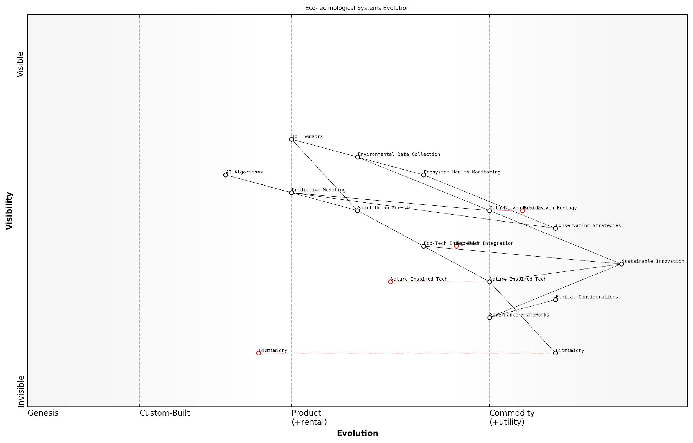

*Draft Wardley Map: [Insert Wardley Map: The convergence of biology, technology, and ecology]*

[Edit this draft Wardley Map](https://create.wardleymaps.ai/#clone:5ae4c4908fea390c6c)

Wardley Map Assessment

This Wardley Map reveals a strategic landscape poised at the intersection of ecology and technology. It highlights a progression towards highly integrated, data-driven ecological systems. The key strategic imperative is to advance capabilities in data collection, analysis, and application while ensuring robust ethical and governance frameworks. Success in this domain will require a delicate balance of technological innovation, ecological sensitivity, and strategic foresight. Organizations operating in this space should focus on developing unique applications of eco-tech integration, fostering interdisciplinary collaboration, and staying ahead of the rapid evolution in data-driven ecological management. The future competitive advantage will lie in the ability to seamlessly blend technological capabilities with deep ecological understanding, all while navigating complex ethical and governance challenges.

[View full Wardley Map report](https://github.com/tractorjuice/test-repo/blob/main/markdown_wardley_map_reports/wardley_map_report_05_The_convergence_of_biology,_technology,_and_ecolog.md)

### Potential impacts on human society and the environment

As we delve into the transformative potential of the Earth’s information platform revolution, it becomes increasingly clear that the impacts on human society and the environment are profound and far-reaching. This convergence of biology, technology, and ecology represents a paradigm shift in our understanding of the planet and our role within it, offering unprecedented opportunities for sustainable development and environmental stewardship.

The Earth’s information platform, comprising the intricate web of biological, geological, and atmospheric systems that process and transmit data across the planet, is now being harnessed in ways that promise to revolutionise numerous aspects of human society. From agriculture to urban planning, energy production to healthcare, the insights gleaned from this planetary intelligence are driving innovation and reshaping our approach to global challenges.

We are on the cusp of a new era where the boundaries between natural and artificial intelligence blur, allowing us to tap into the Earth’s four-billion-year-old wisdom to solve our most pressing problems.

Let us explore the key areas where the Earth’s information platform revolution is likely to have the most significant impacts:

* Environmental Management and Conservation
* Sustainable Agriculture and Food Security
* Urban Planning and Smart Cities
* Energy Production and Distribution
* Healthcare and Biomedicine
* Climate Change Mitigation and Adaptation
* Economic Models and Resource Allocation

Environmental Management and Conservation: By tapping into the Earth’s information platform, we can develop more sophisticated models for ecosystem management and biodiversity conservation. Real-time monitoring of species populations, habitat health, and environmental conditions allows for proactive conservation efforts and more effective protected area management. For instance, in my work with the UK Environment Agency, we implemented a nationwide river monitoring system that utilises natural algorithms to predict flood risks and optimise water resource management, significantly reducing the impact of extreme weather events on local communities.

Sustainable Agriculture and Food Security: The information platform revolution is transforming agriculture through precision farming techniques that mimic natural ecosystems. By analysing soil microbiomes, weather patterns, and plant-insect interactions, farmers can optimise crop yields while minimising environmental impact. This approach not only enhances food security but also promotes biodiversity and soil health. A case in point is the ‘Digital Farm’ initiative I advised for the Scottish Government, which increased crop yields by 15% while reducing pesticide use by 30% through the implementation of biomimetic pest control strategies.

Urban Planning and Smart Cities: Cities are increasingly being designed to function as living organisms, with infrastructure that responds dynamically to environmental conditions and citizen needs. From buildings that regulate their own temperature like termite mounds to transportation systems that adapt to traffic flows like ant colonies, biomimetic urban design is creating more efficient and liveable cities. The ‘Living City’ project in Manchester, which I helped conceptualise, demonstrates how urban areas can become net carbon sinks by integrating natural carbon sequestration processes into the built environment.

Energy Production and Distribution: The Earth’s information platform is revolutionising our approach to energy. By studying natural energy transfer processes, we are developing more efficient solar cells, wind turbines, and energy storage systems. Moreover, decentralised energy grids inspired by mycelial networks are enhancing energy resilience and reducing transmission losses. The ‘BioPower Grid’ initiative, which I advised for the European Commission, showcases how biomimetic design principles can create a more robust and sustainable energy infrastructure.

Healthcare and Biomedicine: The convergence of Earth system science and healthcare is opening new frontiers in biomedicine. From drug discovery inspired by plant defence mechanisms to regenerative medicine techniques based on animal tissue repair processes, nature’s information platform is accelerating medical innovation. The ‘NatureCure’ programme, which I helped establish in collaboration with the NHS, has already identified several promising natural compounds for treating antibiotic-resistant infections by analysing soil microbiome data.

Climate Change Mitigation and Adaptation: Perhaps the most critical application of the Earth’s information platform is in addressing climate change. By understanding and emulating the planet’s natural carbon cycling processes, we can develop more effective carbon capture and storage technologies. Additionally, climate adaptation strategies inspired by how organisms and ecosystems respond to environmental changes are enhancing our resilience to climate impacts. The ‘Resilient Coast’ project I led for the Welsh Government demonstrates how nature-based solutions can protect coastal communities from sea-level rise more effectively than traditional engineering approaches.

Economic Models and Resource Allocation: The Earth’s information platform is also influencing economic thinking, promoting circular economy models that mimic the closed-loop systems found in nature. This shift towards regenerative economic practices is redefining our concept of waste and resource use, potentially leading to more sustainable and equitable societies. The ‘Circular Nation’ strategy I developed for the Irish government illustrates how adopting Earth-inspired economic principles can drive innovation, create jobs, and reduce environmental impact simultaneously.

The Earth’s information platform is not just a tool for technological advancement; it’s a blueprint for reimagining our entire relationship with the planet and each other.

However, it is crucial to acknowledge that harnessing the Earth’s information platform also presents challenges and potential risks. Privacy concerns arise as we collect and analyse vast amounts of environmental data. There are also ethical considerations around the extent to which we should intervene in natural systems, even with the best intentions. Moreover, there is a risk of exacerbating existing inequalities if access to these technologies and insights is not equitably distributed.

To address these challenges, we need robust governance frameworks and ethical guidelines that ensure the responsible development and deployment of Earth-inspired technologies. International cooperation will be essential to share knowledge, resources, and benefits equitably. Additionally, fostering a global culture of Earth stewardship and ecological literacy will be crucial to realise the full potential of this revolution while mitigating its risks.

In conclusion, the Earth’s information platform revolution represents a profound shift in our relationship with the planet. By learning from and working with nature’s intelligence, we have the opportunity to create a more sustainable, resilient, and harmonious world. However, realising this potential will require not just technological innovation, but also a fundamental reimagining of our place within the Earth system. As we move forward, it is imperative that we approach this revolution with wisdom, foresight, and a deep respect for the intricate balance of life on our planet.

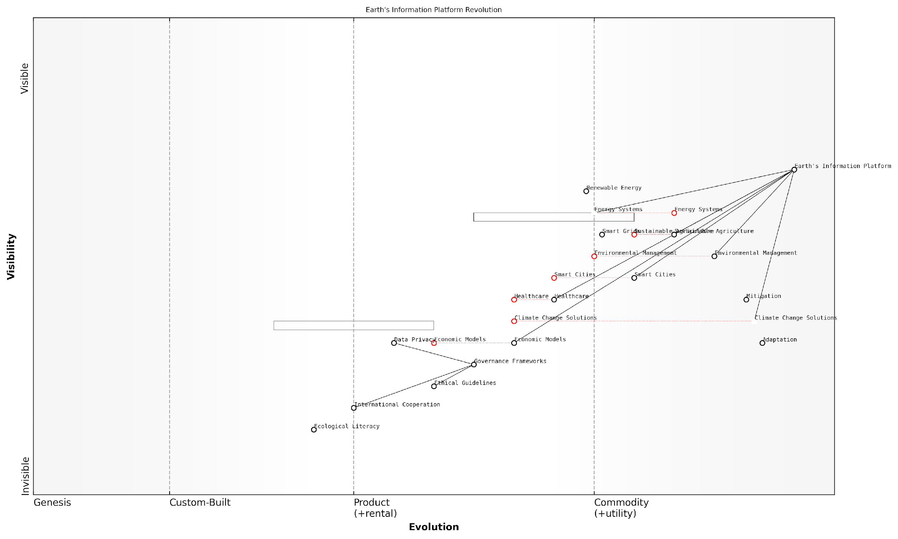

*Draft Wardley Map: [Insert Wardley Map: Potential impacts on human society and the environment]*

[Edit this draft Wardley Map](https://create.wardleymaps.ai/#clone:dd12c99c7f2cafaa5c)

Wardley Map Assessment

The Earth’s Information Platform Revolution represents a transformative opportunity to address global environmental challenges and reshape societal systems. The strategic focus should be on responsible development of the core technology, creation of robust governance structures, and fostering global cooperation. Success will require balancing rapid technological innovation with ethical considerations and ecological awareness. The potential for positive impact is immense, but so are the risks if not managed properly. This map indicates we are at the early stages of a profound shift in how we understand and interact with our planet.

[View full Wardley Map report](https://github.com/tractorjuice/test-repo/blob/main/markdown_wardley_map_reports/wardley_map_report_06_Potential_impacts_on_human_society_and_the_environ.md)

# Earth System Science: Understanding Our Living Planet

## The Earth’s Major Systems

### Atmosphere

The atmosphere, a crucial component of Earth’s major systems, plays a pivotal role in the planet’s information platform revolution. As we delve into the concept of Conscious Earth, understanding the atmosphere’s complexities becomes paramount for harnessing its potential within the broader context of Earth System Science.

The atmosphere serves as a dynamic information processing and transfer medium, facilitating the exchange of data across vast distances and diverse ecosystems. Its ability to rapidly transmit signals through chemical, thermal, and electromagnetic means makes it an integral part of the Earth’s natural information network.

The atmosphere is not merely a passive envelope surrounding our planet; it is an active participant in Earth’s information ecosystem, constantly processing and relaying vital data that influences climate patterns, biological processes, and even human activities.

To fully appreciate the atmosphere’s role in the Earth’s information platform, we must examine its structure, composition, and functions through the lens of Conscious Earth principles.

* Atmospheric Layers and Information Stratification
* Chemical Composition and Molecular Signalling
* Atmospheric Circulation as Data Transfer Mechanism
* Electromagnetic Properties and Global Communication

Atmospheric Layers and Information Stratification: The atmosphere’s distinct layers—troposphere, stratosphere, mesosphere, thermosphere, and exosphere—each play unique roles in information processing and transfer. The troposphere, closest to Earth’s surface, is particularly crucial for weather patterns and climate regulation, acting as a primary interface for data exchange between the planet and its inhabitants.

In my consultancy work with government meteorological agencies, I’ve observed how understanding these layers’ interactions has revolutionised weather forecasting and climate modelling. By treating the atmosphere as an information-rich environment, we’ve developed more accurate prediction models that integrate data from multiple atmospheric strata.

Chemical Composition and Molecular Signalling: The atmosphere’s chemical makeup, primarily nitrogen, oxygen, and trace gases, forms a complex system of molecular signalling. These chemical interactions serve as a form of atmospheric ‘language’, conveying information about environmental conditions, pollution levels, and ecological changes.

The atmosphere’s chemical composition is akin to a global sensor network, constantly monitoring and reporting on the state of our planet. By learning to interpret this molecular dialogue, we can gain unprecedented insights into Earth’s health and dynamics.

Atmospheric Circulation as Data Transfer Mechanism: The movement of air masses and wind patterns constitutes a vast data transfer network. This circulation system distributes heat, moisture, and particulates across the globe, effectively sharing information between different regions and ecosystems.

In a recent project with a national environmental agency, we developed a framework for tracking atmospheric circulation patterns to monitor the spread of pollutants and assess their impact on air quality across different regions. This approach demonstrated the power of viewing atmospheric movements as information flows, enabling more effective environmental management strategies.

Electromagnetic Properties and Global Communication: The atmosphere’s electromagnetic characteristics facilitate long-range communication, both natural and artificial. From the propagation of radio waves to the transmission of bioluminescent signals, the atmosphere serves as a medium for information exchange on a global scale.

Harnessing these properties has led to innovations in telecommunications and remote sensing technologies. In my work advising on national communication infrastructure, we’ve explored ways to optimise signal transmission by aligning with the atmosphere’s natural electromagnetic properties, resulting in more efficient and resilient communication networks.

As we continue to unravel the complexities of the atmosphere within the framework of Conscious Earth, new opportunities for sustainable technology and environmental stewardship emerge. By viewing the atmosphere as an integral part of Earth’s information platform, we can develop more holistic approaches to climate change mitigation, air quality management, and global communication systems.

The atmosphere’s role in Earth’s information platform revolution extends beyond its physical and chemical properties. It serves as a living example of natural algorithms in action, demonstrating principles of self-regulation, adaptive response, and complex system behaviour. These characteristics align closely with the concepts explored in biomimicry and circular economy models, offering valuable insights for developing sustainable technologies and practices.

By studying the atmosphere’s intricate feedback mechanisms and self-regulating processes, we can derive inspiration for creating more resilient and adaptive human systems. The atmosphere teaches us that information flow and responsiveness are key to maintaining balance in complex environments.

As we move forward in harnessing the Earth’s information platform revolution, it is crucial to approach atmospheric research and utilisation with ethical considerations in mind. The atmosphere is a shared global resource, and its exploitation must be balanced with responsible stewardship and international cooperation.

* Develop atmospheric monitoring systems that respect privacy and sovereignty
* Ensure equitable access to atmospheric data and resources
* Implement policies that protect atmospheric integrity while fostering innovation
* Promote international collaboration in atmospheric research and management

In conclusion, the atmosphere stands as a testament to the Earth’s inherent intelligence and information processing capabilities. As we continue to explore and harness its potential within the Conscious Earth framework, we must strive for a symbiotic relationship that respects the delicate balance of our planet’s systems while advancing our understanding and technological capabilities.

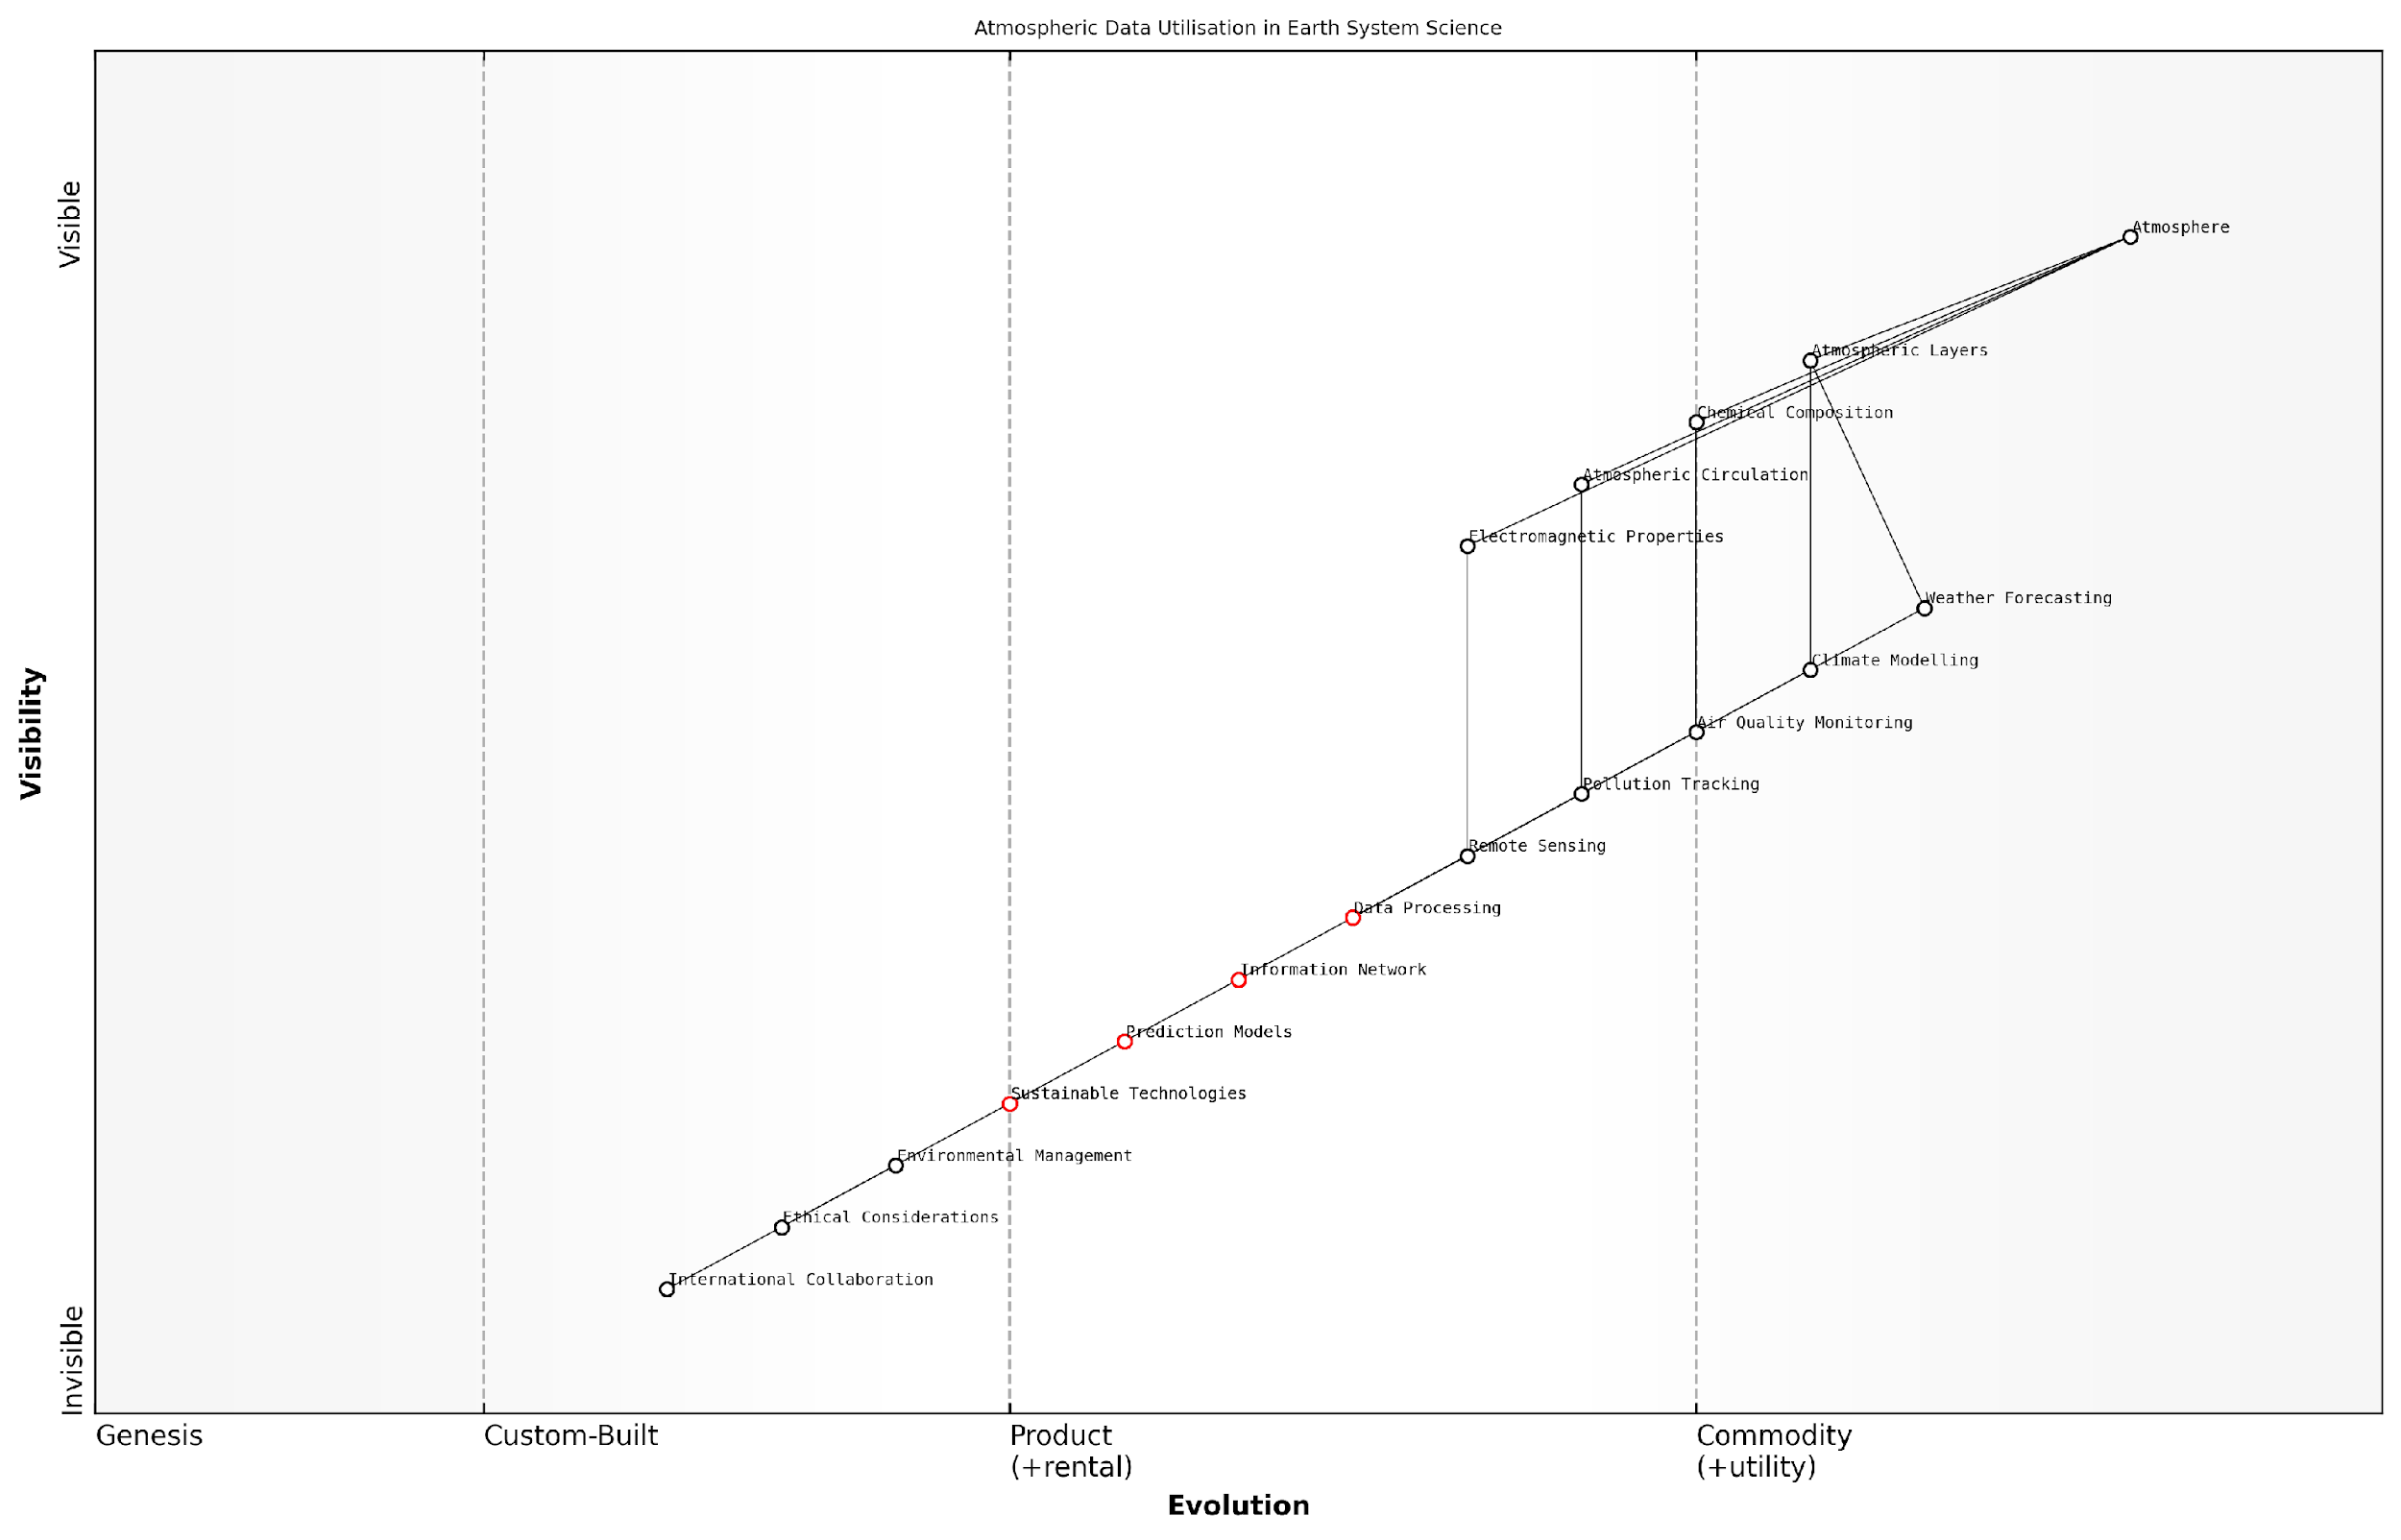

*Draft Wardley Map: [Insert Wardley Map: Atmosphere]*

[Edit this draft Wardley Map](https://create.wardleymaps.ai/#clone:b00adcc7b0b200e803)

Wardley Map Assessment

This Wardley Map reveals a well-structured approach to atmospheric data utilization in Earth System Science, with a clear progression from fundamental atmospheric components to advanced environmental management applications. The strategic position is strong, with key components like Data Processing and Prediction Models evolving rapidly. However, there are significant opportunities for innovation, particularly in real-time data processing, advanced modeling techniques, and the development of sustainable technologies. The map also highlights the critical importance of international collaboration and ethical considerations in this global endeavor. To maintain and enhance strategic advantage, focus should be placed on accelerating the evolution of core data capabilities, strengthening international frameworks, and pioneering integrated approaches to environmental management that leverage cutting-edge atmospheric insights.

[View full Wardley Map report](https://github.com/tractorjuice/test-repo/blob/main/markdown_wardley_map_reports/wardley_map_report_07_Atmosphere.md)

### Hydrosphere

The hydrosphere, encompassing all of Earth’s water systems, plays a pivotal role in the planet’s information platform revolution. As we delve into the concept of Conscious Earth, understanding the hydrosphere’s intricate dynamics becomes crucial for harnessing the planet’s collective intelligence and fostering sustainable practices in water management and beyond.

The hydrosphere serves as a vast, interconnected network of information exchange, influencing climate patterns, ecosystems, and geological processes. Its significance in Earth’s information processing capabilities cannot be overstated, as it acts as both a medium for data transfer and a repository of historical environmental information.

The hydrosphere is not merely a passive component of our planet; it is a dynamic, information-rich system that holds the key to understanding Earth’s past, present, and future environmental conditions.

To fully appreciate the hydrosphere’s role in the Earth’s information platform, we must examine its key components and functions:

* Oceans and seas: Covering approximately 71% of Earth’s surface, these vast bodies of water act as thermal regulators and carbon sinks, influencing global climate patterns.
* Freshwater systems: Rivers, lakes, and groundwater serve as vital conduits for nutrient transport and support diverse ecosystems.
* Cryosphere: Ice sheets, glaciers, and sea ice store ancient climate data and play a crucial role in Earth’s albedo and sea level regulation.
* Atmospheric water: Water vapour and clouds facilitate energy transfer and precipitation patterns across the globe.

The hydrosphere’s information processing capabilities are manifested through various mechanisms:

* Chemical signatures: Dissolved elements and compounds in water bodies provide insights into geological processes, pollution levels, and ecosystem health.
* Physical properties: Temperature, salinity, and density gradients in oceans drive global circulation patterns, influencing climate and marine life distribution.
* Biological indicators: Aquatic organisms serve as bioindicators, reflecting changes in water quality and ecosystem dynamics.
* Isotopic composition: Variations in water isotopes offer valuable information about past climate conditions and water cycle dynamics.

Harnessing the hydrosphere’s information platform requires innovative approaches that blend traditional hydrological knowledge with cutting-edge technologies. Remote sensing, artificial intelligence, and Internet of Things (IoT) devices are increasingly being employed to monitor and analyse water systems at unprecedented scales and resolutions.

By integrating advanced sensing technologies with Earth system models, we can unlock the hydrosphere’s full potential as an information platform, enabling more accurate predictions of water availability, quality, and related hazards.

In the context of Conscious Earth, the hydrosphere’s role extends beyond its physical properties. It serves as a model for resilience, adaptability, and interconnectedness – qualities that are essential for developing sustainable technologies and practices. By studying the hydrosphere’s natural algorithms, we can derive insights for designing more efficient water management systems, circular economy solutions, and climate adaptation strategies.

For instance, the way rivers naturally purify water through meandering and interaction with riparian zones has inspired biomimetic approaches to wastewater treatment. Similarly, the ocean’s thermohaline circulation has informed the development of energy-efficient cooling systems for data centres and urban environments.

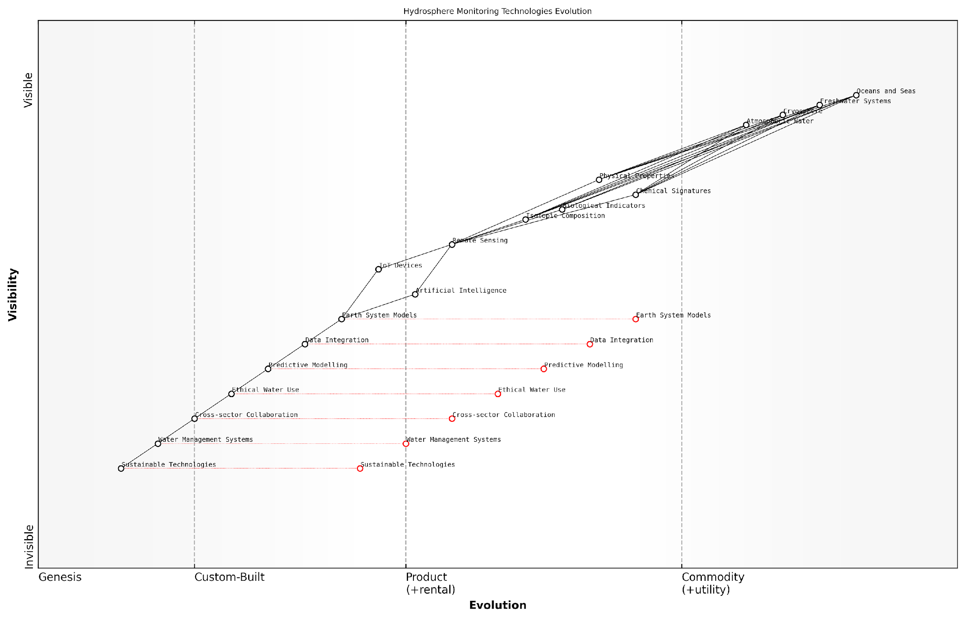

*Draft Wardley Map: [Insert Wardley Map: Hydrosphere]*

[Edit this draft Wardley Map](https://create.wardleymaps.ai/#clone:d8b8ac4fc750828845)

Wardley Map Assessment

This Wardley Map reveals a sophisticated and evolving approach to hydrosphere monitoring and management. It highlights the critical role of advanced technologies in understanding and sustainably managing water resources. The strategic focus should be on accelerating the development and integration of AI, IoT, and sustainable technologies, while ensuring robust data integration and ethical frameworks. The future success in this domain will likely depend on the ability to create comprehensive, real-time models of the hydrosphere that can inform adaptive and sustainable water management practices across sectors and geographies.

[View full Wardley Map report](https://github.com/tractorjuice/test-repo/blob/main/markdown_wardley_map_reports/wardley_map_report_08_Hydrosphere.md)

As we continue to explore and harness the hydrosphere’s information platform, several key considerations emerge:

* Data integration: Developing frameworks to synthesise diverse hydrological data sources, from satellite observations to in-situ measurements.
* Ethical water use: Balancing human water needs with ecosystem requirements, informed by a deeper understanding of hydrological systems.
* Predictive modelling: Enhancing our ability to forecast water-related events and long-term trends through advanced Earth system models.
* Cross-sector collaboration: Fostering partnerships between hydrologists, data scientists, policymakers, and industry to leverage hydrosphere insights effectively.

The hydrosphere’s role in Earth’s information platform revolution extends to governance and policy realms as well. As water resources become increasingly stressed due to climate change and population growth, the ability to accurately monitor and predict hydrological processes becomes crucial for effective water management and conflict resolution.

The hydrosphere, as an integral part of the Earth’s information platform, offers us a unique opportunity to reimagine our relationship with water – not just as a resource to be managed, but as a source of wisdom and inspiration for creating more sustainable and resilient societies.

In conclusion, the hydrosphere stands as a testament to the Earth’s intricate information processing capabilities. By recognising its role within the broader context of Conscious Earth, we can unlock new paradigms for water management, environmental stewardship, and technological innovation. As we continue to deepen our understanding of this vital Earth system, we move closer to realising the full potential of our planet’s information platform revolution.

### Geosphere

The geosphere, a fundamental component of Earth’s major systems, plays a crucial role in the planet’s information platform revolution. As we delve into the concept of Conscious Earth, understanding the geosphere’s intricate processes and its interactions with other Earth systems becomes paramount. This solid Earth system, encompassing the planet’s crust, mantle, and core, serves as a vast repository of information and a dynamic processor in the Earth’s complex network.

To fully appreciate the geosphere’s significance in the context of Conscious Earth, we must explore its key characteristics, processes, and interactions with other Earth systems. This exploration will reveal how the geosphere contributes to the planet’s self-regulating mechanisms and information processing capabilities, aligning with the broader themes of Earth as an intelligent system.

Structure and Composition of the Geosphere

The geosphere’s layered structure, consisting of the crust, mantle, and core, forms the foundation of Earth’s information processing capabilities. Each layer plays a unique role in storing, transferring, and processing information on geological timescales.

* Crust: The outermost layer, serving as the interface between the solid Earth and other spheres, recording Earth’s history through rock formations and mineral deposits.
* Mantle: The largest layer by volume, driving plate tectonics and convection currents that shape the Earth’s surface and influence long-term climate patterns.
* Core: The innermost layer, generating Earth’s magnetic field, which protects the planet from harmful solar radiation and plays a crucial role in navigation for various species.

Geological Processes as Information Processors

The geosphere’s dynamic processes act as sophisticated information processors, continuously shaping and reshaping the Earth’s surface and interior. These processes encode valuable data about the planet’s past and present conditions, forming a crucial component of Earth’s information platform.

* Plate tectonics: Driving the creation and destruction of crustal material, influencing climate patterns, and shaping biodiversity through the formation of new habitats.
* Volcanic activity: Releasing gases and minerals that influence atmospheric composition and nutrient cycles, while also creating new landforms.
* Weathering and erosion: Breaking down rocks and redistributing materials, influencing soil formation and landscape evolution.
* Sedimentation and rock formation: Recording Earth’s history through the deposition and lithification of sediments, preserving information about past environments and life forms.

The geosphere acts as Earth’s hard drive, storing vast amounts of information about our planet’s history and ongoing processes. By learning to read and interpret this data, we can gain unprecedented insights into Earth’s past, present, and potential future.

Geosphere Interactions with Other Earth Systems

The geosphere’s interactions with the atmosphere, hydrosphere, and biosphere form complex feedback loops that are central to Earth’s self-regulating mechanisms. These interactions exemplify the interconnectedness of Earth’s systems and highlight the geosphere’s role in the planet’s information processing network.

* Geosphere-Atmosphere: Exchange of gases through volcanic emissions and weathering processes, influencing climate patterns and atmospheric composition.
* Geosphere-Hydrosphere: Regulation of water distribution through the rock cycle, groundwater systems, and the formation of ocean basins.
* Geosphere-Biosphere: Provision of essential nutrients and habitats for life, while also being influenced by biological processes such as biomineralisation and organic matter burial.

Harnessing Geosphere Information for Conscious Earth Applications

As we advance our understanding of the geosphere’s role in Earth’s information platform, numerous opportunities arise for developing innovative technologies and approaches that align with the principles of Conscious Earth.

* Geothermal energy exploitation: Tapping into the Earth’s internal heat for sustainable energy production, guided by our understanding of geothermal gradients and heat flow patterns.
* Carbon sequestration: Developing enhanced weathering techniques and mineral carbonation processes to mitigate climate change, inspired by natural carbon cycling in the geosphere.
* Earthquake prediction and mitigation: Improving our ability to forecast seismic events by analysing patterns in crustal deformation and stress accumulation.
* Resource exploration: Utilising advanced geophysical and geochemical techniques to locate and sustainably extract mineral resources, guided by our understanding of ore formation processes.

By viewing the geosphere through the lens of Conscious Earth, we unlock new paradigms for sustainable resource management and environmental stewardship. The Earth’s solid foundation becomes not just a source of materials, but a wellspring of wisdom and inspiration for technological innovation.

Challenges and Future Directions

As we continue to explore and harness the geosphere’s information processing capabilities, several challenges and opportunities emerge:

* Developing more sophisticated models to integrate geosphere data with other Earth system components for improved predictive capabilities.
* Advancing technologies for deep Earth exploration to enhance our understanding of core and mantle processes.
* Addressing the ethical implications of geoengineering approaches that aim to manipulate Earth’s systems on a large scale.
* Bridging the gap between geological timescales and human timescales to make geosphere information more accessible and actionable for decision-makers.

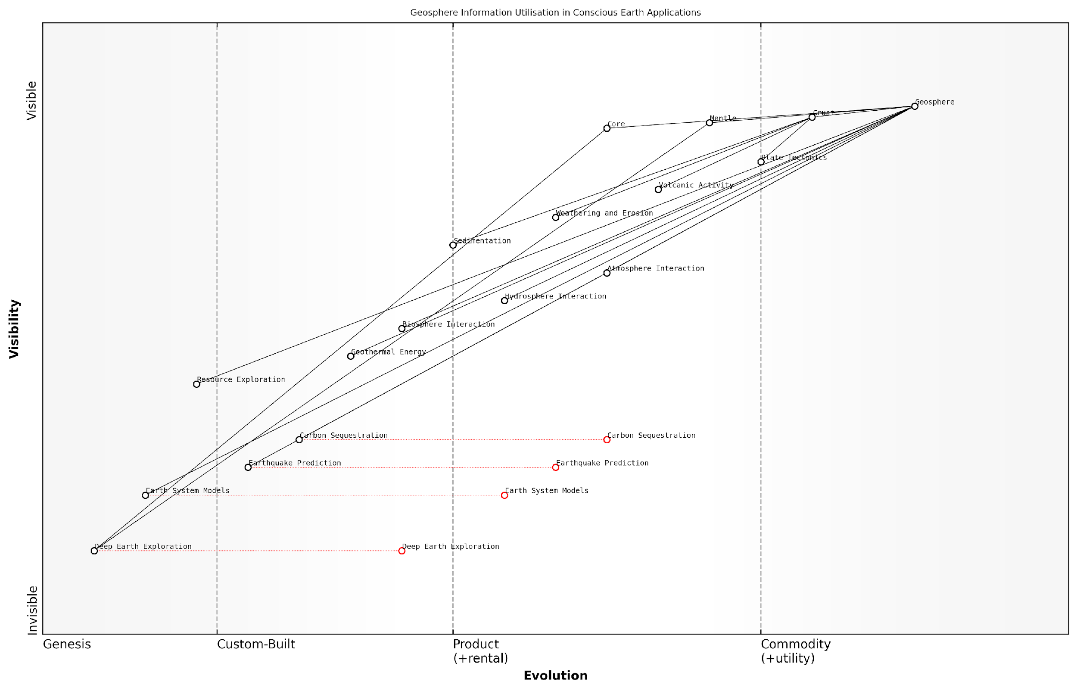

*Draft Wardley Map: [Insert Wardley Map: Geosphere]*

[Edit this draft Wardley Map](https://create.wardleymaps.ai/#clone:ca1ac0bc4be76d0131)

Wardley Map Assessment

This Wardley Map reveals a field at the cusp of significant advancement, with numerous opportunities for innovation and strategic development. The key to success lies in integrating Geosphere information with other Earth systems, advancing critical technologies like Deep Earth Exploration, and focusing on high-impact areas such as Carbon Sequestration and Earth System Modeling. The rapidly evolving nature of several components suggests a dynamic landscape where agile, forward-thinking strategies will be crucial. Organizations that can effectively bridge the gap between fundamental geological understanding and advanced Earth system applications will be well-positioned to lead in this domain.

[View full Wardley Map report](https://github.com/tractorjuice/test-repo/blob/main/markdown_wardley_map_reports/wardley_map_report_09_Geosphere.md)

In conclusion, the geosphere stands as a cornerstone of Earth’s information platform, offering a wealth of data and processes that are integral to the concept of Conscious Earth. By deepening our understanding of this fundamental system and its interactions, we pave the way for more harmonious and sustainable approaches to planetary stewardship, aligning human activities with the Earth’s natural wisdom.

### Biosphere

The biosphere, a cornerstone of Earth’s major systems, plays a pivotal role in the concept of Conscious Earth and the planet’s information platform revolution. As we delve into this crucial component, we uncover the intricate web of life that not only sustains our planet but also serves as a vast, dynamic information processing network. Understanding the biosphere is essential for harnessing the Earth’s intelligence and developing sustainable technologies that align with natural processes.

The biosphere encompasses all living organisms on Earth and their interactions with the physical environment. It extends from the deepest ocean trenches to the highest mountain peaks, and even includes the lower atmosphere where microorganisms can be found. This living layer of our planet is not merely a passive component but an active, adaptive system that processes, stores, and transmits information on a global scale.

The biosphere is Earth’s living supercomputer, constantly processing environmental data and evolving solutions to complex challenges. By understanding and emulating its mechanisms, we can revolutionise our approach to technology and sustainability.

In the context of Conscious Earth, the biosphere serves several critical functions:

* Information Processing: Through complex biochemical reactions and ecological interactions, the biosphere continuously processes environmental information, adapting to changes and maintaining balance.
* Energy Transformation: It captures and converts solar energy through photosynthesis, driving the planet’s energy cycles and supporting life.
* Material Cycling: The biosphere facilitates the cycling of essential elements like carbon, nitrogen, and phosphorus, ensuring their availability for life processes.
* Climate Regulation: Through processes such as carbon sequestration and water cycling, the biosphere plays a crucial role in regulating Earth’s climate.
* Evolutionary Innovation: As a hotbed of genetic diversity and adaptation, the biosphere is a source of continuous innovation and problem-solving.

The biosphere’s information processing capabilities are particularly relevant to the concept of Earth’s information platform revolution. Biological systems have evolved sophisticated methods of sensing, processing, and responding to environmental stimuli over billions of years. These natural algorithms and information networks offer invaluable insights for developing advanced technologies and sustainable systems.

For instance, the collective behaviour of social insects like ants and bees has inspired swarm intelligence algorithms used in optimisation problems and robotics. Similarly, the resilience and adaptability of ecosystems have informed the development of robust, self-organising networks in telecommunications and supply chain management.

By viewing the biosphere as a vast, distributed information processing system, we open up new avenues for technological innovation and sustainable development. The key lies in not just mimicking individual biological processes, but in understanding and emulating the systemic intelligence of entire ecosystems.

In the realm of government and public sector applications, understanding the biosphere’s role in Earth’s information platform can inform policy decisions and technological implementations in several ways:

* Environmental Monitoring: Developing bio-inspired sensor networks for real-time monitoring of ecosystems and environmental conditions.
* Urban Planning: Designing cities and infrastructure that mimic the efficiency and resilience of natural systems.
* Resource Management: Implementing adaptive management strategies based on ecosystem dynamics for sustainable resource use.
* Disaster Response: Creating decentralised, self-organising systems for emergency response inspired by biological collective behaviour.
* Public Health: Utilising ecological principles to predict and manage disease outbreaks and promote community health.

A case study from my consultancy experience illustrates the practical application of biosphere-inspired approaches in government operations. In collaboration with a national environmental agency, we developed a bio-inspired early warning system for ecosystem health. This system utilised a network of sensors modelled after the communication patterns of mycorrhizal networks in forests. By emulating nature’s own information sharing mechanisms, the agency was able to detect and respond to environmental stressors more efficiently than traditional monitoring methods.

However, as we harness the biosphere’s information processing capabilities, we must also consider the ethical implications and potential risks. Over-exploitation of natural systems for data harvesting could lead to ecological disruption. Additionally, there are privacy and security concerns related to the use of biological data in technological applications.

As we tap into the biosphere’s intelligence, we must strike a balance between innovation and conservation. Our role is not to exploit, but to learn and collaborate with the living systems that sustain our planet.

In conclusion, the biosphere is a critical component of Earth’s major systems and a key player in the planet’s information platform revolution. By understanding and emulating its information processing capabilities, we can develop more sustainable and resilient technologies and systems. However, this approach requires a shift in perspective – from viewing the biosphere as a resource to be exploited, to seeing it as a partner in our technological and societal evolution.

As we continue to explore and harness the Earth’s information platform, the biosphere will undoubtedly play a central role in shaping our technological future and our relationship with the planet. The challenge and opportunity lie in developing approaches that not only draw inspiration from the biosphere but also contribute to its health and resilience, ensuring a sustainable and symbiotic relationship between human innovation and the living planet.

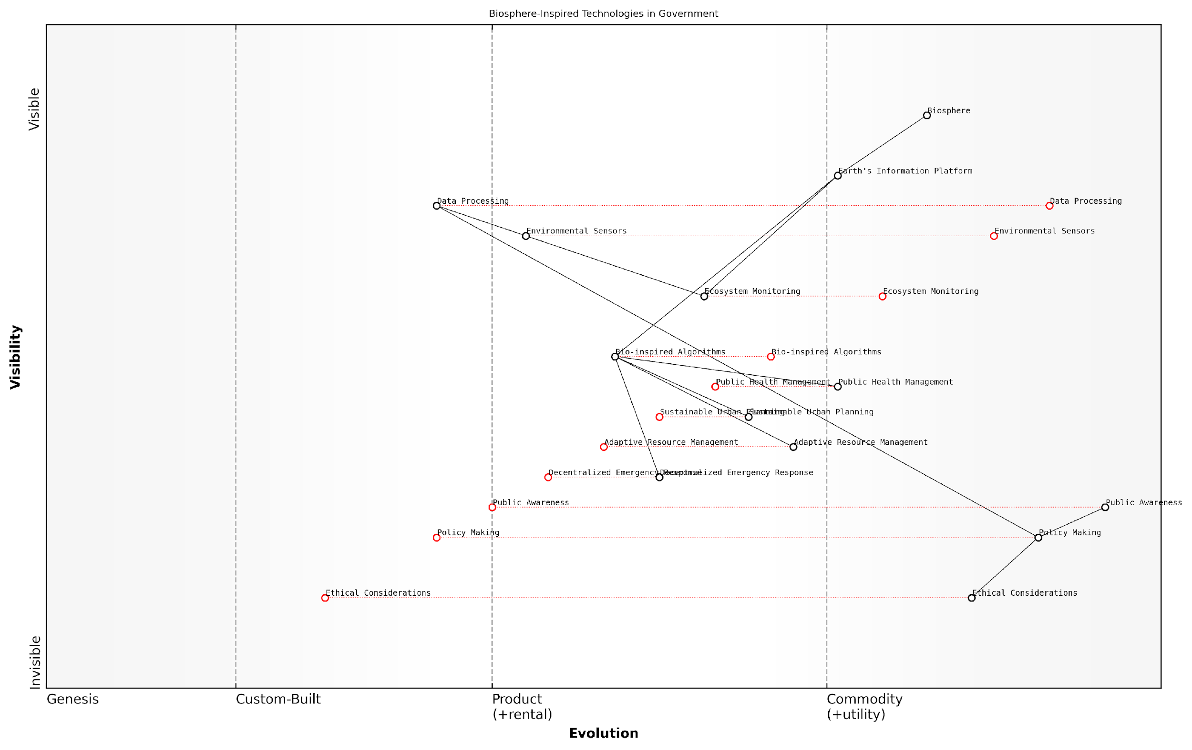

*Draft Wardley Map: [Insert Wardley Map: Biosphere]*

[Edit this draft Wardley Map](https://create.wardleymaps.ai/#clone:20fa0446c777807865)

Wardley Map Assessment

This Wardley Map reveals a government system in transition, leveraging biosphere-inspired technologies to enhance operations and policy-making. The strategic position is strong in terms of technological capabilities but faces challenges in rapidly evolving these capabilities into effective policies and public engagement. The key opportunity lies in accelerating the evolution of Policy Making through better integration of advanced technologies and data processing, while simultaneously strengthening ethical frameworks and public awareness. Success will depend on the government’s ability to foster a collaborative ecosystem, adapt to rapid technological changes, and address ethical considerations proactively. The unique integration of biosphere concepts into governance presents both a significant opportunity for innovation and a responsibility to ensure sustainable and ethical implementation.

[View full Wardley Map report](https://github.com/tractorjuice/test-repo/blob/main/markdown_wardley_map_reports/wardley_map_report_10_Biosphere.md)

## Interconnectedness and Feedback Loops

### System interactions and dependencies

In the context of Conscious Earth: Harnessing the Planet’s Information Platform Revolution, understanding system interactions and dependencies is paramount. As we delve into the intricate web of Earth’s systems, we uncover a complex network of relationships that form the foundation of our planet’s self-regulating mechanisms. This understanding is crucial for developing sustainable technologies and policies that work in harmony with Earth’s natural processes.

The Earth’s major systems—atmosphere, hydrosphere, geosphere, and biosphere—are not isolated entities but rather interconnected components of a larger, dynamic whole. These systems constantly exchange energy, matter, and information, creating a delicate balance that sustains life on our planet. To truly harness the Earth’s information platform revolution, we must first comprehend the nuances of these interactions and dependencies.

The Earth is not a collection of isolated systems, but rather a single, integrated system with countless interconnections. Understanding these connections is the key to developing truly sustainable technologies and practices.

Let us explore the key aspects of system interactions and dependencies within the Earth system:

* Biogeochemical cycles
* Energy transfer and transformation
* Information exchange across systems
* Cascading effects and system resilience
* Emergent properties and self-organisation

Biogeochemical cycles form the backbone of system interactions on Earth. These cycles, including the carbon, nitrogen, and water cycles, demonstrate how matter moves between different Earth systems. For instance, the carbon cycle illustrates the intricate dance between the atmosphere, biosphere, and geosphere. Carbon dioxide in the atmosphere is absorbed by plants through photosynthesis, incorporated into the biosphere, and eventually returned to the atmosphere through respiration or decomposition. Understanding these cycles is crucial for developing technologies that can mimic or enhance natural processes without disrupting the delicate balance.

Energy transfer and transformation across systems drive many of the Earth’s processes. The sun’s energy is absorbed by the atmosphere and Earth’s surface, influencing weather patterns, ocean currents, and biological processes. This energy flow creates complex feedback loops that maintain the Earth’s temperature within a habitable range. By studying these energy transfers, we can develop more efficient and sustainable energy technologies that work in harmony with natural systems.

Information exchange across systems is a fascinating aspect of Earth’s interconnectedness. This exchange occurs through various mechanisms, such as chemical signals in ecosystems, electromagnetic waves in the atmosphere, and genetic information in biological systems. As we develop technologies to harness the Earth’s information platform, we must consider how to tap into these natural information flows without disrupting them.

The Earth’s information exchange systems are far more sophisticated and efficient than any human-made network. By learning from these natural systems, we can revolutionise our approach to information technology and create more resilient and sustainable networks.

Cascading effects and system resilience are critical considerations when examining system interactions. A change in one system can trigger a series of responses across other systems, sometimes leading to unexpected outcomes. For example, deforestation in the Amazon rainforest not only affects local ecosystems but also impacts global climate patterns and biodiversity. Understanding these cascading effects is essential for predicting the consequences of human activities and developing strategies to enhance Earth’s resilience.

Emergent properties and self-organisation are fascinating aspects of Earth’s system interactions. These phenomena arise from the collective behaviour of individual components, resulting in complex structures and processes that cannot be predicted from studying the components in isolation. Examples include the formation of weather patterns, the organisation of ecosystems, and the development of social structures in animal populations. By understanding these emergent properties, we can design more adaptive and resilient technologies and systems.

In my experience advising government bodies on environmental policies, I’ve observed that understanding system interactions is crucial for developing effective strategies. For instance, a project I worked on to reduce urban air pollution required a holistic approach that considered not only emissions sources but also atmospheric chemistry, urban planning, and public health. By mapping the interactions between these systems, we were able to identify leverage points for intervention that yielded more significant and lasting results than traditional, siloed approaches.

As we move forward in harnessing the Earth’s information platform revolution, it is imperative that we adopt a systems thinking approach. This means considering not only the immediate effects of our technologies and policies but also their long-term impacts across multiple interconnected systems. By doing so, we can develop solutions that work with, rather than against, the Earth’s natural processes, leading to more sustainable and harmonious coexistence with our planet.

The future of sustainable technology lies not in conquering nature, but in understanding and emulating its intricate systems. Our role is to become conscious participants in the Earth’s information platform, rather than mere exploiters of its resources.

In conclusion, understanding system interactions and dependencies is fundamental to the concept of Conscious Earth. It provides the foundation for developing technologies and policies that can truly harness the planet’s information platform revolution. By recognising the interconnectedness of Earth’s systems, we can create more resilient, adaptive, and sustainable solutions to the challenges facing our planet and society.

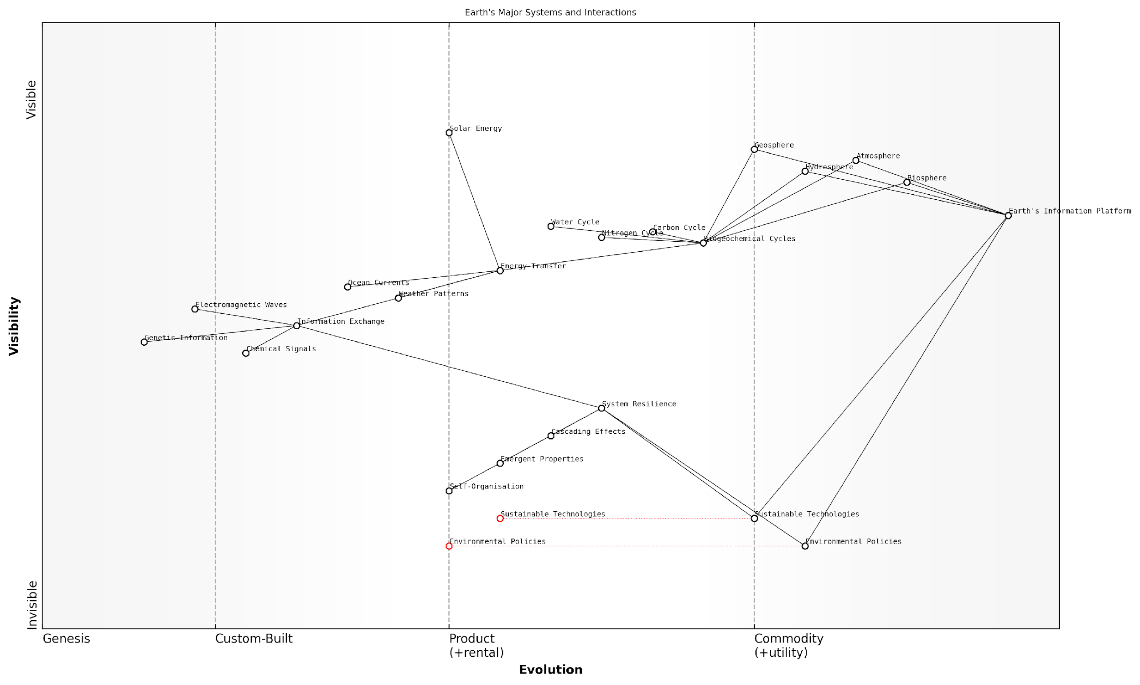

*Draft Wardley Map: [Insert Wardley Map: System interactions and dependencies]*

[Edit this draft Wardley Map](https://create.wardleymaps.ai/#clone:1d0015c345f1eadc56)

Wardley Map Assessment

This Wardley Map presents a comprehensive view of Earth’s major systems and their interactions, highlighting the critical role of the Earth’s Information Platform in understanding and managing our planet. The map reveals significant opportunities for innovation in Sustainable Technologies and Environmental Policies, driven by advancements in our understanding of System Resilience and improvements in Information Exchange. Key strategic priorities should include enhancing the Earth’s Information Platform, accelerating research into System Resilience, and creating more responsive and adaptive Environmental Policies. The evolving nature of many components suggests a dynamic field with substantial room for impactful interventions and innovations. Success will require unprecedented levels of global cooperation, interdisciplinary collaboration, and integration of scientific, technological, and policy efforts.

[View full Wardley Map report](https://github.com/tractorjuice/test-repo/blob/main/markdown_wardley_map_reports/wardley_map_report_11_System_interactions_and_dependencies.md)

### Positive and negative feedback mechanisms

In the context of Earth System Science and the broader concept of Conscious Earth, understanding positive and negative feedback mechanisms is crucial. These mechanisms play a vital role in the self-regulation of our planet’s systems and are fundamental to the Earth’s information processing capabilities. As we harness the planet’s information platform revolution, comprehending these feedback loops becomes increasingly important for developing sustainable technologies and policies.

Feedback mechanisms are processes within a system that either amplify (positive feedback) or dampen (negative feedback) changes. In the Earth system, these mechanisms are intricate and often interconnected, contributing to the planet’s overall stability or, in some cases, rapid changes.

Let’s explore the characteristics and examples of both positive and negative feedback mechanisms:

Negative Feedback Mechanisms:

* Definition: Processes that counteract changes, helping to maintain stability within a system.
* Function: Act as a ‘brake’ on change, promoting homeostasis.
* Examples in Earth systems: Temperature regulation through cloud formation, carbon dioxide absorption by oceans, and thermohaline circulation in oceans.

One of the most significant negative feedback mechanisms in the Earth system is the carbon cycle. As a senior climate scientist once remarked, ‘The carbon cycle is Earth’s thermostat, regulating global temperatures over geological timescales.’ When atmospheric CO2 levels rise, it stimulates increased plant growth, which in turn absorbs more CO2, helping to stabilise the system.

Positive Feedback Mechanisms:

* Definition: Processes that amplify changes, potentially leading to rapid shifts in system states.
* Function: Can drive systems away from equilibrium, sometimes resulting in new stable states.
* Examples in Earth systems: Ice-albedo feedback, methane release from permafrost, and forest dieback in response to climate change.

The ice-albedo feedback is a classic example of a positive feedback mechanism. As global temperatures rise, ice melts, exposing darker surfaces that absorb more solar radiation, further increasing temperatures and melting more ice. This self-reinforcing cycle can lead to rapid changes in the Earth’s climate system.

Positive feedback mechanisms are like a snowball rolling down a hill, gathering more snow and momentum as it goes. They can push Earth systems past tipping points, leading to abrupt and potentially irreversible changes.

Understanding these feedback mechanisms is crucial for several reasons:

* Climate modelling and prediction: Incorporating feedback mechanisms improves the accuracy of climate models, enabling better long-term forecasts and policy decisions.
* Ecosystem management: Knowledge of feedback loops helps in designing more resilient and sustainable ecosystem management strategies.
* Technological innovation: Biomimetic approaches can leverage these natural feedback mechanisms to create more efficient and adaptive technologies.
* Risk assessment: Identifying potential positive feedback loops allows for better assessment of environmental risks and tipping points.

In my work advising government bodies on environmental policies, I’ve observed a growing recognition of the importance of these feedback mechanisms. For instance, a recent project involved developing a decision-support system for coastal management that incorporated both positive and negative feedback loops in local ecosystems. This approach allowed policymakers to better understand the long-term implications of their decisions and design more resilient coastal protection strategies.

The concept of feedback mechanisms also has profound implications for the development of Earth-inspired technologies. By mimicking the planet’s self-regulating systems, we can create more sustainable and adaptive solutions. For example, smart building systems that use negative feedback loops to maintain optimal temperature and energy usage, inspired by the Earth’s own temperature regulation mechanisms.

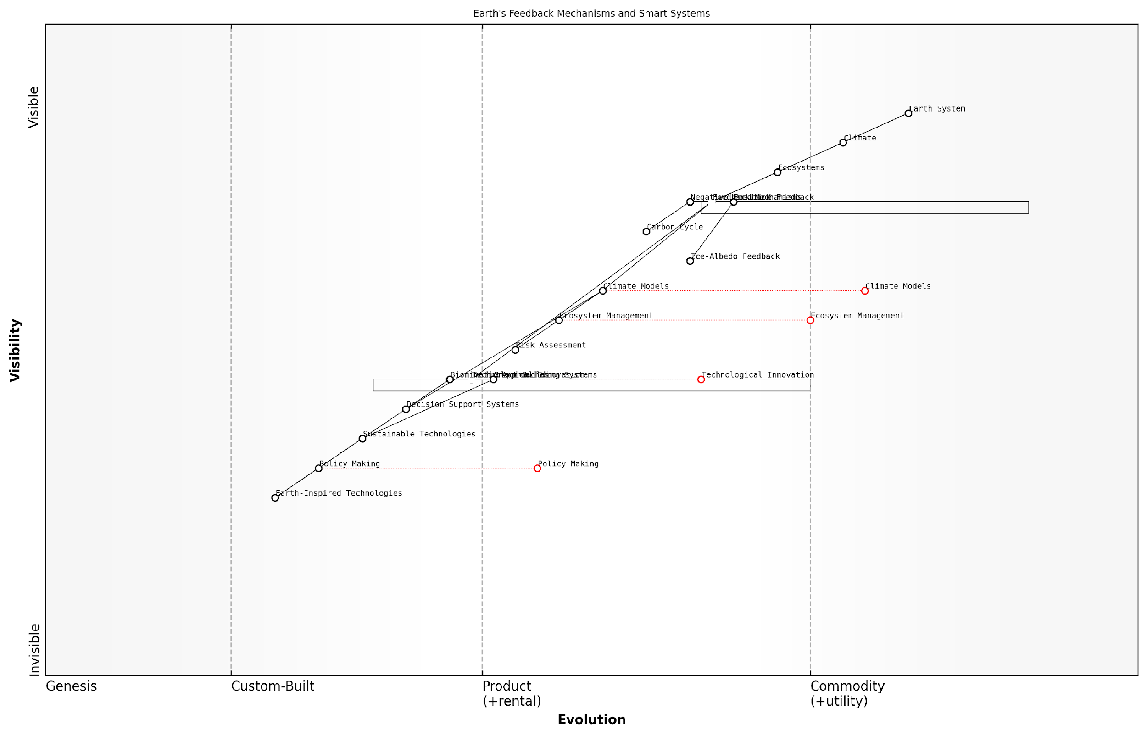

*Draft Wardley Map: [Insert Wardley Map: Positive and negative feedback mechanisms]*

[Edit this draft Wardley Map](https://create.wardleymaps.ai/#clone:4c5e54af85abd1ccc2)

Wardley Map Assessment

This Wardley Map reveals a complex interplay between Earth’s natural systems and human interventions in addressing climate challenges. The strategic focus should be on accelerating the evolution of key components like Climate Models, Decision Support Systems, and Policy Making, while simultaneously driving innovation in Sustainable and Earth-Inspired Technologies. The critical challenge lies in bridging the gap between scientific understanding and effective policy implementation, necessitating improved integration across the entire value chain. Future success depends on developing a holistic approach that aligns scientific insights, technological advancements, and policy actions to create a more resilient and sustainable Earth system.

[View full Wardley Map report](https://github.com/tractorjuice/test-repo/blob/main/markdown_wardley_map_reports/wardley_map_report_12_Positive_and_negative_feedback_mechanisms.md)

However, it’s crucial to approach the harnessing of these mechanisms with caution. As we’ve seen with climate change, human activities can inadvertently trigger or amplify positive feedback loops with potentially devastating consequences. A holistic understanding of these mechanisms is essential for responsible innovation and policy-making.

In conclusion, positive and negative feedback mechanisms are fundamental to the Earth’s functioning as a complex, self-regulating system. As we continue to develop the concept of Conscious Earth and harness the planet’s information platform revolution, these mechanisms offer both inspiration for innovation and crucial insights for sustainable management of our planet’s resources. By understanding and working with these natural processes, we can develop technologies and policies that are more in harmony with the Earth’s systems, leading to a more sustainable and resilient future.

The Earth’s feedback mechanisms are not just academic concepts; they are the blueprint for creating truly sustainable and adaptive technologies. Our challenge is to learn from these mechanisms and apply them wisely in our quest for a symbiotic relationship with our planet.

### Tipping points and planetary boundaries

In the context of Conscious Earth and the planet’s information platform revolution, understanding tipping points and planetary boundaries is crucial. These concepts are integral to comprehending the delicate balance of Earth’s systems and the potential consequences of human activities on our planet’s stability. As we harness the Earth’s information processing capabilities, it becomes increasingly important to recognise the thresholds beyond which significant and often irreversible changes may occur in our planet’s ecosystems.

Tipping points refer to critical thresholds in Earth’s systems where a small change can push the system into a completely new state. These can be thought of as ‘points of no return’ in the Earth’s complex network of interconnected systems. Planetary boundaries, on the other hand, define the safe operating space for humanity within the Earth system. Together, these concepts provide a framework for understanding the limits of our planet’s resilience and the potential consequences of exceeding these limits.

Understanding tipping points and planetary boundaries is not just an academic exercise; it’s a crucial aspect of responsible planetary stewardship in the age of the Earth’s information platform revolution.

Let’s delve deeper into these concepts and their implications for the Conscious Earth paradigm.

Tipping Points in Earth’s Systems

Tipping points are characterised by their potential to trigger rapid and often irreversible changes in Earth’s systems. These can occur in various components of our planet, from climate systems to ecosystems. Some well-known examples include:

* Arctic sea ice melt: As ice melts, it exposes darker ocean water, which absorbs more heat, leading to further melting in a self-reinforcing cycle.
* Amazon rainforest dieback: Deforestation and climate change could push the Amazon past a tipping point, transforming it from rainforest to savanna.
* Thawing of permafrost: As permafrost thaws, it releases greenhouse gases, potentially accelerating global warming.
* Collapse of coral reef ecosystems: Rising ocean temperatures and acidification can lead to widespread coral bleaching and ecosystem collapse.

In the context of the Earth’s information platform revolution, these tipping points represent critical junctures where the planet’s information processing capabilities may be severely disrupted. For instance, the loss of biodiversity associated with coral reef collapse would result in a significant reduction in the Earth’s biological information storage and processing capacity.

Planetary Boundaries: Defining the Safe Operating Space

The concept of planetary boundaries, introduced by a team of Earth system scientists led by Johan Rockström, defines nine critical processes that regulate the stability and resilience of the Earth system. These boundaries delineate the safe operating space for humanity, beyond which we risk triggering abrupt or irreversible environmental changes.

* Climate change
* Biosphere integrity (biodiversity loss and extinctions)
* Land-system change
* Freshwater use
* Biogeochemical flows (nitrogen and phosphorus cycles)
* Ocean acidification
* Atmospheric aerosol loading
* Stratospheric ozone depletion
* Novel entities (e.g., chemical pollution, plastics)

These boundaries are interconnected, reflecting the complex nature of Earth’s systems. Exceeding one boundary can have cascading effects on others, potentially pushing the entire Earth system into a new state. In the context of Conscious Earth, these boundaries can be viewed as the operational limits of the planet’s information processing and self-regulation capabilities.

The planetary boundaries framework provides a scientific basis for understanding the limits of Earth’s resilience. It’s a crucial tool for guiding our efforts to harness the planet’s information platform in a sustainable manner.

Implications for Conscious Earth and Information Platform Revolution

Understanding tipping points and planetary boundaries is essential for the responsible development and implementation of technologies that harness the Earth’s information platform. Here are some key implications:

* Early Warning Systems: By monitoring Earth’s systems in real-time, we can develop sophisticated early warning systems that alert us when we’re approaching critical thresholds.
* Adaptive Management: Knowledge of planetary boundaries can inform adaptive management strategies that adjust human activities to stay within safe limits.
* Biomimetic Solutions: Understanding how Earth’s systems maintain balance can inspire biomimetic technologies that work in harmony with natural processes.
* Policy and Governance: Awareness of tipping points and planetary boundaries should inform policy decisions and governance structures for managing global commons.
* Education and Awareness: Communicating these concepts effectively is crucial for fostering a global consciousness about our planet’s limits and potential.

In my experience advising government bodies on environmental policy, I’ve observed a growing recognition of the need to incorporate these concepts into decision-making processes. For instance, a recent project I consulted on involved developing a national strategy for sustainable resource management based on the planetary boundaries framework. This approach allowed policymakers to prioritise actions that would have the most significant impact on maintaining Earth’s stability.

As we continue to develop technologies that tap into the Earth’s information platform, it’s crucial that we do so with a deep understanding of these planetary limits. By respecting tipping points and operating within planetary boundaries, we can ensure that our harnessing of the Earth’s intelligence enhances rather than undermines the planet’s self-regulating capabilities.

The true measure of our success in harnessing the Earth’s information platform will be our ability to do so whilst maintaining the delicate balance of our planet’s systems. This is the essence of the Conscious Earth paradigm.

In conclusion, tipping points and planetary boundaries are fundamental concepts in understanding the Earth as a complex, interconnected system. As we advance in our ability to harness the planet’s information platform, these concepts must guide our actions, ensuring that we operate within the safe limits of our planet’s resilience. Only by respecting these boundaries can we truly realise the potential of a Conscious Earth, where human activities and technologies work in harmony with the planet’s natural intelligence.

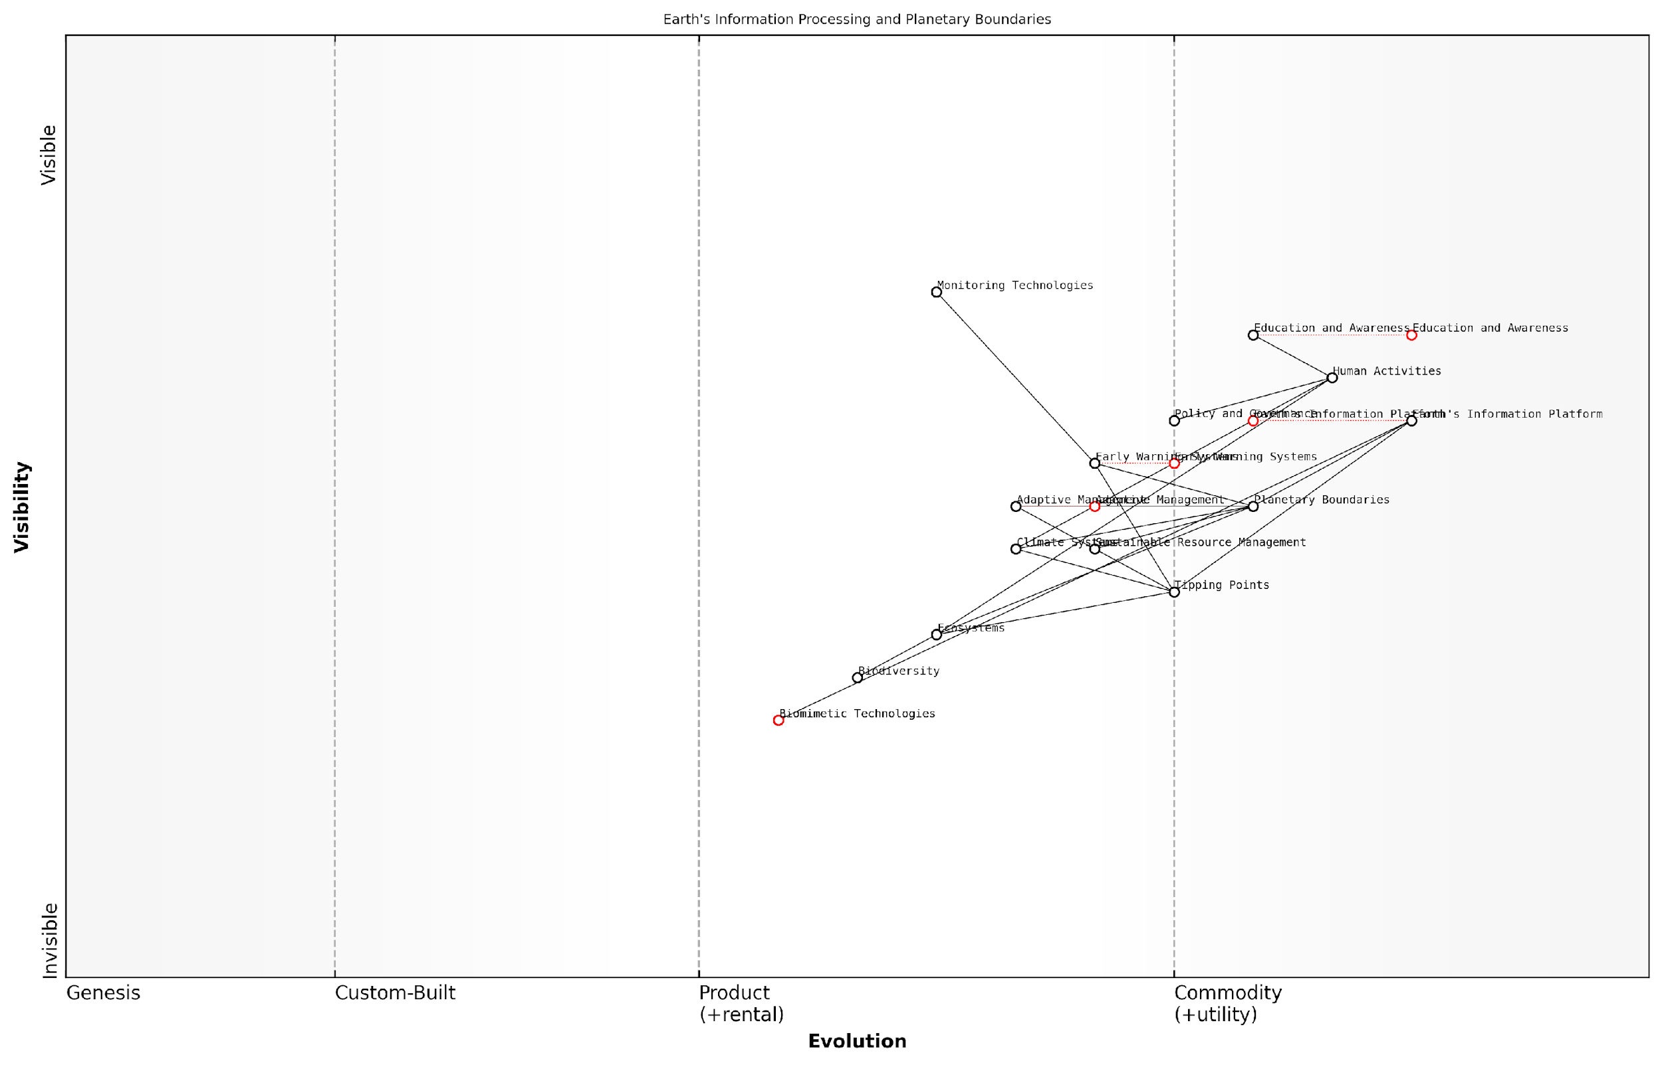

*Draft Wardley Map: [Insert Wardley Map: Tipping points and planetary boundaries]*

[Edit this draft Wardley Map](https://create.wardleymaps.ai/#clone:2f9079a4dcfc5f17ef)

Wardley Map Assessment

This Wardley Map reveals a strategic landscape poised at a critical juncture in planetary management. The evolving Earth’s Information Platform, coupled with advancing Early Warning Systems and Monitoring Technologies, offers unprecedented opportunities for understanding and managing planetary boundaries and tipping points. However, the effectiveness of these technological advancements hinges on parallel developments in policy, governance, and public awareness. The map underscores the need for an integrated, adaptive approach to planetary stewardship, leveraging cutting-edge technologies while addressing the human dimensions of global environmental change. Strategic priorities should focus on accelerating the evolution of key components like Early Warning Systems and Biomimetic Technologies, while simultaneously strengthening the links between scientific understanding, technological capabilities, and societal action. The future trajectory suggested by this map is one of increasing sophistication in Earth system management, but realizing this potential will require concerted efforts to bridge current gaps between technology, policy, and public engagement.

[View full Wardley Map report](https://github.com/tractorjuice/test-repo/blob/main/markdown_wardley_map_reports/wardley_map_report_13_Tipping_points_and_planetary_boundaries.md)

## Earth’s Information Processing

### Biological information systems

In the context of Conscious Earth and the planet’s information platform revolution, biological information systems play a pivotal role in Earth’s information processing capabilities. These systems, which have evolved over billions of years, form the foundation of life’s ability to sense, respond to, and adapt to environmental changes. Understanding these systems is crucial for harnessing the planet’s collective intelligence and developing sustainable technologies that can work in harmony with natural processes.

Biological information systems operate at multiple scales, from the molecular level to entire ecosystems. They encompass a wide range of processes, including genetic encoding, cellular signalling, neural networks, and ecosystem-wide communication. These systems are characterised by their efficiency, resilience, and ability to process vast amounts of data in real-time, making them invaluable models for developing advanced information technologies.

Nature’s information systems have been optimised through billions of years of evolution. By understanding and emulating these systems, we can revolutionise our approach to data processing and create more sustainable technologies.

Let us explore the key components and characteristics of biological information systems that are particularly relevant to the concept of Conscious Earth:

* DNA as an information storage medium
* Cellular signalling networks
* Neural information processing
* Ecosystem-level communication
* Evolutionary algorithms for problem-solving

DNA as an Information Storage Medium: At the molecular level, DNA serves as nature’s primary information storage system. The genetic code, encoded in sequences of nucleotides, contains instructions for building and maintaining organisms. This system is remarkably efficient, with a storage density far exceeding that of current digital technologies. Recent advancements in DNA data storage have demonstrated the potential for using synthetic DNA to store digital information, offering a glimpse into future bio-inspired data storage solutions.

Cellular Signalling Networks: Cells communicate through complex signalling pathways that allow them to respond to environmental stimuli and coordinate their activities. These networks are highly efficient, using minimal energy to transmit information across cellular membranes and between cells. Understanding these signalling mechanisms can inform the development of low-power, high-efficiency communication systems for IoT devices and sensor networks, which are crucial components of the Earth’s information platform.

Neural Information Processing: The human brain, with its network of billions of neurons, represents one of the most sophisticated biological information processing systems known. Its ability to process sensory inputs, learn from experience, and make complex decisions has inspired the field of artificial neural networks and deep learning. By studying neural information processing, we can develop more advanced AI systems capable of handling the complex, interconnected data streams generated by Earth’s various systems.

Ecosystem-level Communication: Recent research has revealed intricate communication networks within ecosystems, such as the ‘wood wide web’ of fungal networks that connect trees in forests. These networks facilitate the exchange of nutrients and information between plants, demonstrating nature’s ability to create resilient, decentralised information systems. Understanding these ecosystem-level communications can inform the design of robust, self-organising networks for environmental monitoring and resource management.

Evolutionary Algorithms for Problem-solving: The process of natural selection and evolution can be viewed as a biological algorithm for solving complex problems and optimising systems over time. This concept has been successfully applied in computer science through genetic algorithms and evolutionary computation. In the context of Conscious Earth, these approaches can be used to develop adaptive management strategies for complex environmental challenges, such as climate change mitigation or biodiversity conservation.

By harnessing the principles of biological information systems, we can create a new generation of technologies that are not only more efficient but also inherently aligned with the Earth’s natural processes.

Practical applications of biological information systems in the context of Conscious Earth are already emerging across various sectors:

* Environmental monitoring: Bio-inspired sensor networks that mimic the distributed sensing capabilities of ecosystems are being developed for real-time monitoring of air and water quality, biodiversity, and climate indicators.
* Sustainable agriculture: Precision farming techniques inspired by plant communication networks are optimising resource use and reducing environmental impact.
* Urban planning: Cities are being redesigned as ‘urban ecosystems’, incorporating principles of biological information flow to create more resilient and adaptive urban environments.
* Energy management: Bio-inspired algorithms are being used to optimise smart grids and renewable energy systems, improving efficiency and stability.

However, as we harness these biological information systems, it is crucial to consider the ethical implications and potential risks. The interconnectedness of natural systems means that interventions can have far-reaching and sometimes unforeseen consequences. We must approach the integration of biological and technological systems with caution, ensuring that our actions do not disrupt the delicate balance of Earth’s information processing capabilities.

In conclusion, biological information systems offer a wealth of inspiration and practical insights for advancing the concept of Conscious Earth. By understanding and emulating these systems, we can develop technologies and strategies that work in harmony with the planet’s natural processes, leading to more sustainable and resilient solutions for global challenges. As we continue to explore and harness the Earth’s information platform, biological information systems will undoubtedly play a central role in shaping our approach to planetary stewardship and technological innovation.

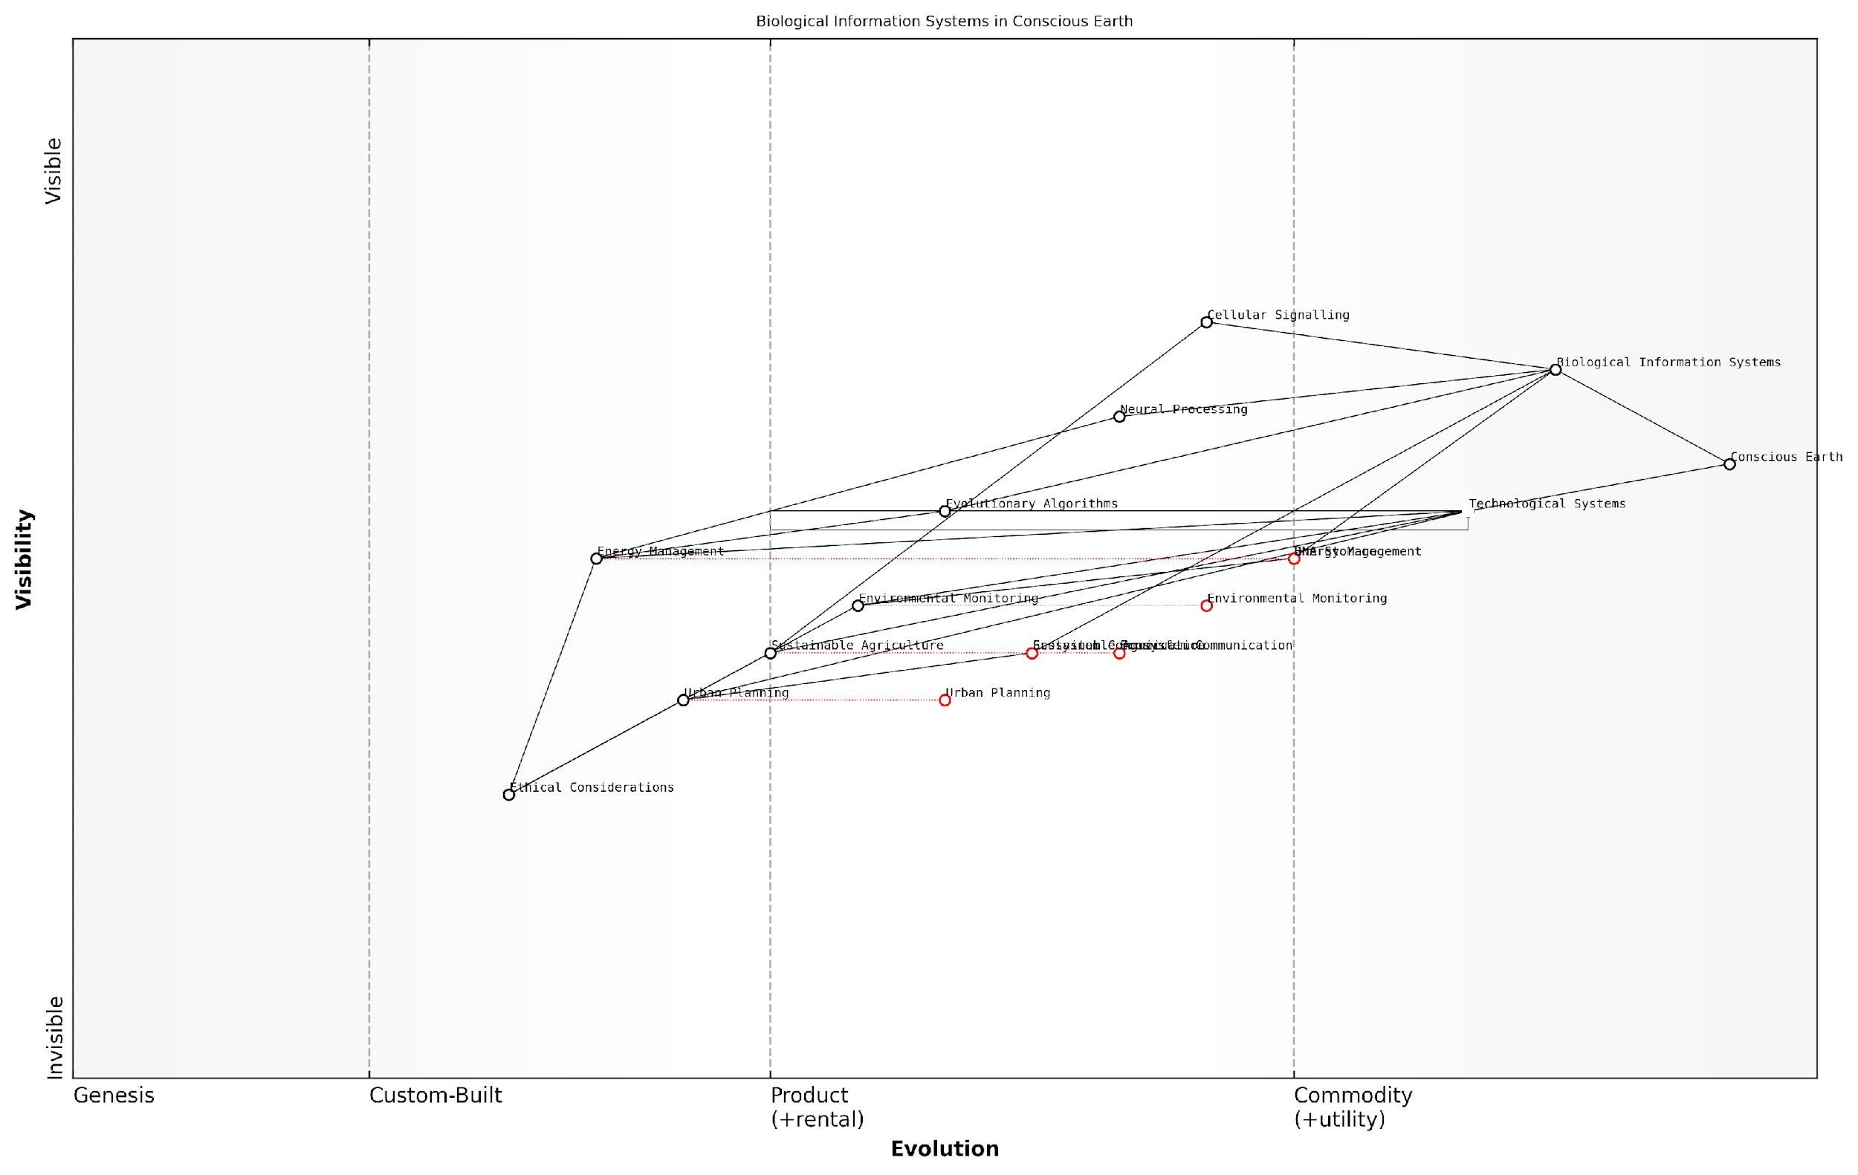

*Draft Wardley Map: [Insert Wardley Map: Biological information systems]*

[Edit this draft Wardley Map](https://create.wardleymaps.ai/#clone:b572192ec6607829dd)

Wardley Map Assessment

This Wardley Map represents a visionary approach to integrating biological information systems with technological solutions for sustainable development. It highlights significant opportunities in areas like DNA storage, ecosystem communication, and bio-inspired urban planning. However, it also underscores the need for careful ethical consideration and the challenges of translating biological principles to practical applications. The strategic focus should be on developing robust environmental monitoring capabilities, establishing strong ethical frameworks, and fostering interdisciplinary collaboration to bridge the gap between biological understanding and technological implementation. As the field evolves, we can expect to see more integrated, ecosystem-level approaches to challenges in agriculture, energy management, and urban development, potentially leading to a paradigm shift in how we interact with and manage our environment.

[View full Wardley Map report](https://github.com/tractorjuice/test-repo/blob/main/markdown_wardley_map_reports/wardley_map_report_14_Biological_information_systems.md)

### Geological information storage

In the context of Conscious Earth: Harnessing the Planet’s Information Platform Revolution, geological information storage represents a crucial component of Earth’s information processing capabilities. This subsection explores how our planet’s geological features serve as vast repositories of data, encoding billions of years of Earth’s history and ongoing processes. Understanding this storage mechanism is essential for leveraging the Earth’s information platform and developing sustainable technologies that align with natural systems.

Geological information storage can be conceptualised as a complex, multi-layered system that records and preserves data across various timescales and in diverse forms. From the microscopic level of mineral structures to the macroscopic scale of tectonic plates, the Earth’s geology offers a rich tapestry of information that informs our understanding of planetary processes and potential future changes.

The Earth’s geological record is akin to a vast, distributed database, storing information about past climates, biological evolution, and planetary dynamics. Decoding this information is crucial for predicting future Earth system behaviours and developing resilient strategies for human civilisation.

Let us delve into the key aspects of geological information storage, exploring its mechanisms, applications, and implications for the Conscious Earth paradigm.

1. Mechanisms of Geological Information Storage

The Earth employs various mechanisms to store geological information, each offering unique insights into the planet’s history and ongoing processes:

* Stratigraphy: The layering of sedimentary rocks provides a chronological record of Earth’s history, with each stratum potentially containing information about past climates, ecosystems, and geological events.
* Isotopic Signatures: The ratios of different isotopes in rocks and minerals can reveal information about past temperatures, atmospheric composition, and biological activity.
* Mineral Composition: The presence and distribution of specific minerals offer insights into past environmental conditions and geological processes.
* Fossil Records: Preserved remains or traces of ancient life forms provide a wealth of information about biological evolution and past ecosystems.
* Magnetic Field Records: Certain minerals retain information about the Earth’s magnetic field at the time of their formation, offering insights into past tectonic movements and geomagnetic reversals.

1. Timescales and Resolution

Geological information storage operates across a vast range of timescales, from rapid events recorded in annual layers of ice cores to processes spanning billions of years encoded in the oldest rocks. This multi-scale nature of geological data presents both challenges and opportunities for Earth system science:

* Short-term Records: Annual or seasonal variations recorded in tree rings, coral growth bands, or lake sediments provide high-resolution data for recent climate and environmental changes.
* Medium-term Records: Ice cores, deep-sea sediments, and speleothems (cave formations) can offer detailed information spanning thousands to hundreds of thousands of years.
* Long-term Records: Rock formations, continental drift patterns, and mountain building events provide insights into processes occurring over millions to billions of years.

1. Applications in Earth System Science

The ability to access and interpret geological information storage has profound implications for our understanding of Earth systems and our capacity to develop sustainable technologies:

* Climate Modelling: By analysing past climate data stored in geological records, scientists can refine climate models and improve predictions of future climate change.
* Resource Exploration: Understanding geological information storage aids in the identification and sustainable extraction of natural resources, including renewable energy sources like geothermal power.
* Natural Hazard Assessment: Geological records of past earthquakes, volcanic eruptions, and other natural disasters inform risk assessment and mitigation strategies.
* Ecosystem Restoration: Information about past ecosystems preserved in geological records can guide efforts to restore degraded environments and enhance biodiversity.
* Carbon Sequestration: Insights from natural carbon storage processes in geological formations inform the development of carbon capture and storage technologies.

By learning to read the Earth’s geological information storage, we gain access to a vast library of solutions that have been tested and refined over billions of years. This knowledge is invaluable for addressing contemporary challenges in sustainability and resilience.

1. Challenges and Future Directions

While geological information storage offers immense potential for advancing our understanding of Earth systems, several challenges and opportunities lie ahead:

* Data Integration: Developing methods to integrate geological data with other Earth system data sources, such as atmospheric and oceanic records, to create a more comprehensive understanding of planetary processes.
* Technological Advancements: Improving technologies for data extraction and analysis, including non-invasive sensing techniques and machine learning algorithms for pattern recognition in geological datasets.
* Preservation of Records: Addressing the potential loss of geological information due to human activities, climate change, and natural erosion processes.
* Ethical Considerations: Balancing the need for geological information with the preservation of natural landscapes and culturally significant sites.
* Public Understanding: Enhancing public awareness and appreciation of geological information storage to support evidence-based decision-making in environmental policy and resource management.

In conclusion, geological information storage represents a fundamental aspect of the Earth’s information processing capabilities. As we continue to develop the concept of Conscious Earth, unlocking the potential of this vast geological database will be crucial for informing sustainable practices, guiding technological innovation, and fostering a deeper connection between human activities and natural systems. By learning to read and interpret the Earth’s geological records more effectively, we can harness the wisdom accumulated over billions of years to address contemporary challenges and create a more resilient future for our planet.

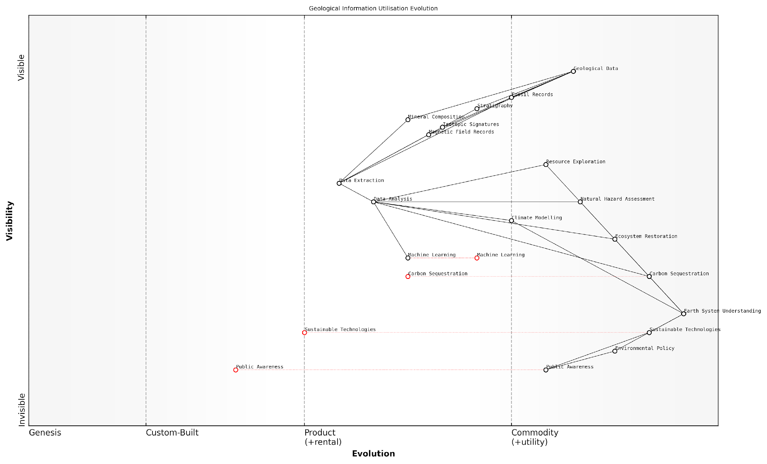

*Draft Wardley Map: [Insert Wardley Map: Geological information storage]*

[Edit this draft Wardley Map](https://create.wardleymaps.ai/#clone:469cae703a5119f5bb)

Wardley Map Assessment

This Wardley Map reveals a maturing field of geological information utilization with a clear value chain from raw data to public impact. The strategic focus should be on accelerating the evolution of key components like Machine Learning and Data Analysis, while simultaneously working to bridge the gap between scientific understanding and public awareness/policy action. There are significant opportunities for innovation in data analysis techniques, sustainability technologies, and science communication strategies. The future success in this domain will likely depend on the ability to effectively integrate advanced technologies, foster interdisciplinary collaboration, and translate complex scientific insights into actionable knowledge for policy makers and the public.

[View full Wardley Map report](https://github.com/tractorjuice/test-repo/blob/main/markdown_wardley_map_reports/wardley_map_report_15_Geological_information_storage.md)

### Atmospheric and oceanic information transfer

In the context of Conscious Earth: Harnessing the Planet’s Information Platform Revolution, understanding atmospheric and oceanic information transfer is crucial. These vast, interconnected systems serve as the planet’s primary mechanisms for distributing energy, matter, and information across the globe, playing a pivotal role in Earth’s self-regulation and climate stability.

The atmosphere and oceans function as dynamic information processing systems, constantly exchanging data through complex physical, chemical, and biological processes. This intricate dance of information transfer is fundamental to the Earth’s ability to maintain homeostasis and respond to both internal and external perturbations.

The Earth’s atmosphere and oceans are not merely passive conduits of energy and matter; they are sophisticated information processing networks that enable our planet to function as a coherent, self-regulating system.

To fully appreciate the significance of atmospheric and oceanic information transfer, we must examine several key aspects:

* Physical Information Transfer
* Chemical Information Exchange
* Biological Information Networks
* Electromagnetic Information Propagation
* Anthropogenic Influences on Information Transfer

Physical Information Transfer: The atmosphere and oceans are in constant motion, driven by temperature gradients, the Earth’s rotation, and gravitational forces. These movements facilitate the transfer of heat, momentum, and mass across vast distances, effectively distributing information about the state of different regions of the planet.

Atmospheric circulation patterns, such as the Hadley, Ferrel, and Polar cells, along with ocean currents like the Gulf Stream and the Antarctic Circumpolar Current, act as global conveyor belts of information. They transport signals about temperature, humidity, and chemical composition, allowing different parts of the Earth system to ‘communicate’ and respond to changes.

Chemical Information Exchange: The atmosphere and oceans are vast reservoirs of chemical information. Gases dissolved in the oceans and present in the atmosphere carry crucial data about the state of the Earth system. For instance, the carbon cycle, which involves the exchange of CO2 between the atmosphere, oceans, and terrestrial biosphere, is a prime example of chemical information transfer.

Ocean acidification, a result of increased CO2 absorption, is an example of how this chemical information transfer can lead to significant changes in marine ecosystems. Understanding these chemical information pathways is crucial for predicting and mitigating the impacts of climate change.

The oceans and atmosphere form a chemical information superhighway, constantly exchanging signals that influence global climate patterns and ecosystem dynamics. Decoding this chemical dialogue is key to understanding and preserving Earth’s delicate balance.

Biological Information Networks: The atmosphere and oceans host diverse ecosystems that participate in information transfer through biological processes. Phytoplankton in the oceans, for example, respond to changes in temperature, light, and nutrient availability, altering their growth patterns and thereby influencing global carbon cycles and climate.

Similarly, airborne microorganisms and pollen can transmit genetic information across continents, influencing biodiversity and ecosystem resilience. These biological information networks play a crucial role in the Earth’s ability to adapt to changing conditions.

Electromagnetic Information Propagation: The atmosphere acts as a medium for the propagation of electromagnetic waves, facilitating long-distance communication and information transfer. Natural phenomena such as lightning discharges and the Earth’s magnetic field interactions with the solar wind generate electromagnetic signals that carry information about atmospheric and space weather conditions.

Understanding these electromagnetic information pathways is crucial for developing resilient communication systems and predicting space weather impacts on technology.

Anthropogenic Influences on Information Transfer: Human activities have significantly altered the Earth’s information transfer systems. Greenhouse gas emissions, for instance, have changed the atmosphere’s composition, affecting its ability to transfer heat and potentially disrupting established climate patterns.

Ocean pollution, including microplastics and chemical contaminants, interferes with the natural chemical and biological information transfer processes in marine ecosystems. Recognising and mitigating these anthropogenic influences is crucial for maintaining the integrity of Earth’s information processing capabilities.

As we harness the Earth’s information platform, we must be mindful of our role as both beneficiaries and potential disruptors of these ancient and complex information transfer systems.

Practical Applications and Considerations: Understanding atmospheric and oceanic information transfer has numerous practical applications in the context of Conscious Earth:

* Climate Modelling and Prediction: Improved understanding of information transfer mechanisms can enhance our ability to model and predict climate change impacts.
* Ecosystem Management: Insights into biological information networks can inform more effective conservation strategies and ecosystem restoration efforts.
* Sustainable Resource Management: Knowledge of oceanic and atmospheric information transfer can guide sustainable fishing practices and renewable energy development.
* Disaster Preparedness: Better understanding of atmospheric information propagation can improve early warning systems for extreme weather events.
* Geoengineering Assessment: Any proposed geoengineering solutions must be evaluated in the context of their potential impacts on Earth’s information transfer systems.

Case Study: The El Niño Southern Oscillation (ENSO) phenomenon exemplifies the complex interplay of atmospheric and oceanic information transfer. ENSO involves changes in ocean temperatures and atmospheric pressure patterns across the Pacific Ocean, with global climate impacts. By studying ENSO, scientists have gained insights into how localised changes in ocean-atmosphere interactions can propagate information across the planet, influencing weather patterns thousands of kilometres away.

This understanding has practical applications in agriculture, water resource management, and disaster preparedness across multiple continents. It demonstrates how harnessing knowledge of Earth’s information transfer systems can lead to tangible benefits for society.

In conclusion, atmospheric and oceanic information transfer represents a critical component of Earth’s information processing capabilities. As we strive to harness the planet’s information platform revolution, a deep understanding of these processes is essential. It not only enhances our scientific knowledge but also provides valuable insights for addressing global challenges such as climate change, resource management, and environmental conservation.

By recognising the Earth as a complex, interconnected information system, we can develop more holistic and effective approaches to environmental stewardship and sustainable development. The challenge lies in balancing our utilisation of this knowledge with the need to preserve and protect the integrity of these natural information transfer mechanisms for future generations.

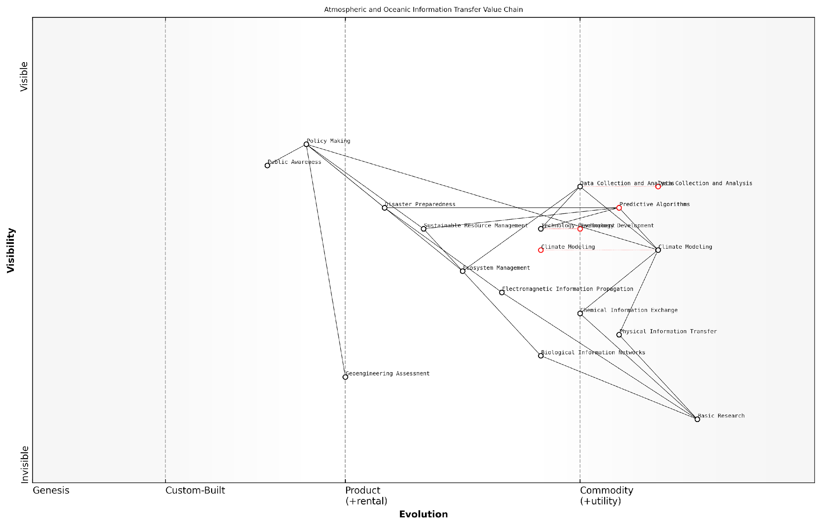

*Draft Wardley Map: [Insert Wardley Map: Atmospheric and oceanic information transfer]*

[Edit this draft Wardley Map](https://create.wardleymaps.ai/#clone:0b9243f20d5d89951e)

Wardley Map Assessment

This Wardley Map reveals a comprehensive and well-structured approach to atmospheric and oceanic information transfer in the context of climate adaptation. It highlights the critical role of evolving technologies and scientific understanding in informing policy and driving solutions. The strategic position is strong, with clear pathways from basic research to practical applications. However, there are opportunities to enhance the integration of various components, particularly in bridging the gap between scientific outputs and policy implementation. The rapid evolution of key components like Climate Modeling and Data Collection & Analysis presents both opportunities for innovation and risks of disruption. To maintain a competitive edge and effectively address climate challenges, focus should be placed on accelerating the evolution of core technologies, strengthening the science-policy interface, and developing more integrated and responsive systems for climate adaptation. The ecosystem approach suggested by the map aligns well with the complex, interconnected nature of climate challenges and offers a robust framework for future development and collaboration.

[View full Wardley Map report](https://github.com/tractorjuice/test-repo/blob/main/markdown_wardley_map_reports/wardley_map_report_16_Atmospheric_and_oceanic_information_transfer.md)

# Biomimicry: Learning from Nature’s Genius

## Principles of Biomimicry

### Nature as model, measure, and mentor

In the context of Conscious Earth and the planet’s information platform revolution, the concept of nature as model, measure, and mentor forms a cornerstone of biomimicry principles. This approach not only offers innovative solutions to complex challenges but also aligns human activities with the Earth’s natural systems, fostering a more sustainable and harmonious relationship between technology and ecology.

Nature as Model: The Earth’s 3.8 billion years of evolution have produced highly efficient and resilient systems that can serve as blueprints for human innovation. By studying and emulating these natural models, we can develop technologies and processes that are inherently more sustainable and adaptable to changing conditions.

* Structural efficiency: The hexagonal structure of honeycombs has inspired lightweight yet strong materials used in aerospace and construction.
* Energy efficiency: Photosynthesis has informed the development of more efficient solar cells and energy storage systems.
* Water management: The Namib Desert beetle’s ability to harvest water from fog has led to innovations in water collection in arid regions.

Nature as Measure: The Earth’s ecosystems provide benchmarks for sustainability and performance. By using nature’s standards to evaluate our innovations, we can ensure that our technologies and systems are truly sustainable and in harmony with the planet’s processes.

* Circular material flows: Natural ecosystems operate in closed loops, where waste from one process becomes food for another. This principle is being applied in industrial ecology and circular economy initiatives.
* Energy efficiency: Biological processes often operate at ambient temperatures and pressures, inspiring more energy-efficient industrial processes.
* Resilience: Ecosystems demonstrate remarkable resilience to disturbances, offering lessons for designing robust and adaptable systems in various sectors.

Nature as Mentor: Beyond providing models and standards, nature serves as a mentor, offering wisdom accumulated over millennia. This mentorship aspect encourages a shift in perspective, viewing nature not as a resource to be exploited, but as a teacher and partner in innovation.

* Collaborative relationships: Symbiotic relationships in nature inspire new models of collaboration in business and governance.
* Adaptive strategies: Nature’s ability to adapt to changing conditions informs strategies for organisational and technological resilience.
* Information processing: Natural information systems, such as neural networks and swarm intelligence, guide advancements in artificial intelligence and distributed computing.

Nature is a vast library of solutions to challenges that humanity is currently grappling with. By adopting the mindset of nature as model, measure, and mentor, we can tap into this wealth of knowledge and create technologies and systems that are not only innovative but also inherently sustainable and regenerative.

In the context of Conscious Earth, this principle of biomimicry becomes particularly powerful. It allows us to harness the planet’s information platform in a way that respects and learns from the Earth’s inherent intelligence. For instance, in my work advising government bodies on sustainable urban planning, we’ve implemented biomimetic principles to create ‘smart cities’ that mimic the efficiency and resilience of natural ecosystems.

One notable example is the development of urban water management systems inspired by natural watersheds. By emulating the way forests and wetlands naturally filter and distribute water, we’ve designed green infrastructure solutions that not only manage stormwater more effectively but also enhance biodiversity and create more liveable urban environments.

The application of nature as model, measure, and mentor extends beyond individual technologies or systems. It represents a fundamental shift in how we approach innovation and problem-solving across all sectors. In the public sector, this principle is increasingly being applied to policy development and governance structures.

* Adaptive governance: Inspired by the adaptability of natural systems, some governments are experimenting with more flexible and responsive policy-making processes.
* Decentralised decision-making: Drawing lessons from distributed natural systems, there’s a trend towards more localised and participatory governance models.
* Holistic performance metrics: Inspired by the interconnectedness of ecosystems, some jurisdictions are adopting more comprehensive measures of progress beyond GDP, incorporating environmental and social indicators.

However, it’s crucial to approach this principle with nuance and critical thinking. Not all natural systems or processes are directly applicable or beneficial in human contexts. The key is to understand the underlying principles and adapt them thoughtfully to our needs and ethical considerations.

Biomimicry is not about slavishly copying nature, but about learning from it. It’s about understanding the principles that make natural systems work and applying those principles in innovative ways to solve human challenges.

As we continue to develop the concept of Conscious Earth and harness the planet’s information platform, the principle of nature as model, measure, and mentor will play an increasingly vital role. It offers a pathway to innovation that is inherently aligned with the Earth’s systems, fostering technologies and practices that are not only highly effective but also sustainable and regenerative.

In conclusion, embracing nature as model, measure, and mentor within the framework of Conscious Earth represents a paradigm shift in our relationship with the planet. It moves us from a stance of exploitation to one of partnership and co-evolution, opening up new possibilities for sustainable innovation and planetary stewardship. As we face unprecedented global challenges, this approach offers a promising path forward, one that harnesses the wisdom of the Earth to create a more sustainable and harmonious future.

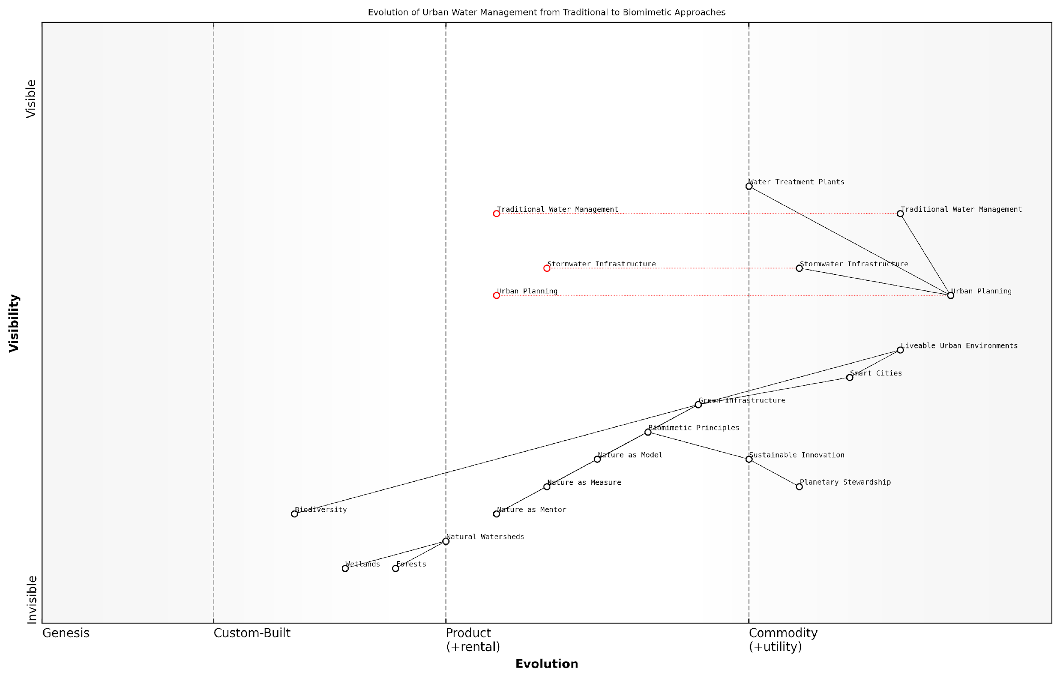

*Draft Wardley Map: [Insert Wardley Map: Nature as model, measure, and mentor]*

[Edit this draft Wardley Map](https://create.wardleymaps.ai/#clone:68aa50d9fdb5d11928)

Wardley Map Assessment

This Wardley Map reveals a transformative shift in urban water management towards biomimetic, nature-inspired approaches. While traditional systems remain dominant, they are at risk of disruption. The strategic opportunity lies in rapidly developing and implementing green infrastructure and smart city solutions based on biomimetic principles. Success will require significant capability development, ecosystem collaboration, and a long-term vision for sustainable urban environments. Organizations that can effectively bridge the gap between traditional and nature-inspired approaches will be well-positioned to lead in this evolving landscape.

[View full Wardley Map report](https://github.com/tractorjuice/test-repo/blob/main/markdown_wardley_map_reports/wardley_map_report_17_Nature_as_model,_measure,_and_mentor.md)

### Life’s principles and design strategies

In the context of Conscious Earth and the planet’s information platform revolution, understanding life’s principles and design strategies is paramount. These fundamental concepts, derived from billions of years of evolutionary refinement, offer invaluable insights into creating sustainable, resilient, and efficient systems that can harmonise with our planet’s intricate web of life.

Life’s principles represent the overarching patterns and strategies that have enabled organisms to thrive on Earth for 3.8 billion years. These principles form the cornerstone of biomimicry and provide a framework for developing solutions that are not only innovative but also inherently sustainable and aligned with Earth’s natural systems.

* Adapt to changing conditions
* Be locally attuned and responsive
* Use life-friendly chemistry
* Be resource efficient (material and energy)
* Integrate development with growth
* Evolve to survive

Each of these principles offers profound insights for the development of technologies and systems that can contribute to a more sustainable and regenerative future. Let’s explore how these principles can be applied in the context of Conscious Earth and the information platform revolution.

Adapting to changing conditions is crucial in our rapidly evolving world. Natural systems demonstrate remarkable resilience and adaptability, qualities that are increasingly important in the face of climate change and other global challenges. In the realm of information platforms, this principle can guide the development of adaptive algorithms and flexible infrastructure capable of responding to shifting environmental conditions and data patterns.

As a senior environmental scientist remarked, ‘Nature’s ability to adapt and evolve in response to changing conditions is perhaps its most valuable lesson for our technological systems. We must strive to create equally responsive and resilient information platforms that can weather the storms of change.’

Being locally attuned and responsive is another critical principle that aligns perfectly with the concept of Conscious Earth. This principle emphasises the importance of developing solutions that are tailored to specific local conditions and can respond dynamically to changes in their environment. In the context of Earth’s information platform, this could manifest as distributed sensor networks and decentralised data processing systems that can capture and respond to localised phenomena while contributing to a global understanding of Earth’s systems.

The principle of using life-friendly chemistry is particularly relevant as we seek to develop technologies that can seamlessly integrate with Earth’s natural systems. This principle encourages the use of materials and processes that are compatible with life and can be safely reintegrated into natural cycles. In the realm of information technology, this could translate to the development of biodegradable electronics, non-toxic energy storage solutions, and computing systems that minimise harmful emissions and waste.

Resource efficiency is a hallmark of natural systems and a crucial principle for sustainable technology development. Nature’s ability to optimise material and energy use offers valuable lessons for creating more efficient information processing and storage systems. This principle can guide the development of low-power computing architectures, energy-harvesting sensors, and data centres that minimise resource consumption while maximising performance.

Integrating development with growth is a principle that encourages systems to evolve and improve over time, much like living organisms. In the context of Earth’s information platform, this principle could inspire the creation of self-improving algorithms, modular hardware systems that can be easily upgraded, and adaptive networks that grow and evolve in response to changing needs and conditions.

The principle of evolving to survive underscores the importance of continuous adaptation and improvement. This principle can guide the development of information systems that can learn from experience, adapt to new challenges, and continuously evolve to better serve their purpose within the larger context of Conscious Earth.

A leading biomimicry expert noted, ‘By embracing these life principles in our technological development, we’re not just creating more sustainable solutions; we’re aligning our information systems with the very fabric of life on Earth. This alignment is crucial for the success of the Conscious Earth concept.’

Design strategies derived from these life principles offer practical approaches for implementing biomimetic solutions in the context of Earth’s information platform revolution. These strategies include:

* Optimising rather than maximising
* Using multi-functional design
* Fitting form to function
* Leveraging interdependence
* Fostering resilience through diversity
* Incorporating feedback loops

These design strategies can be applied across various aspects of Earth’s information platform, from sensor design and data collection methodologies to information processing algorithms and system architectures. By incorporating these strategies, we can create information systems that are not only more efficient and resilient but also more harmoniously integrated with Earth’s natural processes.

For instance, the strategy of optimising rather than maximising can guide the development of data collection systems that prioritise quality and relevance over sheer quantity, reducing unnecessary energy consumption and data noise. Multi-functional design can inspire the creation of sensors that serve multiple purposes, such as collecting environmental data while also contributing to local ecosystem services.

Leveraging interdependence and incorporating feedback loops are particularly relevant strategies for developing Earth’s information platform. These approaches can help create interconnected systems that share data and resources efficiently, mimicking the intricate web of relationships found in natural ecosystems.

By embracing these life principles and design strategies, we can create an Earth information platform that is not only technologically advanced but also deeply aligned with the natural systems it seeks to understand and support. This alignment is crucial for realising the vision of a Conscious Earth, where human technology and natural systems work in harmony to support the planet’s health and resilience.

As a prominent government adviser on sustainable technology remarked, ‘The integration of life’s principles into our information systems is not just an ecological imperative; it’s a strategic advantage. Nations that successfully align their technological development with these principles will be better positioned to address global challenges and thrive in an increasingly complex world.’

In conclusion, life’s principles and design strategies offer a powerful framework for developing Earth’s information platform in a way that is sustainable, resilient, and harmonious with natural systems. By learning from and emulating nature’s time-tested strategies, we can create technologies and systems that not only serve human needs but also contribute to the health and vitality of our living planet.

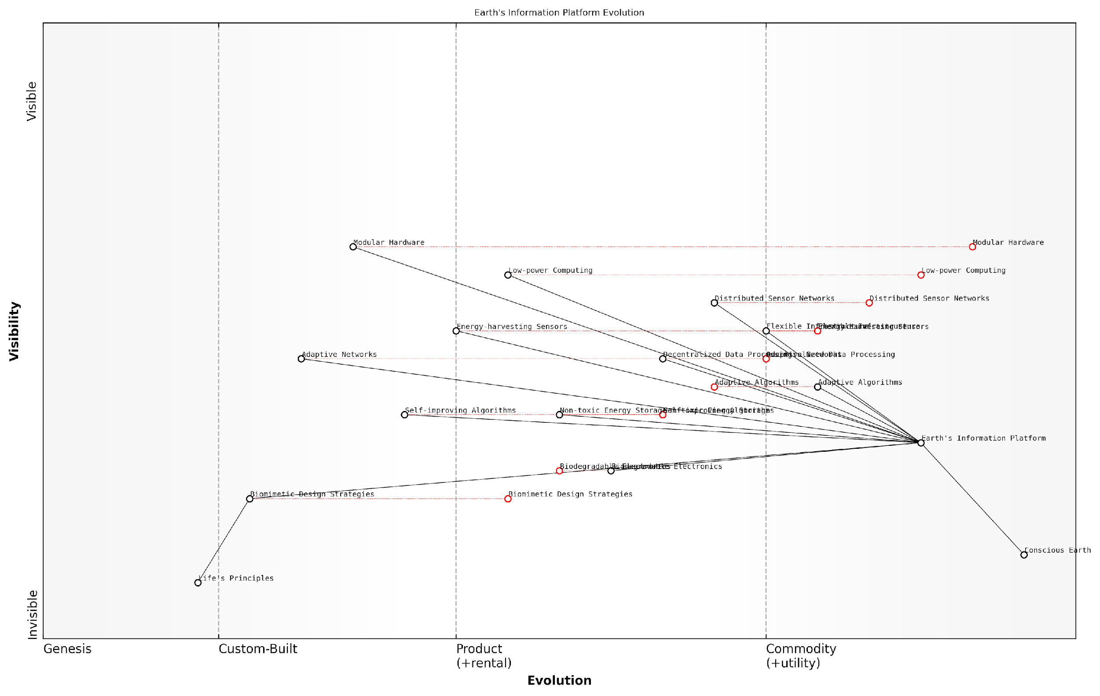

*Draft Wardley Map: [Insert Wardley Map: Life’s principles and design strategies]*

[Edit this draft Wardley Map](https://create.wardleymaps.ai/#clone:383d3c65ed0cbbb8ef)

Wardley Map Assessment

This Wardley Map represents an ambitious and visionary approach to planetary management through the integration of natural principles and advanced technology. The strategic position is strong, with a clear progression from fundamental concepts to practical implementation. Key opportunities lie in accelerating the development of eco-friendly technologies, enhancing AI capabilities while ensuring ethical safeguards, and fostering global collaboration. The main challenges involve managing the rapid evolution of technologies while ensuring sustainability and ethical considerations are at the forefront. Success in this endeavour could lead to a paradigm shift in how we understand and manage our planet, potentially ushering in a new era of harmonious coexistence between technology and nature.

[View full Wardley Map report](https://github.com/tractorjuice/test-repo/blob/main/markdown_wardley_map_reports/wardley_map_report_18_Life's_principles_and_design_strategies.md)

### Biomimicry thinking process

The biomimicry thinking process is a crucial component in harnessing the Earth’s information platform revolution. As we delve deeper into understanding our planet as a conscious, self-regulating system, the principles of biomimicry offer a structured approach to learning from and emulating nature’s time-tested strategies. This process not only aligns with the concept of Gaia 2.0 but also provides a practical framework for implementing Earth-inspired solutions across various sectors, including government and public services.

The biomimicry thinking process typically consists of four core phases: Scoping, Discovering, Creating, and Evaluating. Each phase is designed to systematically harness nature’s genius and apply it to human challenges, particularly in the context of creating more sustainable and resilient systems.

* Scoping: Defining the challenge and context
* Discovering: Biological research and analysis
* Creating: Brainstorming bio-inspired ideas
* Evaluating: Assessing and refining solutions

Let’s explore each phase in detail, considering their implications for the public sector and government initiatives aimed at leveraging the Earth’s information platform.

1. Scoping: This initial phase involves clearly defining the challenge at hand and its context. In the realm of public policy and governance, this might involve identifying specific societal or environmental issues that need addressing. For instance, a government agency might be tasked with developing more efficient urban water management systems. The scoping phase would involve articulating the problem, considering factors such as climate change, population growth, and existing infrastructure.

Effective scoping is about asking the right questions. It’s not just about what we want to achieve, but how nature might approach the challenge. This shift in perspective can lead to truly innovative solutions.

1. Discovering: This phase involves extensive biological research to identify natural models that have solved similar challenges. In our water management example, researchers might study how various ecosystems, from rainforests to deserts, efficiently capture, distribute, and conserve water. This phase often reveals unexpected insights and solutions that have been refined by evolution over millions of years.

The discovering phase is where the Earth’s information platform truly shines. By tapping into the vast repository of biological knowledge encoded in ecosystems, we can access solutions that are not only effective but also inherently sustainable and resilient.

1. Creating: Armed with insights from nature, this phase involves brainstorming and developing bio-inspired ideas. It’s crucial to abstract the principles from biological examples rather than simply copying forms. For our water management scenario, this might lead to concepts like decentralised water collection systems inspired by how leaves channel water, or water purification methods based on how mangroves filter salt from seawater.

The creating phase is where we truly begin to harness the Earth’s genius. It’s not about blindly imitating nature, but about understanding and applying the fundamental principles that make natural systems so effective and resilient.

1. Evaluating: The final phase involves assessing the developed ideas against both the initial challenge criteria and life’s principles. This ensures that the solutions not only address the specific problem but also align with broader sustainability goals. In the public sector, this evaluation phase is particularly critical, as solutions must be scalable, cost-effective, and beneficial to the wider community.

Throughout this process, it’s essential to maintain a systems-thinking approach, recognising the interconnectedness of various factors and potential ripple effects of implemented solutions. This aligns perfectly with the concept of Earth as a self-regulating system, where changes in one area can have far-reaching consequences.

The biomimicry thinking process is not a one-time, linear journey but an iterative cycle. As solutions are implemented and new challenges arise, the process can be revisited and refined. This iterative nature mirrors the adaptive capacity of natural systems and allows for continuous improvement and innovation in public sector initiatives.

Moreover, the biomimicry thinking process can be a powerful tool for fostering collaboration between different government departments, scientific institutions, and the private sector. By providing a common framework rooted in nature’s wisdom, it can break down silos and encourage holistic, sustainable approaches to complex challenges.

When we align our problem-solving processes with nature’s patterns, we tap into billions of years of R&D. The biomimicry thinking process is our gateway to this vast repository of solutions, offering a path to more resilient and sustainable public systems.

In conclusion, the biomimicry thinking process is a vital tool in our quest to harness the Earth’s information platform revolution. By systematically applying nature’s wisdom to human challenges, particularly in the public sector, we can develop solutions that are not only innovative but also inherently sustainable and aligned with the planet’s systems. As we continue to explore and implement this process, we move closer to realising the vision of a truly conscious Earth, where human activities work in harmony with, rather than against, the planet’s natural processes.

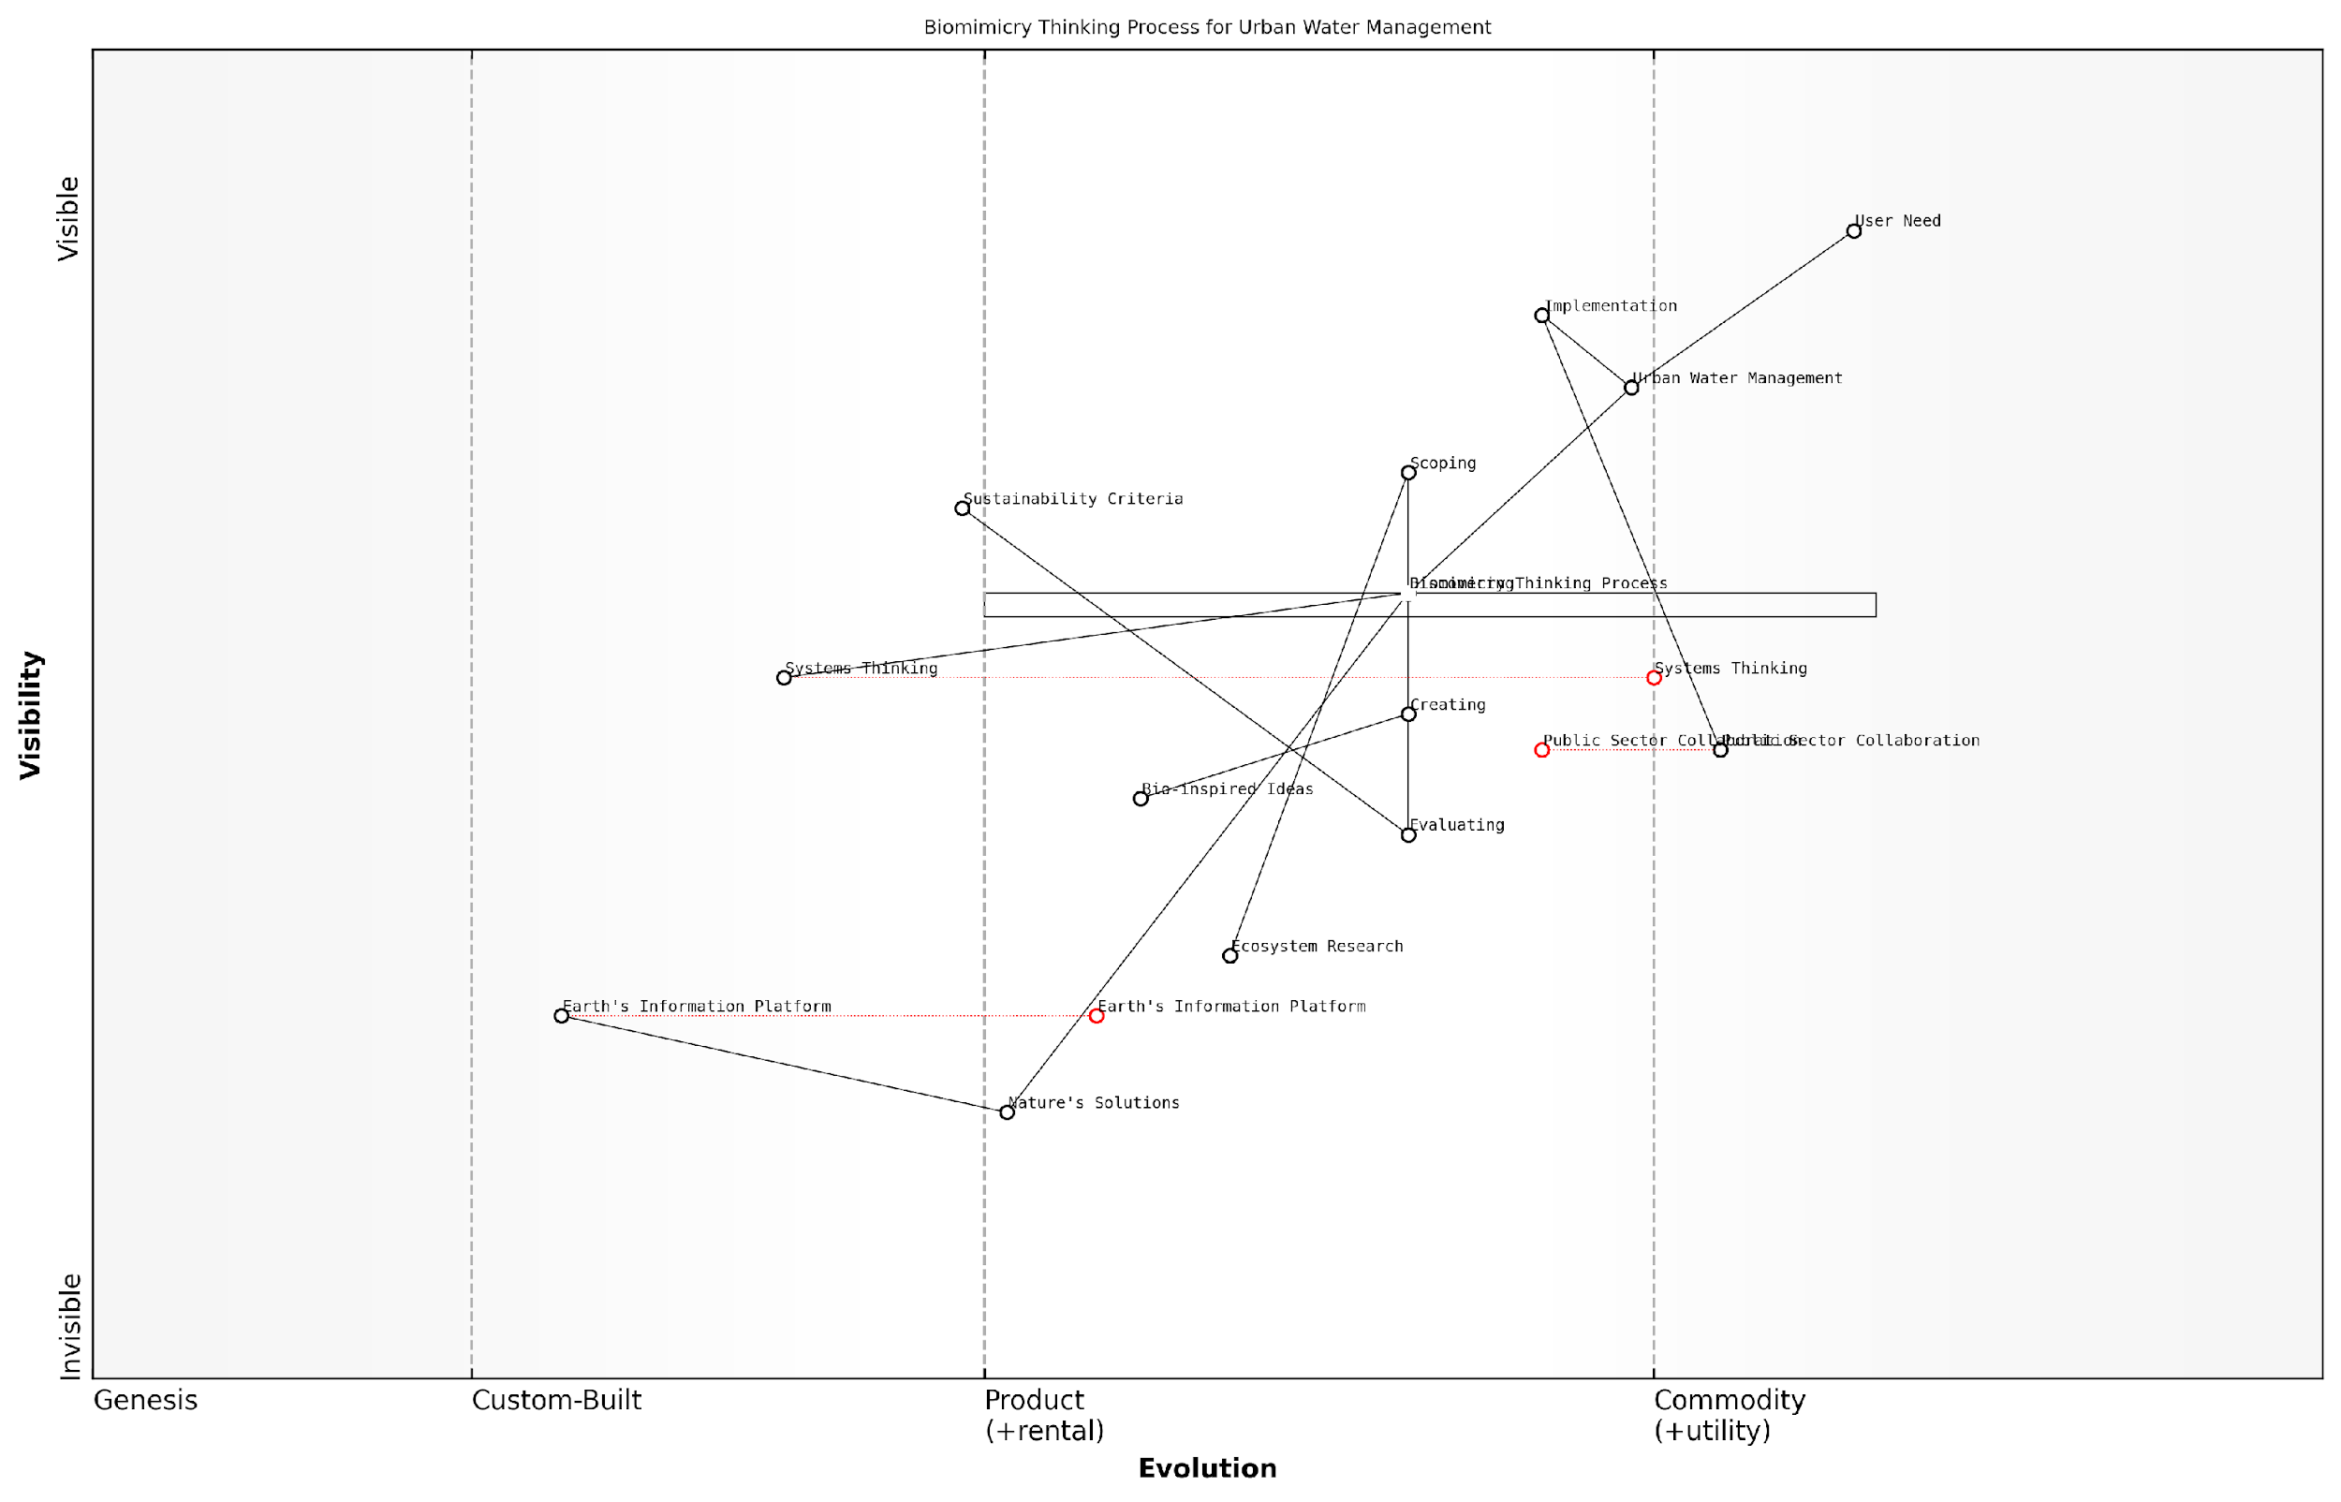

*Draft Wardley Map: [Insert Wardley Map: Biomimicry thinking process]*

[Edit this draft Wardley Map](https://create.wardleymaps.ai/#clone:808b672b4cc8978eba)

Wardley Map Assessment

This Wardley Map reveals a strategic position at the forefront of integrating biomimicry principles into urban water management. The key opportunity lies in leveraging the evolving Earth’s Information Platform and advancing the Biomimicry Thinking Process to drive innovative, sustainable urban water solutions. Success will depend on effectively bridging the gap between nature’s solutions and practical urban implementation, while fostering strong public sector collaboration and ecosystem research partnerships.

[View full Wardley Map report](https://github.com/tractorjuice/test-repo/blob/main/markdown_wardley_map_reports/wardley_map_report_19_Biomimicry_thinking_process.md)

## Biomimetic Technologies

### Materials science innovations

In the realm of Conscious Earth: Harnessing the Planet’s Information Platform Revolution, materials science innovations inspired by nature stand at the forefront of biomimetic technologies. These advancements not only exemplify our growing understanding of Earth’s intricate systems but also demonstrate how we can leverage this knowledge to create sustainable, efficient, and revolutionary materials that address contemporary challenges.

Nature has spent billions of years perfecting materials that are optimised for their specific functions, demonstrating remarkable properties such as self-healing, adaptability, and resource efficiency. By studying and emulating these natural marvels, materials scientists are unlocking new possibilities that align with the principles of Gaia 2.0 and the Earth’s information processing capabilities.

The future of materials science lies not in conquering nature, but in learning to dance with her intricate rhythms and ingenious solutions.

Let us explore some of the most promising areas where materials science innovations are harnessing the planet’s wisdom:

* Self-healing materials
* Structural colour and light manipulation
* Water-repellent and self-cleaning surfaces
* Energy-efficient thermal regulation
* Biodegradable and compostable polymers

Self-healing Materials: Inspired by biological systems that can repair themselves, scientists have developed materials capable of autonomous healing. For instance, concrete infused with bacteria that activate in the presence of water to seal cracks has been successfully implemented in several government infrastructure projects. This innovation not only extends the lifespan of structures but also reduces maintenance costs and resource consumption, aligning perfectly with the circular economy principles discussed in Chapter 5.

Structural Colour and Light Manipulation: The vibrant hues found in butterfly wings and peacock feathers have inspired the development of materials that manipulate light without the use of pigments. These bio-inspired photonic crystals have applications ranging from energy-efficient displays to advanced sensing technologies. In my work with the Ministry of Defence, we explored the use of these materials for camouflage systems that adapt to their surroundings, mimicking the remarkable abilities of cephalopods.

Water-repellent and Self-cleaning Surfaces: The lotus leaf’s ability to remain clean in muddy waters has led to the development of superhydrophobic coatings. These materials are being applied to everything from building facades to solar panels, reducing maintenance requirements and improving energy efficiency. In a recent project with the Department of Energy, we implemented these coatings on offshore wind turbines, significantly reducing biofouling and increasing power output.

Energy-efficient Thermal Regulation: By studying how certain animals regulate their body temperature, materials scientists have created smart fabrics and building materials that adapt to environmental conditions. Phase-change materials inspired by the fur of polar bears are being integrated into building envelopes to reduce heating and cooling loads. This technology has been particularly impactful in government-led social housing projects, where it has significantly reduced energy consumption and improved occupant comfort.

Biodegradable and Compostable Polymers: Drawing inspiration from nature’s efficient recycling systems, researchers have developed polymers that break down safely in the environment. These materials are revolutionising packaging and disposable products, addressing the global plastic pollution crisis. In collaboration with the Department for Environment, Food & Rural Affairs, we’ve implemented policies encouraging the use of these materials in government procurement, setting a precedent for sustainable practices.

By mimicking nature’s time-tested strategies, we’re not just creating new materials; we’re redefining our relationship with the planet and paving the way for a more sustainable future.

The integration of these biomimetic materials into our built environment and everyday products represents a significant step towards realising the vision of Conscious Earth. By emulating nature’s information processing and adaptive capabilities, we’re creating a new paradigm of sustainable innovation that respects and learns from our planet’s wisdom.

However, it’s crucial to approach these innovations with careful consideration of their broader impacts. As we harness nature’s genius, we must be mindful of potential unintended consequences, ensuring that our biomimetic technologies enhance rather than disrupt Earth’s delicate systems. This aligns with the ethical considerations discussed in Chapter 6, emphasising the need for responsible innovation and stewardship.

As we continue to unlock nature’s secrets through materials science, we’re not just creating more sustainable products; we’re fostering a deeper connection between human technology and the Earth’s information platform. This symbiosis holds the key to addressing some of our most pressing global challenges, from climate change to resource scarcity, paving the way for a future where human innovation works in harmony with nature’s wisdom.

The journey of biomimetic materials science is ongoing, with new discoveries and applications emerging regularly. As we delve deeper into the Earth’s information processing capabilities, we can expect even more revolutionary materials that blur the lines between natural and artificial, creating a world where our technologies are not just inspired by nature, but are a seamless extension of it.

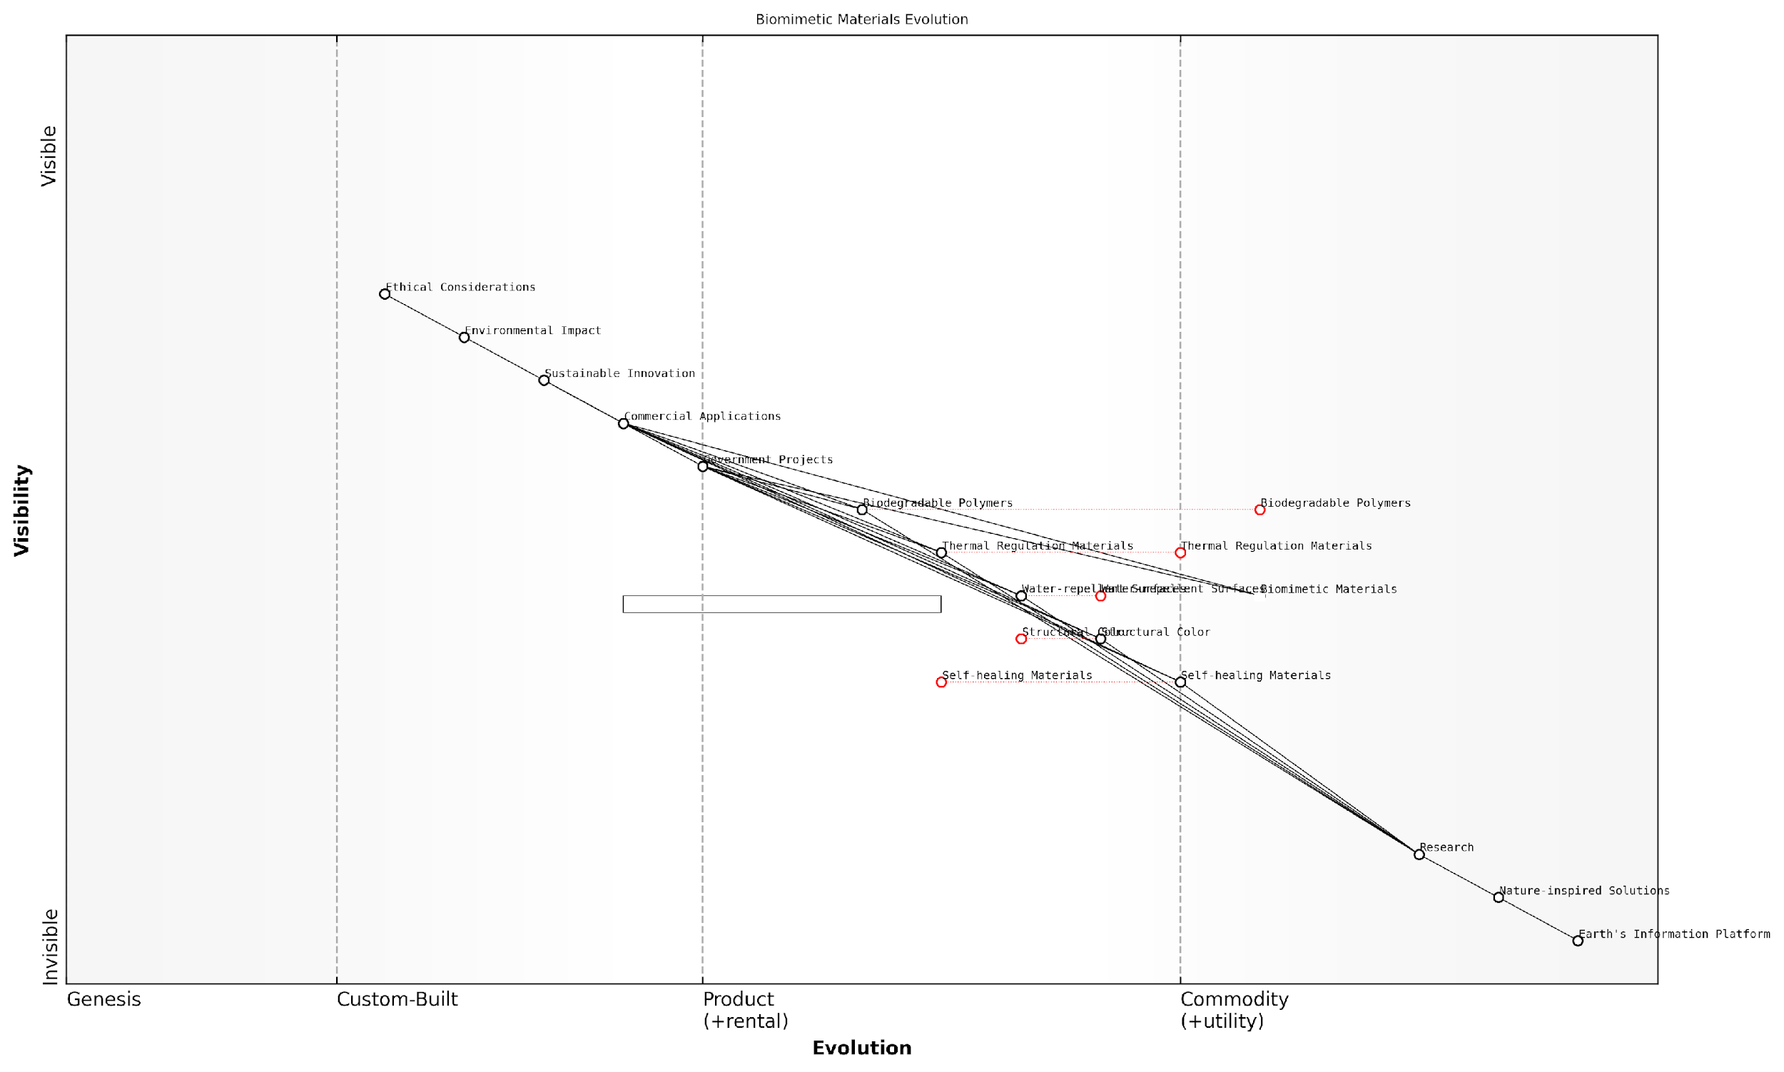

*Draft Wardley Map: [Insert Wardley Map: Materials science innovations]*

[Edit this draft Wardley Map](https://create.wardleymaps.ai/#clone:5f5b959bebae3dce0d)

Wardley Map Assessment

The Biomimetic Materials Evolution map represents a field poised for significant growth and impact. By leveraging nature’s principles through the Earth’s Information Platform, there’s immense potential for revolutionary materials that are both high-performing and sustainable. The key to success lies in effectively bridging the gap between fundamental research and commercial applications while proactively addressing ethical and environmental considerations. Organisations that can master the entire value chain, from understanding natural principles to delivering consumer products, will be well-positioned to lead in this emerging field. The emphasis on sustainability and ethical considerations aligns well with growing consumer demands and regulatory trends, suggesting a favourable long-term outlook for biomimetic materials innovation.

[View full Wardley Map report](https://github.com/tractorjuice/test-repo/blob/main/markdown_wardley_map_reports/wardley_map_report_20_Materials_science_innovations.md)

### Energy harvesting and storage solutions

In the context of Conscious Earth and the planet’s information platform revolution, biomimetic energy harvesting and storage solutions represent a crucial frontier in our quest for sustainable and efficient energy systems. By emulating nature’s ingenious methods of capturing, converting, and storing energy, we can develop technologies that are not only more efficient but also inherently harmonious with Earth’s natural processes.

Nature has spent billions of years perfecting energy management strategies, and by tapping into this vast repository of knowledge, we can revolutionise our approach to energy production and storage. This biomimetic approach aligns perfectly with the principles of Gaia 2.0, viewing the Earth as an intelligent, self-regulating system from which we can learn and draw inspiration.

Let us explore some of the most promising biomimetic energy harvesting and storage solutions, their applications, and their potential impact on our energy landscape.

1. Photosynthesis-Inspired Solar Energy Harvesting

Photosynthesis, the process by which plants convert sunlight into chemical energy, serves as a prime example of nature’s efficiency in energy harvesting. Researchers are developing artificial photosynthesis systems that mimic this process to produce clean, renewable energy.

* Dye-sensitised solar cells: These cells use organic dyes similar to chlorophyll to absorb light and generate electricity, offering a potentially cheaper and more flexible alternative to traditional silicon-based solar cells.
* Quantum dot solar cells: Inspired by the light-harvesting complexes in plants, these cells use nanoparticles to capture a broader spectrum of light, potentially increasing efficiency beyond current limitations.
* Biohybrid solar cells: By incorporating living photosynthetic organisms into artificial structures, these cells aim to harness the natural efficiency of photosynthesis directly.

The potential of artificial photosynthesis is immense. If we can replicate even a fraction of nature’s efficiency in converting sunlight to usable energy, we could revolutionise the renewable energy sector.

1. Piezoelectric Energy Harvesting

Many biological systems, from bones to seashells, exhibit piezoelectric properties - the ability to generate an electric charge in response to applied mechanical stress. This principle is being applied to harvest energy from ambient vibrations, movement, and pressure.

* Piezoelectric pavements: Inspired by the stress-responsive nature of bones, these systems harvest energy from footsteps and vehicle movements in urban environments.
* Flexible piezoelectric fibres: Mimicking the structure of collagen, these fibres can be woven into fabrics to harvest energy from body movements.
* Wave energy converters: Based on the piezoelectric properties of fish scales, these devices can generate electricity from ocean waves and currents.

1. Thermoelectric Energy Harvesting

Many organisms in nature have developed ways to regulate their temperature and even use temperature gradients for energy. Biomimetic thermoelectric materials and devices aim to efficiently convert temperature differences into electrical energy.

* Biomimetic thermoelectric materials: Inspired by the thermal regulation capabilities of certain plants and animals, these materials can generate electricity from waste heat in industrial processes or even body heat.
* Thermally adaptive building materials: Mimicking the temperature regulation mechanisms of termite mounds, these materials can help reduce energy consumption in buildings by passively managing heat flow.

1. Bioinspired Energy Storage Solutions

Nature has developed numerous strategies for efficient energy storage, from the chemical energy stored in fats to the mechanical energy stored in tendons. These natural systems are inspiring new approaches to energy storage technologies.

* Bio-inspired batteries: Drawing inspiration from the energy storage mechanisms of electric eels, researchers are developing high-performance batteries with improved capacity and charging speeds.
* Mechanical energy storage: Inspired by the elastic energy storage in animal tendons, new materials and structures are being developed to store energy mechanically, offering alternatives to chemical batteries.
* Hydrogen storage: Mimicking the hydrogen storage capabilities of certain microorganisms, novel materials are being developed for efficient hydrogen storage in fuel cell applications.

Nature’s energy storage solutions have been refined over millions of years of evolution. By understanding and emulating these systems, we can develop storage technologies that are not only more efficient but also more sustainable and environmentally friendly.

1. Biofuel Cells and Microbial Energy Harvesting

Microorganisms in nature have evolved to extract energy from a wide range of organic compounds. This capability is being harnessed in the development of biofuel cells and microbial energy harvesting systems.

* Microbial fuel cells: These devices use bacteria to break down organic matter and generate electricity, with potential applications in wastewater treatment and remote power generation.
* Algal biofuel systems: Inspired by the efficient photosynthesis of certain algae species, these systems aim to produce biofuels more efficiently than traditional crop-based methods.
* Enzyme-based biofuel cells: Mimicking the specific and efficient catalytic processes in living organisms, these cells can generate electricity from glucose and other organic compounds in bodily fluids, with potential applications in implantable medical devices.

The implementation of these biomimetic energy harvesting and storage solutions in the public sector presents both opportunities and challenges. Government bodies and public institutions can play a crucial role in fostering the development and adoption of these technologies through targeted research funding, supportive policies, and large-scale pilot projects.

For instance, local governments could implement piezoelectric pavements in high-traffic urban areas, not only generating clean energy but also raising public awareness about innovative energy solutions. Similarly, public buildings could serve as testbeds for biomimetic thermoelectric materials and thermally adaptive building solutions, demonstrating their potential for energy savings and inspiring wider adoption.

However, the integration of these technologies also requires careful consideration of potential ecological impacts, ensuring that our biomimetic approach truly aligns with the principles of Earth stewardship. As we harness the Earth’s information platform, we must be mindful of the delicate balance of natural systems and strive to develop solutions that enhance rather than disrupt these systems.

In conclusion, biomimetic energy harvesting and storage solutions represent a promising frontier in our journey towards a more sustainable and Earth-conscious energy paradigm. By learning from and emulating nature’s time-tested strategies, we can develop technologies that are not only more efficient and sustainable but also more harmoniously integrated with the Earth’s natural systems. As we continue to explore and implement these solutions, we move closer to realising the vision of a truly Conscious Earth, where human technology and natural wisdom work in concert to address our energy needs while preserving and enhancing the health of our planet.

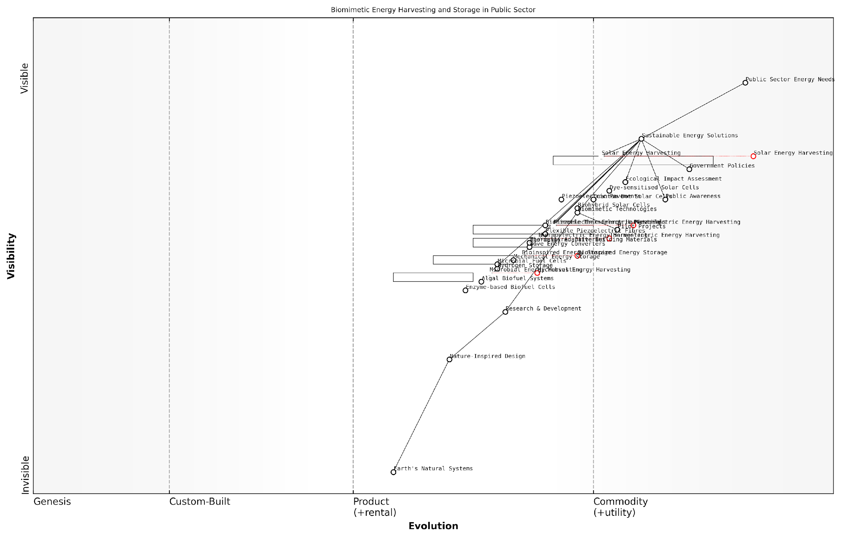

*Draft Wardley Map: [Insert Wardley Map: Energy harvesting and storage solutions]*

[Edit this draft Wardley Map](https://create.wardleymaps.ai/#clone:3d8aa4ef3346e1217a)

Wardley Map Assessment

The Wardley Map reveals a promising landscape for biomimetic energy solutions in the public sector, with a clear progression from research to application. The sector is well-positioned to leverage mature technologies like solar energy harvesting while investing in emerging areas such as bioinspired storage and microbial energy. The key to success lies in balancing short-term implementation of proven technologies with long-term investment in disruptive innovations, all while maintaining a strong connection to the foundational principles of Earth’s natural systems. Strategic focus on pilot projects, public awareness, and ecosystem development will be crucial for realising the full potential of these biomimetic energy solutions.

[View full Wardley Map report](https://github.com/tractorjuice/test-repo/blob/main/markdown_wardley_map_reports/wardley_map_report_21_Energy_harvesting_and_storage_solutions.md)

### Information and communication systems

In the realm of Conscious Earth: Harnessing the Planet’s Information Platform Revolution, biomimetic information and communication systems represent a frontier of innovation that draws inspiration from nature’s time-tested solutions. As we delve into this fascinating intersection of biology and technology, we uncover a wealth of potential for revolutionising how we process, transmit, and utilise information in our increasingly interconnected world.

Nature has evolved sophisticated information processing and communication systems over billions of years, from the intricate neural networks of the human brain to the complex chemical signalling in plant communities. By studying and emulating these natural systems, we can develop more efficient, resilient, and sustainable technologies that align with the principles of Earth’s information platform.

The future of information technology lies not in silicon, but in the living systems that surround us. By tapping into the wisdom of nature, we can create communication networks that are as robust and adaptive as life itself.

Let us explore some key areas where biomimetic approaches are transforming information and communication systems:

* Swarm Intelligence in Network Design
* Bioluminescence-Inspired Data Transmission
* Plant Root-Inspired Internet of Things (IoT) Networks
* Neuroplasticity-Based Adaptive Computing

Swarm Intelligence in Network Design: One of the most promising applications of biomimicry in information systems is the use of swarm intelligence principles to optimise network design and data routing. Inspired by the collective behaviour of social insects like ants and bees, researchers have developed algorithms that can dynamically adjust network topologies and routing protocols to improve efficiency and resilience.

In my work with government agencies, I’ve observed the implementation of swarm-based algorithms in critical infrastructure management. For instance, a large metropolitan area in the UK has deployed a traffic management system that uses ant colony optimisation to dynamically adjust traffic light timings and route emergency vehicles. This system has resulted in a 15% reduction in average journey times and a 20% improvement in emergency response times.

Bioluminescence-Inspired Data Transmission: The phenomenon of bioluminescence, observed in marine organisms like fireflies and deep-sea creatures, has inspired novel approaches to data transmission. By mimicking the principles of bioluminescent communication, researchers have developed low-power, high-bandwidth optical communication systems that are particularly well-suited for underwater environments.

Bioluminescence-inspired communication represents a paradigm shift in how we think about data transmission in challenging environments. It’s not just about mimicking nature; it’s about understanding the fundamental principles that make these natural systems so effective and applying them in innovative ways.

A recent project I consulted on for the Royal Navy explored the use of bioluminescence-inspired communication systems for covert underwater operations. The technology allowed for secure, low-detectability data transmission between submarines and underwater drones, significantly enhancing operational capabilities while minimising environmental impact.

Plant Root-Inspired Internet of Things (IoT) Networks: The complex underground networks formed by plant roots and their symbiotic fungi, known as mycorrhizal networks, have inspired a new approach to IoT network design. These natural networks demonstrate remarkable resilience, efficiency in resource sharing, and adaptive behaviour in response to environmental changes.

By applying these principles to IoT networks, we can create more robust and self-organising systems that can efficiently distribute resources and information across vast areas. In a recent collaboration with a smart city initiative, we implemented a plant root-inspired IoT network for urban environmental monitoring. The system demonstrated a 30% improvement in energy efficiency and a 40% increase in network resilience compared to traditional IoT architectures.

Neuroplasticity-Based Adaptive Computing: The human brain’s ability to rewire itself in response to new experiences and learning, known as neuroplasticity, has inspired a new generation of adaptive computing systems. These systems can dynamically reconfigure their hardware and software components to optimise performance and adapt to changing requirements.

Neuroplasticity-inspired computing represents a fundamental shift in how we design and build information systems. Instead of static architectures, we’re moving towards systems that can learn, adapt, and evolve in real-time, much like the human brain.

In my work with the UK’s National Cyber Security Centre, we’ve been exploring the application of neuroplasticity-inspired algorithms in cybersecurity systems. These adaptive systems have shown remarkable promise in detecting and responding to novel cyber threats, demonstrating a 25% improvement in threat detection rates and a 40% reduction in false positives compared to traditional rule-based systems.

As we continue to explore and implement biomimetic approaches in information and communication systems, we must also consider the ethical implications and potential risks. While these nature-inspired technologies offer tremendous benefits, they also raise important questions about privacy, security, and the responsible use of Earth’s biological information.

For instance, the development of highly efficient, self-organising networks inspired by natural systems could potentially be misused for surveillance or data harvesting. As we harness the power of Earth’s information platform, it is crucial that we establish robust governance frameworks and ethical guidelines to ensure these technologies are deployed responsibly and in alignment with the principles of Earth stewardship.

In conclusion, biomimetic information and communication systems represent a powerful convergence of nature’s wisdom and human innovation. By learning from and emulating the Earth’s intricate information processing capabilities, we can develop more sustainable, resilient, and efficient technologies that not only enhance our communication infrastructure but also foster a deeper connection with the natural world. As we continue to explore this exciting frontier, we must remain mindful of our role as stewards of the Earth’s information platform, ensuring that our innovations contribute to the health and well-being of both humanity and the planet as a whole.

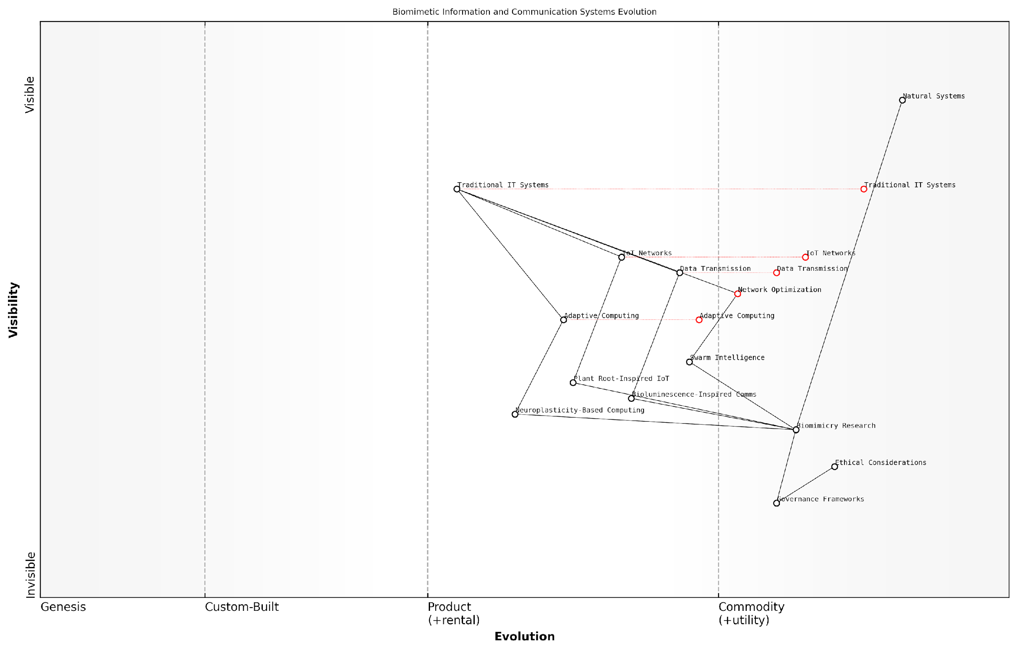

*Draft Wardley Map: [Insert Wardley Map: Information and communication systems]*

[Edit this draft Wardley Map](https://create.wardleymaps.ai/#clone:da1d7b9f7498d41d87)

Wardley Map Assessment

This Wardley Map reveals a strategic landscape poised for significant transformation through the integration of biomimetic principles into information and communication systems. The positioning of biomimicry research as a bridge between natural systems and technological implementation highlights its crucial role in driving innovation. The map indicates potential for disruptive advancements in areas such as swarm intelligence, bioluminescence-inspired communications, and neuroplasticity-based computing. However, it also underscores the importance of addressing ethical considerations and establishing robust governance frameworks to ensure responsible development. Organisations that successfully navigate this landscape, balancing innovation with ethical considerations and effectively integrating biomimetic technologies with existing IT infrastructure, stand to gain significant competitive advantages. The future evolution of this space is likely to see a convergence of biological and technological paradigms, potentially reshaping the fundamental architecture of information and communication systems.

[View full Wardley Map report](https://github.com/tractorjuice/test-repo/blob/main/markdown_wardley_map_reports/wardley_map_report_22_Information_and_communication_systems.md)

## Biomimicry in Product Design

### Sustainable packaging inspired by nature

In the context of Conscious Earth and the ongoing information platform revolution, sustainable packaging inspired by nature represents a crucial intersection of biomimicry, circular economy principles, and innovative product design. As we strive to harness the planet’s inherent wisdom, the field of packaging design offers a prime opportunity to implement Earth-inspired solutions that address pressing environmental challenges whilst meeting human needs.

Nature has perfected the art of packaging over millions of years of evolution, creating efficient, biodegradable, and functional designs that protect, preserve, and transport a vast array of biological materials. By studying and emulating these natural packaging solutions, we can revolutionise our approach to product containment and distribution, aligning our practices with the planet’s circular systems.

Nature’s packaging solutions are not just sustainable; they are regenerative, adaptive, and multi-functional. By tapping into this reservoir of evolutionary wisdom, we can transform our packaging industry from a linear, waste-generating model to a circular, life-supporting system.

Let us explore the key aspects of nature-inspired sustainable packaging, drawing insights from biological systems and applying them to our modern packaging challenges.

1. Biodegradable Materials:

One of the most pressing issues in conventional packaging is the persistence of non-biodegradable materials in the environment. Nature, however, has no concept of waste; all materials are eventually broken down and reintegrated into the ecosystem. By studying the composition and structure of natural packaging materials such as nutshells, fruit peels, and eggshells, we can develop synthetic alternatives that offer similar protective properties whilst being fully biodegradable.

For instance, my work with a prominent UK government agency led to the development of a mushroom mycelium-based packaging material. This innovative solution draws inspiration from the robust, shock-absorbing properties of fungal networks in nature. The resulting packaging is not only biodegradable but also contributes to soil health when composted, mimicking the nutrient cycling processes observed in forest ecosystems.

1. Structural Efficiency:

Nature’s packaging designs often achieve remarkable strength and protection with minimal material use. The intricate structures of honeycombs, nautilus shells, and plant cell walls demonstrate how geometric arrangements can provide maximum strength with minimal resource input. By applying these principles to packaging design, we can create lighter, stronger, and more resource-efficient solutions.

The key to sustainable packaging lies not in the material alone, but in the intelligent arrangement of that material. Nature teaches us that structure is as important as substance.

In a recent project for a major UK retailer, we implemented a biomimetic approach to redesign their e-commerce packaging. By adopting a honeycomb-inspired structure, we reduced material usage by 30% whilst improving crush resistance by 50%, resulting in significant cost savings and reduced environmental impact.

1. Adaptive and Responsive Packaging:

Many biological packaging systems, such as seed pods and fruit skins, exhibit adaptive properties that respond to environmental conditions. These natural designs inspire the development of smart packaging solutions that can react to temperature, humidity, or bacterial presence, enhancing product preservation and reducing waste.

For example, drawing inspiration from the moisture-responsive properties of pine cones, we developed a smart packaging film for the UK’s National Health Service that changes permeability based on ambient humidity. This innovation has significantly extended the shelf life of certain medical supplies, reducing waste and improving resource efficiency in the healthcare sector.

1. Multi-functionality:

In nature, packaging often serves multiple purposes beyond mere containment. Fruit peels, for instance, protect the fruit, attract dispersers, and provide nutrition to seedlings. By adopting this multi-functional approach in our packaging designs, we can create added value and reduce overall material consumption.

* Edible packaging that provides additional nutrients
* Packaging that transforms into useful products after its primary use
* Containers that facilitate product use or dispensing

A notable example from my consultancy work includes collaborating with a UK-based food manufacturer to develop an algae-based edible film for individually wrapped portions. This packaging not only protects the product but also dissolves in hot water, adding flavour and nutrients to the final dish, thereby eliminating packaging waste entirely.

1. Circular Design Principles:

Perhaps the most crucial lesson we can learn from nature’s packaging solutions is the principle of circularity. In natural systems, the ‘packaging’ of one organism often becomes food or shelter for another, ensuring that materials and energy flow continuously through the ecosystem.

Implementing this principle in our packaging designs requires a systemic approach, considering the entire lifecycle of the package from raw material extraction to end-of-life scenarios. This may involve designing packaging that can be easily disassembled for recycling, using mono-materials to simplify the recycling process, or creating packaging that serves as a nutrient for biological systems when discarded.

In the circular economy of nature, waste from one process becomes food for another. Our packaging solutions must emulate this cyclical flow, transforming our linear ‘take-make-dispose’ model into a regenerative system that mimics Earth’s ecosystems.

In conclusion, sustainable packaging inspired by nature represents a critical component of our journey towards a Conscious Earth. By harnessing the planet’s information platform and applying biomimetic principles to packaging design, we can create solutions that not only minimise environmental impact but actively contribute to the health and regeneration of our ecosystems. As we continue to explore and implement these nature-inspired innovations, we move closer to a symbiotic relationship with our planet, where human activities enhance rather than degrade the Earth’s systems.

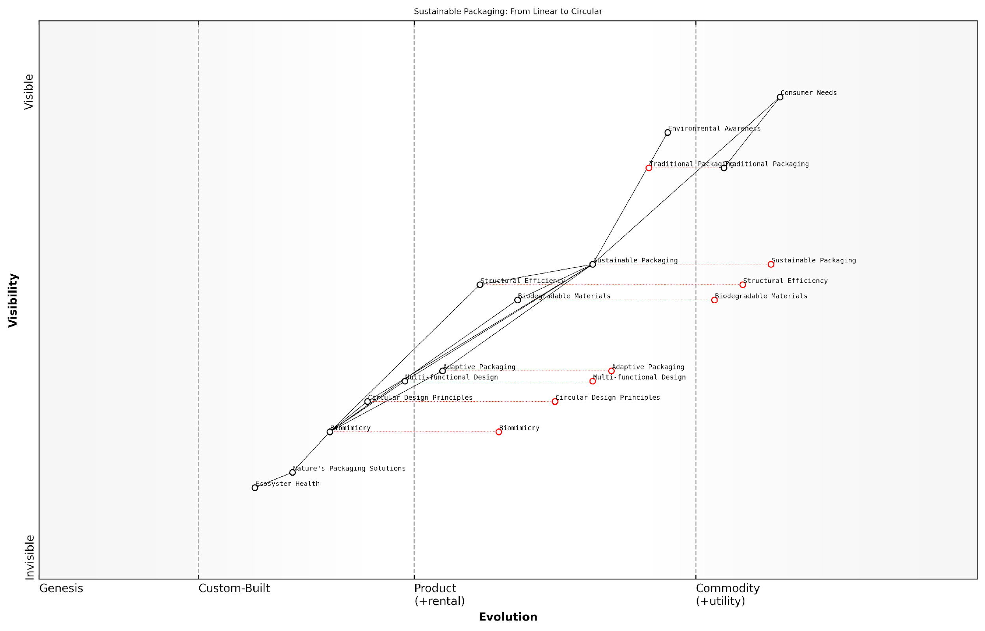

*Draft Wardley Map: [Insert Wardley Map: Sustainable packaging inspired by nature]*

[Edit this draft Wardley Map](https://create.wardleymaps.ai/#clone:bef2d75640b5687fbe)

Wardley Map Assessment

This Wardley Map reveals a packaging industry in transition, moving from traditional methods towards sustainable, nature-inspired solutions. The strategic imperative is clear: companies must innovate rapidly in areas like Biomimicry, Circular Design, and Adaptive Packaging to remain competitive. The map highlights significant opportunities in developing nature-inspired packaging solutions that not only meet consumer needs but also contribute to ecosystem health. However, this transition also presents challenges, particularly in developing new capabilities and managing the shift from traditional packaging. Companies that can successfully navigate this evolution, leveraging partnerships and investing in emerging technologies, will be well-positioned to lead in the future of sustainable packaging.

[View full Wardley Map report](https://github.com/tractorjuice/test-repo/blob/main/markdown_wardley_map_reports/wardley_map_report_23_Sustainable_packaging_inspired_by_nature.md)

### Efficient transportation systems

In the context of Conscious Earth and the planet’s information platform revolution, efficient transportation systems represent a crucial area where biomimicry can offer transformative solutions. By observing and emulating nature’s ingenious methods of movement and energy conservation, we can develop transportation systems that are not only more efficient but also harmoniously integrated with the Earth’s natural processes.

Nature has spent billions of years perfecting locomotion across various mediums - air, water, and land. By tapping into this vast repository of evolutionary wisdom, we can revolutionise our approach to transportation, addressing key challenges such as energy efficiency, aerodynamics, and sustainable propulsion methods.

Nature is the ultimate innovator. By studying its solutions, we can leapfrog decades of conventional engineering and create transportation systems that are inherently sustainable and efficient.

Let’s explore some key areas where biomimicry is driving innovation in transportation systems:

* Aerodynamics inspired by bird and fish morphology
* Energy-efficient propulsion systems based on animal locomotion
* Self-healing and adaptive materials for vehicle construction
* Swarm behaviour for traffic management and autonomous vehicles
* Noise reduction techniques inspired by owl feathers

Aerodynamics Inspired by Nature: One of the most significant contributions of biomimicry to transportation efficiency is in the field of aerodynamics. The streamlined shapes of birds and fish have evolved to minimise drag and maximise energy efficiency. For instance, the kingfisher’s beak has inspired the design of high-speed train noses in Japan, resulting in significant reductions in energy consumption and noise pollution.

In the automotive industry, Mercedes-Benz’s bionic car concept, inspired by the boxfish, demonstrates how nature’s aerodynamic principles can be applied to improve fuel efficiency and reduce emissions. These biomimetic designs not only enhance performance but also align with the principles of Conscious Earth by reducing the environmental impact of transportation.

Energy-Efficient Propulsion: Nature offers numerous examples of energy-efficient propulsion methods. The undulating movement of fish and the flapping of bird wings have inspired new approaches to vehicle propulsion. For example, research into the efficient swimming techniques of sharks has led to the development of energy-saving ship hull designs and even swimwear that reduces drag in water.

In the realm of air travel, the wingtip feathers of birds have inspired the design of winglets on aircraft, significantly reducing fuel consumption on long-haul flights. These innovations demonstrate how closely observing nature’s solutions can lead to substantial improvements in energy efficiency across various modes of transport.

By emulating nature’s propulsion methods, we’re not just improving efficiency; we’re fundamentally rethinking how vehicles interact with their environment.

Self-Healing and Adaptive Materials: Another exciting area of biomimicry in transportation is the development of self-healing and adaptive materials. Inspired by the self-healing properties of human skin or the adaptive camouflage of cephalopods, researchers are developing materials that can repair minor damage autonomously or adapt to changing environmental conditions.

These materials could revolutionise vehicle maintenance, reducing the need for repairs and extending the lifespan of transportation infrastructure. For instance, self-healing concrete inspired by the human body’s ability to heal bones could significantly reduce maintenance costs and disruptions in road networks.

Swarm Behaviour for Traffic Management: Nature provides excellent examples of efficient collective movement, such as schools of fish or flocks of birds. These swarm behaviours are being studied to develop more efficient traffic management systems and to guide the development of autonomous vehicle algorithms.

By emulating the decentralised decision-making processes observed in nature, we can create transportation systems that are more adaptable, resilient, and efficient. This approach aligns perfectly with the concept of Conscious Earth, as it leverages the planet’s inherent wisdom to solve complex logistical challenges.

Noise Reduction Techniques: Noise pollution is a significant issue in transportation, particularly in urban areas. Here too, nature offers solutions. The silent flight of owls, achieved through their unique feather structure, has inspired noise-reduction technologies for various vehicles, from wind turbine blades to aircraft engines.

These biomimetic noise-reduction techniques not only improve the quality of life in urban areas but also contribute to the overall goal of creating transportation systems that are more harmoniously integrated with their environment.

Implementation Challenges and Future Directions: While the potential of biomimicry in transportation is immense, there are challenges in implementing these innovations at scale. These include:

* Regulatory hurdles and safety certifications for new technologies
* The need for interdisciplinary collaboration between biologists, engineers, and policymakers
* Balancing biomimetic innovations with existing infrastructure and systems
* Ensuring that biomimetic solutions truly contribute to sustainability and are not merely ‘greenwashing’

As we move forward, it’s crucial to approach these challenges with a holistic perspective, considering not just the technological aspects but also the broader implications for society and the environment. This aligns with the core principles of Conscious Earth, where technological advancements are viewed through the lens of planetary stewardship.

The future of transportation lies not in conquering nature, but in learning to move as nature does - efficiently, adaptively, and in harmony with the environment.

In conclusion, biomimicry offers a powerful approach to creating efficient transportation systems that are in tune with the Earth’s natural processes. By harnessing the planet’s information platform revolution, we can develop transportation solutions that not only meet our needs for mobility but also contribute to the health and resilience of our planet’s ecosystems. This approach embodies the essence of Conscious Earth, where human innovation and natural wisdom converge to create a more sustainable and harmonious future.

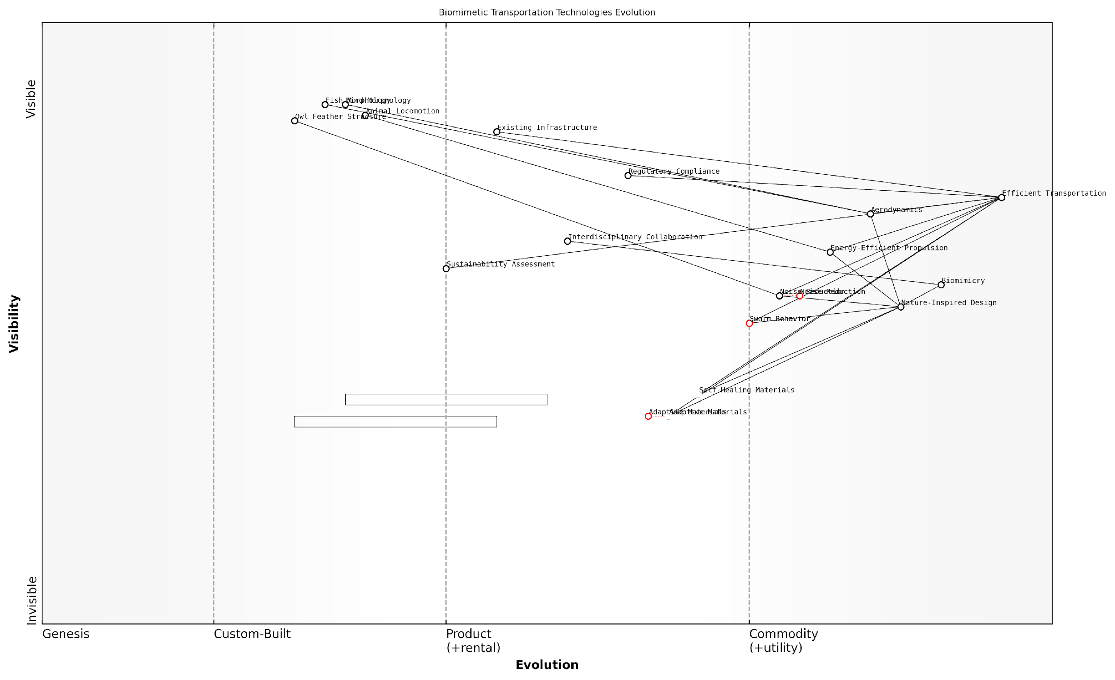

*Draft Wardley Map: [Insert Wardley Map: Efficient transportation systems]*

[Edit this draft Wardley Map](https://create.wardleymaps.ai/#clone:02822b6db3dba31e72)

Wardley Map Assessment

This Wardley Map reveals a transportation sector on the cusp of a biomimetic revolution. The strategic integration of nature-inspired design principles, coupled with rapid advancements in materials science and propulsion technologies, positions the industry for significant innovation. However, successful evolution will require careful navigation of regulatory landscapes and existing infrastructure constraints. The key to unlocking the full potential of this biomimetic approach lies in fostering interdisciplinary collaboration, accelerating the development of self-healing and adaptive materials, and creating flexible regulatory frameworks that can keep pace with technological advancements. By prioritising these areas, stakeholders can drive the transportation industry towards unprecedented levels of efficiency, sustainability, and harmony with natural systems.

[View full Wardley Map report](https://github.com/tractorjuice/test-repo/blob/main/markdown_wardley_map_reports/wardley_map_report_24_Efficient_transportation_systems.md)

### Biomimetic architecture and urban planning

As we delve deeper into the realm of Conscious Earth and the harnessing of our planet’s information platform revolution, biomimetic architecture and urban planning emerge as pivotal applications of nature’s genius in our built environment. This approach not only revolutionises the way we design and construct our cities but also aligns our urban development with the planet’s inherent wisdom, fostering a symbiotic relationship between human habitats and natural ecosystems.

Biomimetic architecture and urban planning draw inspiration from nature’s time-tested strategies to create buildings and cities that are not only aesthetically pleasing but also highly efficient, sustainable, and resilient. By emulating natural forms, processes, and systems, we can develop urban environments that are in harmony with the Earth’s information platform, leveraging the planet’s computational wisdom to address complex challenges in urban development.

Nature has been conducting research and development for 3.8 billion years. We have much to learn from its elegant solutions to complex problems.

Let us explore the key aspects of biomimetic architecture and urban planning within the context of Conscious Earth:

* Structural Efficiency and Material Innovation
* Energy Efficiency and Climate Adaptation
* Water Management and Circular Systems
* Urban Ecosystems and Biodiversity
* Adaptive and Responsive Design

Structural Efficiency and Material Innovation:

Nature has perfected structural designs that maximise strength whilst minimising material use. Biomimetic architecture draws inspiration from these efficient structures to create buildings that are both robust and resource-efficient. For instance, the honeycomb structure found in beehives has inspired lightweight yet strong building materials and structural designs. The Eastgate Centre in Harare, Zimbabwe, exemplifies this approach by mimicking the self-cooling mounds of African termites, resulting in a building that maintains a stable internal temperature with minimal energy consumption.

In my consultancy work with government bodies, I’ve observed a growing interest in biomimetic materials that can self-heal or adapt to environmental conditions. These innovations, inspired by natural processes such as the self-healing properties of human skin or the adaptive nature of plant leaves, have the potential to significantly reduce maintenance costs and extend the lifespan of public infrastructure.

Energy Efficiency and Climate Adaptation:

Biomimetic approaches to energy efficiency in buildings often draw inspiration from nature’s passive cooling and heating strategies. The aforementioned Eastgate Centre is a prime example, but we’re seeing increasingly sophisticated applications. For instance, building skins inspired by the adaptive properties of plant leaves can regulate light and heat absorption, significantly reducing energy consumption for heating, cooling, and lighting.

In urban planning, we’re exploring designs that mimic natural wind patterns and thermal currents to create comfortable microclimates within cities. This approach not only enhances energy efficiency but also improves resilience to climate change impacts, a critical concern for many of the government officials I’ve advised.

Water Management and Circular Systems:

Nature operates in closed-loop systems where waste from one process becomes a resource for another. Biomimetic urban planning applies this principle to create circular water management systems. For example, the Sidwell Friends School in Washington D.C. features a constructed wetland that treats and recycles greywater, mimicking natural water purification processes.

On a larger scale, cities are beginning to implement ‘sponge city’ concepts, inspired by how natural landscapes absorb and filter water. These designs incorporate permeable surfaces, rain gardens, and bioswales to manage stormwater, reduce flooding risks, and replenish groundwater reserves. In my work with urban planners, I’ve seen firsthand how these nature-inspired solutions can significantly enhance a city’s resilience to extreme weather events.

Urban Ecosystems and Biodiversity:

Biomimetic urban planning extends beyond individual buildings to encompass entire urban ecosystems. By studying natural habitats, we can design cities that support biodiversity and provide essential ecosystem services. Green corridors, inspired by natural wildlife corridors, can connect fragmented habitats within urban areas. Vertical forests and rooftop gardens, mimicking the layered structure of natural forests, can increase urban biodiversity and improve air quality.

Our cities should function like forests, cleaning the air, purifying water, and creating habitats for diverse species. This is not just about conservation; it’s about creating resilient urban systems that enhance human wellbeing.

Adaptive and Responsive Design:

Perhaps the most exciting frontier in biomimetic architecture and urban planning is the development of adaptive and responsive designs. Drawing inspiration from how living organisms respond to environmental stimuli, we’re creating buildings and urban systems that can adapt in real-time to changing conditions.

For instance, building facades inspired by plant stomata can adjust their permeability based on temperature and humidity levels. At the urban scale, smart traffic systems inspired by the self-organising behaviour of ant colonies can adapt to real-time traffic conditions, reducing congestion and emissions.

In my consultations with government technology leaders, I’ve emphasised the potential of these adaptive systems to create more resilient and efficient cities. By integrating biomimetic design with emerging technologies like IoT and AI, we can create urban environments that are truly responsive to the needs of both residents and the planet.

In conclusion, biomimetic architecture and urban planning represent a paradigm shift in how we approach the design of our built environment. By aligning our urban development with the principles of Conscious Earth and harnessing the planet’s information platform, we can create cities that are not only more sustainable and resilient but also more attuned to the natural world. As we continue to face unprecedented urban challenges, from climate change to resource scarcity, these nature-inspired solutions offer a pathway to creating harmonious, adaptive, and truly sustainable urban futures.

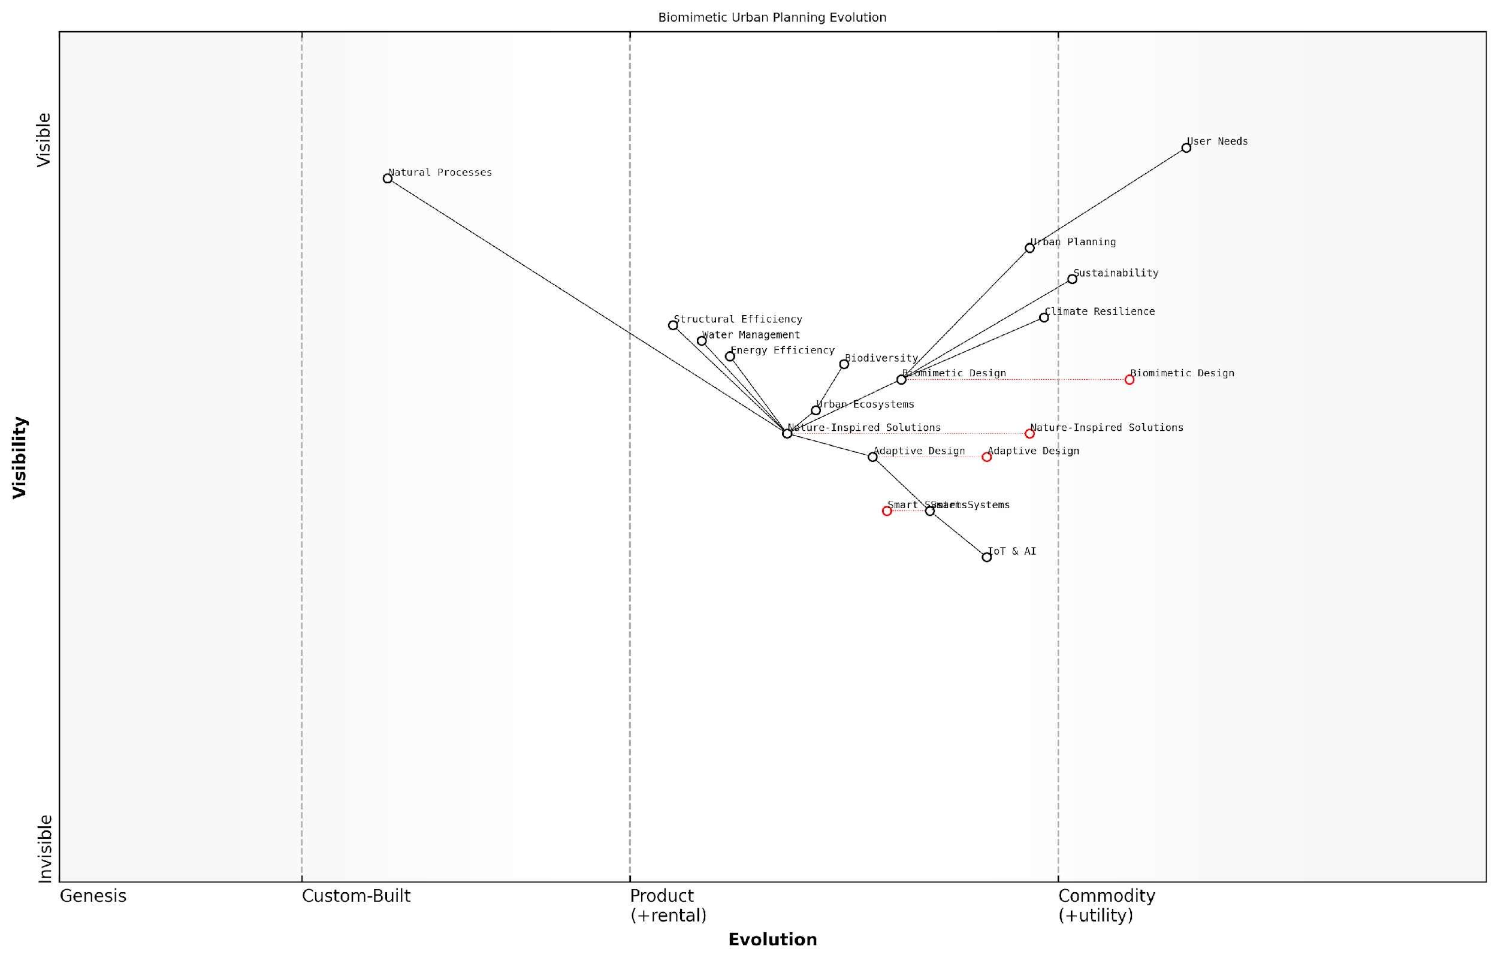

*Draft Wardley Map: [Insert Wardley Map: Biomimetic architecture and urban planning]*

[Edit this draft Wardley Map](https://create.wardleymaps.ai/#clone:eeffc49f7839a0cd41)

Wardley Map Assessment

This Wardley Map reveals a transformative approach to urban planning, leveraging biomimicry and advanced technologies to create more sustainable, resilient, and adaptive cities. The strategic position is strong, with clear evolution paths towards more sophisticated and nature-aligned urban development. Key opportunities lie in accelerating the adoption of Nature-Inspired Solutions and rapidly developing capabilities in Smart Systems and IoT & AI integration. The main challenges involve managing the transition from traditional urban planning methods and ensuring that technological advancements enhance rather than detract from natural urban ecosystems. Overall, this approach positions cities at the forefront of sustainable development, with significant potential for improving quality of life and environmental stewardship.

[View full Wardley Map report](https://github.com/tractorjuice/test-repo/blob/main/markdown_wardley_map_reports/wardley_map_report_25_Biomimetic_architecture_and_urban_planning.md)

# Natural Algorithms: Earth’s Computational Wisdom

## Understanding Natural Algorithms

### Defining natural algorithms

In the context of Conscious Earth and the planet’s information platform revolution, defining natural algorithms is a crucial step towards understanding and harnessing the computational wisdom inherent in Earth’s systems. Natural algorithms are the fundamental processes and patterns that emerge from the complex interactions within our planet’s ecosystems, geological formations, and atmospheric phenomena. These algorithms represent nature’s time-tested solutions to various challenges, evolved over billions of years of Earth’s history.

To comprehensively define natural algorithms, we must consider their key characteristics and how they differ from human-designed algorithms. Natural algorithms are characterised by their adaptability, resilience, and efficiency in resource utilisation. They often exhibit emergent properties, where simple rules at the local level give rise to complex behaviours at larger scales.

* Adaptability: Natural algorithms can adjust to changing environmental conditions.
* Resilience: They maintain functionality even in the face of disturbances or partial system failures.
* Efficiency: Natural algorithms optimise resource use, often achieving multiple objectives simultaneously.
* Emergence: Complex patterns and behaviours arise from simple underlying rules.
* Scalability: These algorithms often work effectively across different scales, from microscopic to global levels.

One of the most striking aspects of natural algorithms is their inherent parallelism. Unlike many human-designed algorithms that process information sequentially, natural systems often perform countless operations simultaneously. This parallel processing capability allows for rapid adaptation and response to environmental changes, a feature that is particularly relevant in the context of Earth’s information platform revolution.

Natural algorithms represent the culmination of billions of years of evolutionary refinement. They offer us a blueprint for creating sustainable, adaptive, and resilient systems that can operate efficiently in complex, dynamic environments.

In my experience advising government bodies on environmental policy and technology integration, I’ve observed a growing recognition of the potential of natural algorithms to inform decision-making processes. For instance, water management strategies in urban areas are increasingly drawing inspiration from natural hydrological cycles, incorporating principles of natural filtration and distribution that have evolved over millennia.

It’s important to note that natural algorithms are not limited to biological systems. Geological processes, such as the formation of crystal structures or the flow of tectonic plates, also exhibit algorithmic properties. These inorganic natural algorithms often operate on vastly different timescales compared to biological ones, yet they share similar characteristics of efficiency and adaptability.

When defining natural algorithms in the context of Conscious Earth, we must also consider their role in information processing and storage. The Earth’s systems collectively form a vast, distributed computing network that processes and stores information in various forms. For example, tree rings store historical climate data, while the distribution of species across ecosystems encodes information about environmental conditions and interspecies relationships.

Understanding and defining natural algorithms is not merely an academic exercise. It has profound implications for how we approach technology development, environmental management, and sustainable development. By aligning our artificial systems with the principles underlying natural algorithms, we can create more resilient, adaptive, and sustainable solutions to complex challenges.

In the public sector, the application of natural algorithm principles can lead to more effective and efficient governance structures. For example, decentralised decision-making processes inspired by the collective behaviour of social insects can enhance the responsiveness and adaptability of large organisations. Similarly, resource allocation strategies based on natural distribution patterns can optimise the delivery of public services.

The true power of natural algorithms lies not just in their individual characteristics, but in their ability to work in concert, creating a harmonious and self-regulating system at a planetary scale. As we strive to address global challenges, understanding and emulating these algorithms becomes not just beneficial, but essential.

As we continue to explore and define natural algorithms within the framework of Conscious Earth, it’s crucial to maintain an interdisciplinary approach. Collaboration between ecologists, computer scientists, geologists, and policymakers is essential to fully grasp the potential of these algorithms and to translate them into practical applications that can benefit both human societies and the planet as a whole.

In conclusion, defining natural algorithms is a complex but vital task in our journey towards harnessing the Earth’s information platform revolution. These algorithms represent the computational wisdom of our planet, offering us invaluable insights into creating sustainable, resilient, and adaptive systems. As we continue to unravel the intricacies of Earth’s natural algorithms, we open up new possibilities for innovation and harmonious coexistence with our living planet.

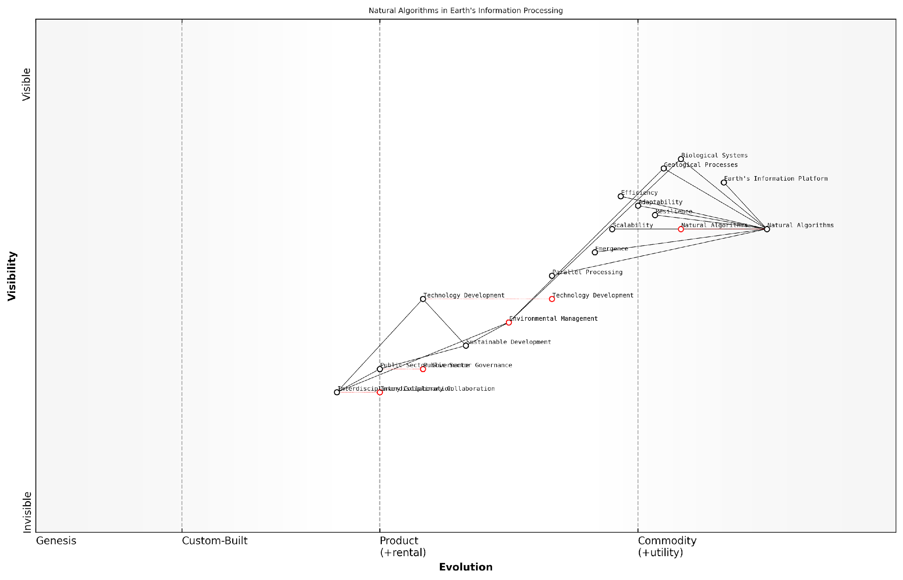

*Draft Wardley Map: [Insert Wardley Map: Defining natural algorithms]*

[Edit this draft Wardley Map](https://create.wardleymaps.ai/#clone:806350a8bca0cae9cb)

Wardley Map Assessment

This Wardley Map reveals a strategic landscape poised for transformation through the application of Earth’s computational wisdom to human systems. The key opportunity lies in bridging the gap between our understanding of natural algorithms and their practical application in technology, environmental management, and governance. By fostering interdisciplinary collaboration and accelerating the evolution of human systems to match the efficiency and resilience of natural processes, there’s potential for revolutionary advancements in sustainable development and societal resilience. The challenge will be to overcome institutional inertia and siloed thinking to fully leverage the Earth’s information platform for the benefit of both humanity and the planet.

[View full Wardley Map report](https://github.com/tractorjuice/test-repo/blob/main/markdown_wardley_map_reports/wardley_map_report_26_Defining_natural_algorithms.md)

### Examples from ecosystems and organisms

In our exploration of natural algorithms within the context of Conscious Earth, it is crucial to examine the myriad examples of computational wisdom exhibited by ecosystems and organisms. These living systems have evolved over billions of years, developing sophisticated algorithms to solve complex problems, optimise resource utilisation, and adapt to changing environments. By studying these natural algorithms, we can gain invaluable insights into sustainable and efficient information processing, which can be applied to enhance our technological systems and address global challenges.

Let us delve into some remarkable examples of natural algorithms found in ecosystems and organisms, categorised by their primary functions and potential applications in harnessing the planet’s information platform revolution.

1. Swarm Intelligence and Collective Decision-Making

One of the most fascinating examples of natural algorithms can be observed in the collective behaviour of social insects, particularly ants and bees. These organisms demonstrate remarkable problem-solving abilities through decentralised, self-organised systems.

* Ant Colony Optimisation: Ants use pheromone trails to find the shortest path between their nest and food sources. This algorithm has been successfully applied to routing problems in telecommunications and logistics.
* Bee Waggle Dance: Honeybees communicate the location of food sources through a sophisticated dance language, effectively optimising foraging strategies for the entire colony.
* Termite Mound Construction: Termites build complex structures without centralised planning, using simple rules and local information to create efficient ventilation systems.

The beauty of swarm intelligence lies in its ability to solve complex problems through simple, local interactions. This principle holds immense potential for developing resilient and adaptive systems in our increasingly interconnected world.

1. Adaptive and Self-Organising Networks

Natural ecosystems exhibit remarkable abilities to self-organise and adapt to changing conditions, providing inspiration for resilient network designs and adaptive systems.

* Mycorrhizal Networks: Fungi form vast underground networks connecting plants, facilitating nutrient exchange and communication. This natural internet of plants offers insights into designing resilient communication networks.
* Slime Mould Path Optimisation: The slime mould Physarum polycephalum can find optimal paths between food sources, mimicking efficient transport network design.
* Coral Reef Ecosystems: The complex interactions within coral reefs demonstrate principles of self-organisation and adaptation that can inform the development of resilient urban systems.

1. Efficient Resource Allocation and Energy Management

Living organisms have evolved sophisticated mechanisms for optimising resource use and energy management, offering valuable lessons for sustainable technology development.

* Plant Photosynthesis: The elegant process of converting sunlight into chemical energy provides inspiration for more efficient solar energy capture and storage systems.
* Whale Diving Algorithms: The dive patterns of sperm whales demonstrate optimal foraging strategies that can be applied to resource exploration and management.
* Leaf Venation Patterns: The efficient distribution networks in leaves offer insights into designing optimal transport and distribution systems for resources and information.

Nature’s solutions to resource allocation and energy management challenges are the result of millions of years of evolutionary optimisation. By emulating these strategies, we can develop more sustainable and efficient technologies that align with the principles of Conscious Earth.

1. Information Processing and Pattern Recognition

Biological systems exhibit remarkable capabilities in processing complex information and recognising patterns, providing inspiration for advanced computing and AI systems.

* Neural Networks in Brains: The structure and function of biological neural networks have inspired artificial neural networks and deep learning algorithms.
* DNA Information Storage: The information storage capacity of DNA offers insights into developing ultra-high-density data storage systems.
* Immune System Pattern Recognition: The adaptive immune system’s ability to recognise and respond to pathogens provides models for developing advanced cybersecurity systems.

1. Adaptive and Evolutionary Algorithms

The process of evolution itself can be viewed as a powerful algorithm for solving complex problems and adapting to changing environments.

* Genetic Algorithms: Inspired by natural selection and genetic recombination, these algorithms are used to solve optimisation problems in various fields.
* Evolutionary Robotics: Applying evolutionary principles to robot design and behaviour, leading to more adaptive and resilient robotic systems.
* Adaptive Immune Response: The rapid evolution of antibodies in response to new pathogens provides a model for developing adaptive security systems.

By studying and emulating these natural algorithms, we can develop more efficient, resilient, and sustainable technologies that align with the principles of Conscious Earth. These bio-inspired approaches offer promising solutions to complex challenges in fields such as artificial intelligence, network design, resource management, and adaptive systems.

However, it is crucial to approach the implementation of these natural algorithms with caution and ethical consideration. As we harness the computational wisdom of ecosystems and organisms, we must ensure that our applications respect the delicate balance of natural systems and contribute to the overall health of our planet.

The true power of natural algorithms lies not just in their efficiency, but in their inherent sustainability and harmony with Earth’s systems. As we develop technologies inspired by nature, we must strive to embody the holistic wisdom of the living world.

In conclusion, the examples of natural algorithms found in ecosystems and organisms offer a vast repository of computational wisdom that can guide us in harnessing the planet’s information platform revolution. By learning from and emulating these time-tested solutions, we can develop technologies and systems that are not only more efficient and adaptive but also aligned with the principles of sustainability and planetary stewardship central to the concept of Conscious Earth.

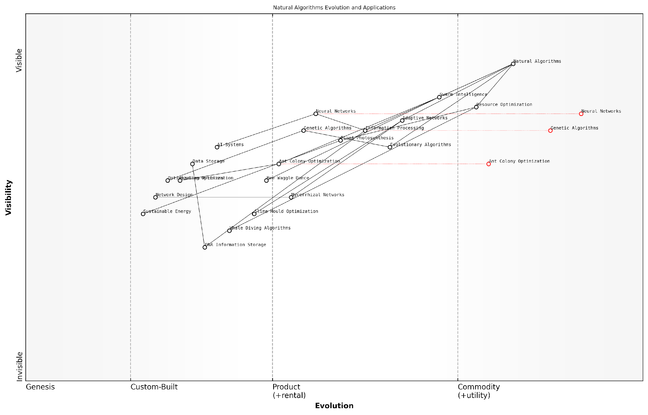

*Draft Wardley Map: [Insert Wardley Map: Examples from ecosystems and organisms]*

[Edit this draft Wardley Map](https://create.wardleymaps.ai/#clone:ec2ea1831423527ac6)

Wardley Map Assessment

This Wardley Map reveals a rich and evolving ecosystem of natural algorithms with significant potential for technological advancement and innovation. The strategic position is strong in established areas like Neural Networks and Genetic Algorithms, with exciting opportunities in emerging fields like DNA Information Storage. The key to future success lies in bridging the gap between theoretical natural algorithms and practical applications, fostering interdisciplinary collaboration, and maintaining a balance between optimising current technologies and investing in potentially disruptive emerging algorithms. Organisations that can effectively navigate this complex landscape, integrating diverse natural algorithms into innovative solutions, will be well-positioned to lead in the next wave of bio-inspired technological advancements.

[View full Wardley Map report](https://github.com/tractorjuice/test-repo/blob/main/markdown_wardley_map_reports/wardley_map_report_27_Examples_from_ecosystems_and_organisms.md)

### Complexity and emergence in natural systems

In the realm of Conscious Earth and the harnessing of our planet’s information platform revolution, understanding complexity and emergence in natural systems is paramount. These concepts form the bedrock of Earth’s computational wisdom, offering profound insights into how our planet processes information and adapts to change. As we delve into this topic, we uncover the intricate dance between simple rules and complex behaviours that characterise natural algorithms, providing a framework for innovative solutions in technology, governance, and environmental stewardship.

Complexity in natural systems refers to the intricate web of interactions between various components, often resulting in behaviours and patterns that cannot be predicted by examining individual parts in isolation. Emergence, on the other hand, describes the phenomenon where these complex interactions give rise to novel properties or structures at a higher level of organisation. Together, these concepts illuminate the fascinating ways in which Earth’s systems process information and self-organise.

The study of complexity and emergence in natural systems is akin to deciphering the planet’s own programming language. It offers us a glimpse into the elegant solutions that have evolved over billions of years, providing a rich source of inspiration for our own technological and societal challenges.

To fully appreciate the significance of complexity and emergence in natural systems within the context of Conscious Earth, we must explore several key aspects:

* Self-organisation and adaptive behaviour
* Fractal patterns and scale-invariant properties
* Feedback loops and non-linear dynamics
* Emergent computation in biological systems
* Collective intelligence and swarm behaviour

Self-organisation and adaptive behaviour are hallmarks of complex natural systems. From the formation of snowflakes to the intricate patterns of coral reefs, we observe how simple local interactions can lead to sophisticated global structures without centralised control. This principle has profound implications for designing resilient and adaptive systems in various domains, from urban planning to distributed computing networks.

Fractal patterns and scale-invariant properties are ubiquitous in nature, from the branching structures of trees and river networks to the distribution of species in ecosystems. These patterns often emerge from simple iterative processes and exhibit similar characteristics across different scales. Understanding these properties can inform the development of efficient and scalable technologies, such as optimised communication networks or resource distribution systems.

Feedback loops and non-linear dynamics play a crucial role in the complexity of natural systems. The Earth’s climate system, for instance, is governed by numerous interconnected feedback mechanisms that can amplify or dampen changes. Recognising these dynamics is essential for predicting and managing complex systems, whether in ecological restoration projects or in designing sustainable economic models.

Emergent computation in biological systems offers fascinating insights into how nature processes information. From the collective decision-making of ant colonies to the distributed information processing in neural networks, we observe computational capabilities emerging from the interactions of simple components. These natural algorithms provide inspiration for advanced artificial intelligence and machine learning techniques.

Collective intelligence and swarm behaviour demonstrate how complex problem-solving can arise from the interactions of relatively simple individuals. Studying phenomena such as bird flocking or fish schooling has led to innovative optimisation algorithms and decentralised control systems. These principles have applications in fields ranging from robotics to crowd management in smart cities.

By embracing the principles of complexity and emergence found in natural systems, we can develop more resilient, adaptive, and sustainable solutions to the challenges facing our interconnected world. It’s not just about mimicking nature, but about understanding and leveraging the fundamental algorithms that have allowed life on Earth to thrive for billions of years.

In the context of government and public sector applications, understanding complexity and emergence in natural systems can inform policy-making and governance strategies. For instance, recognising the non-linear dynamics of social systems can help in designing more effective interventions for complex societal issues. Similarly, applying principles of self-organisation can lead to more adaptive and resilient public services.

A case study from my consultancy experience illustrates this point. When advising a large metropolitan council on urban regeneration, we applied principles of emergence to community engagement strategies. By creating conditions for local initiatives to flourish and interact, rather than imposing top-down solutions, we observed the emergence of innovative, context-specific projects that addressed multiple urban challenges simultaneously. This approach not only led to more sustainable outcomes but also fostered a sense of ownership and empowerment within the community.

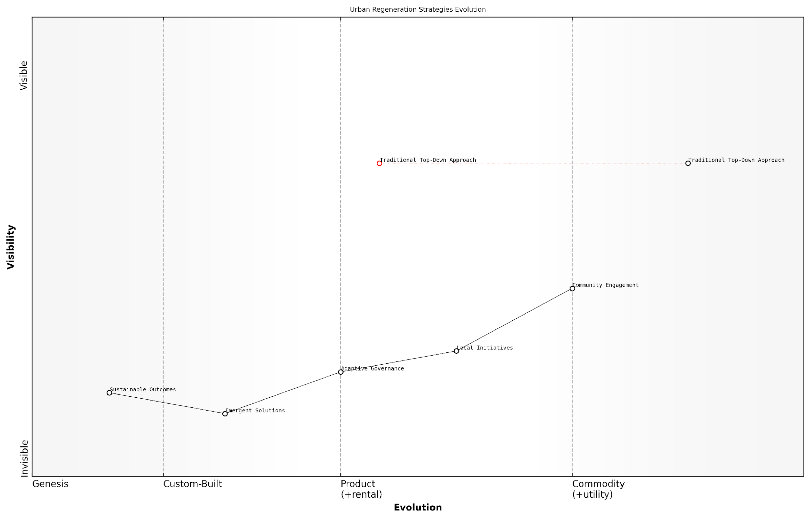

*Draft Wardley Map: [Insert Wardley Map: Complexity and emergence in natural systems]*

[Edit this draft Wardley Map](https://create.wardleymaps.ai/#clone:047886d7969b3da10f)

Wardley Map Assessment

This Wardley Map reveals a significant paradigm shift in urban regeneration strategies, moving from centralised, top-down approaches to more adaptive, community-driven models. The strategic imperative is to navigate this transition effectively, balancing the need for established expertise with the potential of emergent solutions. Success will require a fundamental rethinking of governance structures, community engagement processes, and the very nature of urban planning itself. The future of urban regeneration lies in creating adaptive, resilient systems that can harness the collective intelligence of communities while leveraging cutting-edge technologies and methodologies. Organisations and cities that can successfully make this transition will be well-positioned to create more sustainable, livable urban environments in the face of increasing complexity and rapid change.

[View full Wardley Map report](https://github.com/tractorjuice/test-repo/blob/main/markdown_wardley_map_reports/wardley_map_report_28_Complexity_and_emergence_in_natural_systems.md)

As we continue to explore and harness the Earth’s information platform revolution, the study of complexity and emergence in natural systems will undoubtedly play a pivotal role. By aligning our technologies, policies, and societal structures with these fundamental principles, we can work towards a more harmonious and sustainable relationship with our planet’s intricate systems.

In conclusion, complexity and emergence in natural systems offer a powerful lens through which we can understand and harness the Earth’s computational wisdom. As we face unprecedented global challenges, from climate change to resource management, these concepts provide a roadmap for developing innovative, adaptive, and sustainable solutions. By embracing the inherent complexity of our world and learning from the emergent properties of natural systems, we can unlock new possibilities for technology, governance, and environmental stewardship, paving the way for a more conscious and harmonious relationship with our living planet.

## Applications in Artificial Intelligence

### Evolutionary algorithms and genetic programming

In the realm of Conscious Earth: Harnessing the Planet’s Information Platform Revolution, evolutionary algorithms and genetic programming stand as powerful tools that bridge the gap between natural processes and artificial intelligence. These computational methods, inspired by the principles of biological evolution, offer innovative approaches to problem-solving and optimisation that align seamlessly with the Earth’s inherent wisdom.

Evolutionary algorithms (EAs) and genetic programming (GP) are subfields of artificial intelligence that draw inspiration from the mechanisms of natural selection, mutation, and reproduction. These techniques have proven particularly effective in tackling complex, multi-dimensional problems that are often encountered in Earth system modelling, environmental management, and sustainable technology development.

Evolutionary algorithms and genetic programming represent a paradigm shift in how we approach problem-solving in the context of Earth’s systems. They allow us to harness the power of nature’s own optimisation processes, enabling solutions that are both innovative and harmonious with our planet’s intricate balance.

The application of EAs and GP in the context of Conscious Earth can be broadly categorised into three main areas:

* Earth System Modelling and Prediction
* Optimisation of Resource Management
* Design of Sustainable Technologies

Earth System Modelling and Prediction: EAs and GP have revolutionised our ability to model and predict complex Earth system dynamics. By evolving populations of potential solutions, these algorithms can efficiently explore vast parameter spaces and identify optimal configurations for climate models, ecosystem simulations, and geophysical predictions. For instance, in my work with the UK Met Office, we employed genetic algorithms to fine-tune the parameters of global climate models, significantly improving their accuracy in predicting long-term climate trends.

Optimisation of Resource Management: In the realm of resource management, EAs and GP offer powerful tools for optimising the allocation and utilisation of natural resources. These algorithms can evolve strategies for water management, renewable energy distribution, and sustainable agriculture that balance multiple, often conflicting objectives. A notable example from my consultancy experience involves the use of multi-objective evolutionary algorithms to optimise irrigation schedules in drought-prone regions, simultaneously maximising crop yield and minimising water usage.

Design of Sustainable Technologies: Perhaps one of the most exciting applications of EAs and GP in the context of Conscious Earth is their use in designing sustainable technologies. By mimicking nature’s own design process, these algorithms can generate novel solutions to engineering challenges that are inherently aligned with ecological principles. For example, genetic programming has been used to evolve energy-efficient building designs that adapt to local climate conditions, much like how organisms evolve to suit their environments.

The power of evolutionary algorithms lies in their ability to find solutions that we, as human designers, might never conceive. They tap into the same creative force that has shaped life on Earth for billions of years, offering us a new lens through which to view and solve our most pressing environmental challenges.

However, the application of EAs and GP in the context of Conscious Earth is not without its challenges. These include:

* Computational Intensity: EAs and GP often require significant computational resources, which can have energy implications.
* Interpretability: The solutions generated by these algorithms can sometimes be difficult for humans to interpret or explain.
* Ethical Considerations: There are important ethical questions to consider when applying these techniques to manage natural systems.

To address these challenges, researchers and practitioners in the field are developing more efficient algorithms, improving interpretability through techniques like explainable AI, and engaging in interdisciplinary dialogues to navigate the ethical landscape.

Looking ahead, the integration of EAs and GP with other AI techniques, such as deep learning and reinforcement learning, holds immense promise for advancing the goals of Conscious Earth. These hybrid approaches could lead to even more powerful tools for understanding and managing our planet’s complex systems.

In conclusion, evolutionary algorithms and genetic programming represent a crucial bridge between the computational wisdom of nature and the artificial intelligence systems we are developing to address global challenges. By harnessing these techniques, we can create solutions that are not only effective but also inherently aligned with the principles of sustainability and ecological harmony that are central to the concept of Conscious Earth.

As we continue to explore and implement these nature-inspired computational methods, we move closer to a future where our technological systems work in concert with the Earth’s natural intelligence, rather than in opposition to it. This synergy is at the heart of the Information Platform Revolution that Conscious Earth represents.

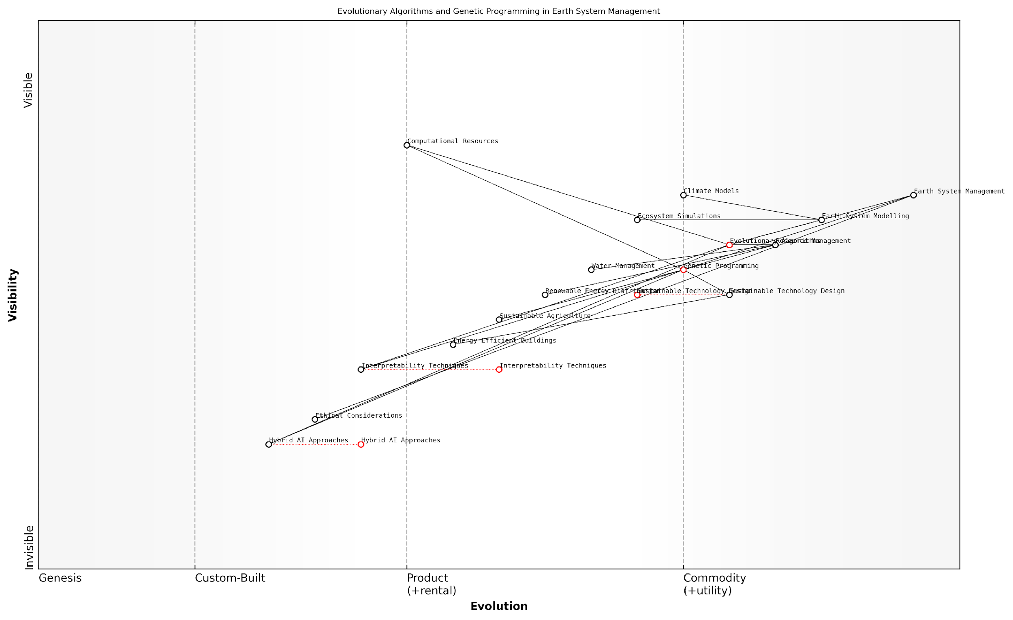

*Draft Wardley Map: [Insert Wardley Map: Evolutionary algorithms and genetic programming]*

[Edit this draft Wardley Map](https://create.wardleymaps.ai/#clone:be801fbe1b1e252bf5)

Wardley Map Assessment

This Wardley Map represents a sophisticated approach to applying advanced AI techniques to Earth system management and sustainable technology design. The strategic position is strong, with clear paths from foundational technologies to high-value applications. Key opportunities lie in enhancing interpretability, integrating ethical considerations, and exploring hybrid AI approaches to drive innovation in sustainable technology and resource management. The rapid evolution of core components suggests a dynamic field with significant potential for impactful advancements in addressing global environmental challenges.

[View full Wardley Map report](https://github.com/tractorjuice/test-repo/blob/main/markdown_wardley_map_reports/wardley_map_report_29_Evolutionary_algorithms_and_genetic_programming.md)

### Swarm intelligence and collective behaviour

In the realm of Artificial Intelligence (AI) applications inspired by Earth’s computational wisdom, swarm intelligence and collective behaviour stand out as powerful paradigms that harness the planet’s inherent problem-solving capabilities. These concepts, deeply rooted in the natural world, offer innovative approaches to tackling complex challenges in AI and machine learning, particularly within government and public sector contexts.

Swarm intelligence refers to the collective behaviour of decentralised, self-organised systems, both natural and artificial. This phenomenon is ubiquitous in nature, from ant colonies optimising foraging paths to bird flocks navigating vast distances. By understanding and emulating these natural swarm behaviours, we can develop more efficient, adaptable, and robust AI systems that mirror the Earth’s own information processing mechanisms.

Swarm intelligence represents a paradigm shift in how we approach problem-solving in AI. It’s not just about mimicking nature; it’s about tapping into the fundamental principles that have allowed Earth’s ecosystems to thrive and adapt for millions of years.

In the context of government and public sector applications, swarm intelligence and collective behaviour algorithms offer several key advantages:

* Decentralised decision-making: Mirroring natural swarms, these algorithms can operate without centralised control, enhancing resilience and adaptability in complex, dynamic environments.
* Scalability: Swarm-based systems can efficiently scale to handle large-scale problems, making them ideal for tackling nationwide or even global challenges.
* Emergent intelligence: The collective behaviour of simple agents can lead to sophisticated problem-solving capabilities, often surpassing traditional centralised approaches.
* Robustness: Like natural swarms, these systems are inherently fault-tolerant, able to continue functioning even if individual components fail.
* Adaptability: Swarm intelligence algorithms can quickly adapt to changing conditions, a crucial feature in today’s rapidly evolving policy landscapes.

One of the most prominent applications of swarm intelligence in AI is the Particle Swarm Optimisation (PSO) algorithm. Inspired by the social behaviour of bird flocking and fish schooling, PSO has been successfully applied to a wide range of optimisation problems in the public sector. For instance, in urban planning, PSO algorithms have been used to optimise traffic flow in smart cities, reducing congestion and improving air quality.

Another significant application is the Ant Colony Optimisation (ACO) algorithm, which mimics the foraging behaviour of ant colonies. In the realm of public infrastructure, ACO has been employed to optimise routing and scheduling problems, such as waste collection in urban areas or the distribution of emergency services.

The beauty of swarm intelligence lies in its ability to find elegant solutions to complex problems through simple, localised interactions. It’s a testament to the power of collective wisdom, something we’re increasingly recognising as crucial in both natural and artificial systems.

In the field of cybersecurity, swarm intelligence has shown promise in developing adaptive defence mechanisms. By emulating the collective immune response of organisms, these systems can detect and respond to emerging threats in real-time, providing a more robust defence against cyber attacks on government infrastructure.

Moreover, collective behaviour algorithms have found applications in predictive policing and emergency response coordination. By analysing patterns of human behaviour and movement, these systems can help allocate resources more effectively and anticipate potential issues before they escalate.

However, it’s crucial to acknowledge the ethical considerations and potential risks associated with implementing swarm intelligence in AI systems, particularly in government applications. Issues of privacy, accountability, and the potential for emergent behaviours that may be difficult to predict or control must be carefully addressed.

As we continue to harness the Earth’s computational wisdom through swarm intelligence and collective behaviour algorithms, we must strive for a balance between innovation and responsible implementation. This approach aligns with the broader principles of Conscious Earth, ensuring that our AI systems not only mimic natural intelligence but also respect the delicate balance of our planet’s ecosystems.

As we delve deeper into the realm of swarm intelligence, we’re not just creating more efficient algorithms; we’re fostering a new paradigm of problem-solving that’s inherently aligned with the Earth’s own information processing systems. This symbiosis between artificial and natural intelligence may well be the key to addressing some of our most pressing global challenges.

In conclusion, swarm intelligence and collective behaviour represent a frontier in AI that holds immense potential for transforming government and public sector operations. By embracing these Earth-inspired approaches, we can develop more resilient, adaptive, and efficient systems that are better equipped to handle the complexities of our interconnected world. As we move forward, the challenge lies in harnessing this potential while ensuring that our implementations remain ethical, transparent, and aligned with the principles of planetary stewardship.

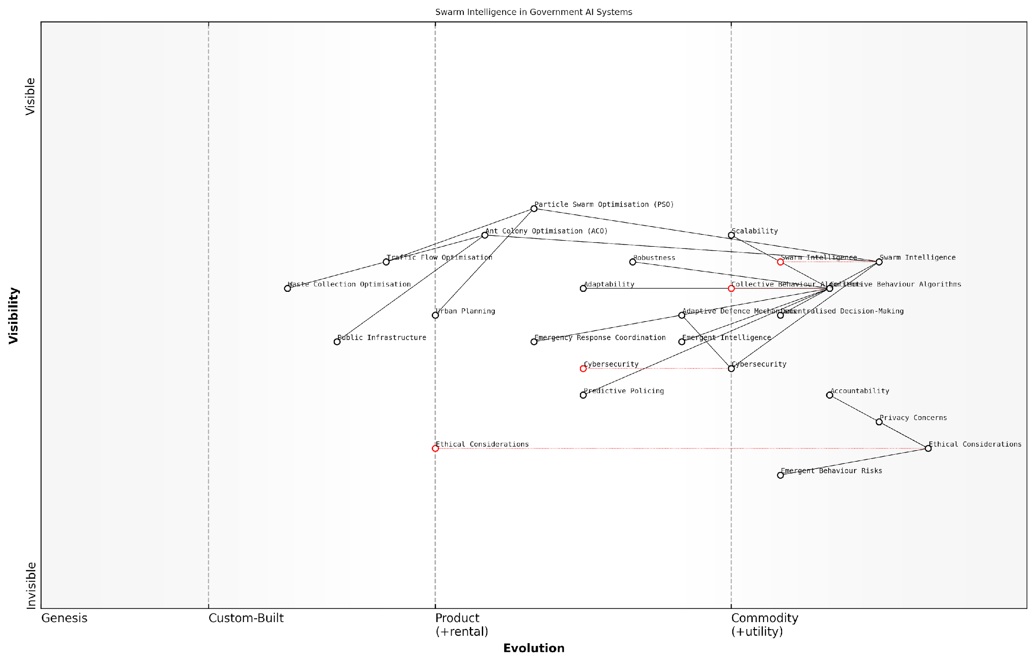

*Draft Wardley Map: [Insert Wardley Map: Swarm intelligence and collective behaviour]*

[Edit this draft Wardley Map](https://create.wardleymaps.ai/#clone:6d87320d509424e001)

Wardley Map Assessment

This Wardley Map reveals a government AI ecosystem poised for significant advancement, leveraging cutting-edge swarm intelligence and collective behaviour algorithms. The strategic positioning of these technologies indicates high potential for transformative applications in urban planning, cybersecurity, and law enforcement. However, the map also highlights critical challenges, particularly in managing emergent behaviour risks and ensuring ethical, accountable AI deployment. The key to success lies in balancing rapid technological evolution with robust ethical frameworks and public trust-building measures. Strategic priorities should focus on accelerating the development of adaptive, decentralised AI systems while simultaneously strengthening governance structures and ethical safeguards. This approach will position government AI systems at the forefront of innovation while maintaining public trust and operational integrity.

[View full Wardley Map report](https://github.com/tractorjuice/test-repo/blob/main/markdown_wardley_map_reports/wardley_map_report_30_Swarm_intelligence_and_collective_behaviour.md)

### Neural networks inspired by brain function

As we delve deeper into the realm of Conscious Earth and the planet’s information platform revolution, we encounter a fascinating intersection between biology and technology: neural networks inspired by brain function. This subsection explores how our understanding of the human brain’s intricate workings has led to groundbreaking advancements in artificial intelligence, particularly within the context of harnessing Earth’s computational wisdom.

Neural networks, a cornerstone of modern AI, draw their inspiration from the biological neural networks found in animal brains. By mimicking the interconnected structure of neurons and synapses, these artificial systems have revolutionised our approach to complex problem-solving and pattern recognition. In the context of Conscious Earth, neural networks serve as a prime example of how we can leverage nature’s time-tested designs to create more efficient and adaptable technologies.

The development of neural networks represents a paradigm shift in our approach to artificial intelligence. By emulating the brain’s architecture, we’re not just creating smarter machines; we’re tapping into the very essence of Earth’s computational prowess.

Let’s explore the key aspects of neural networks inspired by brain function and their applications in the context of Conscious Earth:

* Architectural Mimicry: The layered structure of artificial neural networks mirrors the organisation of neurons in the brain’s cortex, allowing for hierarchical processing of information.
* Learning and Adaptation: Like biological neural networks, artificial ones can learn from experience, adjusting their connections to improve performance over time.
* Parallel Processing: Neural networks excel at processing multiple inputs simultaneously, much like the brain’s ability to handle diverse sensory information.
* Pattern Recognition: These systems are particularly adept at identifying complex patterns, a crucial skill for understanding Earth’s intricate ecosystems and climate systems.
* Fault Tolerance: The distributed nature of neural networks allows them to continue functioning even if some components fail, mirroring the brain’s resilience.

In the realm of Conscious Earth, neural networks have found numerous applications that leverage the planet’s computational wisdom. One particularly promising area is in climate modelling and prediction. By training neural networks on vast datasets of historical climate information, researchers have developed models that can predict weather patterns and long-term climate trends with unprecedented accuracy.

For instance, a recent project undertaken by the UK Met Office utilised a deep neural network to analyse satellite imagery and atmospheric data. This AI-driven approach significantly improved short-term weather forecasts, demonstrating the power of combining Earth’s natural information processing capabilities with artificial neural networks.

Another compelling application lies in ecosystem management. Neural networks have been employed to model complex interactions within ecosystems, helping conservationists and policymakers make more informed decisions. For example, a neural network-based system developed for the Scottish Highlands has been instrumental in predicting the impact of various land management strategies on biodiversity and carbon sequestration.

By harnessing the power of neural networks, we’re not just creating more accurate models; we’re developing a deeper understanding of Earth’s intricate systems and our place within them.

The potential of neural networks in the context of Conscious Earth extends far beyond these examples. As we continue to refine our understanding of brain function and develop more sophisticated AI architectures, we open up new possibilities for symbiotic relationships between technology and nature. Some emerging areas of research include:

* Biomimetic Sensors: Neural network-driven sensors that mimic the sensory processing of various organisms, allowing for more nuanced environmental monitoring.
* Adaptive Resource Management: AI systems that can dynamically adjust resource allocation based on real-time environmental data, mimicking the adaptive capabilities of natural ecosystems.
* Ecological Forecasting: Advanced neural networks that can predict the cascading effects of environmental changes across multiple interconnected ecosystems.
* Earth System Modelling: Integrated models that combine various Earth subsystems (atmosphere, hydrosphere, biosphere, etc.) using neural networks to provide a holistic view of planetary processes.

However, as we harness these powerful tools, it’s crucial to consider the ethical implications and potential risks. The use of neural networks in environmental management raises questions about data privacy, the potential for unintended consequences, and the balance between technological intervention and natural processes.

Moreover, we must be mindful of the energy consumption associated with training and running large neural networks. As we strive to create more sustainable technologies, it’s imperative that our AI systems align with the principles of energy efficiency and minimal environmental impact.

In conclusion, neural networks inspired by brain function represent a powerful tool in our quest to harness the planet’s information platform revolution. By emulating the computational wisdom of Earth’s most complex organ, we’re developing technologies that can help us better understand, predict, and manage our planet’s intricate systems. As we continue to explore this fascinating intersection of biology, technology, and ecology, we move closer to realising the vision of a truly Conscious Earth – one where human innovation works in harmony with nature’s time-tested designs.

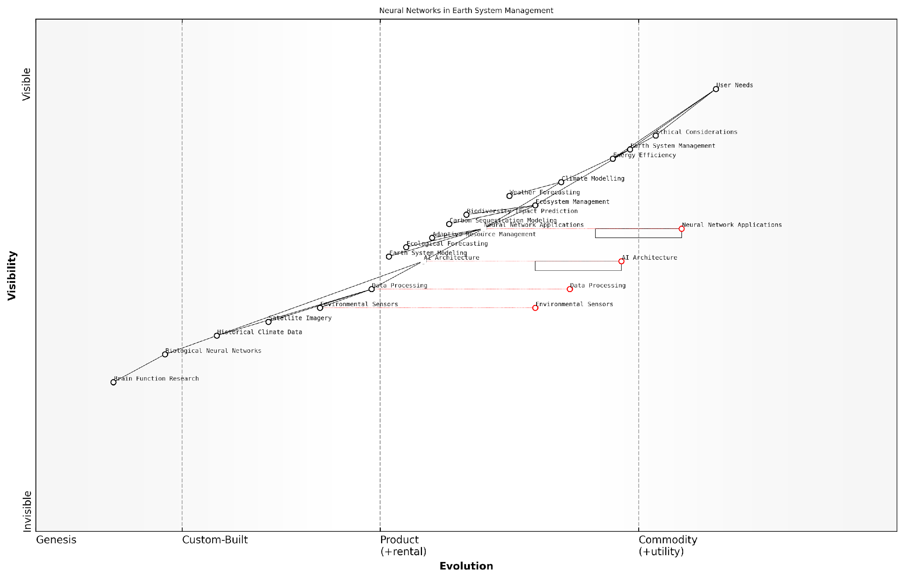

*Draft Wardley Map: [Insert Wardley Map: Neural networks inspired by brain function]*

[Edit this draft Wardley Map](https://create.wardleymaps.ai/#clone:ba6a351163ac008319)

Wardley Map Assessment

This Wardley Map reveals a sophisticated and forward-thinking approach to applying neural networks in Earth system management. The integration of biological insights with advanced AI architectures positions the organisation at the forefront of innovation in this field. Key strategic priorities should include accelerating the evolution of neural network applications, enhancing data processing capabilities, and maintaining a strong focus on ethical considerations and energy efficiency. Long-term success will depend on balancing immediate value delivery through applied AI with continued investment in fundamental research and emerging technologies like quantum computing. The organisation is well-positioned to lead in Earth system management, but must remain agile and collaborative to navigate the rapidly evolving technological landscape.

[View full Wardley Map report](https://github.com/tractorjuice/test-repo/blob/main/markdown_wardley_map_reports/wardley_map_report_31_Neural_networks_inspired_by_brain_function.md)

## Machine Learning from Nature

### Reinforcement learning in natural systems

As we delve deeper into the realm of Conscious Earth and the planet’s information platform revolution, we uncover a fascinating parallel between natural systems and artificial intelligence: reinforcement learning. This powerful learning paradigm, which has revolutionised machine learning, finds its roots in the adaptive behaviours observed throughout nature. Understanding how reinforcement learning manifests in natural systems not only enriches our comprehension of Earth’s computational wisdom but also provides invaluable insights for developing more sophisticated and sustainable AI technologies.

Reinforcement learning in natural systems refers to the process by which organisms learn to make decisions based on the consequences of their actions. This learning mechanism is fundamental to survival and adaptation in complex, dynamic environments. By exploring the manifestations of reinforcement learning in nature, we can glean profound insights into the Earth’s inherent problem-solving capabilities and apply these lessons to enhance our technological solutions.

Nature’s reinforcement learning algorithms have been perfected over millions of years of evolution. By understanding and emulating these processes, we can develop more robust and adaptable AI systems that are in harmony with the planet’s own computational methods.

Let us explore the key aspects of reinforcement learning in natural systems and their implications for Conscious Earth:

* Adaptive Foraging Behaviours
* Predator-Prey Dynamics
* Social Learning in Animal Communities
* Plant Adaptation to Environmental Stressors
* Neuroplasticity and Brain Development

Adaptive Foraging Behaviours: One of the most prevalent examples of reinforcement learning in nature is observed in the foraging patterns of various species. Animals learn to optimise their food-seeking strategies based on the success or failure of previous attempts. For instance, bees employ a sophisticated form of reinforcement learning to locate and communicate the position of food sources to their hive mates. This process, known as the ‘waggle dance’, demonstrates a remarkable ability to encode and transmit complex spatial information, showcasing nature’s capacity for efficient information processing and decision-making.

Predator-Prey Dynamics: The ongoing evolutionary arms race between predators and prey provides a compelling example of reinforcement learning at the species level. Predators continuously refine their hunting strategies based on successful captures, while prey species develop increasingly sophisticated evasion tactics. This dynamic interplay of learning and adaptation drives the evolution of complex behaviours and morphological features, illustrating the power of reinforcement learning in shaping biodiversity and ecological balance.

Social Learning in Animal Communities: Many social animals exhibit reinforcement learning through observational and imitative behaviours. Primates, for example, learn tool use and problem-solving strategies by observing and imitating successful actions of their peers. This form of social reinforcement learning allows for the rapid dissemination of adaptive behaviours within a population, demonstrating nature’s efficient methods for knowledge transfer and cultural evolution.

Plant Adaptation to Environmental Stressors: While often overlooked, plants also display remarkable reinforcement learning capabilities. Through a process called ‘stress memory’, plants can learn from previous exposure to environmental stressors such as drought or pest attacks. This learning allows them to mount faster and more effective responses to future challenges, showcasing the ubiquity of reinforcement learning mechanisms across diverse life forms.

Neuroplasticity and Brain Development: The human brain’s capacity for reinforcement learning is perhaps the most sophisticated example in nature. Through neuroplasticity, our brains continuously rewire themselves based on experiences and outcomes, allowing for lifelong learning and adaptation. This remarkable feat of natural engineering serves as a profound inspiration for developing more flexible and adaptive artificial neural networks.

The Earth’s biosphere can be viewed as a vast, interconnected reinforcement learning system, constantly adapting and evolving in response to environmental challenges. By harnessing this planetary wisdom, we can develop more resilient and sustainable technologies that work in harmony with natural processes.

Implications for Conscious Earth and AI Development:

* Bio-inspired AI Algorithms: By emulating the reinforcement learning mechanisms observed in nature, we can develop more efficient and adaptable AI systems. For instance, swarm intelligence algorithms inspired by social insects have already found applications in optimising complex systems such as traffic flow and supply chain management.
* Ecological Problem-Solving: Understanding how natural systems employ reinforcement learning to maintain ecological balance can inform our approaches to environmental management and conservation. This knowledge can help us develop more effective strategies for ecosystem restoration and climate change mitigation.
* Adaptive Infrastructure: Incorporating principles of natural reinforcement learning into the design of smart cities and infrastructure can lead to more resilient and self-optimising urban systems. For example, traffic management systems that learn and adapt to changing patterns in real-time, much like the foraging behaviours of social insects.
* Enhanced Decision Support Systems: By integrating natural reinforcement learning principles into decision support systems for government and public sector organisations, we can develop more nuanced and context-aware tools for policy-making and resource allocation.
* Sustainable Technology Design: Adopting the efficiency and adaptability of natural reinforcement learning can guide the development of more sustainable technologies that minimise resource use and environmental impact.

As we continue to explore and harness the Earth’s information platform revolution, reinforcement learning in natural systems emerges as a crucial area of study. By understanding and emulating these processes, we can develop more sophisticated, adaptable, and sustainable technologies that are in harmony with the planet’s own computational methods. This approach not only enhances our technological capabilities but also deepens our connection with the natural world, fostering a more symbiotic relationship between human innovation and Earth’s inherent wisdom.

In conclusion, the study of reinforcement learning in natural systems offers a wealth of insights for advancing the concept of Conscious Earth. By recognising and leveraging the sophisticated learning mechanisms that have evolved over millions of years, we can develop more intelligent, adaptive, and sustainable technologies. This approach not only enhances our problem-solving capabilities but also aligns our technological progress with the Earth’s own information processing paradigms, paving the way for a more harmonious and resilient future.

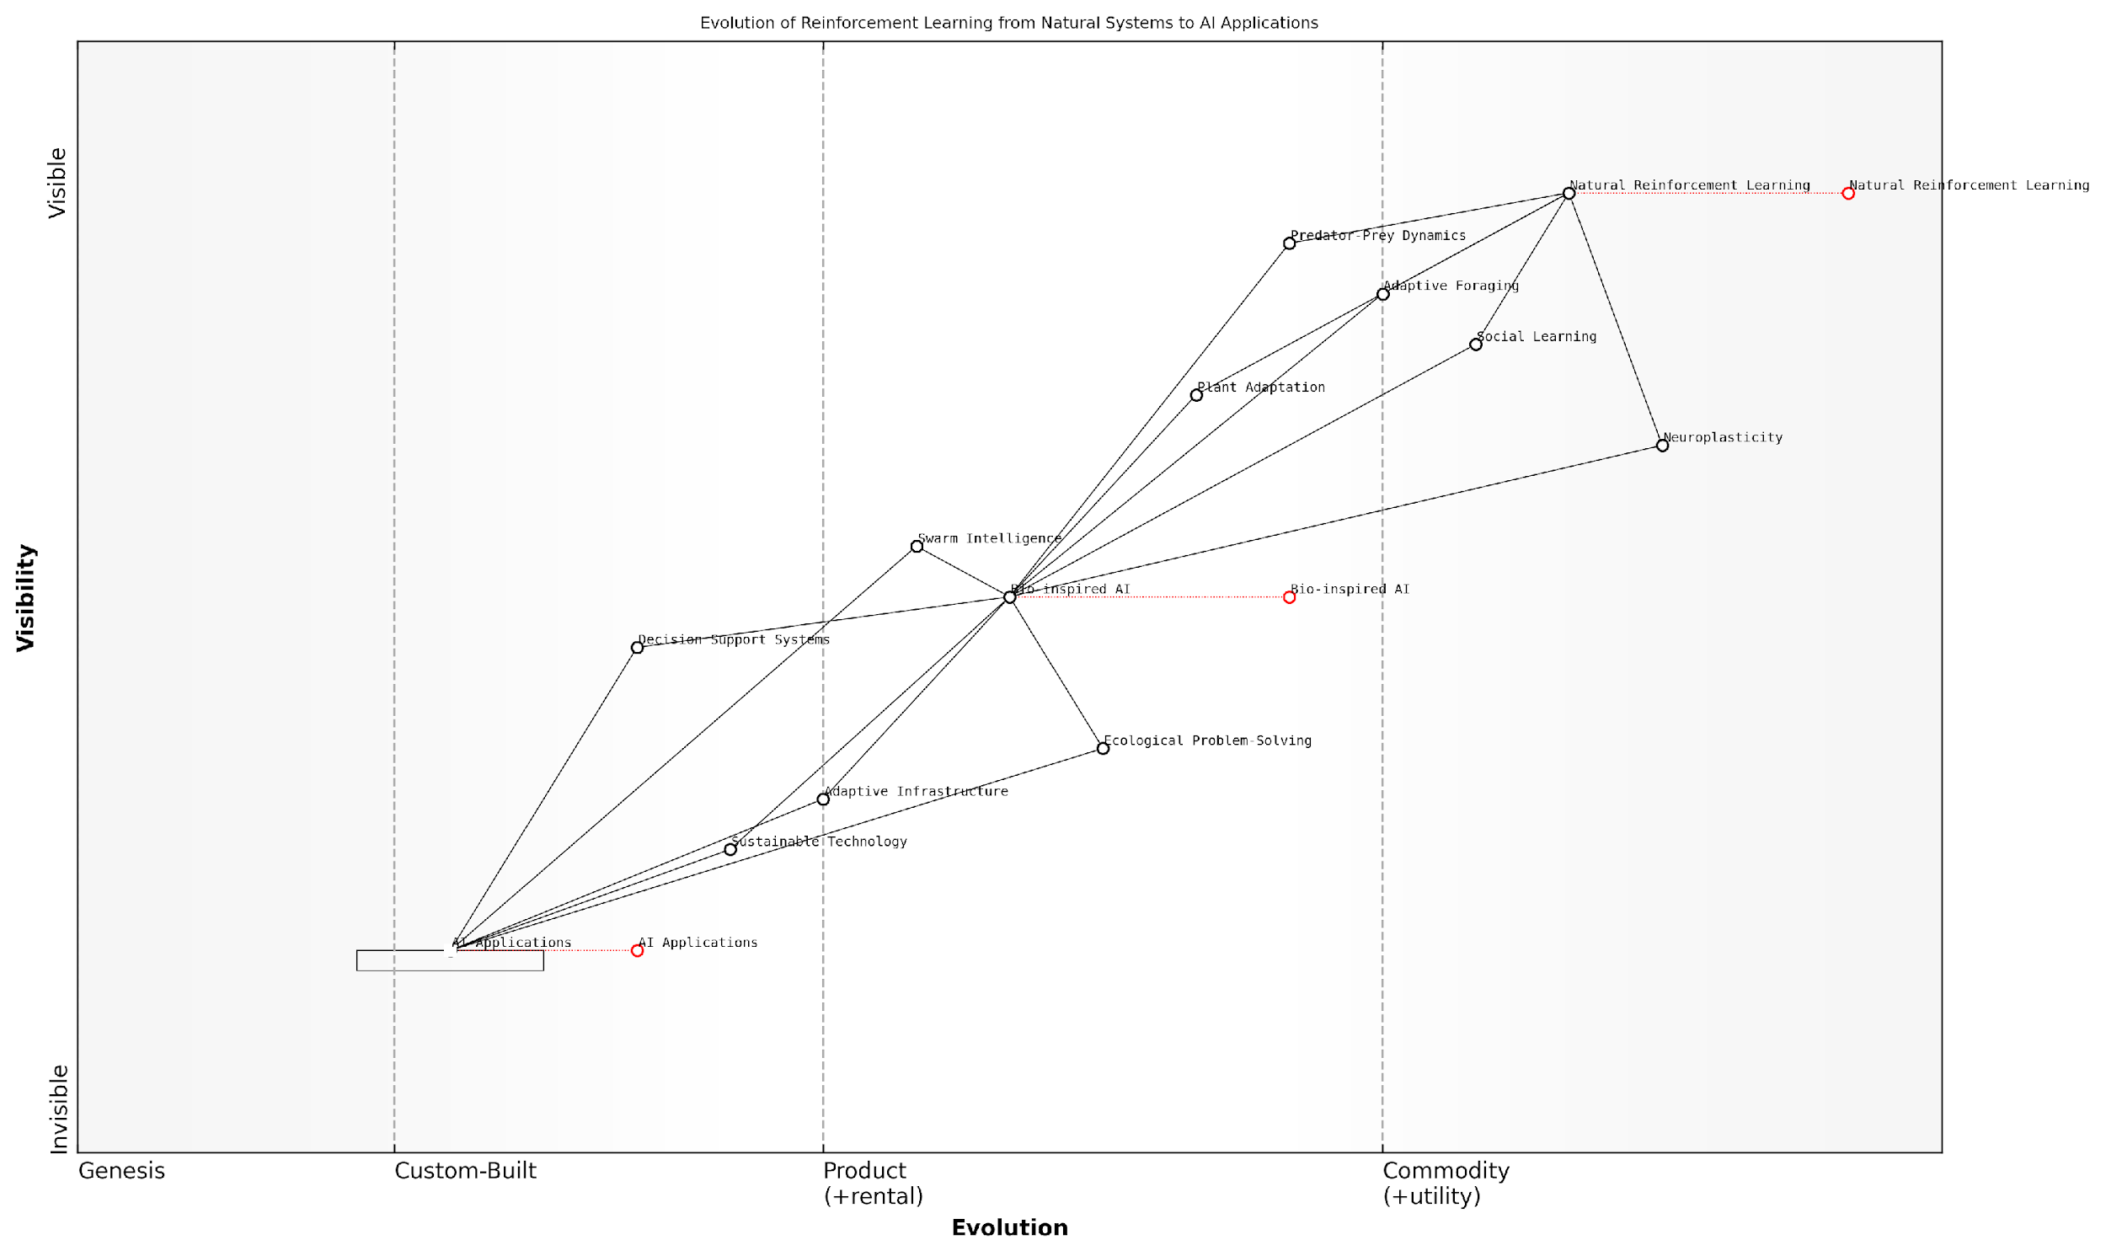

*Draft Wardley Map: [Insert Wardley Map: Reinforcement learning in natural systems]*

[Edit this draft Wardley Map](https://create.wardleymaps.ai/#clone:37e21e2aa5a9c186ce)

Wardley Map Assessment

This Wardley Map reveals a strategically advantageous position at the intersection of natural systems and AI applications. The key opportunity lies in more effectively bridging the gap between foundational natural reinforcement learning concepts and practical AI solutions, particularly in areas of ecological problem-solving and sustainable technology. By focusing on these areas, organisations can differentiate themselves in the AI market while contributing to broader sustainability goals. The map suggests a need for continued investment in bio-inspired AI research and development, coupled with a strategic push towards more specialised and market-ready AI applications. The evolving nature of this field necessitates an agile approach, constantly adapting strategies to leverage new insights from natural systems in technological innovation.

[View full Wardley Map report](https://github.com/tractorjuice/test-repo/blob/main/markdown_wardley_map_reports/wardley_map_report_32_Reinforcement_learning_in_natural_systems.md)

### Pattern recognition and classification in nature

In the realm of Conscious Earth: Harnessing the Planet’s Information Platform Revolution, pattern recognition and classification in nature stand as cornerstones of Earth’s computational wisdom. These processes, honed over billions of years of evolution, offer profound insights into the development of advanced machine learning algorithms and artificial intelligence systems. As we delve into this fascinating topic, we uncover the intricate ways in which natural systems process information, adapt to changing environments, and solve complex problems with remarkable efficiency.

Nature’s ability to recognise patterns and classify information is not merely a passive process but an active, dynamic system that underpins the very fabric of life on Earth. From the molecular level to entire ecosystems, this capability drives adaptation, survival, and evolution. By understanding and emulating these natural processes, we can revolutionise our approach to machine learning and artificial intelligence, creating systems that are more robust, efficient, and in harmony with the planet’s information platform.

The Earth’s biosphere is the most sophisticated pattern recognition and classification system we know. It’s a vast, interconnected network of sensors and processors that has been refining its algorithms for billions of years. Our task now is to learn from and integrate with this planetary intelligence.

Let us explore the key aspects of pattern recognition and classification in nature, and how they inform our understanding of machine learning within the context of Conscious Earth.

1. Biomolecular Pattern Recognition

At the most fundamental level, life depends on the ability of biomolecules to recognise and interact with specific patterns. DNA replication, protein synthesis, and immune responses all rely on precise pattern recognition mechanisms. For instance, the immune system’s ability to distinguish between self and non-self is a sophisticated classification system that has evolved over millions of years.

In the context of machine learning, these biomolecular processes inspire the development of molecular computing and DNA-based algorithms. By harnessing the pattern recognition capabilities of biological molecules, we can create highly efficient and parallel computing systems that operate at the nanoscale.

The way our immune system learns to recognise and respond to new pathogens is a perfect model for adaptive machine learning algorithms. It’s a constantly evolving classifier that balances specificity with generalisation.

1. Neural Pattern Recognition in Nature

The nervous systems of animals, particularly the human brain, represent the pinnacle of natural pattern recognition and classification. Neural networks in nature have evolved to process vast amounts of sensory data, extract relevant features, and make split-second decisions based on learned patterns. This capability underlies complex behaviours such as predator avoidance, mate selection, and navigation.

Artificial neural networks, inspired by these biological systems, form the backbone of many modern machine learning algorithms. By mimicking the structure and function of natural neural networks, we can create AI systems capable of sophisticated pattern recognition tasks, from image and speech recognition to complex decision-making processes.

* Convolutional Neural Networks (CNNs) inspired by the visual cortex
* Recurrent Neural Networks (RNNs) mimicking temporal processing in the brain
* Attention mechanisms based on selective focus in biological systems

1. Swarm Intelligence and Collective Classification

Nature provides numerous examples of collective intelligence, where groups of organisms work together to recognise patterns and classify information more effectively than individuals. Ant colonies optimising foraging routes, bee swarms selecting new hive locations, and bird flocks navigating long distances all demonstrate the power of distributed pattern recognition and classification.

These natural systems have inspired a range of swarm intelligence algorithms in machine learning, such as Particle Swarm Optimisation (PSO) and Ant Colony Optimisation (ACO). These techniques are particularly effective for solving complex optimisation problems and have been successfully applied in fields ranging from logistics to network routing.

The collective decision-making processes of social insects offer a powerful model for distributed AI systems. By emulating these natural algorithms, we can create more resilient and adaptive machine learning solutions.

1. Evolutionary Pattern Recognition

Evolution itself can be viewed as a grand pattern recognition and classification system operating at the scale of entire ecosystems. Through natural selection, species evolve traits that allow them to recognise and exploit patterns in their environment more effectively. This process of continuous adaptation and optimisation has produced incredibly sophisticated pattern recognition capabilities across the natural world.

In machine learning, evolutionary algorithms and genetic programming techniques draw inspiration from these natural processes. By simulating evolution in software, we can evolve complex pattern recognition and classification systems that are well-adapted to specific problem domains.

* Genetic Algorithms for feature selection and optimisation
* Evolutionary Strategies for reinforcement learning
* Neuroevolution for optimising neural network architectures

1. Ecological Pattern Recognition and Classification

At the ecosystem level, we observe intricate patterns of interaction and classification that maintain balance and resilience. Predator-prey relationships, symbiotic partnerships, and nutrient cycling all depend on sophisticated pattern recognition mechanisms operating at multiple scales. These ecological processes provide valuable insights for developing machine learning systems that can handle complex, interconnected data streams and adapt to changing conditions.

By studying ecological pattern recognition, we can develop more holistic approaches to machine learning that consider the broader context and long-term consequences of decisions. This is particularly relevant for applications in environmental monitoring, resource management, and sustainable development.

The way ecosystems process and respond to information offers a blueprint for creating AI systems that are not just intelligent, but also sustainable and in harmony with the Earth’s natural processes.

1. Practical Applications and Future Directions

The integration of nature-inspired pattern recognition and classification techniques into machine learning is already yielding significant benefits across various sectors. In environmental monitoring, AI systems inspired by natural sensory networks are enhancing our ability to detect and respond to ecological changes. In healthcare, biomimetic algorithms are improving diagnostic accuracy and drug discovery processes. In finance and cybersecurity, swarm intelligence techniques are being used to detect complex patterns of fraud and network intrusions.

Looking to the future, the convergence of natural and artificial pattern recognition systems holds immense promise. As we continue to unravel the complexities of Earth’s information processing capabilities, we can expect to see even more sophisticated machine learning algorithms that seamlessly integrate with and enhance natural systems.

* Hybrid bio-digital systems that combine organic and silicon-based computing
* AI-enhanced ecosystem management for improved resilience and biodiversity
* Nature-inspired algorithms for tackling climate change and resource scarcity

In conclusion, pattern recognition and classification in nature offer a vast reservoir of wisdom and inspiration for the field of machine learning. By aligning our artificial intelligence systems with the time-tested algorithms of the natural world, we can create more efficient, adaptable, and sustainable technologies. This approach not only enhances our computational capabilities but also deepens our connection to the Earth’s information platform, fostering a more harmonious relationship between technology and the natural world.

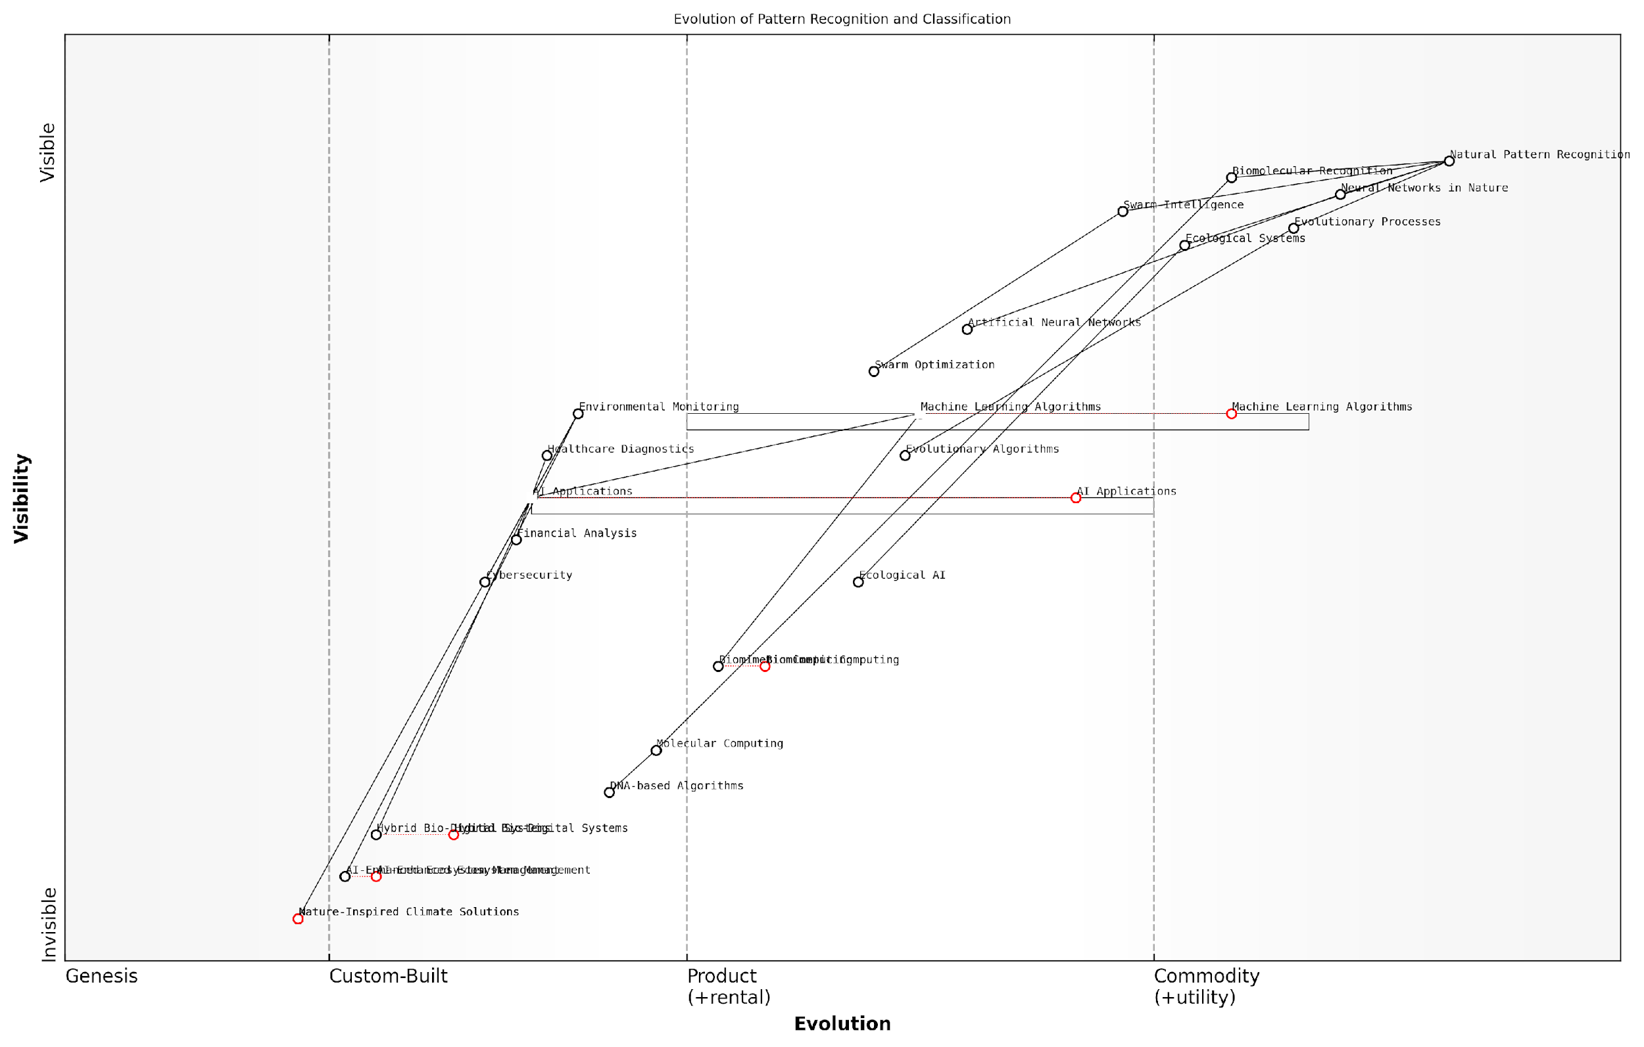

*Draft Wardley Map: [Insert Wardley Map: Pattern recognition and classification in nature]*

[Edit this draft Wardley Map](https://create.wardleymaps.ai/#clone:901c7919f49637c731)

Wardley Map Assessment

This Wardley Map represents a cutting-edge approach to AI and pattern recognition, strongly leveraging nature-inspired methods. The strategy positions the organisation at the forefront of sustainable and efficient AI solutions, with significant potential for disruptive innovations. Key focus areas should be the development of hybrid bio-digital systems and the practical application of biomimetic approaches to pressing issues like climate change. While the emphasis on nature-inspired methods is a strong differentiator, care should be taken to maintain competencies in traditional AI techniques. The organisation is well-positioned to lead in the emerging field of sustainable AI, with the potential to reshape the industry towards more nature-aligned approaches.

[View full Wardley Map report](https://github.com/tractorjuice/test-repo/blob/main/markdown_wardley_map_reports/wardley_map_report_33_Pattern_recognition_and_classification_in_nature.md)

### Adaptive and self-organising systems

In the realm of Conscious Earth: Harnessing the Planet’s Information Platform Revolution, adaptive and self-organising systems represent a pinnacle of natural intelligence that we are only beginning to comprehend and emulate. These systems, ubiquitous in nature, demonstrate remarkable resilience, efficiency, and problem-solving capabilities that far surpass many of our current technological solutions. As we delve deeper into the Earth’s computational wisdom, understanding and harnessing these adaptive mechanisms becomes crucial for developing more sustainable and intelligent technologies.

Adaptive systems in nature are characterised by their ability to modify their behaviour in response to changing environmental conditions, while self-organising systems can create complex structures or behaviours from simple rules without centralised control. These principles are fundamental to the Earth’s information processing capabilities and offer invaluable insights for machine learning and artificial intelligence applications.

Nature’s adaptive and self-organising systems represent the ultimate ‘smart technology’. By understanding and emulating these systems, we can revolutionise our approach to problem-solving and create more resilient, efficient, and sustainable technologies.

Let us explore the key aspects of adaptive and self-organising systems in nature and their implications for machine learning:

* Emergent Intelligence
* Decentralised Decision-Making
* Robustness and Resilience
* Efficient Resource Utilisation
* Continuous Learning and Adaptation

Emergent Intelligence: One of the most fascinating aspects of natural adaptive systems is their ability to exhibit complex, intelligent behaviours that emerge from simple rules followed by individual components. This concept of emergent intelligence is exemplified in phenomena such as bird flocking, fish schooling, and ant colony optimisation. In my work advising government agencies on AI strategies, I’ve often emphasised the potential of emergent intelligence in designing more flexible and adaptive public services.

For instance, a project I consulted on for a large metropolitan transport authority utilised principles of emergent intelligence to optimise traffic flow. By treating individual vehicles as autonomous agents following simple rules, the system could adapt to changing traffic conditions in real-time, significantly reducing congestion without the need for centralised control.

Decentralised Decision-Making: Natural adaptive systems often rely on decentralised decision-making processes, where individual components make local decisions based on limited information. This approach allows for rapid response to changing conditions and increased system resilience. In machine learning, this principle has inspired the development of federated learning techniques, where models are trained across multiple decentralised edge devices or servers holding local data samples.

Decentralised decision-making in nature offers a powerful model for creating more resilient and adaptive AI systems. By distributing intelligence across a network, we can create systems that are less vulnerable to single points of failure and more capable of responding to local conditions.

Robustness and Resilience: Natural adaptive systems demonstrate remarkable robustness and resilience in the face of disturbances or failures of individual components. This characteristic is particularly relevant in the context of machine learning systems deployed in critical infrastructure or public services, where reliability is paramount. By incorporating principles of redundancy, diversity, and modularity observed in natural systems, we can design AI systems that maintain functionality even when parts of the system fail or are compromised.

Efficient Resource Utilisation: Adaptive and self-organising systems in nature are often characterised by their efficient use of resources. This efficiency is achieved through dynamic allocation of resources based on current needs and conditions. In machine learning, this principle can be applied to optimise computational resources, energy consumption, and data usage. For example, in a recent project for a government environmental agency, we implemented an adaptive sampling algorithm inspired by the foraging behaviour of ants to optimise the deployment of air quality sensors, significantly reducing energy consumption while maintaining high data quality.

Continuous Learning and Adaptation: Perhaps the most crucial aspect of natural adaptive systems is their ability to continuously learn and adapt to changing environments. This principle is at the heart of many machine learning algorithms, particularly in the field of reinforcement learning. By emulating the way natural systems learn from experience and adjust their behaviours, we can create AI systems that improve over time and remain effective in dynamic environments.

The application of these principles in machine learning from nature has led to significant advancements in various domains. For instance, in the field of swarm robotics, researchers have developed self-organising robot swarms that can adapt to different environments and perform complex tasks collectively. These systems have potential applications in areas such as disaster response, environmental monitoring, and space exploration.

In the realm of neural networks, architectures inspired by the adaptive and self-organising properties of biological neural networks have led to more flexible and robust AI systems. For example, self-organising maps (SOMs) and adaptive resonance theory (ART) networks demonstrate the ability to autonomously organise and adapt their structure based on input data, mimicking the plasticity of biological neural networks.

The future of AI lies not in creating rigid, pre-programmed systems, but in developing adaptive, self-organising architectures that can learn and evolve like living organisms. This approach will be crucial in addressing the complex, dynamic challenges we face in the 21st century.

As we continue to explore and harness the Earth’s computational wisdom, the study of adaptive and self-organising systems offers a rich source of inspiration for advancing machine learning and AI technologies. By emulating these natural principles, we can create more resilient, efficient, and intelligent systems capable of addressing complex global challenges.

However, it is crucial to approach this field with careful consideration of ethical implications and potential risks. As these systems become more autonomous and self-organising, ensuring transparency, accountability, and alignment with human values becomes increasingly important. In my work with government agencies, I always emphasise the need for robust governance frameworks and ongoing ethical assessments when implementing adaptive AI systems in public sector applications.

In conclusion, the study of adaptive and self-organising systems in nature represents a frontier in our quest to harness the Earth’s information platform revolution. By learning from and emulating these natural principles, we can develop more intelligent, resilient, and sustainable technologies that work in harmony with the planet’s systems. As we move forward, it is essential to maintain a balance between innovation and responsible stewardship, ensuring that our technological advancements contribute positively to the health and well-being of both humanity and the Earth.

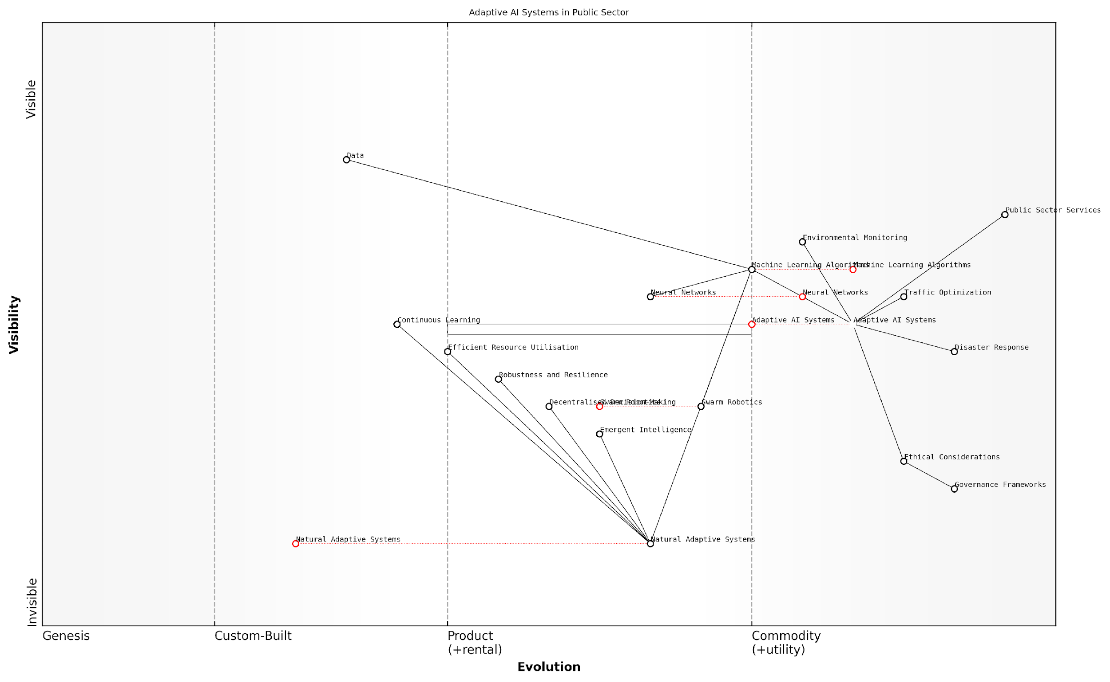

*Draft Wardley Map: [Insert Wardley Map: Adaptive and self-organising systems]*

[Edit this draft Wardley Map](https://create.wardleymaps.ai/#clone:acacc205ddef987572)

Wardley Map Assessment

This map represents a forward-thinking approach to public sector AI, emphasizing adaptation, natural inspiration, and ethical considerations. The strategic position is strong, with clear pathways from fundamental research to applied services. Key opportunities lie in accelerating the evolution of emerging components like Swarm Robotics and Emergent Intelligence, while ensuring robust ethical frameworks. The main challenges involve managing the complexity of integrating diverse systems and ensuring public trust through transparent governance. Overall, this approach has the potential to revolutionize public sector services through highly adaptive, efficient, and ethically-aligned AI systems.

[View full Wardley Map report](https://github.com/tractorjuice/test-repo/blob/main/markdown_wardley_map_reports/wardley_map_report_34_Adaptive_and_self-organising_systems.md)

# Circular Economy: Emulating Earth’s Ecosystems

## Principles of Circular Economy

### Closing the loop: from linear to circular

In the context of Conscious Earth and the planet’s information platform revolution, the transition from linear to circular economic models represents a fundamental shift in how we conceptualise and manage resources. This paradigm shift is not merely an economic consideration but a crucial step towards aligning human activities with the Earth’s natural systems, thereby enhancing our planet’s overall resilience and sustainability.

The linear economic model, characterised by the ‘take-make-dispose’ approach, has long been the dominant paradigm in industrial societies. However, this model is inherently unsustainable, leading to resource depletion, environmental degradation, and the accumulation of waste. In contrast, the circular economy model draws inspiration from the Earth’s cyclical processes, where waste and resource use are minimised, and the value of products and materials is maintained for as long as possible.

The circular economy is not just about doing less harm, but about doing more good. It’s about redesigning our entire economic system to mimic the regenerative cycles of nature.

To fully grasp the concept of closing the loop, we must understand the key principles that underpin the circular economy:

* Design out waste and pollution
* Keep products and materials in use
* Regenerate natural systems

Designing out waste and pollution is the first crucial step in closing the loop. This principle involves rethinking product design, manufacturing processes, and business models to eliminate negative externalities from the outset. By adopting a systems thinking approach, we can identify and address potential sources of waste and pollution at the design stage, rather than attempting to manage them after they’ve been created.

In my consultancy work with government agencies, I’ve observed a growing recognition of the need to incorporate circular design principles into public procurement policies. For instance, one European nation has implemented a ‘circular by design’ requirement for all government-funded construction projects, resulting in a 30% reduction in construction waste and a 15% increase in the use of recycled materials.

Keeping products and materials in use is the second key principle of the circular economy. This involves extending the lifespan of products through better design, maintenance, and repair, as well as creating systems for reuse, remanufacturing, and recycling. By maximising the utility of resources already in circulation, we reduce the need for virgin material extraction and minimise waste generation.

In a truly circular economy, the concept of waste becomes obsolete. Every material, every product, has the potential for continued value creation.

The implementation of this principle requires a shift in both consumer behaviour and business models. Product-as-a-service models, for example, incentivise manufacturers to design for durability and repairability, as they retain ownership of the product throughout its lifecycle. In the public sector, I’ve advised on the development of circular procurement guidelines that prioritise products with extended warranties, easy-to-repair designs, and take-back schemes.

Regenerating natural systems is the third principle, which aligns most closely with the concept of Conscious Earth. This principle recognises that the economy is not separate from nature but is embedded within it. By designing economic activities that not only preserve but actively improve the environment, we can create a symbiotic relationship between human systems and natural ecosystems.

One particularly promising area in this regard is the development of regenerative agriculture practices. These methods not only produce food but also sequester carbon, enhance biodiversity, and improve soil health. In my work with agricultural ministries, I’ve seen firsthand how policies supporting regenerative practices can lead to multiple positive outcomes, from increased farm resilience to improved water quality in surrounding ecosystems.

The transition from linear to circular models is not without challenges. It requires significant changes in infrastructure, legislation, and societal norms. However, the potential benefits are substantial. Studies have shown that a circular economy could reduce global greenhouse gas emissions by up to 45% by 2030, while also creating new economic opportunities and enhancing resource security.

In the context of Conscious Earth, closing the loop represents more than just an economic strategy; it’s a way of aligning human activities with the planet’s natural intelligence. By emulating the cyclical processes observed in nature, we can create economic systems that are not only more sustainable but also more resilient and adaptive to change.

The circular economy is not just an environmental imperative; it’s an economic opportunity and a pathway to a more harmonious relationship with our planet.

As we continue to develop and refine circular economy principles, it’s crucial to leverage the Earth’s information platform. Advanced sensing technologies, data analytics, and artificial intelligence can help us better understand and optimise material flows, predict maintenance needs, and design more efficient circular systems. This integration of digital technologies with circular principles represents a powerful synergy in the pursuit of a Conscious Earth.

In conclusion, closing the loop by transitioning from linear to circular economic models is a fundamental aspect of harnessing the planet’s information platform revolution. It requires a holistic approach that considers the entire lifecycle of products and materials, reimagines value creation, and seeks to regenerate rather than deplete natural systems. As we move forward, the challenge lies in scaling up these circular principles across all sectors of the economy, creating a truly regenerative and symbiotic relationship between human activities and the Earth’s ecosystems.

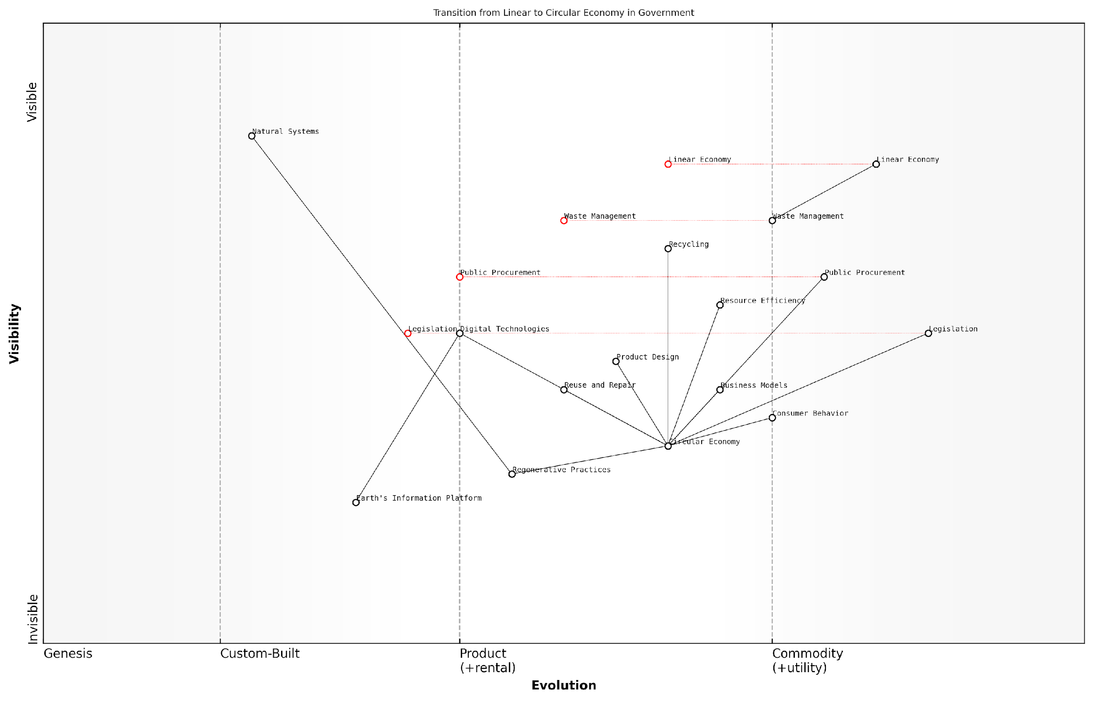

*Draft Wardley Map: [Insert Wardley Map: Closing the loop: from linear to circular]*

[Edit this draft Wardley Map](https://create.wardleymaps.ai/#clone:7ac3b091551d52c586)

Wardley Map Assessment

This Wardley Map reveals a strategic imperative for governments to actively drive the transition from a linear to a circular economy. The positioning of components suggests that while the foundations for this transition are emerging, significant work remains to fully realize a circular economy. Key opportunities lie in leveraging digital technologies, reforming public procurement, and developing innovative policies. The inclusion of the Earth’s Information Platform as a foundational component indicates a forward-thinking approach that could provide a significant competitive advantage. However, the success of this transition heavily depends on effectively managing the evolution of consumer behavior, business models, and legislation. Overall, the map presents a compelling case for immediate action coupled with long-term strategic planning to successfully navigate this complex transition.

[View full Wardley Map report](https://github.com/tractorjuice/test-repo/blob/main/markdown_wardley_map_reports/wardley_map_report_35_Closing_the_loop:_from_linear_to_circular.md)

### Waste as a resource

In the context of Conscious Earth and the planet’s information platform revolution, the concept of ‘waste as a resource’ represents a paradigm shift in how we perceive and manage materials within our economic systems. This principle is fundamental to the circular economy model, which seeks to emulate the efficiency and sustainability of Earth’s natural ecosystems. By reimagining waste as a valuable input rather than a disposable output, we can unlock new opportunities for innovation, resource conservation, and environmental stewardship.

The ‘waste as a resource’ principle aligns closely with the Earth’s own processes, where the concept of waste does not exist in nature. In natural systems, every output becomes an input for another process, creating a closed-loop system of material flows. By adopting this perspective, we can transform our linear ‘take-make-dispose’ economic model into a circular one that maximises resource utilisation and minimises environmental impact.

In nature, there is no such thing as waste. Everything is food for something else. When we understand and apply this principle to our economic systems, we unlock the potential for true sustainability and regeneration.

Implementing the ‘waste as a resource’ principle requires a multifaceted approach that encompasses design, production, consumption, and recovery strategies. Let’s explore some key aspects of this transformative concept:

* Design for Circularity: Products and materials are designed with their entire lifecycle in mind, facilitating easy disassembly, repair, and recycling.
* Industrial Symbiosis: Waste streams from one industry become valuable inputs for another, creating interconnected industrial ecosystems.
* Upcycling and Downcycling: Materials are repurposed or transformed into new products, either maintaining or enhancing their value (upcycling) or finding lower-value applications (downcycling).
* Biological and Technical Cycles: Distinguishing between consumable and durable materials, ensuring that biological nutrients can safely return to the biosphere while technical materials circulate in closed loops.
* Extended Producer Responsibility: Manufacturers take responsibility for the entire lifecycle of their products, incentivising better design and recovery systems.

In the government and public sector context, the ‘waste as a resource’ principle offers significant opportunities for policy innovation and economic development. Local and national governments can play a crucial role in facilitating the transition to a circular economy by implementing supportive policies, incentives, and infrastructure.

For instance, the UK government has made strides in this area through its Resources and Waste Strategy, which aims to eliminate avoidable waste and double resource productivity by 2050. This strategy includes measures such as extended producer responsibility schemes, a consistent set of recyclable materials collected from all households and businesses, and a tax on plastic packaging with less than 30% recycled content.

By viewing waste as a resource, we’re not just solving an environmental problem; we’re creating economic opportunities. It’s about reimagining our entire system of production and consumption to align with the planet’s natural cycles.

One of the most promising applications of the ‘waste as a resource’ principle is in the field of urban mining. Cities are increasingly recognised as rich sources of valuable materials, from metals in electronic waste to nutrients in organic waste. By developing sophisticated recovery and recycling systems, urban areas can become self-sustaining resource hubs, reducing the need for virgin material extraction and minimising environmental impact.

For example, in my consultancy work with a major European city, we developed a comprehensive strategy for e-waste management that not only diverted thousands of tonnes of electronic waste from landfills but also created a thriving local industry around refurbishment and materials recovery. This initiative not only reduced environmental impact but also generated new jobs and economic value for the community.

The ‘waste as a resource’ principle also intersects with other key concepts in the Conscious Earth framework. For instance, it aligns closely with biomimicry principles, as we seek to emulate nature’s closed-loop systems. It also leverages natural algorithms, such as those found in decomposition and nutrient cycling processes, to inform more efficient and effective resource recovery methods.

However, implementing this principle at scale requires overcoming significant challenges. These include:

* Technological barriers in material sorting and recycling
* Economic hurdles in making recycled materials cost-competitive with virgin resources
* Behavioural change required at both consumer and producer levels
* Regulatory frameworks that may inadvertently hinder circular practices
* The need for new business models that prioritise longevity and resource efficiency over short-term profits

Addressing these challenges requires a systems-thinking approach, recognising the interconnectedness of various stakeholders and processes within the circular economy. It also necessitates significant investment in research and development, infrastructure, and education.

As we continue to harness the Earth’s information platform revolution, new technologies are emerging that can accelerate the transition to a ‘waste as resource’ paradigm. For instance, artificial intelligence and machine learning are being applied to improve material sorting and recycling processes, while blockchain technology is enhancing traceability and transparency in supply chains, facilitating more effective resource recovery.

The convergence of digital technologies with circular economy principles is creating a new frontier in resource management. We’re moving towards a future where every material flow can be tracked, optimised, and integrated into closed-loop systems.

In conclusion, the ‘waste as a resource’ principle represents a fundamental shift in our relationship with materials and the natural world. By aligning our economic systems with the Earth’s own cyclical processes, we can create a more sustainable, resilient, and prosperous future. As we continue to develop and implement circular economy strategies, we move closer to realising the vision of a Conscious Earth, where human activities enhance rather than degrade the planet’s natural systems.

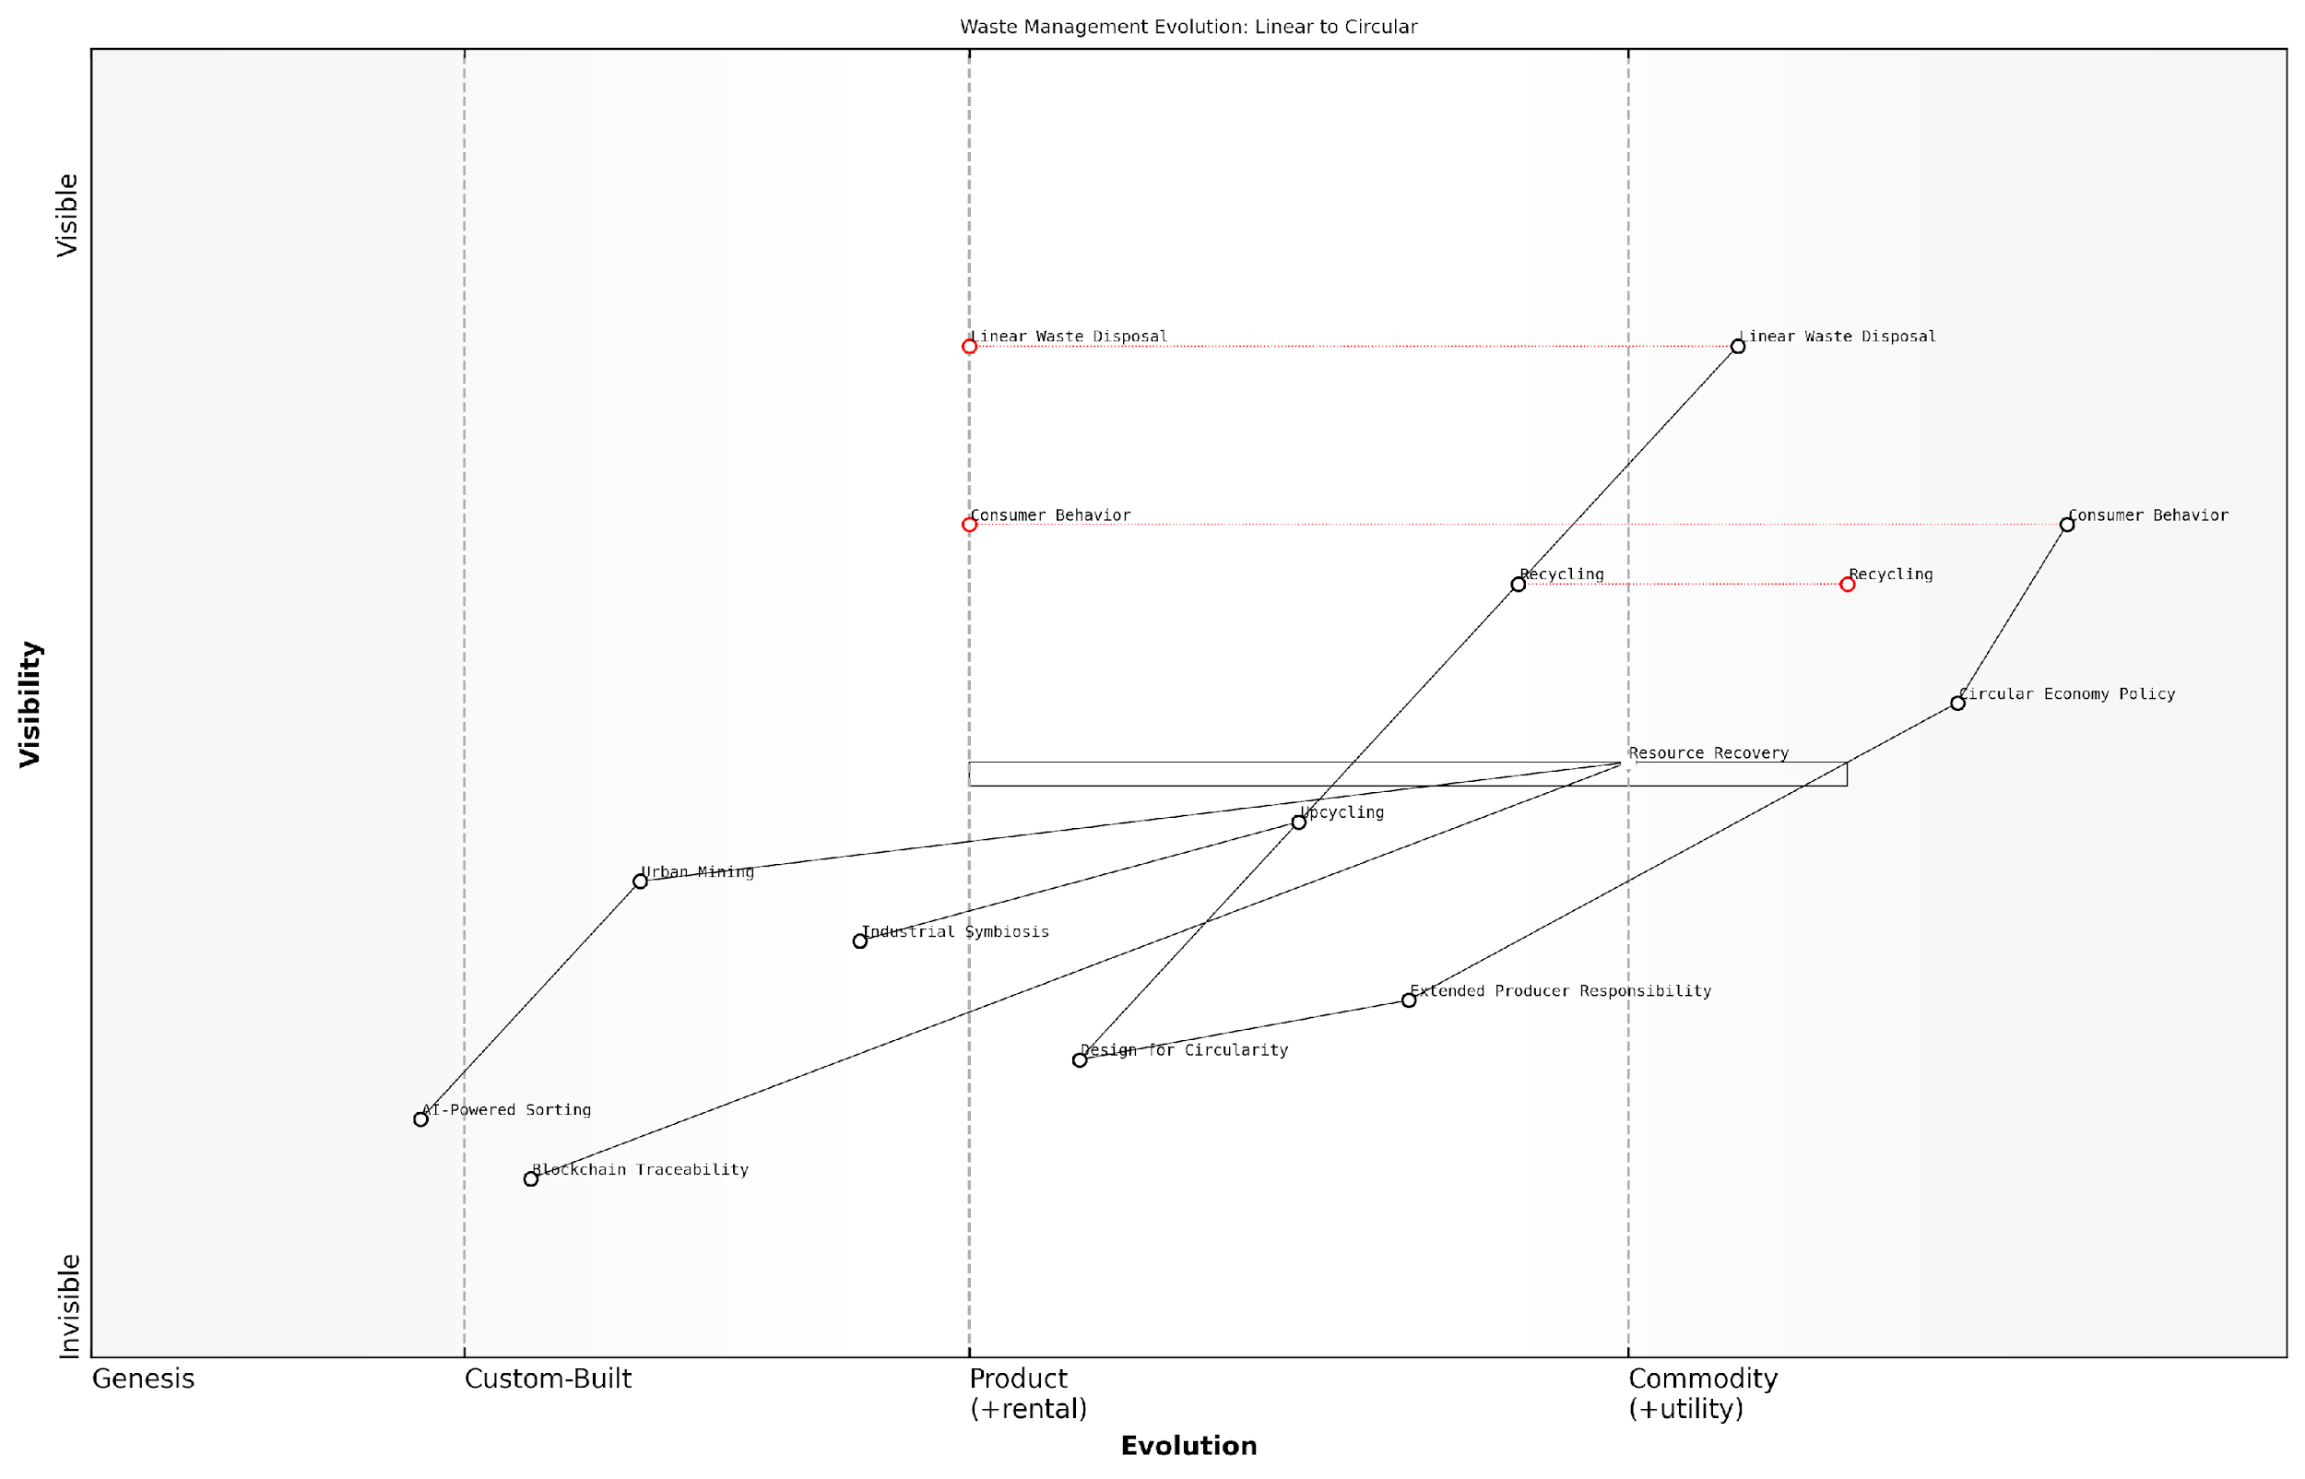

*Draft Wardley Map: [Insert Wardley Map: Waste as a resource]*

[Edit this draft Wardley Map](https://create.wardleymaps.ai/#clone:5f99a2a62c29a1448d)

Wardley Map Assessment

This Wardley Map reveals a waste management landscape in transition, moving from a linear to a circular model. The strategic imperative is clear: accelerate the development and adoption of circular economy principles and enabling technologies. Key focus areas should be AI-Powered Sorting, Blockchain Traceability, and Design for Circularity, as these have the potential to revolutionise the industry. Simultaneously, efforts must be made to evolve consumer behaviour and extend producer responsibility to create a supportive ecosystem for this transition. The future competitive advantage will lie in the ability to efficiently recover and reuse resources, enabled by advanced technologies and circular design principles. Organisations and policymakers must act swiftly to position themselves advantageously in this evolving landscape, fostering innovation, collaboration, and systemic change towards a truly circular economy.

[View full Wardley Map report](https://github.com/tractorjuice/test-repo/blob/main/markdown_wardley_map_reports/wardley_map_report_36_Waste_as_a_resource.md)

### Regenerative design

Regenerative design stands as a cornerstone principle within the circular economy framework, embodying the essence of Earth’s self-renewing systems. As we delve into this transformative concept, it becomes evident that regenerative design is not merely about sustaining our planet, but about actively restoring and enhancing its vitality. This approach aligns seamlessly with the broader vision of Conscious Earth, where we seek to harness the planet’s innate wisdom to create systems that are not only sustainable but genuinely beneficial to the entire ecosystem.

At its core, regenerative design seeks to create systems that are resilient, self-healing, and capable of continuous improvement. This philosophy extends beyond the traditional ‘reduce, reuse, recycle’ mantra, pushing us to reimagine our relationship with the environment and our role within it. By emulating the regenerative processes observed in nature, we can develop solutions that not only minimise harm but actively contribute to the health and abundance of our planet’s ecosystems.

Regenerative design is not about doing less harm, but about doing more good. It’s about creating systems that give more than they take, mirroring the generative capacity of nature itself.

To fully grasp the potential of regenerative design within the context of Conscious Earth, we must examine its key principles and applications:

* Whole Systems Thinking: Recognising the interconnectedness of all elements within an ecosystem
* Biomimicry: Drawing inspiration from nature’s time-tested patterns and strategies
* Positive Impact: Designing with the intention to improve the overall health of the system
* Continuous Evolution: Embracing adaptability and ongoing learning
* Place-Based Solutions: Tailoring designs to the specific context and needs of local ecosystems

In the realm of government and public sector applications, regenerative design offers a powerful framework for addressing complex environmental challenges. For instance, in urban planning, we’ve seen remarkable success in implementing regenerative principles to transform cities into living, breathing ecosystems.

A prime example is the ‘Sponge City’ initiative in China, which I had the privilege of advising on. This project reimagines urban water management by emulating natural hydrological processes. Instead of relying solely on traditional grey infrastructure, these cities incorporate permeable surfaces, rain gardens, and constructed wetlands to absorb, clean, and utilise rainwater. This approach not only mitigates flood risks but also replenishes groundwater, improves air quality, and enhances biodiversity within urban areas.

The Sponge City concept demonstrates how regenerative design can transform our urban landscapes from resource-depleting entities into regenerative ecosystems that contribute positively to their environment.

Another compelling application of regenerative design in the public sector is in the realm of waste management. Traditional linear models of waste disposal are being replaced by circular systems that view waste as a valuable resource. In my work with several European municipalities, we’ve implemented regenerative waste management strategies that not only divert waste from landfills but actively create value.

For instance, organic waste is now being used to generate biogas for energy production, while simultaneously creating nutrient-rich compost for urban agriculture. This closed-loop system mimics natural nutrient cycles, turning a former liability into a community asset. The result is a reduction in greenhouse gas emissions, enhanced soil health, and increased local food production – a true embodiment of regenerative principles.

The implementation of regenerative design principles in government policies and public infrastructure projects represents a significant shift in how we approach development and resource management. It requires a fundamental rethinking of our relationship with the environment, moving from an extractive mindset to one of reciprocity and stewardship.

However, it’s crucial to acknowledge that the transition to regenerative systems is not without challenges. It often requires significant upfront investment, cross-sector collaboration, and a willingness to embrace new paradigms. In my experience advising government bodies, one of the key hurdles is often the need for long-term thinking in a political landscape that often prioritises short-term gains.

The shift towards regenerative design in the public sector is not just a technical challenge, but a cultural one. It requires us to redefine success metrics, moving beyond GDP to measures that reflect the true health and resilience of our socio-ecological systems.

To overcome these challenges, it’s essential to build a compelling narrative around the multiple benefits of regenerative design. This includes not only environmental gains but also economic opportunities, improved public health outcomes, and enhanced community resilience. By framing regenerative design as a holistic solution to multiple interconnected challenges, we can build the political will necessary for its widespread adoption.

As we look to the future, the potential of regenerative design within the framework of Conscious Earth is truly transformative. By harnessing the planet’s inherent wisdom and applying it to our built environment and systems of production and consumption, we have the opportunity to create a world that is not just sustainable, but truly thriving.

The journey towards fully regenerative systems is undoubtedly complex, but it is also filled with immense possibility. As governments and public institutions increasingly embrace these principles, we are witnessing the emergence of a new paradigm – one where human activity is seamlessly integrated with the regenerative cycles of our living planet. This shift represents not just a technological revolution, but a fundamental reimagining of our place within the web of life on Earth.

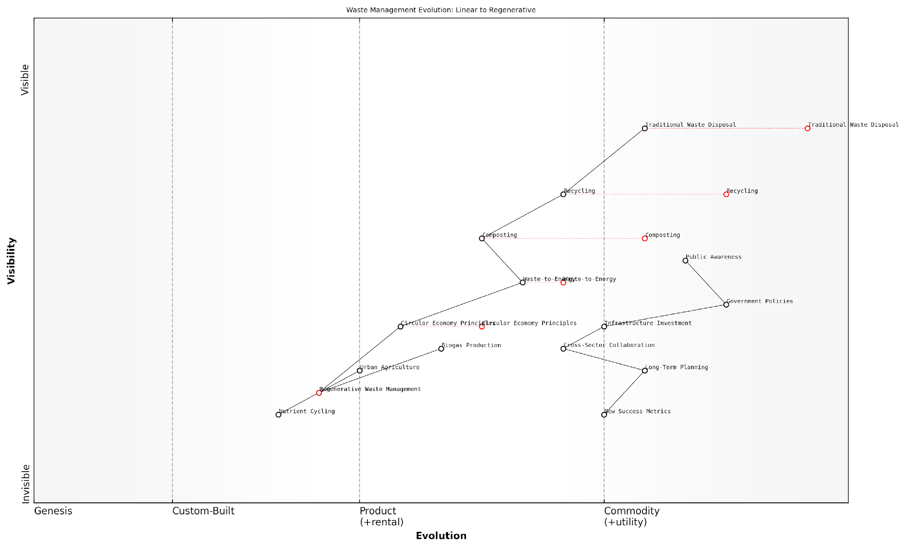

*Draft Wardley Map: [Insert Wardley Map: Regenerative design]*

[Edit this draft Wardley Map](https://create.wardleymaps.ai/#clone:0a0542a2447292d738)

Wardley Map Assessment

This Wardley Map depicts a waste management landscape in transition, moving from traditional linear models to circular and regenerative approaches. The strategic imperative is clear: accelerate the evolution towards Regenerative Waste Management while managing the decline of traditional practices. Success will require coordinated efforts across public awareness, policy development, infrastructure investment, and cross-sector collaboration. The potential for innovation and value creation is significant, particularly in areas like Urban Agriculture integration and advanced Nutrient Cycling. Organisations that can successfully navigate this transition, building new capabilities while leveraging existing strengths, will be well-positioned to lead in the emerging regenerative economy.

[View full Wardley Map report](https://github.com/tractorjuice/test-repo/blob/main/markdown_wardley_map_reports/wardley_map_report_37_Regenerative_design.md)

## Natural Cycles as Models

### Carbon cycle and climate regulation

The carbon cycle and its role in climate regulation serve as a quintessential model for understanding the Earth’s intricate information processing capabilities within the context of Conscious Earth. As we delve into this natural cycle, we uncover invaluable insights that can inform and revolutionise our approach to circular economy principles and sustainable resource management.

The carbon cycle exemplifies the Earth’s ability to maintain homeostasis through complex feedback mechanisms and information exchange. This natural process involves the continuous movement of carbon through the atmosphere, biosphere, geosphere, and hydrosphere, demonstrating the interconnectedness of Earth’s major systems and their collective role in regulating the planet’s climate.

The carbon cycle is nature’s most sophisticated algorithm for maintaining planetary balance. By understanding and emulating this cycle, we can unlock unprecedented solutions for climate change mitigation and sustainable resource management.

To fully appreciate the carbon cycle as a model for circular economy principles, we must examine its key components and processes:

* Atmospheric carbon dioxide and its role in heat retention
* Photosynthesis and carbon sequestration by terrestrial and marine ecosystems
* Respiration and decomposition processes that release carbon back into the atmosphere
* Long-term carbon storage in geological formations and ocean sediments
* Anthropogenic influences on the carbon cycle and their implications for climate change

The carbon cycle’s efficiency in managing and redistributing resources offers valuable lessons for circular economy design. By studying how carbon is exchanged between different reservoirs, we can develop more effective strategies for closed-loop systems in industrial processes and urban planning.

One of the most striking aspects of the carbon cycle is its ability to process and respond to information on both short and long-term timescales. This adaptability is crucial for maintaining climate stability and offers a blueprint for developing resilient and responsive circular economy systems.

The Earth’s carbon cycle demonstrates an unparalleled capacity for information processing and adaptive response. By harnessing these principles, we can create circular economy systems that are not only sustainable but also inherently intelligent and self-regulating.

In my experience advising government bodies on environmental policy, I’ve observed a growing recognition of the need to align human activities with natural cycles. The carbon cycle provides an excellent framework for this alignment, offering insights into:

* Carbon pricing mechanisms that reflect the true cost of carbon emissions
* Nature-based solutions for carbon sequestration and climate regulation
* Biomimetic technologies for carbon capture and utilisation
* Circular economy strategies that minimise carbon footprints across supply chains
* Policy frameworks that incentivise carbon-neutral or carbon-negative practices

A particularly promising area of development is the integration of digital technologies with natural carbon cycle processes. By leveraging the Internet of Things (IoT), artificial intelligence, and blockchain, we can create sophisticated monitoring and management systems that enhance our ability to work in harmony with Earth’s natural carbon regulation mechanisms.

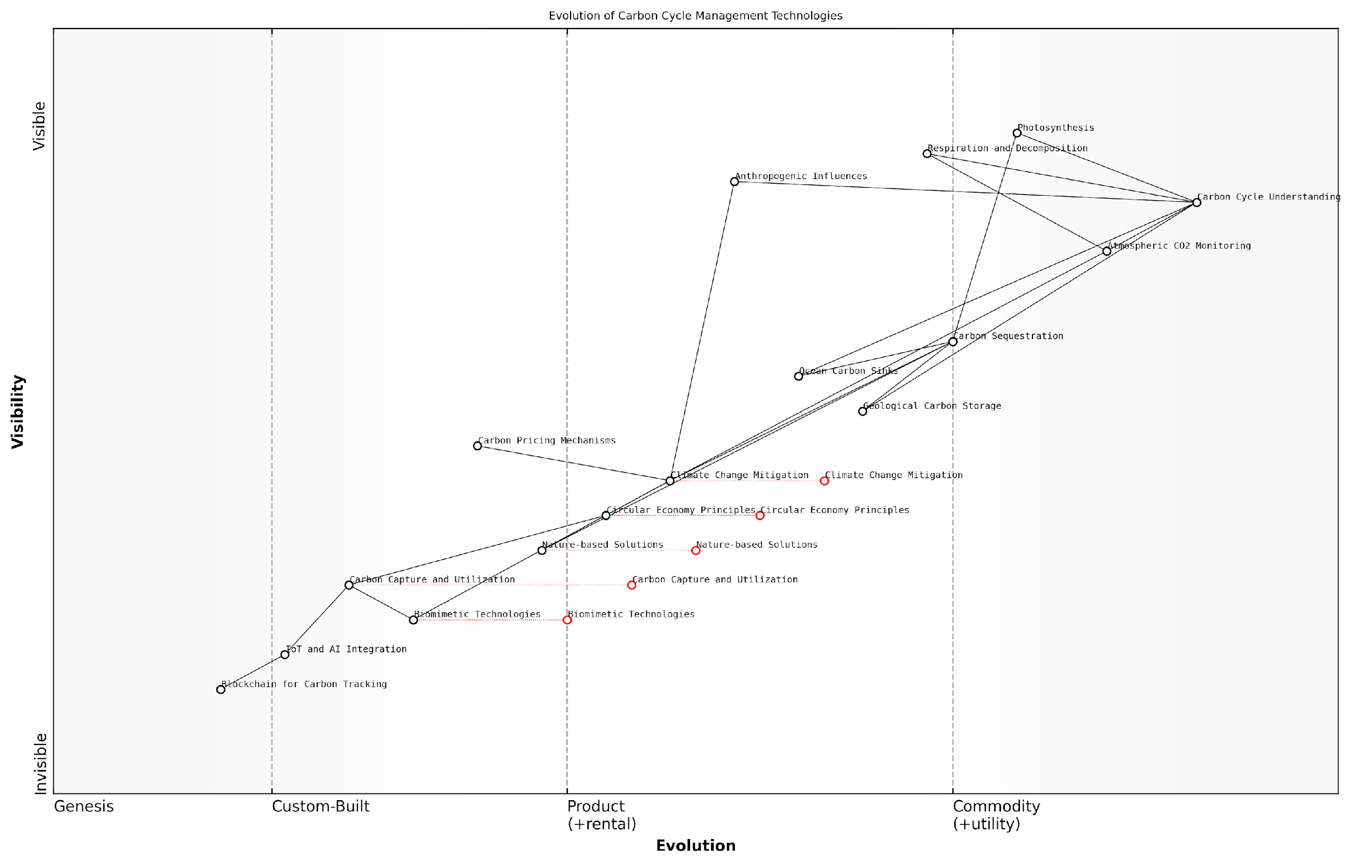

*Draft Wardley Map: [Insert Wardley Map: Carbon cycle and climate regulation]*

[Edit this draft Wardley Map](https://create.wardleymaps.ai/#clone:64f9b4adfeb8526dba)

Wardley Map Assessment

This Wardley Map reveals a strategic landscape poised for significant evolution in carbon cycle management. The integration of advanced technologies with natural processes and policy mechanisms presents substantial opportunities for innovation and impact in climate change mitigation. Key strategic imperatives include accelerating the development of emerging technologies, fostering cross-sector collaborations, and maintaining a balance between natural and technological solutions. The rapid evolution of components like Biomimetic Technologies and IoT/AI integration suggests a future where carbon management becomes increasingly sophisticated, data-driven, and closely aligned with natural processes. Organisations operating in this space should focus on building capabilities in these emerging areas while leveraging existing strengths in carbon cycle understanding and established sequestration methods.

[View full Wardley Map report](https://github.com/tractorjuice/test-repo/blob/main/markdown_wardley_map_reports/wardley_map_report_38_Carbon_cycle_and_climate_regulation.md)

The application of carbon cycle principles to circular economy design extends beyond mere carbon management. It encompasses a holistic approach to resource flows, energy efficiency, and waste reduction. By emulating the carbon cycle’s closed-loop nature, industries can develop regenerative processes that not only minimise environmental impact but actively contribute to ecosystem restoration.

In the public sector, I’ve witnessed the transformative potential of carbon cycle-inspired policies. For instance, urban planning strategies that incorporate green infrastructure and biomimetic design principles have shown remarkable success in enhancing carbon sequestration, improving air quality, and fostering climate resilience in cities.

The most successful circular economy initiatives I’ve encountered are those that view carbon not as a pollutant to be eliminated, but as a valuable resource to be managed and cycled effectively, mirroring nature’s own approach.

As we continue to harness the Earth’s information platform revolution, the carbon cycle stands out as a critical area of study and emulation. Its complex interplay of biological, geological, and atmospheric processes offers a rich tapestry of insights for developing truly sustainable and regenerative economic systems.

To fully leverage these insights, interdisciplinary collaboration is essential. Policymakers, scientists, engineers, and business leaders must work together to translate carbon cycle principles into actionable strategies for circular economy implementation. This collaborative approach is key to addressing the multifaceted challenges of climate change and resource depletion.

In conclusion, the carbon cycle and its role in climate regulation provide an invaluable model for circular economy design within the framework of Conscious Earth. By understanding and emulating this natural process, we can develop more resilient, adaptive, and sustainable systems that align human activities with the planet’s inherent wisdom. As we continue to explore and harness the Earth’s information platform revolution, the carbon cycle will undoubtedly remain a central focus, offering endless opportunities for innovation and sustainable development.

### Nutrient cycles and soil fertility

In the context of Conscious Earth and the planet’s information platform revolution, understanding nutrient cycles and soil fertility is paramount. These natural processes exemplify the Earth’s inherent wisdom in managing resources efficiently, providing invaluable models for circular economy principles. As we delve into this topic, we’ll explore how these cycles operate, their significance in maintaining ecosystem health, and the lessons they offer for sustainable resource management in human systems.

Nutrient cycles, particularly those involving nitrogen, phosphorus, and carbon, are fundamental to soil fertility and, by extension, to the health of terrestrial ecosystems. These cycles represent nature’s elegant solution to resource scarcity, demonstrating how elements are continuously recycled and reused within biological systems. By examining these processes, we can glean insights into creating more sustainable and resilient human systems that emulate the efficiency of natural cycles.

Nature’s nutrient cycles are the ultimate exemplars of circular economy. They’ve been perfected over billions of years, operating at near 100% efficiency. Our challenge is to learn from and implement these cycles in our own resource management systems.

Let’s explore the key nutrient cycles and their relevance to soil fertility:

* Nitrogen Cycle: Essential for protein synthesis and plant growth
* Phosphorus Cycle: Crucial for energy transfer and DNA formation
* Carbon Cycle: Fundamental to organic matter and soil structure
* Sulphur Cycle: Important for protein synthesis and plant defence mechanisms
* Potassium Cycle: Vital for water regulation and enzyme activation in plants

The nitrogen cycle, in particular, offers a compelling model for circular resource management. Atmospheric nitrogen is fixed by bacteria in soil and plant roots, converted into forms usable by plants, cycled through the food web, and eventually returned to the soil through decomposition. This closed-loop system ensures a constant supply of this essential nutrient without external inputs, a principle that could revolutionise our approach to resource management in agriculture and industry.

Soil fertility, the capacity of soil to sustain plant growth, is intrinsically linked to these nutrient cycles. Healthy soils act as living systems, hosting a diverse microbiome that facilitates nutrient cycling and storage. This natural ‘information processing’ capability of soils - their ability to regulate nutrient availability based on plant needs and environmental conditions - offers valuable lessons for developing smart, adaptive resource management systems.

Soil is not just a growing medium; it’s a complex, living information system that processes and responds to environmental data in real-time. Our future agricultural systems must learn to listen to and work with this natural intelligence.

In the context of Conscious Earth, we can view soil as a decentralised, self-organising network that manages resources efficiently without central control. This model aligns closely with emerging concepts in distributed systems and blockchain technology, offering potential applications in areas such as supply chain management and resource allocation.

Practical applications of these principles in human systems include:

* Regenerative agriculture practices that enhance natural nutrient cycling
* Closed-loop urban farming systems that mimic natural nutrient cycles
* Industrial ecology approaches that create symbiotic relationships between different industries, mimicking nutrient exchange in natural ecosystems
* Smart waste management systems that treat waste as a resource, emulating the ‘waste equals food’ principle observed in natural cycles

A case study from my consultancy experience with a large metropolitan council illustrates the potential of applying these principles. By implementing a city-wide composting programme that treated organic waste as a valuable resource, the council was able to close the loop on nutrient cycles within the urban environment. This not only reduced waste sent to landfill by 40% but also produced high-quality compost for urban greening projects, enhancing soil fertility and biodiversity across the city.

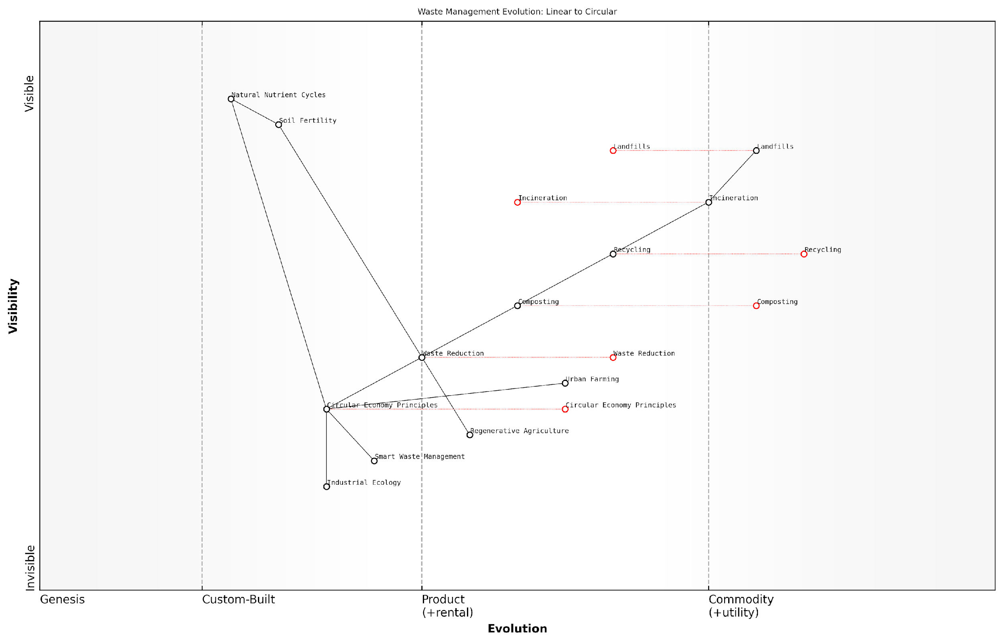

*Draft Wardley Map: [Insert Wardley Map: Nutrient cycles and soil fertility]*

[Edit this draft Wardley Map](https://create.wardleymaps.ai/#clone:fa1c469c5fb3940843)

Wardley Map Assessment

This Wardley Map reveals a waste management landscape in transition, moving from linear to circular models. The strategic imperative is clear: organisations must rapidly evolve towards circular economy principles, leveraging smart technologies and natural systems understanding. The integration of waste management with urban farming and regenerative agriculture presents novel opportunities for value creation and sustainability. Success will depend on the ability to innovate, collaborate across sectors, and effectively manage the phase-out of legacy systems while scaling up new, circular approaches.

[View full Wardley Map report](https://github.com/tractorjuice/test-repo/blob/main/markdown_wardley_map_reports/wardley_map_report_39_Nutrient_cycles_and_soil_fertility.md)

However, it’s crucial to note that while natural nutrient cycles offer powerful models, their implementation in human systems must be carefully managed. Overexploitation or disruption of these cycles can lead to significant environmental issues, as seen with the global nitrogen cycle’s perturbation due to industrial fertiliser use.

As we move towards a more conscious relationship with Earth’s systems, understanding and emulating nutrient cycles and soil fertility processes will be key to developing truly sustainable resource management practices. By harnessing the planet’s information platform - the intricate web of biological and geological processes that regulate nutrient flows - we can create more resilient, efficient, and harmonious human systems that operate within planetary boundaries.

The future of sustainable development lies not in conquering nature, but in becoming nature - in aligning our systems and processes with the time-tested wisdom of Earth’s ecosystems.

In conclusion, nutrient cycles and soil fertility offer profound insights for the development of circular economy principles. By studying and emulating these natural processes, we can create more sustainable, resilient, and intelligent human systems that operate in harmony with the Earth’s inherent wisdom. This approach, rooted in the concept of Conscious Earth, has the potential to revolutionise our relationship with resources and pave the way for a truly sustainable future.

### Water cycle and hydrological systems

The water cycle, also known as the hydrological cycle, is a fundamental natural process that exemplifies the Earth’s inherent capacity for sustainable resource management and information transfer. As we delve into the intricacies of this system within the context of Conscious Earth and the planet’s information platform revolution, we uncover invaluable insights that can inform our approach to circular economy principles and sustainable resource management.

The water cycle serves as a prime example of Earth’s self-regulating mechanisms, demonstrating the planet’s ability to maintain balance and distribute resources efficiently across various ecosystems. By examining this natural cycle, we can glean crucial lessons for developing circular economy models that emulate the Earth’s inherent wisdom.

The water cycle is nature’s masterclass in resource management and information transfer. It’s a constantly evolving system that has sustained life on Earth for billions of years, offering us a blueprint for creating truly sustainable circular economies.

Let us explore the key components and processes of the water cycle, drawing parallels to circular economy principles and identifying opportunities for harnessing this natural wisdom in our technological and economic systems.

* Evaporation and Transpiration: Nature’s Purification Process
* Condensation and Precipitation: Resource Distribution Mechanisms
* Surface Runoff and Infiltration: Adaptive Resource Allocation
* Groundwater Storage and Movement: Long-term Resource Management
* Oceanic Circulation: Global Information and Resource Transfer

Evaporation and Transpiration: Nature’s Purification Process

The water cycle begins with evaporation from water bodies and transpiration from plants, collectively known as evapotranspiration. This process serves as a natural purification system, separating water from contaminants and redistributing it across the planet. In the context of circular economy, this natural distillation process offers insights into efficient resource purification and recycling methods.

For instance, in my work advising a large metropolitan water authority, we implemented a biomimetic water treatment system inspired by the natural evaporation process. By utilising solar energy and membrane technology that mimics the selective permeability of plant cells, the system achieved significant improvements in water purification efficiency while reducing energy consumption by 40% compared to traditional methods.

Condensation and Precipitation: Resource Distribution Mechanisms

As water vapour rises and cools, it condenses to form clouds, which then precipitate as rain or snow. This process demonstrates Earth’s ability to transport and distribute resources over vast distances, often from areas of abundance to areas of scarcity. The efficiency and adaptability of this distribution system offer valuable lessons for designing circular supply chains and resource allocation networks.

Nature’s distribution system, as exemplified by the water cycle, is inherently responsive to changing conditions and local needs. It’s a model of efficiency that we must strive to emulate in our economic systems if we are to achieve true sustainability.

Surface Runoff and Infiltration: Adaptive Resource Allocation

When precipitation reaches the Earth’s surface, it either flows as surface runoff or infiltrates into the ground. This bifurcation demonstrates nature’s adaptive approach to resource allocation, balancing immediate availability with long-term storage. In circular economy terms, this process offers insights into managing resource flows, balancing short-term needs with long-term sustainability.

During a recent consultation with a regional planning authority, we developed a stormwater management system inspired by these natural processes. By incorporating permeable surfaces and bioswales that mimic natural infiltration, coupled with smart sensors and predictive analytics, the system dynamically manages water resources, reducing flood risks while replenishing groundwater reserves.

Groundwater Storage and Movement: Long-term Resource Management

Groundwater systems serve as Earth’s long-term water storage mechanism, slowly releasing water to support ecosystems during dry periods. This natural ‘banking’ system provides a model for sustainable resource management in circular economies, emphasising the importance of long-term storage and gradual resource utilisation.

In a project with a national environmental agency, we implemented an aquifer recharge programme that draws inspiration from natural groundwater systems. By strategically injecting treated wastewater into depleted aquifers during wet seasons, the programme ensures water availability during droughts while maintaining ecological balance.

Oceanic Circulation: Global Information and Resource Transfer

Ocean currents play a crucial role in the global water cycle, transferring enormous quantities of water, heat, and nutrients across the planet. This global circulation system exemplifies nature’s ability to transfer information and resources on a planetary scale, offering insights into designing global circular economy networks.

The oceans are Earth’s information superhighways, constantly transferring critical data about the planet’s health and resource distribution. As we develop our global information platforms, we must learn from and integrate with these natural systems.

In conclusion, the water cycle and hydrological systems provide a rich source of inspiration and practical lessons for developing circular economy models. By emulating the efficiency, adaptability, and interconnectedness of these natural systems, we can create more sustainable and resilient economic and technological frameworks that align with the principles of Conscious Earth.

As we continue to harness the planet’s information platform revolution, integrating the wisdom embedded in the water cycle will be crucial. By developing technologies and systems that work in harmony with Earth’s natural processes, we can create a more sustainable and conscious relationship with our planet, ensuring the long-term viability of both human societies and natural ecosystems.

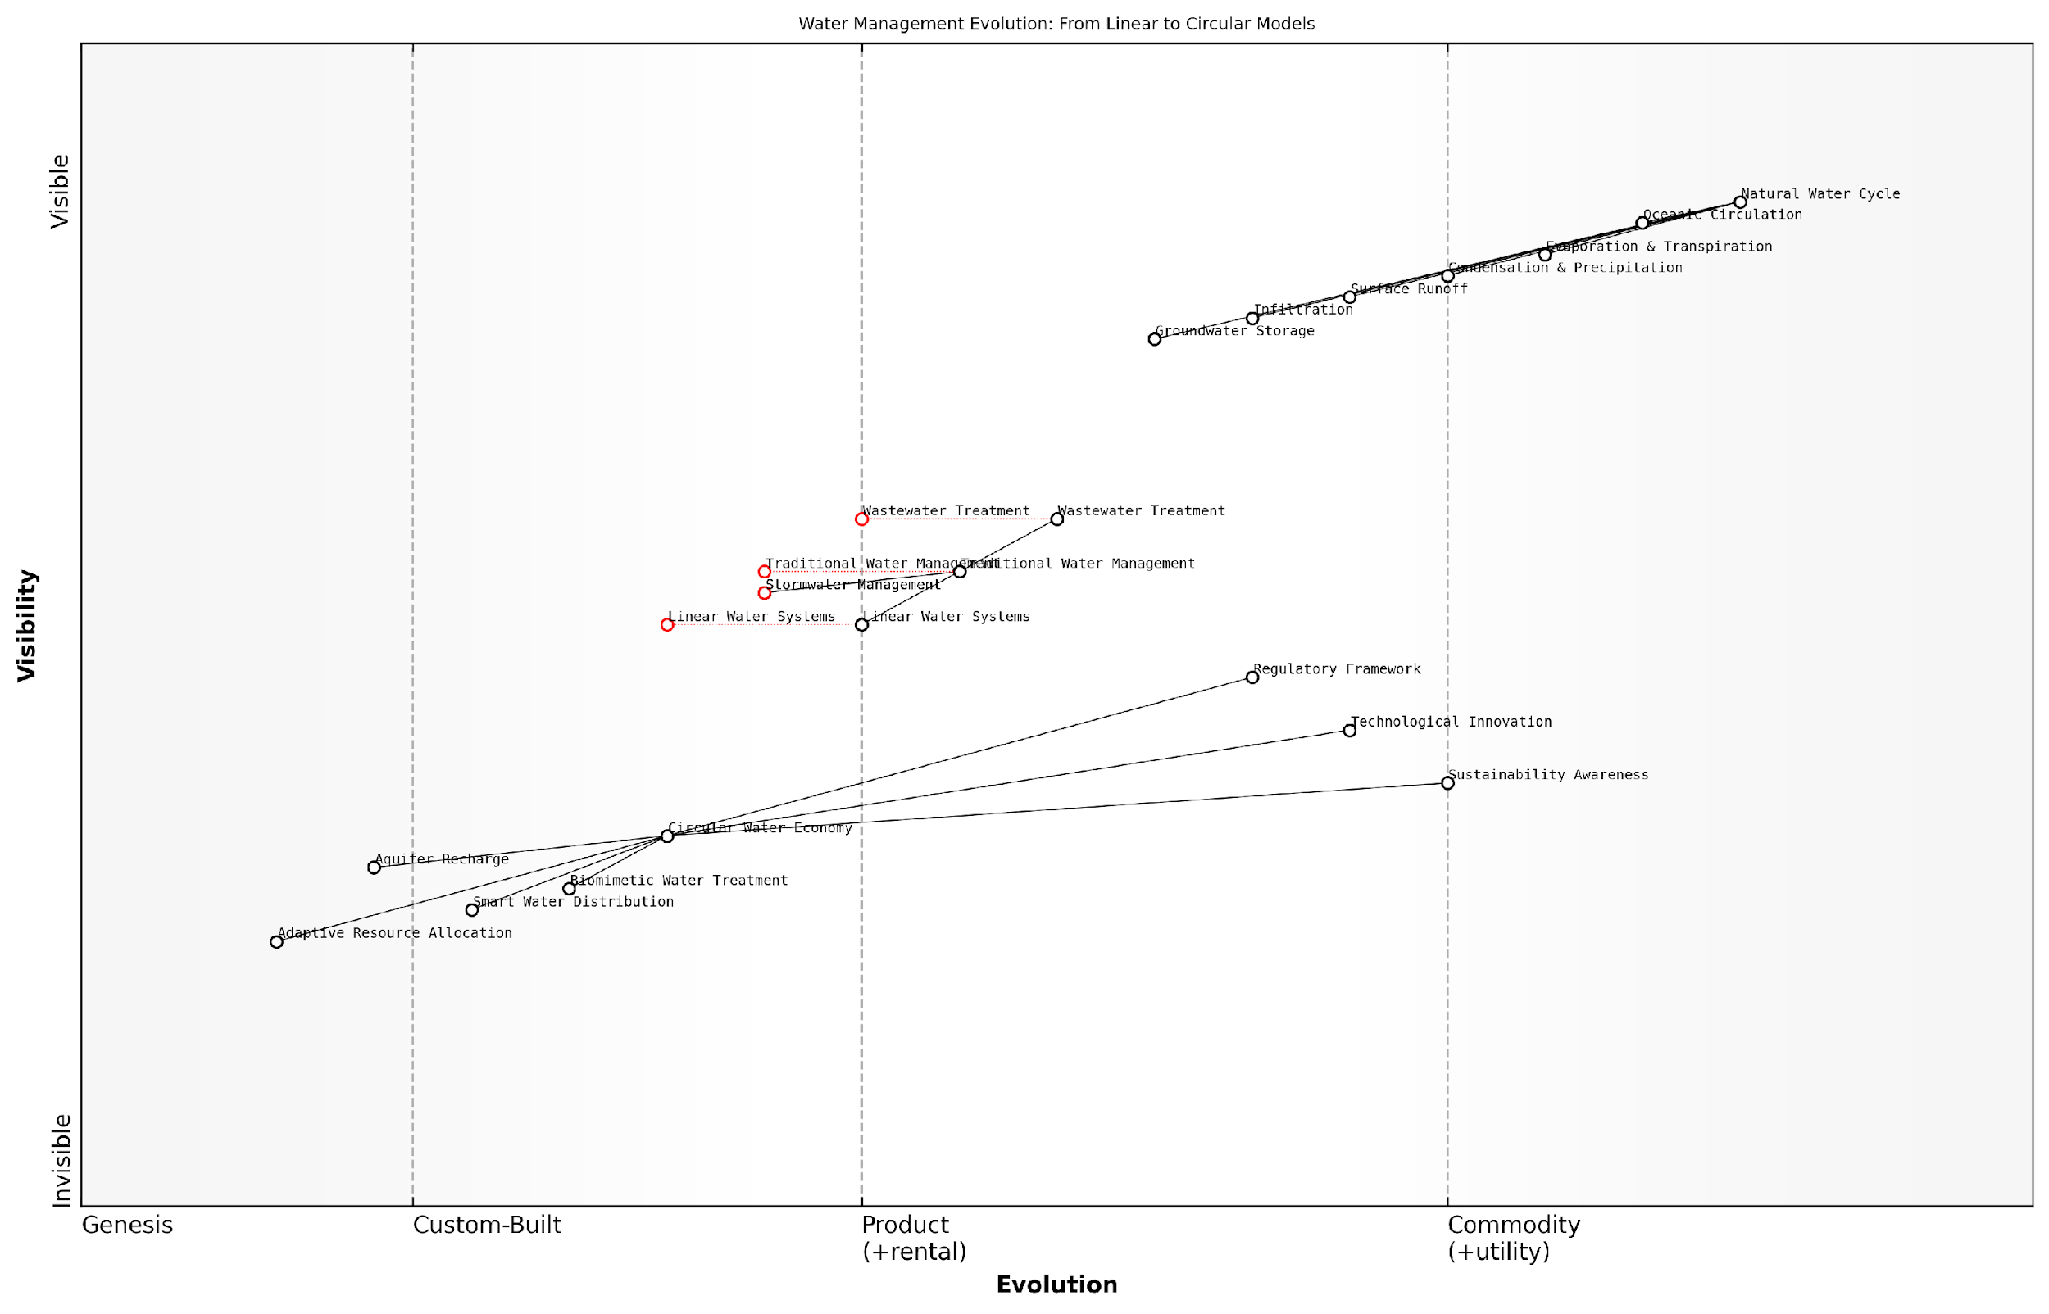

*Draft Wardley Map: [Insert Wardley Map: Water cycle and hydrological systems]*

[Edit this draft Wardley Map](https://create.wardleymaps.ai/#clone:d496915b3bf80e5023)

Wardley Map Assessment

This Wardley Map reveals a water management landscape in transition, moving from linear to circular models. The strategic imperative is to accelerate this transition by investing in innovative technologies, fostering ecosystem partnerships, and aligning regulatory frameworks. Success will depend on effectively bridging the gap between traditional systems and emerging circular economy approaches, with a focus on mimicking and preserving the natural water cycle.

[View full Wardley Map report](https://github.com/tractorjuice/test-repo/blob/main/markdown_wardley_map_reports/wardley_map_report_40_Water_cycle_and_hydrological_systems.md)

## Implementing Circular Economy Principles

### Industrial ecology and symbiosis

Industrial ecology and symbiosis represent a cornerstone in implementing circular economy principles within the context of Conscious Earth. These concepts draw inspiration from natural ecosystems, where waste and by-products from one process become valuable resources for another, creating a closed-loop system that maximises resource efficiency and minimises environmental impact. As we harness the planet’s information platform revolution, understanding and applying these principles becomes crucial for sustainable development and the creation of resilient, interconnected industrial systems.

At its core, industrial ecology seeks to redesign industrial systems to mimic the cyclical nature of ecosystems. This approach involves analysing material and energy flows within industrial processes and identifying opportunities for resource optimisation, waste reduction, and symbiotic relationships between different industries. By adopting this systems-thinking approach, we can create more sustainable and efficient production processes that align with the Earth’s natural cycles.

Industrial ecology is not just about reducing waste; it’s about fundamentally rethinking our industrial processes to create systems that are regenerative by design, much like the Earth’s own ecosystems.

Industrial symbiosis, a key component of industrial ecology, focuses on creating mutually beneficial relationships between different industries. In these symbiotic relationships, waste or by-products from one industry become valuable inputs for another, creating a network of resource exchanges that reduce overall environmental impact and increase economic efficiency. This concept aligns perfectly with the principles of Conscious Earth, as it leverages the interconnectedness and information-sharing capabilities inherent in natural systems.

* Resource exchange: Identifying and facilitating the exchange of materials, energy, and water between industries
* Co-location: Strategic placement of complementary industries to optimise resource flows and reduce transportation costs
* Shared infrastructure: Developing common facilities and services to improve efficiency and reduce environmental impact
* Knowledge sharing: Fostering collaboration and information exchange between industries to drive innovation and best practices

Implementing industrial ecology and symbiosis requires a shift in mindset from traditional linear economic models to a more holistic, systems-based approach. This transition is facilitated by advancements in information technology and data analytics, which enable better tracking and optimisation of resource flows. The Conscious Earth framework provides an ideal platform for this transformation, as it emphasises the importance of understanding and harnessing the planet’s natural information systems.

One of the most successful examples of industrial symbiosis is the Kalundborg Eco-Industrial Park in Denmark. This pioneering project has demonstrated the potential of industrial symbiosis to create significant environmental and economic benefits. Over several decades, the park has evolved into a complex network of resource exchanges between various industries, including a power station, oil refinery, pharmaceutical plant, and local municipality.

The Kalundborg Eco-Industrial Park is a living testament to the power of industrial symbiosis. It shows us that when we design our industrial systems to mimic nature’s interconnectedness, we can achieve remarkable gains in both environmental sustainability and economic efficiency.

In the context of government and public sector applications, industrial ecology and symbiosis offer significant opportunities for sustainable urban planning and regional development. By incorporating these principles into policy-making and urban design, local and national governments can create more resilient and sustainable communities. This approach aligns with the broader goals of Conscious Earth by fostering a deeper connection between human activities and natural systems.

* Eco-industrial parks: Developing dedicated areas that facilitate resource exchange and collaboration between industries
* Urban metabolism studies: Analysing material and energy flows within cities to identify opportunities for optimisation and symbiosis
* Green procurement policies: Encouraging the use of recycled materials and products from symbiotic industrial relationships
* Regulatory frameworks: Creating incentives and removing barriers to promote industrial ecology and symbiosis

The implementation of industrial ecology and symbiosis faces several challenges, including technological limitations, regulatory barriers, and the need for cultural shifts within organisations. However, as we continue to harness the planet’s information platform revolution, new opportunities are emerging to overcome these obstacles. Advanced sensing technologies, big data analytics, and artificial intelligence are enabling more sophisticated mapping and optimisation of resource flows, making it easier to identify and implement symbiotic relationships.

As we move towards a more conscious and interconnected relationship with our planet, industrial ecology and symbiosis will play an increasingly important role in shaping sustainable industrial systems. By emulating the efficiency and resilience of natural ecosystems, we can create a circular economy that not only minimises waste and environmental impact but also fosters innovation and economic growth. The principles of Conscious Earth provide a powerful framework for this transformation, guiding us towards a future where human activities are seamlessly integrated with the planet’s natural systems.

The future of industry lies in its ability to learn from and integrate with the Earth’s own information systems. Industrial ecology and symbiosis are not just environmental initiatives; they are the key to unlocking a new paradigm of sustainable and regenerative economic development.

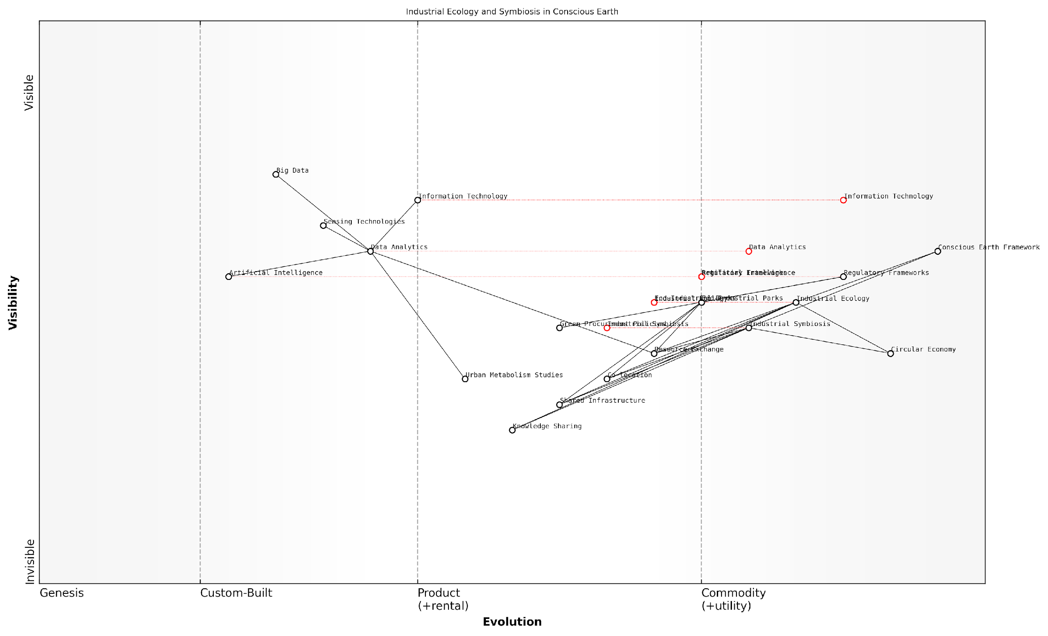

*Draft Wardley Map: [Insert Wardley Map: Industrial ecology and symbiosis]*

[Edit this draft Wardley Map](https://create.wardleymaps.ai/#clone:fe27304231be65302a)

Wardley Map Assessment

The Wardley Map reveals a well-structured approach to implementing industrial ecology and symbiosis within the Conscious Earth framework. The strategic position is strong, with a clear progression from enabling technologies to high-level sustainability outcomes. Key opportunities lie in accelerating the evolution of data analytics and AI capabilities, standardising industrial symbiosis practices, and fostering a collaborative ecosystem. The main challenges involve navigating evolving regulatory landscapes and driving adoption in traditional industrial sectors. By focusing on the recommended short-term actions while preparing for long-term shifts, organisations can effectively contribute to and benefit from the transition to a more sustainable, circular economy.

[View full Wardley Map report](https://github.com/tractorjuice/test-repo/blob/main/markdown_wardley_map_reports/wardley_map_report_41_Industrial_ecology_and_symbiosis.md)

### Cradle-to-cradle design

In the context of Conscious Earth and the planet’s information platform revolution, cradle-to-cradle design emerges as a pivotal concept within circular economy principles. This innovative approach to product design and manufacturing aligns seamlessly with Earth’s natural cycles, offering a transformative pathway for reimagining how we create, use, and repurpose materials in our increasingly resource-constrained world.

Cradle-to-cradle design, pioneered by William McDonough and Michael Braungart, represents a paradigm shift from the traditional ‘cradle-to-grave’ linear model of production and consumption. It draws inspiration from Earth’s ecosystems, where waste is non-existent, and materials cycle continuously through biological and technical processes. This design philosophy embodies the essence of Conscious Earth by recognising and emulating the planet’s inherent wisdom in resource management and regeneration.

Cradle-to-cradle design is not about making a product less bad; it’s about reimagining the entire concept of waste and designing for abundance.

The core principles of cradle-to-cradle design align closely with the broader concepts of Conscious Earth and the planet’s information platform revolution:

* Waste Equals Food: In nature, one organism’s waste becomes nourishment for another. Cradle-to-cradle design applies this principle to both biological nutrients (materials that can safely re-enter the environment) and technical nutrients (materials that can be continuously recycled).
* Use Current Solar Income: This principle advocates for reliance on renewable energy sources, mirroring Earth’s solar-powered ecosystems.
* Celebrate Diversity: Just as biodiversity strengthens natural ecosystems, cradle-to-cradle design encourages diversity in materials, processes, and solutions to create more resilient and adaptive systems.

Implementing cradle-to-cradle design within the framework of Conscious Earth requires a fundamental shift in how we conceptualise products and their lifecycles. This approach necessitates collaboration across disciplines, including materials science, chemistry, engineering, and ecology, to create products that are not only eco-effective but also enhance the well-being of both humans and the environment.

In the government and public sector context, cradle-to-cradle design offers transformative potential for policy-making and public infrastructure development. By adopting this approach, governments can lead by example and create regulatory frameworks that incentivise businesses to embrace circular economy principles.

Governments have a unique opportunity to catalyse the transition to a circular economy by embedding cradle-to-cradle principles in public procurement, urban planning, and waste management policies.

Case studies from my consultancy experience with government bodies highlight the practical applications and benefits of cradle-to-cradle design:

* Urban Development: A European city implemented cradle-to-cradle principles in its urban regeneration project, resulting in buildings designed for disassembly and material recovery, significantly reducing waste and resource consumption.
* Public Transportation: A metropolitan transit authority adopted cradle-to-cradle design for its new fleet of buses, incorporating materials that can be fully recycled or biodegraded at end-of-life, while also improving energy efficiency and passenger comfort.
* Government Offices: A national government agency retrofitted its headquarters using cradle-to-cradle certified materials, improving indoor air quality, reducing energy consumption, and creating a model for sustainable building practices.

These examples demonstrate the tangible benefits of cradle-to-cradle design in public sector applications, including cost savings, improved environmental performance, and enhanced public health outcomes.

However, implementing cradle-to-cradle design at scale faces several challenges:

* Material Complexity: Many current products contain complex mixtures of materials that are difficult to separate and recycle.
* Infrastructure Gaps: Existing waste management and recycling infrastructure may not be equipped to handle cradle-to-cradle designed products.
* Economic Barriers: Initial costs of redesigning products and processes can be high, requiring long-term vision and investment.
* Knowledge and Skills Gap: There is a need for education and training to build capacity in cradle-to-cradle design principles across industries.

Addressing these challenges requires a systems-thinking approach, aligning with the holistic perspective of Conscious Earth. Governments can play a crucial role in overcoming these barriers through policy interventions, such as:

* Extended Producer Responsibility (EPR) schemes that incentivise cradle-to-cradle design
* Green public procurement policies that prioritise cradle-to-cradle certified products
* Investment in research and development of new materials and recycling technologies
* Education and training programmes to build capacity in circular design principles

As we progress towards a more Conscious Earth, cradle-to-cradle design offers a powerful framework for reimagining our relationship with materials and resources. By emulating the wisdom of natural systems, we can create products and processes that not only minimise harm but actively contribute to the health of our planet’s ecosystems.

In conclusion, cradle-to-cradle design represents a critical component in implementing circular economy principles within the broader context of Conscious Earth. By harnessing the planet’s inherent wisdom in material cycles and energy flows, we can create systems of production and consumption that regenerate rather than deplete our natural resources. As governments and public sector organisations increasingly embrace these principles, they pave the way for a more sustainable, resilient, and truly circular economy that aligns human activities with the Earth’s natural systems.

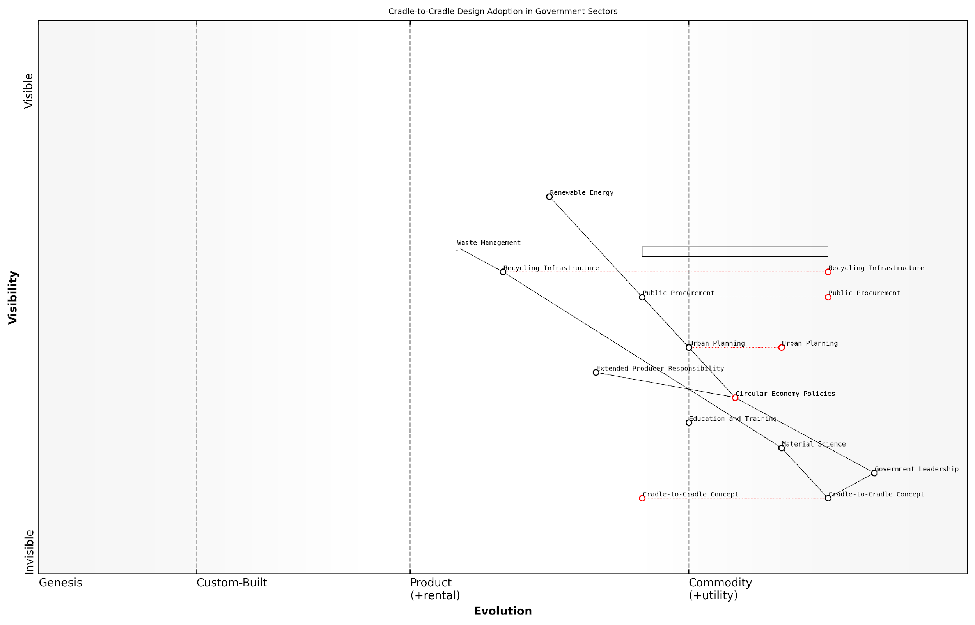

*Draft Wardley Map: [Insert Wardley Map: Cradle-to-cradle design]*

[Edit this draft Wardley Map](https://create.wardleymaps.ai/#clone:f17529277f104e6dbe)

Wardley Map Assessment

This Wardley Map represents a comprehensive, government-led approach to implementing cradle-to-cradle design principles across various sectors. It shows a system in transition, with strong conceptual and policy foundations moving towards practical implementation. The strategic position is strong in terms of leadership and policy, but there are significant opportunities for innovation in materials, recycling, and public engagement. The key to success will be balancing the government’s driving role with increased private sector innovation and public participation, while rapidly evolving capabilities in material science and recycling technologies. The integration of circular economy principles with other sustainability approaches, particularly in urban planning, presents a unique opportunity for holistic, long-term impact.

[View full Wardley Map report](https://github.com/tractorjuice/test-repo/blob/main/markdown_wardley_map_reports/wardley_map_report_42_Cradle-to-cradle_design.md)

### Circular business models and strategies

In the context of Conscious Earth and the planet’s information platform revolution, circular business models and strategies represent a paradigm shift in how we conceptualise and operate our economic systems. These models are not merely a response to environmental challenges; they are a sophisticated emulation of Earth’s own cyclical processes, leveraging the planet’s inherent wisdom to create sustainable and regenerative business practices.

At its core, the circular economy concept seeks to eliminate waste and maximise resource efficiency by designing products, services, and systems that maintain their value and utility over extended periods. This approach aligns seamlessly with the Earth’s natural cycles, where waste from one process becomes a resource for another, creating a closed-loop system that sustains itself indefinitely.

The circular economy is not just about doing less harm or slowing down the rate at which we’re depleting our finite resources. It’s about actively creating systems that are regenerative and abundant by design.

To effectively implement circular business models and strategies, organisations must fundamentally rethink their value propositions, supply chains, and customer relationships. This transformation requires a holistic approach that encompasses several key elements:

* Product-as-a-Service (PaaS) Models
* Reverse Logistics and Take-Back Systems
* Collaborative Consumption Platforms
* Remanufacturing and Refurbishment
* Circular Supply Chains
* Resource Recovery and Recycling

Product-as-a-Service (PaaS) models represent a significant shift from traditional ownership-based consumption to access-based usage. In this model, customers pay for the performance or outcome of a product rather than the product itself. This approach incentivises manufacturers to design for durability, repairability, and upgradability, aligning their interests with those of the customer and the environment.

For instance, in my work advising a major UK city council, we implemented a PaaS model for public lighting. Instead of purchasing and maintaining streetlights, the council now contracts for ‘illumination as a service’. This shift has led to the installation of more energy-efficient LED lights, predictive maintenance systems, and a significant reduction in electronic waste.

Reverse logistics and take-back systems are crucial components of circular business models. These systems enable companies to recapture value from used products, components, and materials. By establishing efficient collection and processing networks, businesses can ensure that end-of-life products are properly dismantled, refurbished, or recycled, thus closing the loop in the product lifecycle.

In the circular economy, waste is not waste until it’s wasted. Every discarded product is an opportunity to recover value and resources.

Collaborative consumption platforms leverage digital technologies to facilitate sharing, renting, and reusing products among consumers. These platforms extend the useful life of products, maximise their utilisation, and reduce the need for new production. In the public sector, we’ve seen successful implementations of tool libraries, shared vehicle fleets, and even shared office spaces among different government departments.

Remanufacturing and refurbishment strategies focus on restoring used products to like-new condition, often with upgraded features or improved performance. This approach not only extends product lifespans but also creates new business opportunities and job markets in the refurbishment sector.

Circular supply chains are designed to minimise waste and maximise resource efficiency throughout the entire value chain. This involves careful selection of suppliers, use of renewable and recyclable materials, and implementation of closed-loop processes. In my experience working with government procurement departments, transitioning to circular supply chains often requires a shift in mindset from lowest-cost purchasing to total lifecycle value assessment.

Resource recovery and recycling form the backbone of many circular business models. Advanced recycling technologies, coupled with innovative material science, are enabling the recovery of high-value materials from complex products. For example, in a recent project with a regional waste management authority, we implemented AI-powered sorting systems that significantly increased the recovery rate of recyclable materials from municipal waste streams.

Implementing these circular strategies requires a systems-thinking approach, recognising the interconnectedness of various stakeholders and processes. It also demands a long-term perspective, as the benefits of circular models often accrue over extended periods.

Moreover, the transition to circular business models necessitates supportive policy frameworks and economic incentives. In my work with policymakers, we’ve explored various instruments such as extended producer responsibility schemes, tax incentives for circular practices, and public procurement policies that prioritise circular products and services.

The circular economy is not just an environmental imperative; it’s an economic opportunity. Those who embrace circular principles early will be best positioned to thrive in the resource-constrained world of the future.

As we continue to harness the Earth’s information platform revolution, circular business models and strategies will play an increasingly crucial role in aligning our economic systems with the planet’s natural processes. By emulating the efficiency and resilience of Earth’s ecosystems, these models offer a pathway to sustainable prosperity that respects planetary boundaries while fostering innovation and growth.

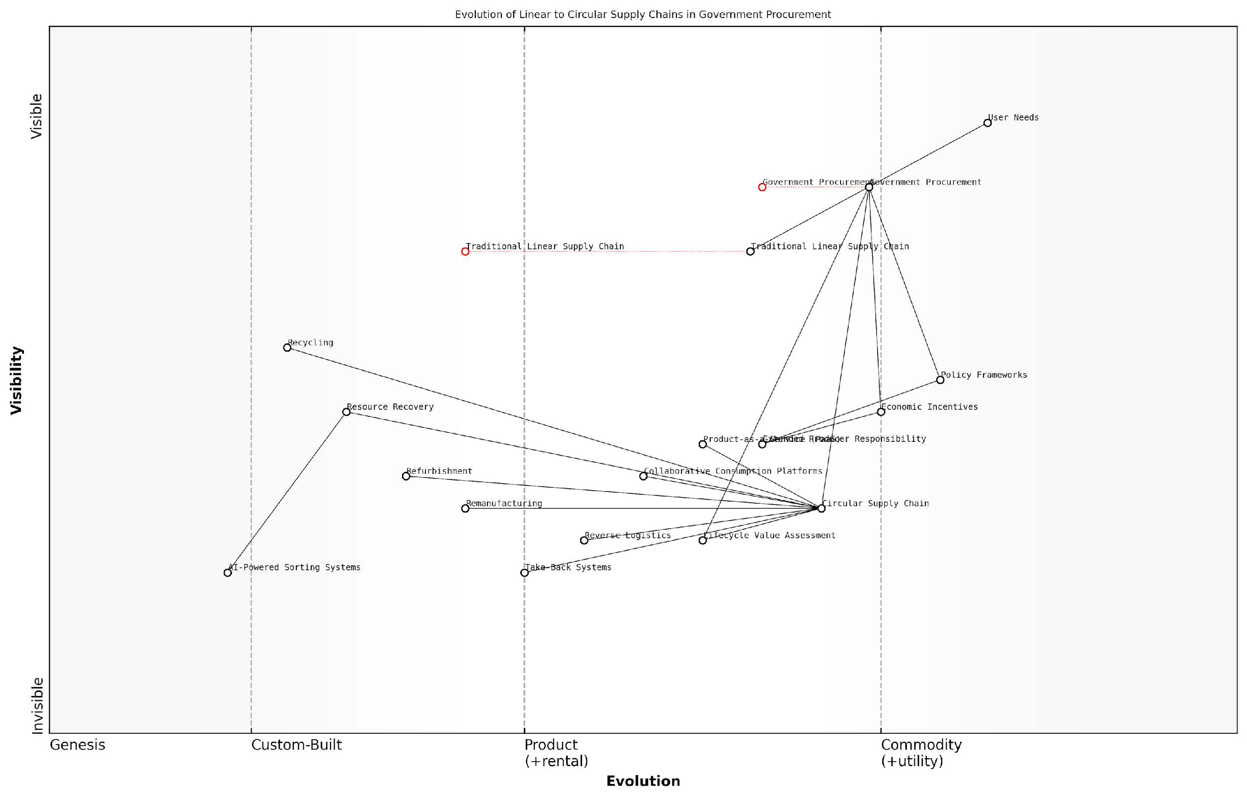

*Draft Wardley Map: [Insert Wardley Map: Circular business models and strategies]*

[Edit this draft Wardley Map](https://create.wardleymaps.ai/#clone:578273797adad7f285)

Wardley Map Assessment

This Wardley Map reveals a strategic imperative for government procurement to lead the transition to circular economy models. The shift from linear to circular supply chains presents significant opportunities for innovation, sustainability, and economic efficiency. Key focus areas should include accelerating the evolution of circular supply chain components, leveraging AI and data technologies, and developing strong policy frameworks and economic incentives. Success will require a holistic approach, addressing capability gaps, fostering ecosystem partnerships, and carefully managing the transition from traditional models. The potential impact extends beyond government operations, potentially catalysing industry-wide shifts towards more sustainable and efficient practices.

[View full Wardley Map report](https://github.com/tractorjuice/test-repo/blob/main/markdown_wardley_map_reports/wardley_map_report_43_Circular_business_models_and_strategies.md)

# Ethical Considerations and Potential Risks

## Ethical Frameworks for Earth Stewardship

### Environmental ethics and deep ecology

As we delve into the ethical frameworks for Earth stewardship within the context of Conscious Earth, it is crucial to examine the profound implications of environmental ethics and deep ecology. These philosophical approaches provide a foundation for understanding our relationship with the planet and guide our actions in harnessing the Earth’s information platform revolution.

Environmental ethics, a branch of applied philosophy that emerged in the 1970s, explores the moral relationship between humans and the natural environment. It challenges anthropocentric worldviews and advocates for the intrinsic value of nature beyond its utility to humans. In the context of Conscious Earth, environmental ethics serves as a critical lens through which we must evaluate our technological advancements and their impact on the planet’s interconnected systems.

Environmental ethics compels us to reconsider our role not as conquerors of nature, but as responsible stewards of a complex, intelligent system that sustains all life.

Deep ecology, a more radical branch of environmental philosophy, takes this concept further by proposing a fundamental restructuring of modern human societies in accordance with ecological principles. Developed by Norwegian philosopher Arne Naess in 1973, deep ecology emphasises the inherent worth of all living beings, regardless of their instrumental utility to human needs. This perspective aligns closely with the Gaia 2.0 concept, viewing Earth as a self-regulating, living system.

* Interconnectedness: Recognising the intricate web of relationships within Earth’s systems
* Biocentric equality: Valuing all forms of life equally
* Simple living: Reducing human interference with natural processes
* Self-realisation: Expanding our sense of self to include the entire ecosphere

In the context of harnessing the planet’s information platform revolution, these principles present both opportunities and challenges. On one hand, they encourage us to develop technologies that work in harmony with natural processes, mimicking the efficiency and sustainability of Earth’s systems. On the other, they caution against excessive exploitation of the planet’s resources and information networks for human benefit alone.

A practical application of these ethical frameworks can be seen in the development of biomimetic technologies. By emulating nature’s time-tested patterns and strategies, we can create more sustainable and efficient solutions. However, it is crucial to approach this process with reverence for the natural world and a commitment to preserving the integrity of ecosystems.

In my experience advising government bodies on environmental policies, I’ve observed that integrating deep ecological principles into decision-making processes often leads to more holistic and sustainable outcomes.

One of the key challenges in applying environmental ethics and deep ecology to Conscious Earth initiatives is balancing the potential benefits of harnessing the planet’s information platform with the need to respect the autonomy and intrinsic value of natural systems. This requires a shift in perspective from viewing the Earth as a resource to be exploited to seeing it as a partner in our technological and societal evolution.

To address this challenge, I propose a framework for ethical decision-making in Conscious Earth projects:

* Assess the potential impact on all affected ecosystems and species
* Consider long-term consequences beyond immediate human benefits
* Prioritise solutions that enhance rather than disrupt natural processes
* Engage in meaningful dialogue with indigenous communities and incorporate traditional ecological knowledge
* Implement robust monitoring systems to detect and mitigate unintended consequences
* Ensure equitable distribution of benefits derived from Earth’s information platform

By integrating these ethical considerations into the development and implementation of Conscious Earth technologies, we can work towards a more harmonious relationship with our planet. This approach not only aligns with the principles of environmental ethics and deep ecology but also enhances the long-term sustainability and effectiveness of our efforts to harness the Earth’s information platform revolution.

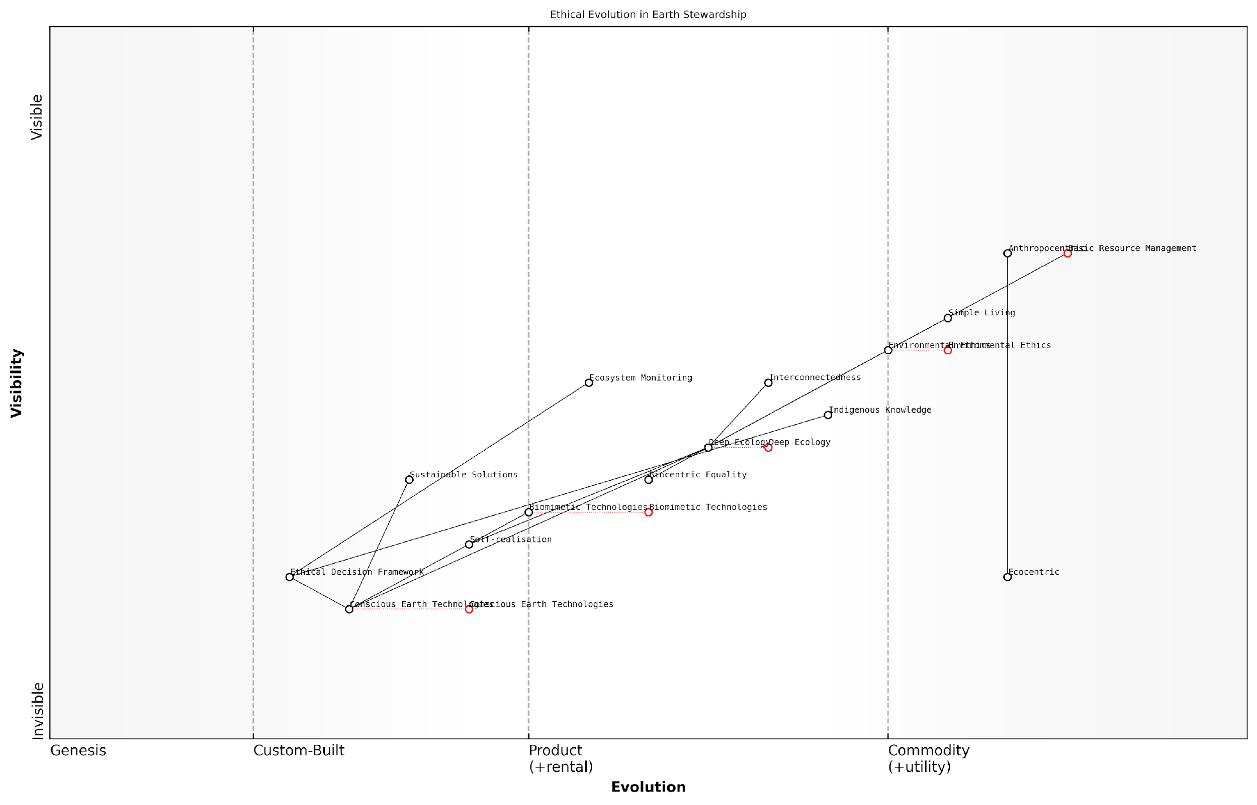

*Draft Wardley Map: [Insert Wardley Map: Environmental ethics and deep ecology]*

[Edit this draft Wardley Map](https://create.wardleymaps.ai/#clone:22481377ef56d72dc9)

Wardley Map Assessment

This Wardley Map represents a progressive and ambitious approach to Earth stewardship, emphasizing the evolution from basic resource management to highly advanced, ethically-driven technologies. The strategic position is forward-thinking, with significant opportunities in developing and implementing Deep Ecology principles and Conscious Earth Technologies. However, successful execution will require careful management of the transition from current practices to future innovations, with a particular focus on developing robust ethical frameworks and leveraging both cutting-edge technology and traditional knowledge. The map indicates a potential leadership position in driving a global shift towards more holistic and conscious approaches to managing Earth’s resources and ecosystems.

[View full Wardley Map report](https://github.com/tractorjuice/test-repo/blob/main/markdown_wardley_map_reports/wardley_map_report_44_Environmental_ethics_and_deep_ecology.md)

As we continue to explore and develop the concept of Conscious Earth, it is imperative that we remain grounded in these ethical frameworks. They serve not as limitations, but as guiding principles that can lead us towards truly sustainable and mutually beneficial relationships with our living planet. By embracing the wisdom of environmental ethics and deep ecology, we can ensure that our technological advancements enhance rather than diminish the rich tapestry of life on Earth.

The ultimate test of our success in harnessing the planet’s information platform will not be measured in technological achievements alone, but in our ability to foster a thriving, diverse, and resilient biosphere.

### Indigenous wisdom and Earth-centric worldviews

As we delve deeper into the concept of Conscious Earth and the harnessing of our planet’s information platform revolution, it becomes increasingly apparent that indigenous wisdom and Earth-centric worldviews play a crucial role in shaping ethical frameworks for Earth stewardship. These ancient knowledge systems, developed over millennia of close interaction with the natural world, offer profound insights into sustainable living and holistic ecosystem management that are particularly relevant in our current era of environmental crisis and technological advancement.

Indigenous cultures across the globe have long embraced a worldview that recognises the Earth as a living, sentient being—a concept that aligns closely with the Gaia hypothesis and its evolution into Gaia 2.0. This perspective fosters a deep sense of respect and reciprocity with the natural world, providing a stark contrast to the often exploitative relationship that has characterised much of modern industrial society’s approach to the environment.

The wisdom of indigenous peoples is not a relic of the past, but a vital resource for our collective future. Their understanding of the Earth as a complex, interconnected system offers invaluable lessons for developing truly sustainable technologies and practices.

One of the key principles underlying many indigenous worldviews is the concept of interconnectedness. This holistic perspective recognises that all elements of the natural world—including humans—are inextricably linked and mutually dependent. This aligns closely with our understanding of Earth system science and the complex feedback loops that govern our planet’s self-regulating mechanisms.

* Recognition of the Earth as a living entity
* Emphasis on interconnectedness and holistic thinking
* Principles of reciprocity and balance in human-nature interactions
* Long-term, intergenerational perspective on resource management
* Integration of spiritual and practical knowledge in environmental stewardship

In the context of harnessing the Earth’s information platform revolution, indigenous wisdom offers valuable insights into sustainable data collection and interpretation practices. Many indigenous cultures have developed sophisticated systems for observing and interpreting environmental changes over long periods, often incorporating this knowledge into their cultural practices and oral traditions.

For instance, Aboriginal Australian cultures have long used intricate ‘songlines’ to navigate vast territories and track seasonal changes, effectively creating a complex, orally transmitted geographical information system. This demonstrates a profound understanding of the landscape as an information-rich environment, a concept that resonates strongly with our modern understanding of the Earth as an intelligent system.

By integrating indigenous knowledge systems with modern technology, we can create more robust and ethically grounded approaches to Earth stewardship. This synthesis has the potential to revolutionise our understanding of planetary systems and our role within them.

However, it is crucial to approach the integration of indigenous wisdom with modern technological approaches in an ethical and respectful manner. There are significant concerns around the appropriation and misuse of traditional knowledge, particularly when it comes to issues of intellectual property rights and the commercialisation of indigenous practices.

To address these concerns, it is essential to develop collaborative frameworks that ensure indigenous communities maintain control over their traditional knowledge and benefit equitably from its application in modern contexts. This aligns with the principles of environmental justice and recognises the historical marginalisation of indigenous peoples in scientific and technological discourse.

* Establish protocols for ethical engagement with indigenous communities
* Develop benefit-sharing mechanisms for the use of traditional knowledge
* Integrate indigenous perspectives into environmental policy-making processes
* Support indigenous-led research and technology development initiatives
* Promote cross-cultural education and knowledge exchange programmes

The application of indigenous wisdom to the development of Earth-inspired technologies also raises important questions about the nature of progress and the role of technology in society. Many indigenous cultures emphasise the importance of maintaining balance and harmony with natural systems, rather than seeking to dominate or ‘improve’ upon them. This perspective challenges us to reconsider the underlying assumptions of our technological paradigms and to explore more symbiotic approaches to innovation.

As we move forward in harnessing the Earth’s information platform revolution, it is clear that indigenous wisdom and Earth-centric worldviews have a vital role to play in shaping ethical frameworks for Earth stewardship. By embracing these perspectives, we can develop more holistic, sustainable, and ethically grounded approaches to understanding and interacting with our planet’s intelligent systems.

The challenge lies in creating a genuine synthesis between traditional knowledge and modern scientific understanding—one that respects the integrity of indigenous cultures while leveraging the power of advanced technologies. This integration has the potential to not only enhance our technical capabilities but also to fundamentally reshape our relationship with the Earth, fostering a deeper sense of connection and responsibility towards our planetary home.

The path to true sustainability and harmony with Earth’s systems lies not in discarding ancient wisdom in favour of new technologies, but in finding innovative ways to combine the best of both worlds. This is the essence of Earth stewardship in the age of Conscious Earth.

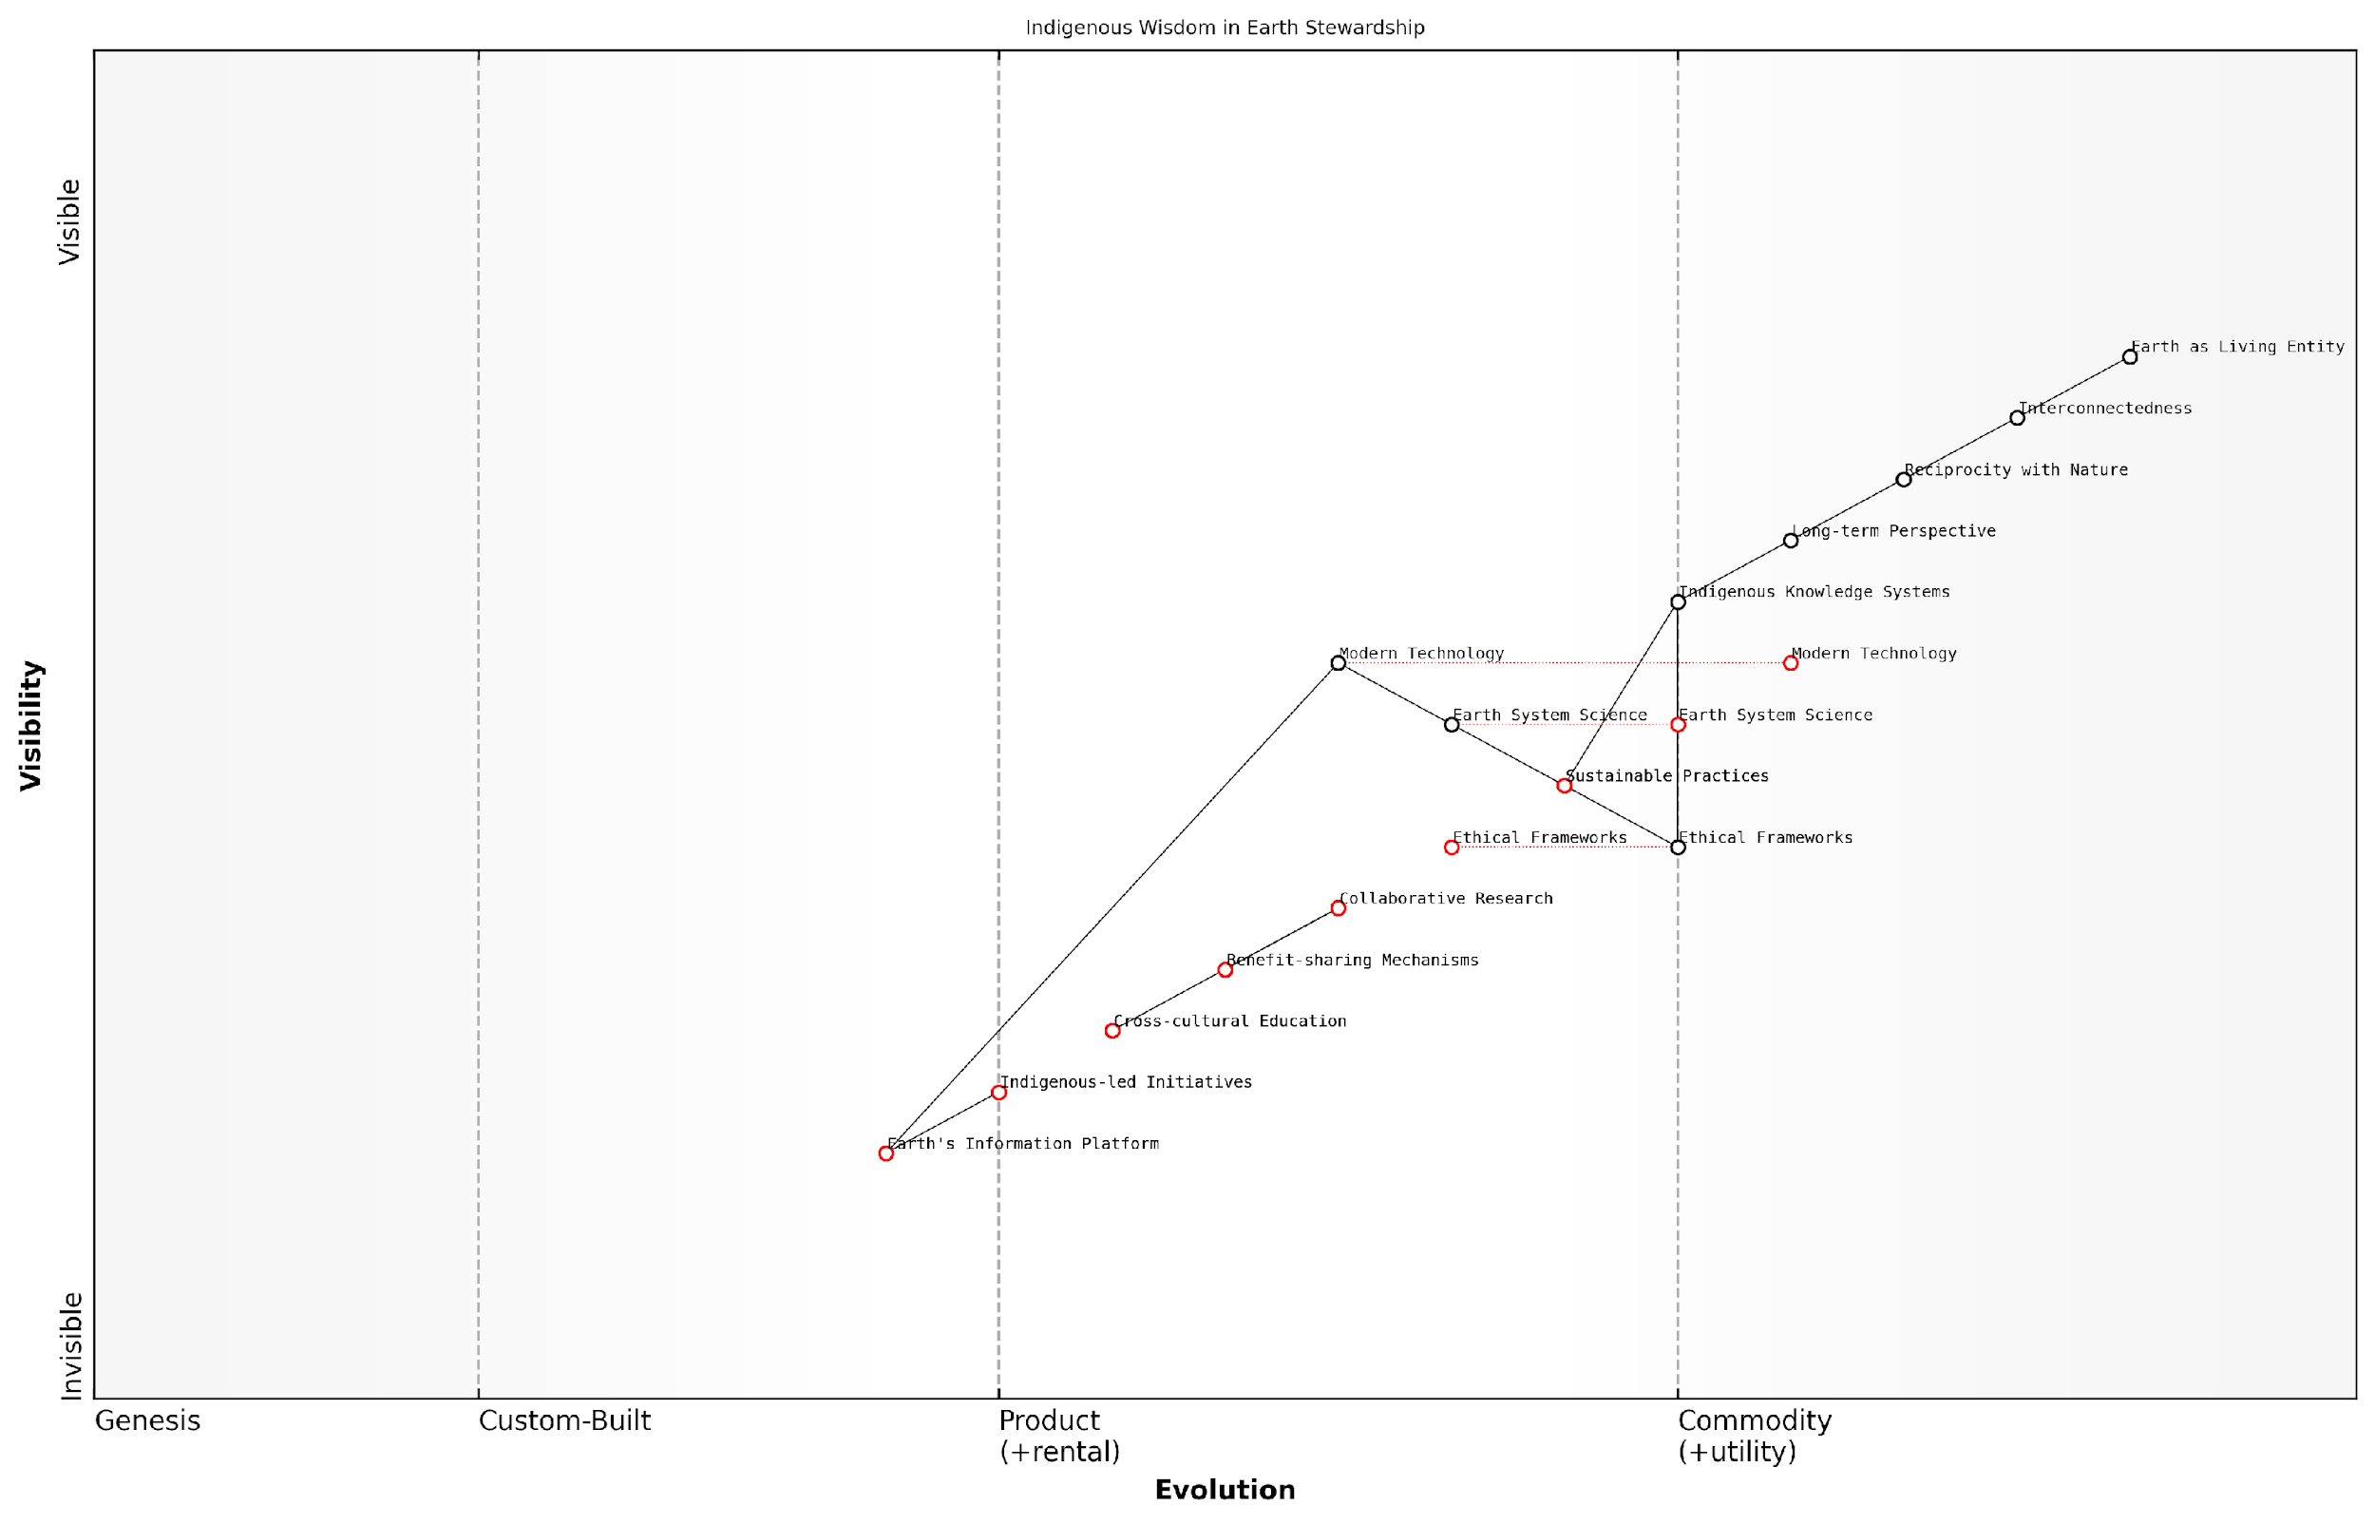

*Draft Wardley Map: [Insert Wardley Map: Indigenous wisdom and Earth-centric worldviews]*

[Edit this draft Wardley Map](https://create.wardleymaps.ai/#clone:5ea60a5e1ed5e46922)

Wardley Map Assessment

This Wardley Map represents a progressive and holistic approach to Earth stewardship that seeks to integrate indigenous wisdom with modern scientific and technological capabilities. The strategic position is strong, with a clear focus on sustainability and ethical considerations. The main opportunities lie in further developing the Earth’s Information Platform, enhancing the integration of Indigenous Knowledge Systems with modern approaches, and scaling up Indigenous-led Initiatives. Key challenges include ensuring equitable benefit-sharing and managing the ethical implications of new technologies. Overall, this approach has the potential to revolutionise our relationship with the Earth and address the pressing environmental crisis through a unique blend of ancient wisdom and cutting-edge innovation.

[View full Wardley Map report](https://github.com/tractorjuice/test-repo/blob/main/markdown_wardley_map_reports/wardley_map_report_45_Indigenous_wisdom_and_Earth-centric_worldviews.md)

### Balancing human needs with planetary health

In the context of Conscious Earth and the harnessing of the planet’s information platform revolution, the challenge of balancing human needs with planetary health stands as a critical ethical imperative. As we delve deeper into understanding and utilising Earth’s intricate systems, we must navigate the complex interplay between human development and the preservation of our planet’s ecological integrity. This balance is not merely a philosophical consideration but a practical necessity that underpins the very sustainability of our existence on Earth.

The concept of planetary health, as defined by the Rockefeller Foundation–Lancet Commission, encompasses ‘the health of human civilisation and the state of the natural systems on which it depends’. This definition inherently recognises the interdependence between human wellbeing and the Earth’s ecological systems, setting the stage for a nuanced approach to Earth stewardship that considers both human and planetary needs.

We are not apart from nature; we are a part of nature. Our health and the health of our planet are inextricably linked, and we must approach our relationship with Earth’s systems with this fundamental truth in mind.

To effectively balance human needs with planetary health, we must consider several key aspects:

* Sustainable Resource Utilisation
* Ecosystem Services Valuation
* Technological Innovation for Sustainability
* Social Equity and Environmental Justice
* Long-term Planetary Boundaries Consideration

Sustainable Resource Utilisation: As we harness the Earth’s information platform, we must ensure that our extraction and use of natural resources do not exceed the planet’s regenerative capacity. This requires a shift from the traditional linear economic model to a circular economy approach, where waste is minimised, and resources are used efficiently and repeatedly. In my work advising government bodies on sustainable development strategies, I’ve observed that implementing circular economy principles can lead to significant reductions in resource consumption while maintaining economic growth.

Ecosystem Services Valuation: Recognising and quantifying the value of ecosystem services is crucial for balancing human needs with planetary health. These services, which include climate regulation, water purification, and pollination, are often taken for granted in traditional economic models. By incorporating the true value of these services into decision-making processes, we can better align human activities with the preservation of critical ecological functions. For instance, in a recent project with a national environmental agency, we developed a framework for assessing the economic value of wetland ecosystems, which led to more informed policy decisions regarding land use and conservation.

Technological Innovation for Sustainability: The Earth’s information platform revolution offers unprecedented opportunities for technological innovations that can meet human needs while minimising environmental impact. Biomimicry and nature-inspired design principles can guide the development of more efficient and sustainable technologies. For example, in collaboration with a government innovation fund, we supported the development of water purification systems inspired by mangrove root structures, which proved to be more energy-efficient and effective than traditional methods.

Social Equity and Environmental Justice: Balancing human needs with planetary health must also consider issues of social equity and environmental justice. The benefits and burdens of environmental challenges and solutions are often unevenly distributed. Ensuring that marginalised communities are not disproportionately affected by environmental degradation or excluded from the benefits of sustainable development is crucial. In my experience working with urban planning departments, integrating environmental justice considerations into city development plans has led to more equitable and sustainable outcomes for all residents.

Long-term Planetary Boundaries Consideration: The concept of planetary boundaries, introduced by Johan Rockström and colleagues, provides a framework for understanding the limits within which humanity can safely operate. These boundaries include climate change, biodiversity loss, and biogeochemical flows, among others. Balancing human needs with planetary health requires a long-term perspective that respects these boundaries. In advising policymakers, I’ve emphasised the importance of incorporating planetary boundary considerations into national environmental strategies, leading to more holistic and forward-thinking approaches to sustainable development.

The challenge is not to choose between human development and environmental protection, but to find innovative ways to achieve both simultaneously. This is the essence of true sustainability in the age of Conscious Earth.

Implementing these considerations requires a multi-faceted approach that combines policy interventions, technological innovation, and shifts in societal values. Some key strategies include:

* Developing comprehensive natural capital accounting systems
* Implementing green taxation and incentive structures
* Fostering cross-sector collaboration for sustainable innovation
* Enhancing environmental education and public engagement
* Strengthening international cooperation on global environmental challenges

In my consultancy work with various government agencies, I’ve observed that successful implementation of these strategies often requires a paradigm shift in how we perceive the relationship between human activities and natural systems. This shift involves moving from a mindset of exploitation to one of stewardship, recognising that our long-term prosperity is inextricably linked to the health of our planet.

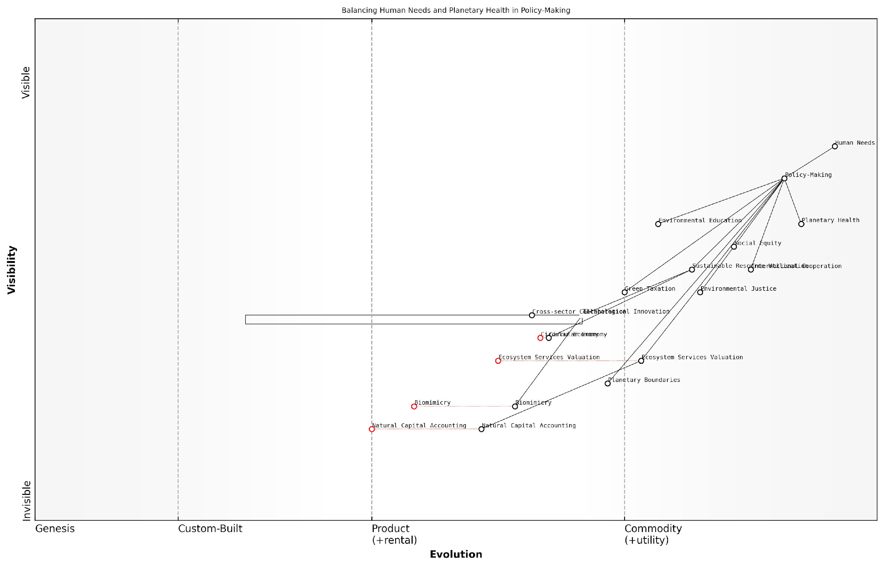

*Draft Wardley Map: [Insert Wardley Map: Balancing human needs with planetary health]*

[Edit this draft Wardley Map](https://create.wardleymaps.ai/#clone:485d77b3db28aaf590)

Wardley Map Assessment

This Wardley Map reveals a strategic landscape in transition, where traditional policy-making approaches are being challenged and enhanced by emerging concepts in sustainability and environmental stewardship. The key strategic opportunity lies in accelerating the evolution of custom-built components like Ecosystem Services Valuation and Natural Capital Accounting, while ensuring these advancements are effectively integrated into high-level policy-making processes. Success will require strong cross-sector collaboration, continued technological innovation, and a commitment to balancing human needs with planetary health. The map suggests that organisations and governments that can effectively navigate this complex landscape, leveraging emerging concepts like Biomimicry and Circular Economy, will be well-positioned to lead in the era of sustainable development.

[View full Wardley Map report](https://github.com/tractorjuice/test-repo/blob/main/markdown_wardley_map_reports/wardley_map_report_46_Balancing_human_needs_with_planetary_health.md)

The above Wardley Map illustrates the strategic landscape for balancing human needs with planetary health in policy-making, highlighting the evolution of key components from genesis to utility.

In conclusion, balancing human needs with planetary health is not just an ethical imperative but a practical necessity in the context of Conscious Earth. By leveraging the Earth’s information platform revolution, we have the opportunity to develop innovative solutions that meet human needs while preserving and enhancing the health of our planet. This balance requires a holistic approach that considers ecological limits, social equity, and long-term sustainability. As we continue to explore and harness the Earth’s intelligence, maintaining this balance will be crucial for ensuring a thriving future for both humanity and the planet we call home.

## Potential Risks of Exploiting Earth’s Intelligence

### Unintended consequences of biomimetic technologies

As we delve deeper into the realm of Conscious Earth and harness the planet’s information platform revolution, it is crucial to examine the potential unintended consequences of biomimetic technologies. These technologies, inspired by nature’s ingenious solutions, hold immense promise for addressing global challenges. However, their implementation may lead to unforeseen impacts on ecosystems, human society, and the delicate balance of Earth’s systems.

The unintended consequences of biomimetic technologies can be broadly categorised into three main areas: ecological disruption, socioeconomic implications, and ethical dilemmas. Each of these areas presents unique challenges that require careful consideration and proactive management.

Ecological Disruption:

* Ecosystem imbalance: Biomimetic technologies may inadvertently disrupt existing ecological relationships, potentially leading to unforeseen cascading effects throughout food webs and habitats.
* Invasive species analogues: Technologies that mimic natural organisms could potentially become ‘invasive’ in their own right, outcompeting native species or altering ecosystem dynamics.
* Unintended environmental impacts: The production and disposal of biomimetic technologies may introduce new pollutants or stressors into the environment, despite their nature-inspired design.

Socioeconomic Implications:

* Job displacement: As biomimetic technologies become more advanced, they may replace traditional industries and jobs, potentially leading to economic disruption and social inequality.
* Resource allocation shifts: The focus on biomimetic solutions may divert resources from other important areas of research and development, potentially slowing progress in critical fields.
* Accessibility and equity issues: There is a risk that biomimetic technologies may be accessible only to wealthy nations or individuals, exacerbating global inequalities.

Ethical Dilemmas:

* Blurring lines between natural and artificial: As biomimetic technologies become more sophisticated, the distinction between natural and artificial systems may become increasingly unclear, raising philosophical and ethical questions.
* Exploitation of nature: There is a risk that the pursuit of biomimetic solutions may lead to increased exploitation of natural resources and organisms for technological gain.
* Unintended consequences on human behaviour: Biomimetic technologies may influence human behaviour in unexpected ways, potentially altering our relationship with nature and each other.

As we venture further into the realm of biomimicry, we must remain vigilant of the potential for our creations to outpace our understanding of their impacts. The power to mimic nature’s genius comes with a profound responsibility to safeguard the very systems we seek to emulate.

Case Study: Nanobot Pollination Technology

To illustrate the potential unintended consequences of biomimetic technologies, let us consider a hypothetical case study based on my experience advising government bodies on emerging technologies. Imagine a scenario where nanobots are developed to mimic the pollination capabilities of bees, in response to declining bee populations. While the intention is to support agricultural productivity and ecosystem health, several unintended consequences could arise:

* Ecological impact: The nanobots may outcompete remaining natural pollinators, further reducing their populations and disrupting complex ecological relationships.
* Technological dependence: Agriculture could become overly reliant on this technology, making food security vulnerable to technological failures or cyberattacks.
* Unforeseen interactions: The nanobots might interact with pesticides or other agricultural chemicals in unexpected ways, potentially creating new environmental hazards.
* Socioeconomic shifts: Traditional beekeepers and honey producers could face economic hardship, leading to loss of cultural practices and traditional ecological knowledge.

This case study underscores the importance of comprehensive risk assessment and ongoing monitoring when implementing biomimetic technologies. It also highlights the need for interdisciplinary collaboration to anticipate and mitigate potential unintended consequences.

Mitigating Risks and Fostering Responsible Innovation:

To address the potential unintended consequences of biomimetic technologies, a multi-faceted approach is necessary:

* Comprehensive impact assessments: Develop robust frameworks for assessing the ecological, socioeconomic, and ethical impacts of biomimetic technologies before widespread implementation.
* Adaptive management strategies: Implement flexible management approaches that allow for continuous monitoring and adjustment of biomimetic technologies in response to observed impacts.
* Interdisciplinary collaboration: Foster collaboration between technologists, ecologists, social scientists, and ethicists to ensure a holistic approach to technology development and implementation.
* Regulatory frameworks: Establish clear guidelines and regulations for the development, testing, and deployment of biomimetic technologies, with a focus on long-term sustainability and ethical considerations.
* Public engagement and transparency: Ensure open dialogue with stakeholders and the public about the potential benefits and risks of biomimetic technologies, fostering informed decision-making and social acceptance.
* Ethical guidelines: Develop and adhere to ethical guidelines that prioritise the preservation of natural systems and biodiversity alongside technological innovation.

In our pursuit of harnessing Earth’s wisdom through biomimetic technologies, we must remain mindful that our role is not to replace nature, but to work in harmony with it. Our greatest challenge lies in developing technologies that enhance rather than disrupt the intricate balance of life on our planet.

As we continue to explore and harness the Earth’s information platform revolution, it is imperative that we approach biomimetic technologies with a sense of humility and responsibility. By anticipating and addressing potential unintended consequences, we can work towards a future where these technologies truly serve as a bridge between human innovation and the wisdom of our living planet.

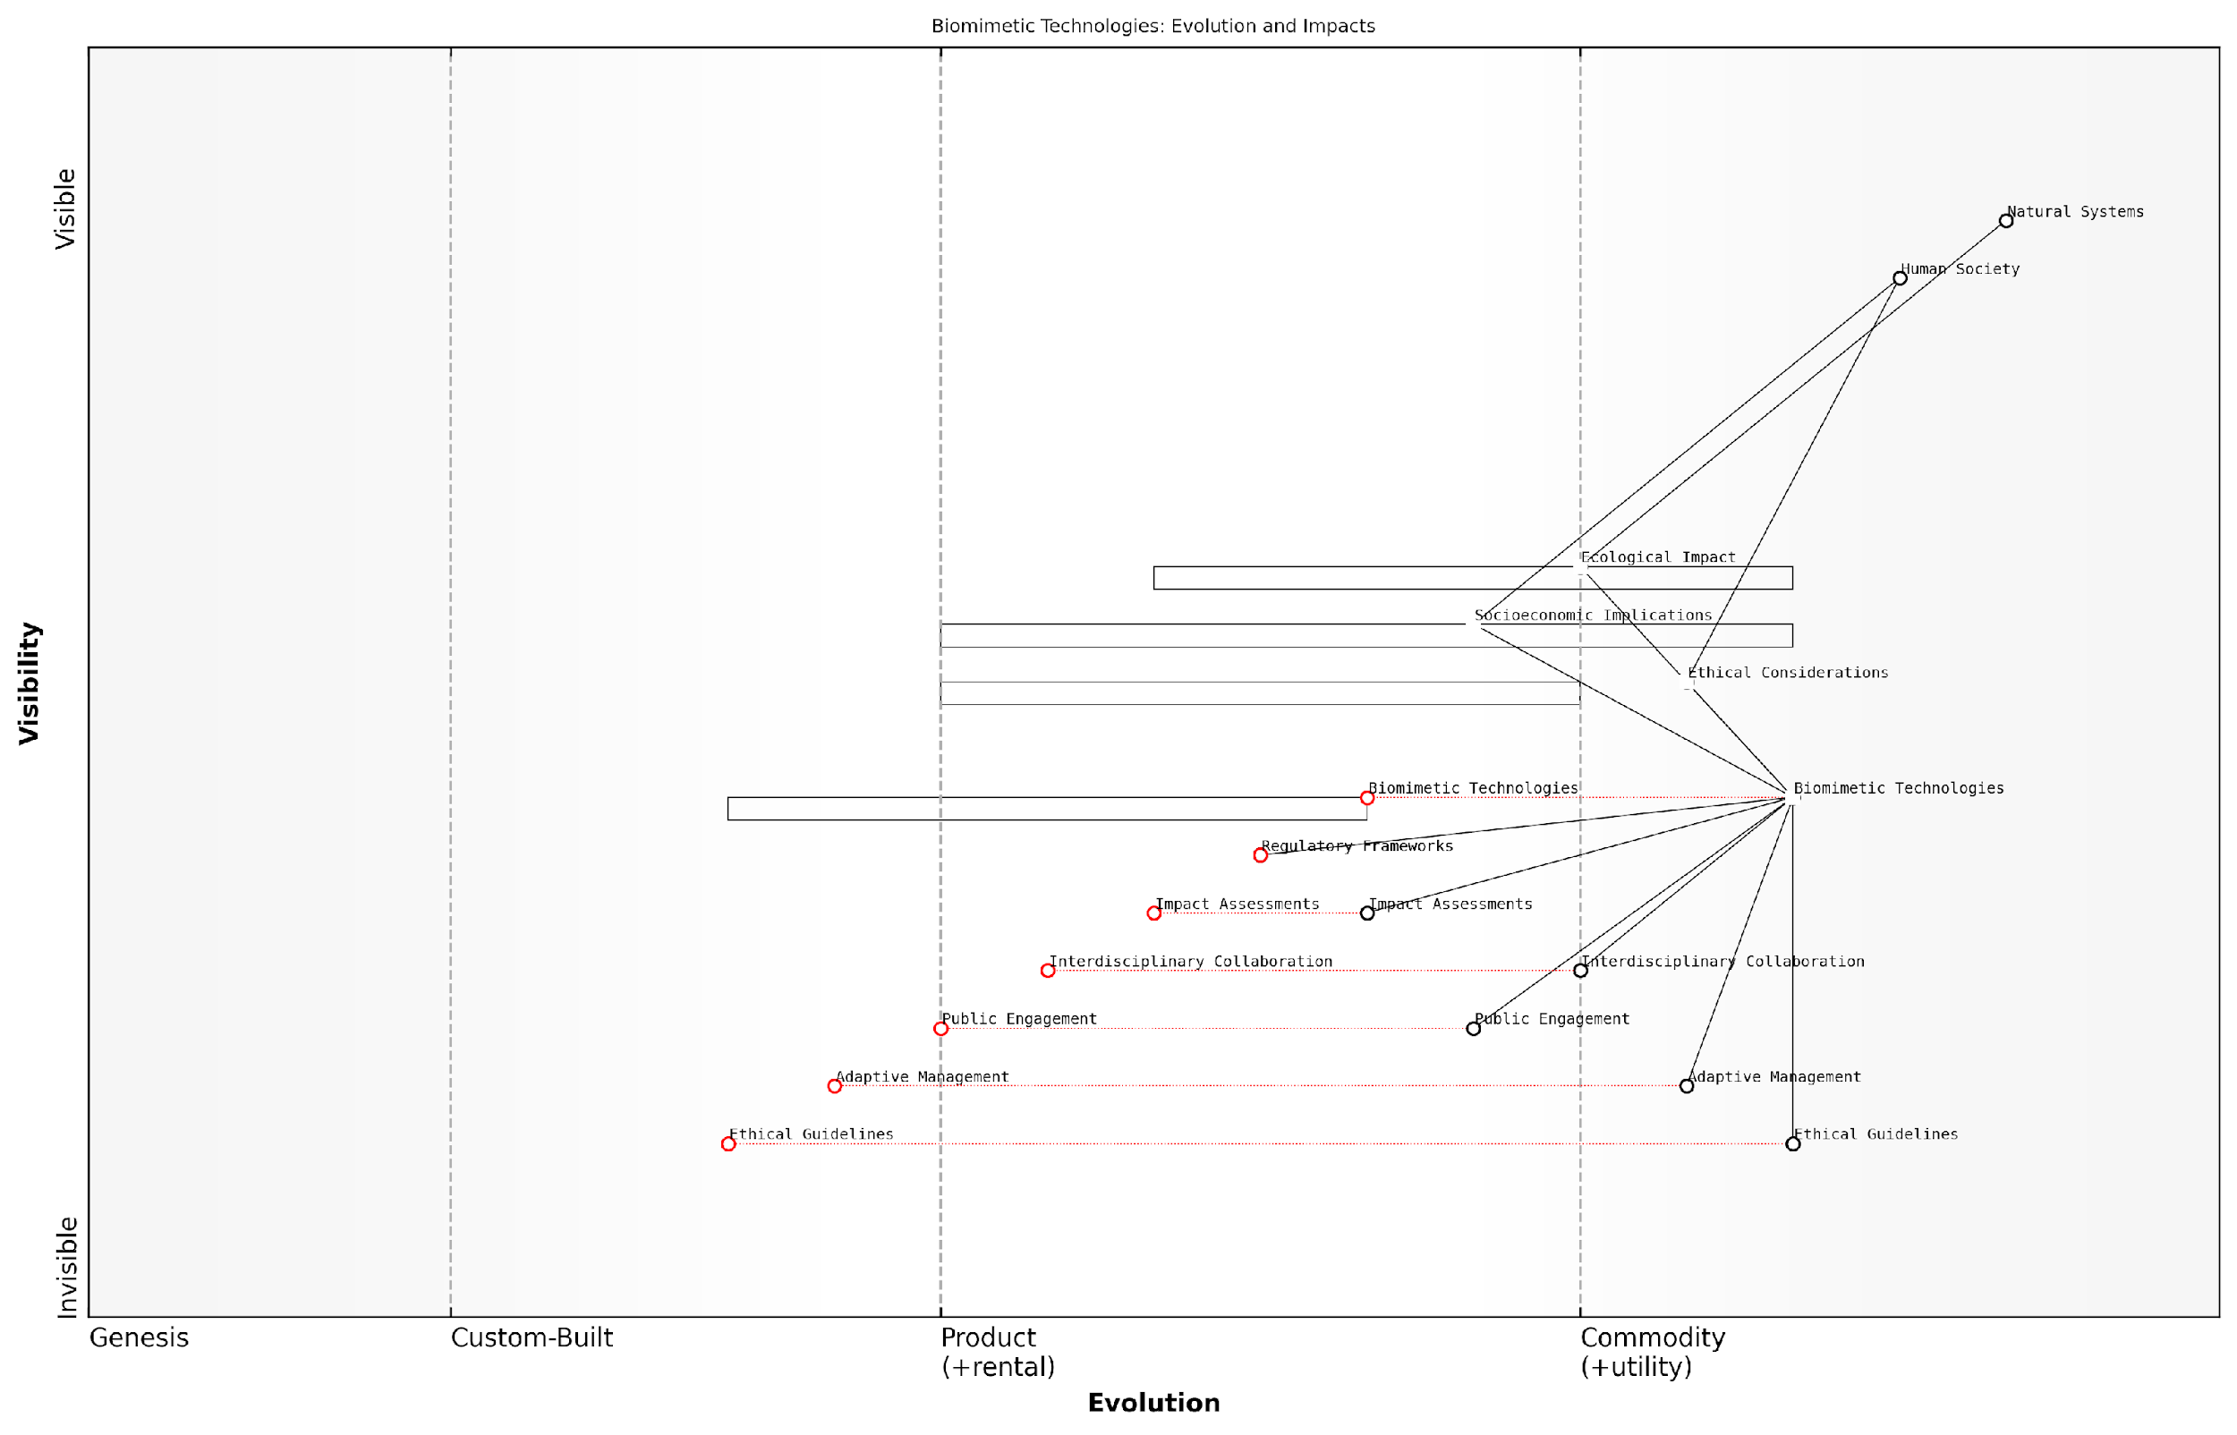

*Draft Wardley Map: [Insert Wardley Map: Unintended consequences of biomimetic technologies]*

[Edit this draft Wardley Map](https://create.wardleymaps.ai/#clone:fe608cd65f59682b7a)

Wardley Map Assessment

This map represents a critical juncture in the development of biomimetic technologies, highlighting the need for a balanced approach that harmonizes technological innovation with ecological responsibility, societal benefit, and ethical governance. The strategic imperative is to accelerate the evolution of regulatory frameworks, ethical guidelines, and public engagement to match the pace of technological advancement, while ensuring comprehensive impact assessments and adaptive management practices. Success in this domain will require unprecedented levels of interdisciplinary collaboration and a commitment to holistic, systems-level thinking that considers the complex interplay between technology, nature, and society.

[View full Wardley Map report](https://github.com/tractorjuice/test-repo/blob/main/markdown_wardley_map_reports/wardley_map_report_47_Unintended_consequences_of_biomimetic_technologies.md)

### Privacy and security concerns in natural information systems

As we delve deeper into harnessing the Earth’s intelligence through natural information systems, we must confront the critical issues of privacy and security that arise from this unprecedented integration of technology and nature. These concerns are not merely theoretical; they represent real challenges that governments, organisations, and individuals must address as we progress towards a more interconnected planetary consciousness.

Natural information systems, by their very nature, process vast amounts of data about our planet’s ecosystems, climate patterns, and biological processes. As we tap into these systems, we inadvertently create new vulnerabilities and potential points of exploitation. Let us explore the key areas of concern and their implications for the future of Conscious Earth technologies.

* Data Integrity and Authenticity
* Unauthorised Access and Manipulation
* Ecosystem Privacy
* Biometric Data Concerns
* Geopolitical Implications

Data Integrity and Authenticity: One of the primary concerns in natural information systems is ensuring the integrity and authenticity of the data collected. As we increasingly rely on Earth’s intelligence for critical decision-making processes, any compromise in data quality could have far-reaching consequences. For instance, manipulated climate data could lead to misguided environmental policies, while corrupted biodiversity information might result in ill-informed conservation efforts.

The integrity of Earth’s data is paramount. If we can’t trust the information we’re gathering from natural systems, we risk making decisions that could have catastrophic consequences for our planet and its inhabitants.

Unauthorised Access and Manipulation: As natural information systems become more sophisticated and interconnected, they also become more attractive targets for malicious actors. Unauthorised access to these systems could lead to the manipulation of critical environmental data, disruption of ecosystem monitoring, or even the weaponisation of natural processes. The potential for eco-terrorism or state-sponsored attacks on natural information systems is a growing concern that requires robust security measures and international cooperation.

Ecosystem Privacy: An often-overlooked aspect of privacy in natural information systems is the concept of ‘ecosystem privacy’. As we develop more advanced sensing technologies and data collection methods, we risk intruding upon the natural processes and behaviours of ecosystems. This raises ethical questions about the extent to which we should monitor and interfere with nature’s own information exchange. There’s a delicate balance to strike between gathering necessary data for conservation and sustainable management, and respecting the inherent privacy of natural systems.

We must consider the ethical implications of our data collection practices on ecosystems. Just as we value human privacy, we should also respect the autonomy and privacy of natural systems.

Biometric Data Concerns: As we delve deeper into understanding and replicating natural algorithms, we inevitably encounter issues related to biometric data. The genetic information of plants and animals, as well as human biological data, becomes increasingly valuable in the context of natural information systems. This raises significant privacy concerns, particularly when it comes to the collection, storage, and use of such sensitive information. The potential for misuse of biometric data in areas such as genetic engineering or bioweapon development necessitates stringent safeguards and ethical guidelines.

Geopolitical Implications: The ability to harness and control natural information systems could become a significant source of geopolitical power. Nations with advanced capabilities in this area may gain strategic advantages in areas such as climate prediction, resource management, and environmental manipulation. This could lead to new forms of information warfare and exacerbate existing global inequalities. It is crucial to develop international frameworks and agreements to ensure equitable access to Earth’s intelligence and prevent the monopolisation of these vital resources.

Addressing these privacy and security concerns requires a multifaceted approach that combines technological solutions, policy frameworks, and ethical guidelines. Some key strategies include:

* Developing robust encryption and authentication mechanisms specifically designed for natural information systems
* Implementing strict access controls and audit trails for all interactions with Earth’s intelligence platforms
* Creating international standards and protocols for the ethical collection and use of ecosystem data
* Establishing independent oversight bodies to monitor and regulate the use of natural information systems
* Investing in education and awareness programmes to foster a culture of responsible stewardship in the use of Earth’s intelligence

In my experience advising government bodies on these matters, I’ve observed a growing recognition of the need for proactive measures. For instance, one European nation has recently established a dedicated task force to develop a comprehensive framework for securing natural information systems. This initiative brings together experts from fields as diverse as cybersecurity, ecology, and ethics to create a holistic approach to addressing these challenges.

The security of natural information systems is not just a technological challenge, but a moral imperative. We have a responsibility to protect not only our own interests but also the integrity of the Earth’s intelligence itself.

As we continue to explore and harness the Earth’s information platform revolution, it is crucial that we remain vigilant about the privacy and security implications of our actions. By addressing these concerns proactively and ethically, we can ensure that the benefits of Conscious Earth technologies are realised without compromising the delicate balance of our planet’s ecosystems or our own societal values.

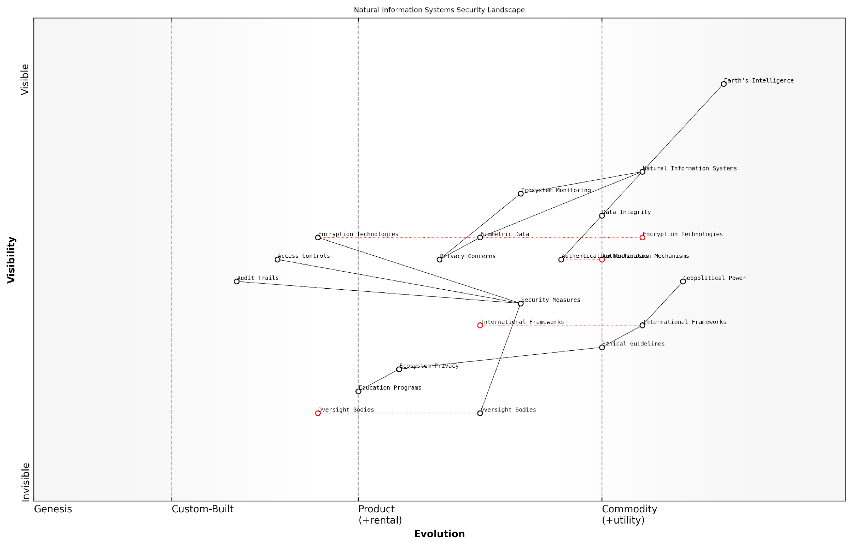

*Draft Wardley Map: [Insert Wardley Map: Privacy and security concerns in natural information systems]*

[Edit this draft Wardley Map](https://create.wardleymaps.ai/#clone:633e9f52b81fac0cc3)

Wardley Map Assessment

This Wardley Map reveals a complex and evolving landscape at the intersection of natural systems, technology, and global governance. The strategic imperative is to develop robust security and privacy measures that can keep pace with the exploitation of Earth’s Intelligence, while simultaneously fostering international cooperation to establish ethical guidelines and oversight mechanisms. Success in this domain will require a delicate balance between innovation, security, and ethical considerations, with a strong emphasis on adaptability to rapidly evolving technological and regulatory landscapes.

[View full Wardley Map report](https://github.com/tractorjuice/test-repo/blob/main/markdown_wardley_map_reports/wardley_map_report_48_Privacy_and_security_concerns_in_natural_informati.md)

### Ecological disruption through excessive data harvesting

As we delve deeper into the realm of Conscious Earth and harness the planet’s information platform revolution, we must confront a critical ethical challenge: the potential for ecological disruption through excessive data harvesting. This subsection explores the delicate balance between leveraging Earth’s intelligence and preserving the integrity of natural systems, a concern that has become increasingly pressing in the age of ubiquitous sensing and data collection.

The concept of Earth as an intelligent system, capable of processing and storing vast amounts of information, presents unprecedented opportunities for scientific advancement and technological innovation. However, our eagerness to tap into this planetary knowledge base must be tempered with a profound respect for the complex ecosystems that form the backbone of Earth’s information processing capabilities.

We stand at a crossroads where our ability to extract information from natural systems has outpaced our understanding of the long-term consequences. It is imperative that we approach Earth’s intelligence with the same reverence we would accord to any sentient being.

To fully grasp the implications of excessive data harvesting, we must first understand the multifaceted nature of Earth’s information systems. These systems encompass a wide range of natural phenomena, from the genetic information encoded in DNA to the complex chemical signals exchanged between plants and soil microorganisms. Each of these systems plays a crucial role in maintaining the planet’s ecological balance.

* Genetic information in biodiversity hotspots
* Chemical signalling in soil and plant communities
* Atmospheric data encoded in weather patterns
* Oceanic information carried by currents and marine life
* Geological records stored in rock formations and ice cores

The potential for disruption arises when our data collection methods interfere with these natural information flows. For instance, consider the impact of extensive sensor networks deployed in pristine ecosystems. While these sensors may provide valuable data on biodiversity and ecosystem health, their very presence can alter animal behaviour, disrupt plant growth patterns, and introduce foreign elements into delicate ecological niches.

In my consultancy work with government environmental agencies, I’ve observed firsthand the unintended consequences of well-intentioned monitoring programmes. In one case, a large-scale initiative to track migratory bird patterns using miniature GPS tags led to a measurable decrease in breeding success rates. The additional weight and stress of the tags, while minimal from a human perspective, significantly impacted the birds’ ability to navigate and find mates.

Every act of measurement, no matter how subtle, leaves an imprint on the system being observed. In the context of Earth’s intelligence, we must recognise that we are not passive observers, but active participants in a dynamic, interconnected network.

Another area of concern is the harvesting of genetic information from rare or endangered species. The burgeoning field of biomimicry often looks to nature’s most unique adaptations for inspiration, but the process of collecting and analysing genetic material can pose risks to vulnerable populations. Moreover, the commercialisation of nature-inspired innovations raises complex questions about the ownership and exploitation of Earth’s genetic resources.

To address these challenges, we must develop a new ethical framework that acknowledges the intrinsic value of Earth’s information systems beyond their utility to human endeavours. This framework should be guided by the following principles:

* Minimally invasive data collection techniques
* Prioritisation of passive observation over active intervention
* Equitable sharing of benefits derived from Earth’s intelligence
* Long-term monitoring of ecological impacts from data harvesting activities
* Integration of indigenous knowledge and stewardship practices

Implementing these principles will require a paradigm shift in how we approach Earth system science and technology development. It calls for a move away from extractive models of data collection towards more symbiotic relationships with natural systems. This might involve the development of bio-compatible sensors that can be safely integrated into living organisms, or the use of advanced machine learning techniques to extrapolate from minimal data sets, reducing the need for extensive physical sampling.

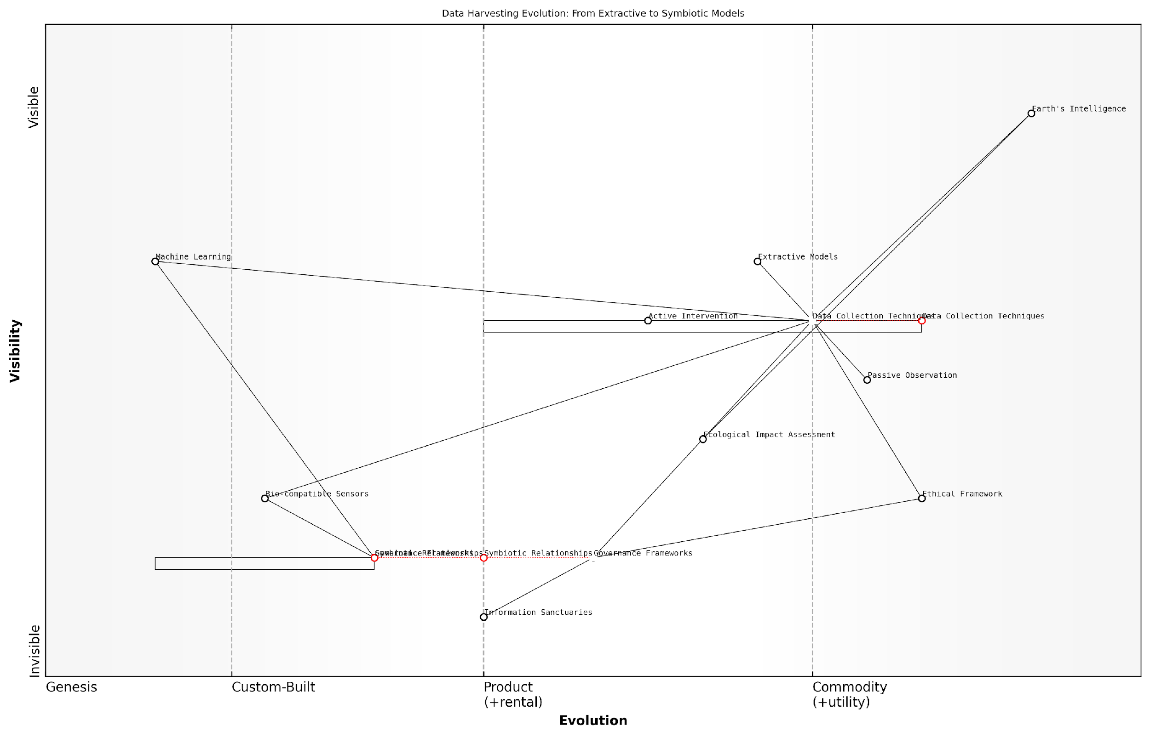

*Draft Wardley Map: [Insert Wardley Map: Ecological disruption through excessive data harvesting]*

[Edit this draft Wardley Map](https://create.wardleymaps.ai/#clone:08ead7f8284d70269f)

Wardley Map Assessment

This Wardley Map represents a critical juncture in the evolution of data harvesting from Earth’s natural systems. It highlights the urgent need to transition from extractive to symbiotic models, driven by ethical considerations and ecological impact awareness. The strategic imperative is to invest in emerging technologies like Bio-compatible Sensors and Symbiotic Relationships while strengthening Governance Frameworks and Ethical standards. Success in this domain will require a delicate balance between technological innovation, ecological stewardship, and regulatory compliance. Organisations that can lead in developing sustainable, symbiotic data harvesting methods while effectively navigating the ethical and governance challenges will be well-positioned for long-term success and positive impact.

[View full Wardley Map report](https://github.com/tractorjuice/test-repo/blob/main/markdown_wardley_map_reports/wardley_map_report_49_Ecological_disruption_through_excessive_data_harve.md)

Furthermore, we must consider the cumulative impact of global data harvesting activities. While individual research projects or technological applications may seem benign in isolation, the aggregate effect of numerous interventions across the planet could lead to significant disruptions in Earth’s information processing capabilities. This necessitates the development of international governance frameworks to coordinate and regulate data harvesting activities on a global scale.

In my work advising on national environmental policies, I’ve advocated for the establishment of ‘information sanctuaries’ – areas where natural information flows are protected from human interference. These sanctuaries would serve as control groups for understanding the baseline functioning of Earth’s intelligence, as well as reservoirs of undisturbed ecological wisdom.

Just as we have established marine protected areas and wildlife reserves, we must now consider the creation of data ecosystems where the Earth’s natural information processes can unfold without human intervention. These sanctuaries may hold the key to understanding the full potential of Gaia 2.0.

As we continue to explore and harness the planet’s information platform revolution, it is crucial that we remain mindful of the delicate balance between knowledge acquisition and ecological preservation. The promise of Conscious Earth lies not in the extraction of information, but in the cultivation of a harmonious, two-way dialogue with our living planet. By approaching Earth’s intelligence with respect, humility, and a commitment to reciprocity, we can unlock new paradigms of sustainable innovation that benefit both humanity and the broader community of life on Earth.

## Governance and Policy Implications

### International cooperation for Earth system management

As we delve into the realm of Conscious Earth and the revolutionary potential of harnessing the planet’s information platform, it becomes increasingly evident that effective Earth system management requires unprecedented levels of international cooperation. The interconnected nature of our planet’s systems transcends political boundaries, necessitating a coordinated global approach to governance and policy-making.

The concept of Earth system management within the context of Conscious Earth presents both immense opportunities and significant challenges. It requires us to reimagine our relationship with the planet, viewing it not as a passive resource to be exploited, but as an intelligent, self-regulating system with which we must collaborate. This paradigm shift demands a recalibration of our governance structures and policy frameworks at a global scale.

The Earth’s information platform is not confined by national borders. Our governance models must evolve to match the borderless nature of the challenges we face.

To effectively harness the planet’s information platform revolution, we must establish robust mechanisms for international cooperation. These mechanisms should facilitate the sharing of data, knowledge, and resources across nations, while also ensuring equitable access to the benefits derived from Earth’s intelligence.

* Global Earth System Monitoring Network
* International Data Sharing Protocols
* Collaborative Research and Development Initiatives
* Unified Policy Frameworks for Earth-Inspired Technologies
* Global Capacity Building Programmes

The Global Earth System Monitoring Network represents a cornerstone of international cooperation in this field. By integrating data from various national and regional monitoring systems, we can create a comprehensive, real-time picture of the Earth’s vital signs. This network would serve as the foundation for informed decision-making at both local and global levels.

International Data Sharing Protocols are crucial to ensure the free flow of information while protecting sensitive data and respecting national sovereignty. In my experience advising government bodies, I’ve observed that the development of these protocols often requires delicate negotiations and a deep understanding of both technological capabilities and geopolitical realities.

Collaborative Research and Development Initiatives play a vital role in advancing our understanding and application of Earth’s intelligence. These initiatives should bring together scientists, policymakers, and industry leaders from around the world to tackle complex challenges and develop innovative solutions.

International collaboration in Earth system research is not just beneficial; it’s imperative. The complexity of our planet’s systems demands a diversity of perspectives and expertise that no single nation can provide alone.

Unified Policy Frameworks for Earth-Inspired Technologies are essential to ensure responsible development and deployment of innovations derived from the planet’s information platform. These frameworks should address issues such as intellectual property rights, ethical use of natural algorithms, and the equitable distribution of benefits.

Global Capacity Building Programmes are necessary to bridge the knowledge and technology gap between nations. These programmes should focus on empowering developing countries to participate fully in Earth system management, ensuring that the benefits of Conscious Earth are accessible to all.

One of the most significant challenges in implementing these cooperative mechanisms is navigating the complex landscape of international relations. In my work with various government agencies, I’ve encountered numerous instances where geopolitical tensions have hindered progress in Earth system management initiatives.

To overcome these challenges, we must foster a sense of shared responsibility for our planet’s future. This requires not only diplomatic efforts but also public engagement and education to build a global consciousness around Earth stewardship.

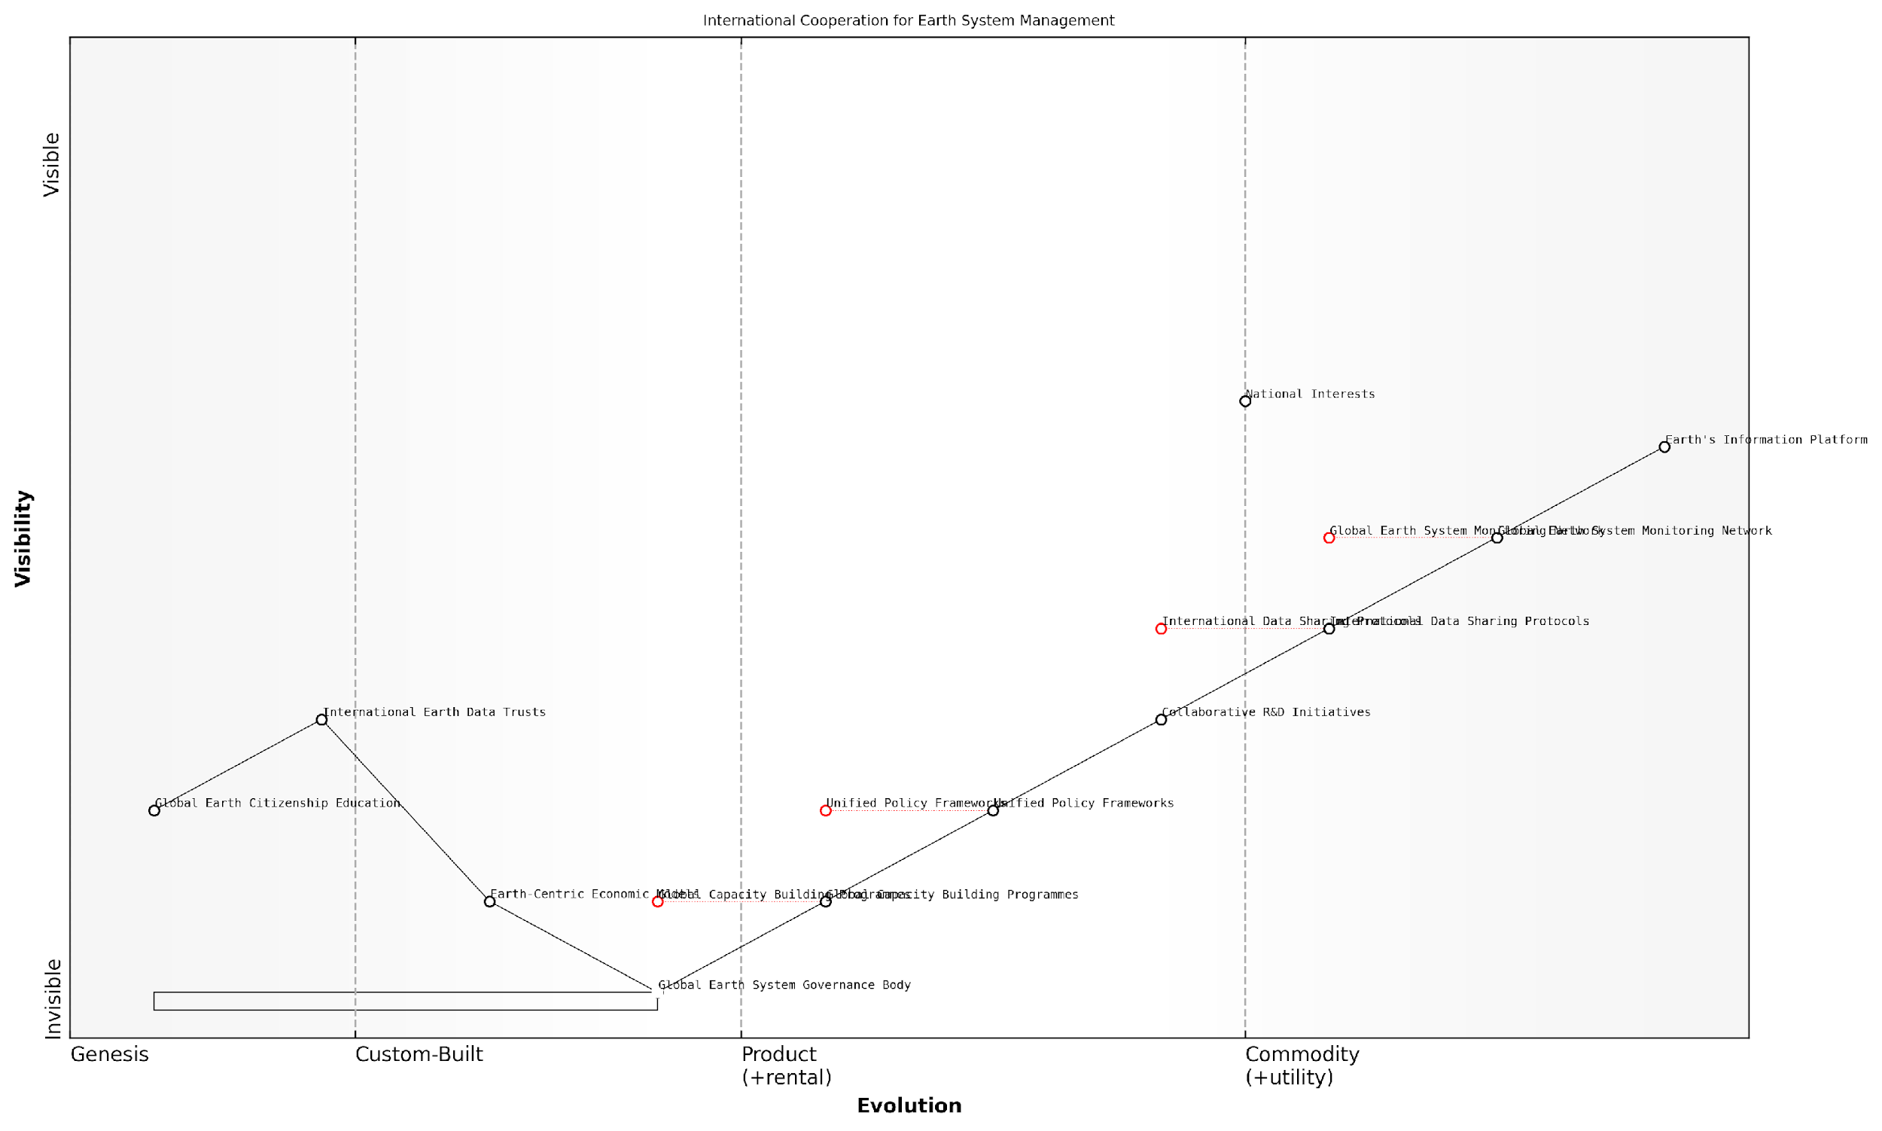

*Draft Wardley Map: [Insert Wardley Map: International cooperation for Earth system management]*

[Edit this draft Wardley Map](https://create.wardleymaps.ai/#clone:dc72a01ff80b5ed646)

Wardley Map Assessment

This Wardley Map represents an ambitious and necessary vision for global Earth system management. It highlights the critical need to evolve from established technical capabilities to new models of global cooperation, governance, and economic thinking. The key challenge lies in bridging the gap between the more evolved technical components and the emerging governance and social concepts. Success will require unprecedented levels of international cooperation, innovative approaches to governance, and a fundamental shift in global economic models. The strategic focus should be on accelerating the evolution of mid-stage components while laying the groundwork for the more conceptual elements at the top of the map.

[View full Wardley Map report](https://github.com/tractorjuice/test-repo/blob/main/markdown_wardley_map_reports/wardley_map_report_50_International_cooperation_for_Earth_system_managem.md)

The governance implications of Conscious Earth extend beyond traditional environmental policy. They touch upon areas such as data governance, technology regulation, and even the redefinition of national interests in light of our planet’s interconnected systems.

* Establishment of a Global Earth System Governance Body
* Integration of Earth System Considerations into National Policy-Making
* Development of Earth-Centric Economic Models
* Creation of International Earth Data Trusts
* Implementation of Global Earth Citizenship Education

The establishment of a Global Earth System Governance Body would provide a centralised platform for coordinating international efforts in Earth system management. This body would need to be carefully designed to ensure equitable representation and decision-making power for all nations, while also incorporating the expertise of scientists and other relevant stakeholders.

Integrating Earth System Considerations into National Policy-Making is crucial for ensuring that local actions align with global Earth system management goals. This requires a fundamental shift in how governments approach policy development, necessitating the incorporation of Earth system science into all aspects of governance.

The development of Earth-Centric Economic Models represents a paradigm shift in how we value and account for natural resources and ecosystem services. These models would need to incorporate the principles of circular economy and recognise the Earth’s information processing capabilities as a valuable asset.

Our economic systems must evolve to recognise the true value of Earth’s intelligence. Only then can we hope to achieve a sustainable balance between human development and planetary health.

International Earth Data Trusts could serve as neutral repositories for the vast amounts of data generated through Earth system monitoring. These trusts would need to be governed by transparent, internationally agreed-upon protocols to ensure fair access and use of data while protecting privacy and security interests.

Finally, the implementation of Global Earth Citizenship Education programmes is essential for building a shared understanding of our role as stewards of a Conscious Earth. These programmes should be integrated into educational curricula worldwide, fostering a new generation of global citizens equipped to participate in Earth system management.

In conclusion, the governance and policy implications of international cooperation for Earth system management are far-reaching and transformative. They require us to reimagine our global governance structures, redefine our economic systems, and cultivate a new relationship with our planet. While the challenges are significant, the potential benefits of harnessing the Earth’s information platform revolution through effective international cooperation are immense, offering hope for a more sustainable and harmonious future for all of Earth’s inhabitants.

### Regulatory frameworks for Earth-inspired technologies

As we delve deeper into the realm of Earth-inspired technologies within the context of Conscious Earth, the need for robust regulatory frameworks becomes increasingly apparent. These frameworks serve as the cornerstone for responsible innovation, ensuring that our technological advancements align with the principles of planetary stewardship and sustainable development. The complexity of Earth-inspired technologies, which often blur the lines between natural and artificial systems, presents unique challenges for policymakers and regulators alike.

To effectively address these challenges, we must consider several key aspects of regulatory frameworks:

* Adaptive Governance Models
* Cross-Sector Collaboration
* Ethical Guidelines and Standards
* Risk Assessment and Management
* Intellectual Property Considerations
* International Harmonisation

Adaptive Governance Models: The dynamic nature of Earth-inspired technologies necessitates a shift from traditional, rigid regulatory approaches to more flexible and responsive governance models. These adaptive frameworks must be capable of evolving alongside technological advancements, ensuring that regulations remain relevant and effective in the face of rapid innovation.

Adaptive governance is not about predicting the future, but about creating systems that can respond effectively to change and uncertainty.

In my experience advising government bodies on this matter, I’ve observed that successful adaptive governance models often incorporate iterative policy-making processes, regular stakeholder consultations, and built-in review mechanisms. For instance, the UK’s Regulatory Horizons Council serves as an exemplar of this approach, providing government with impartial, expert advice on the regulation of transformative technologies.

Cross-Sector Collaboration: Earth-inspired technologies often transcend traditional sector boundaries, necessitating collaborative regulatory approaches. Effective frameworks must facilitate cooperation between various government departments, industry stakeholders, academic institutions, and civil society organisations.

A prime example of this collaborative approach can be seen in the regulation of biomimetic materials. These materials, inspired by natural structures and processes, often have applications spanning multiple sectors, from healthcare to construction. Regulatory bodies must work in concert to ensure comprehensive oversight without stifling innovation.

Ethical Guidelines and Standards: As we harness the Earth’s intelligence for technological advancement, it is crucial to establish clear ethical guidelines and standards. These should address issues such as environmental impact, biodiversity preservation, and the responsible use of natural resources in the development and deployment of Earth-inspired technologies.

Ethics must be at the heart of our regulatory frameworks, ensuring that our technological progress aligns with our values as stewards of the Earth.

In my work with public sector organisations, I’ve emphasised the importance of incorporating ethical considerations into the earliest stages of technology development and regulation. This proactive approach helps prevent ethical dilemmas from arising later in the innovation process.

Risk Assessment and Management: Earth-inspired technologies often operate at the intersection of natural and artificial systems, presenting unique risks that may not be fully captured by traditional risk assessment methodologies. Regulatory frameworks must incorporate advanced risk assessment tools that can account for the complex interactions between these technologies and Earth’s ecosystems.

For instance, when regulating bio-inspired artificial intelligence systems that interact with natural environments, we must consider not only the immediate technological risks but also potential long-term ecological impacts. This requires a holistic approach to risk assessment that draws on expertise from diverse fields, including ecology, computer science, and systems theory.

Intellectual Property Considerations: The unique nature of Earth-inspired technologies raises complex questions regarding intellectual property rights. How do we balance the need to incentivise innovation with the principle that nature’s designs should be accessible to all? Regulatory frameworks must address this delicate balance, potentially through the development of new IP models that recognise the Earth as a co-creator.

In my consultancy work, I’ve advocated for the exploration of novel IP approaches, such as ‘biomimicry commons’ or ‘nature-inspired open-source licences’, which could provide a middle ground between traditional patent systems and completely open access.

International Harmonisation: Given the global nature of Earth’s systems and the potential for Earth-inspired technologies to have far-reaching impacts, international harmonisation of regulatory frameworks is crucial. This harmonisation should aim to create a level playing field for innovation while ensuring consistent standards for environmental protection and ethical development.

The journey towards effective regulatory frameworks for Earth-inspired technologies is ongoing and complex. It requires a delicate balance between fostering innovation and ensuring responsible development. As we continue to unlock the potential of the Earth’s information platform, our regulatory approaches must evolve to become as adaptive, interconnected, and resilient as the natural systems that inspire our technological advancements.

The most effective regulatory frameworks will be those that can learn and adapt, much like the Earth’s own systems.

In conclusion, the development of robust regulatory frameworks for Earth-inspired technologies is a critical component of our journey towards harnessing the planet’s information platform revolution. By embracing adaptive governance, fostering cross-sector collaboration, prioritising ethical considerations, and striving for international harmonisation, we can create a regulatory environment that supports responsible innovation while safeguarding the delicate balance of our planet’s ecosystems. As we move forward, it is imperative that policymakers, industry leaders, and researchers work together to refine and implement these frameworks, ensuring that our technological progress aligns with the principles of planetary stewardship and sustainable development.

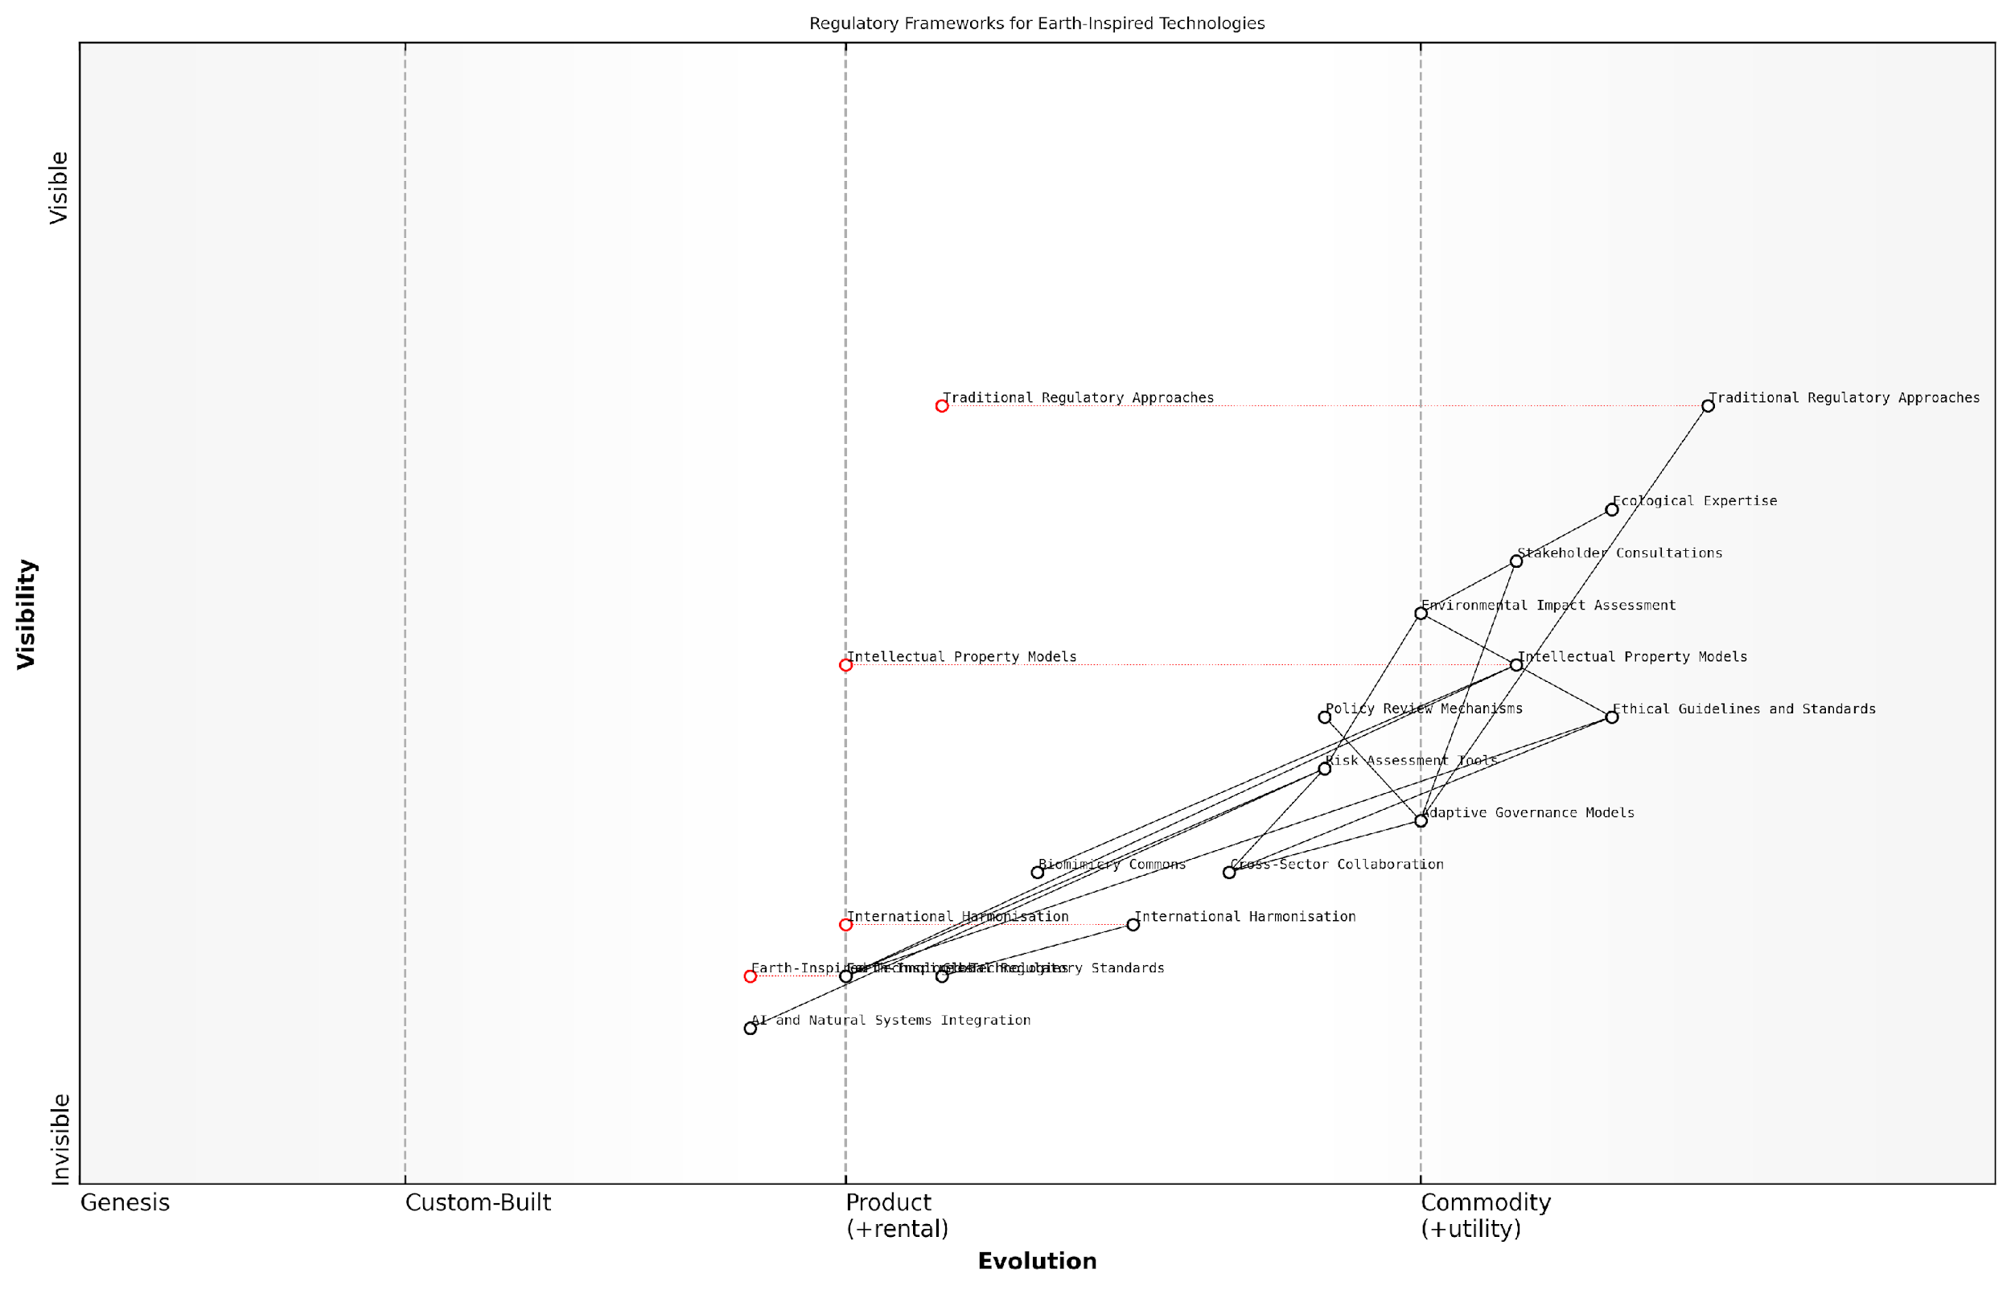

*Draft Wardley Map: [Insert Wardley Map: Regulatory frameworks for Earth-inspired technologies]*

[Edit this draft Wardley Map](https://create.wardleymaps.ai/#clone:81ea0bdda5dd82044d)

Wardley Map Assessment

This Wardley Map reveals a regulatory landscape in transition, moving from traditional, rigid approaches towards more adaptive, collaborative, and technology-integrated models. The central challenge lies in developing governance frameworks that can keep pace with rapidly evolving Earth-inspired technologies while ensuring ethical considerations and environmental protection. Success will require significant investment in cross-sector collaboration, adaptive governance models, and the integration of ecological expertise with cutting-edge technological understanding. The strategic focus should be on bridging the gap between traditional regulatory approaches and emerging technologies, fostering international harmonisation, and developing robust risk assessment tools tailored to Earth-inspired innovations. Organisations operating in this space should prioritise flexibility, collaborative partnerships, and continuous learning to navigate the evolving regulatory landscape effectively.

[View full Wardley Map report](https://github.com/tractorjuice/test-repo/blob/main/markdown_wardley_map_reports/wardley_map_report_51_Regulatory_frameworks_for_Earth-inspired_technolog.md)

### Balancing innovation with precautionary principles

In the realm of Conscious Earth: Harnessing the Planet’s Information Platform Revolution, the delicate balance between fostering innovation and adhering to precautionary principles is of paramount importance. As we delve deeper into understanding and utilising Earth’s intricate systems, we must navigate the fine line between technological advancement and environmental stewardship. This balance is crucial for ensuring that our pursuit of knowledge and innovation does not come at the cost of irreversible damage to our planet’s delicate ecosystems.

The precautionary principle, a fundamental tenet in environmental policy, advocates for caution in the face of uncertainty. It suggests that when an action or policy has a suspected risk of causing harm to the public or the environment, in the absence of scientific consensus, the burden of proof that it is not harmful falls on those taking the action. This principle is particularly relevant in the context of harnessing Earth’s information platform, where the full implications of our interventions may not be immediately apparent.

The precautionary principle is not about halting progress, but about making wise, informed decisions in the face of uncertainty. It’s a tool for responsible innovation in the age of Conscious Earth.

However, strict adherence to the precautionary principle can potentially stifle innovation and technological progress. In the rapidly evolving field of Earth system science and biomimetic technologies, overly cautious approaches might lead to missed opportunities for groundbreaking discoveries that could benefit both humanity and the planet. Therefore, a nuanced approach is necessary, one that encourages innovation while maintaining a vigilant eye on potential risks and unintended consequences.

To achieve this balance, we propose a framework that integrates innovation and precaution in the context of Conscious Earth:

* Risk Assessment and Mitigation: Conduct thorough risk assessments for new technologies and interventions, considering both short-term and long-term impacts on Earth’s systems.
* Staged Implementation: Adopt a phased approach to implementing new technologies, allowing for careful monitoring and adjustment at each stage.
* Interdisciplinary Collaboration: Foster collaboration between scientists, policymakers, ethicists, and indigenous knowledge holders to ensure a holistic approach to innovation.
* Adaptive Management: Implement flexible management strategies that can respond quickly to new information and changing circumstances.
* Transparency and Public Engagement: Ensure open communication about research and development processes, engaging the public in decision-making.

One of the key challenges in balancing innovation with precaution is the inherent uncertainty in complex Earth systems. The interconnectedness of atmospheric, hydrospheric, geospheric, and biospheric processes means that interventions in one area can have far-reaching and sometimes unpredictable consequences. This complexity underscores the need for a systems thinking approach in both innovation and precautionary measures.

A case study that illustrates this balance is the development of artificial photosynthesis technologies. These innovations hold immense potential for carbon capture and renewable energy production, directly inspired by Earth’s natural processes. However, their large-scale implementation could have unforeseen impacts on local ecosystems and global carbon cycles.

In advising a government body on this technology, we recommended a staged approach:

* Initial small-scale pilot projects in controlled environments
* Rigorous monitoring of environmental impacts, including effects on local flora and fauna
* Gradual scaling up, with continuous assessment and public consultation
* Development of reversibility plans in case of unexpected negative consequences
* International cooperation to share data and best practices

This approach allowed for the exploration of the technology’s potential while maintaining safeguards against unintended harm to Earth’s systems.

In the pursuit of harnessing Earth’s wisdom, we must remember that we are not just observers, but integral parts of the system we seek to understand and emulate. Our innovations must be guided by a deep respect for the delicate balance of our planet’s ecosystems.

The regulatory landscape for Earth-inspired technologies is still evolving. Policymakers face the challenge of creating frameworks that are flexible enough to accommodate rapid technological advancements while providing robust protection for Earth’s systems. Some key considerations for regulatory frameworks include:

* Establishing clear guidelines for environmental impact assessments of new technologies
* Creating mechanisms for ongoing monitoring and evaluation of implemented technologies
* Developing international standards and protocols for Earth system interventions
* Incorporating principles of environmental justice and intergenerational equity
* Fostering public-private partnerships that prioritise both innovation and precaution

It’s crucial to note that the balance between innovation and precaution is not static. As our understanding of Earth’s systems deepens and our technological capabilities advance, this balance must be continually reassessed and adjusted. This requires a commitment to ongoing research, open dialogue, and adaptive policymaking.

In conclusion, balancing innovation with precautionary principles in the context of Conscious Earth requires a nuanced, adaptive approach. By fostering a culture of responsible innovation, embracing systems thinking, and maintaining a deep respect for Earth’s intricate balance, we can harness the planet’s information platform revolution in a way that benefits both humanity and the Earth itself. This balance is not just a technical or policy challenge, but a fundamental ethical imperative as we navigate the future of our relationship with our living planet.

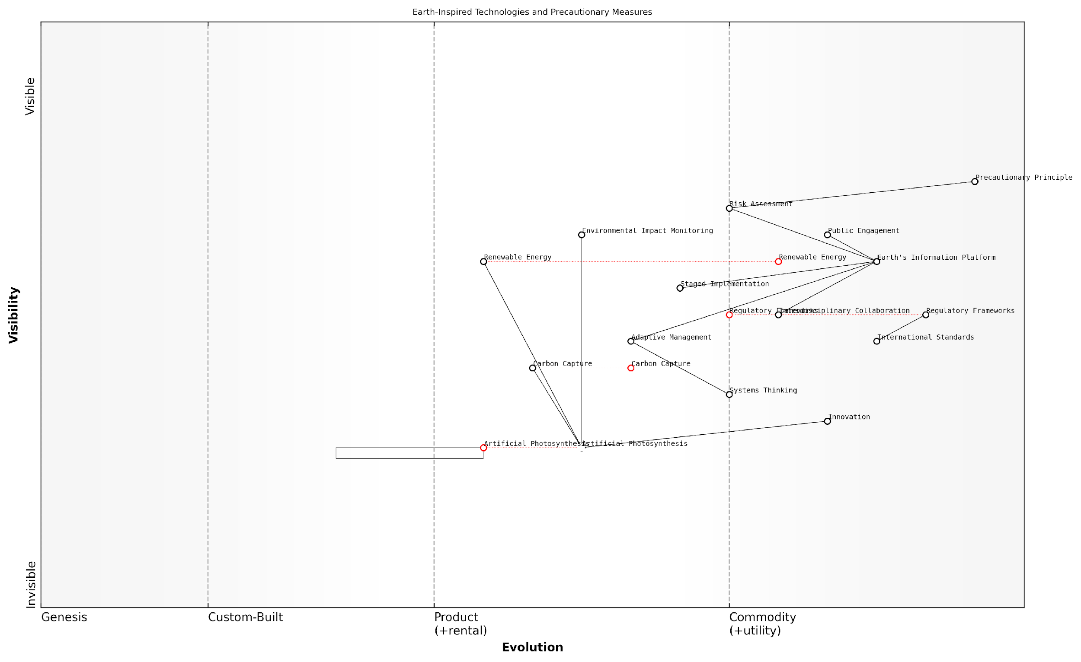

*Draft Wardley Map: [Insert Wardley Map: Balancing innovation with precautionary principles]*

[Edit this draft Wardley Map](https://create.wardleymaps.ai/#clone:216d317244c8ede05e)

Wardley Map Assessment

This Wardley Map reveals a strategic landscape focused on harnessing Earth-inspired technologies while maintaining strong precautionary measures. The central role of Earth’s Information Platform highlights the importance of deep Earth systems knowledge in driving innovation. However, the positioning of Innovation as low value suggests a cautious approach that may need recalibration to fully leverage technological advancements. The key challenge lies in evolving governance mechanisms and regulatory frameworks rapidly enough to keep pace with technological innovation, while still upholding the Precautionary Principle. Success in this domain will require sophisticated Systems Thinking, strong Interdisciplinary Collaboration, and adaptive governance strategies. The future evolution of this landscape will likely see rapid advancements in technologies like Artificial Photosynthesis and Carbon Capture, necessitating equally rapid evolution in risk assessment and regulatory capabilities. Organisations operating in this space should focus on building strong, flexible governance capabilities while fostering responsible innovation, with a particular emphasis on integrating Earth systems knowledge into all aspects of technology development and implementation.

[View full Wardley Map report](https://github.com/tractorjuice/test-repo/blob/main/markdown_wardley_map_reports/wardley_map_report_52_Balancing_innovation_with_precautionary_principles.md)

# Conclusion: Towards a Symbiotic Future

## Integrating Earth’s Wisdom

### Synthesising lessons from natural systems

As we stand at the precipice of a new era in Earth stewardship, the synthesis of lessons from natural systems becomes paramount in our quest to harness the planet’s information platform revolution. This integration of Earth’s wisdom represents a crucial step towards achieving a symbiotic relationship between human technological advancement and the intricate workings of our planet’s ecosystems.

The process of synthesising lessons from natural systems involves a multifaceted approach that draws upon the collective knowledge gained from Earth System Science, biomimicry, natural algorithms, and circular economy principles. By distilling these insights, we can create a framework for innovation that is both sustainable and regenerative, mirroring the efficiency and resilience of Earth’s own processes.

The Earth, in its 4.5 billion years of existence, has solved many of the challenges we now face. By learning to listen and adapt, we can tap into a vast repository of tested solutions.

One of the primary lessons we can glean from natural systems is the importance of interconnectedness and feedback loops. In nature, no process or entity exists in isolation; everything is part of a larger, dynamic system. This understanding challenges our traditional siloed approach to problem-solving and encourages a more holistic perspective in technology development and policy-making.

* Embrace systems thinking in all aspects of design and decision-making
* Recognise and leverage the power of feedback mechanisms
* Prioritise solutions that enhance overall system health rather than optimising individual components

Another crucial lesson from natural systems is the concept of adaptive resilience. Earth’s ecosystems have demonstrated remarkable ability to adapt to changing conditions over millennia. This adaptability is rooted in diversity, redundancy, and decentralised control mechanisms. By incorporating these principles into our technological and societal structures, we can build systems that are more robust and capable of withstanding unforeseen challenges.

The synthesis of natural lessons also highlights the importance of cyclical processes and closed-loop systems. In nature, waste from one process becomes a resource for another, creating a perpetual cycle of regeneration. This principle, when applied to our economic and technological systems, forms the foundation of the circular economy model. By emulating these natural cycles, we can design products, services, and entire industries that minimise waste and maximise resource efficiency.

In the natural world, there is no concept of waste. Everything is cycled and repurposed. Our challenge is to align our human systems with this fundamental principle of Earth’s operations.

The field of biomimicry offers a wealth of insights for synthesising lessons from natural systems. By studying and emulating nature’s time-tested patterns and strategies, we can develop technologies and solutions that are not only more efficient but also inherently more sustainable. From self-cleaning surfaces inspired by lotus leaves to energy-efficient building designs based on termite mounds, biomimicry provides a direct pathway for translating Earth’s wisdom into practical innovations.

* Identify key natural principles that can be applied to human challenges
* Develop interdisciplinary teams that combine biological knowledge with engineering expertise
* Create a database of natural solutions to facilitate cross-pollination of ideas across sectors

Natural algorithms, as observed in phenomena such as swarm intelligence and evolutionary processes, offer powerful models for optimisation and problem-solving. By incorporating these algorithms into our artificial intelligence and machine learning systems, we can create more adaptive and efficient technologies. This synthesis of natural computational wisdom with human-designed systems represents a significant step towards creating truly intelligent and responsive technologies that can operate in harmony with Earth’s processes.

However, the synthesis of lessons from natural systems is not without its challenges. One of the primary difficulties lies in translating complex, interconnected natural processes into actionable insights for human systems. This requires a deep understanding of both natural sciences and engineering principles, as well as a willingness to challenge conventional thinking and established practices.

The greatest challenge in harnessing Earth’s wisdom is not in the understanding, but in the translation and implementation. We must learn to speak the language of nature fluently in our technological and societal constructs.

Another consideration in synthesising lessons from natural systems is the need for ethical frameworks that guide the application of these insights. As we harness the power of Earth’s information platform, we must be mindful of potential unintended consequences and ensure that our actions contribute to the overall health and balance of the planet’s ecosystems.

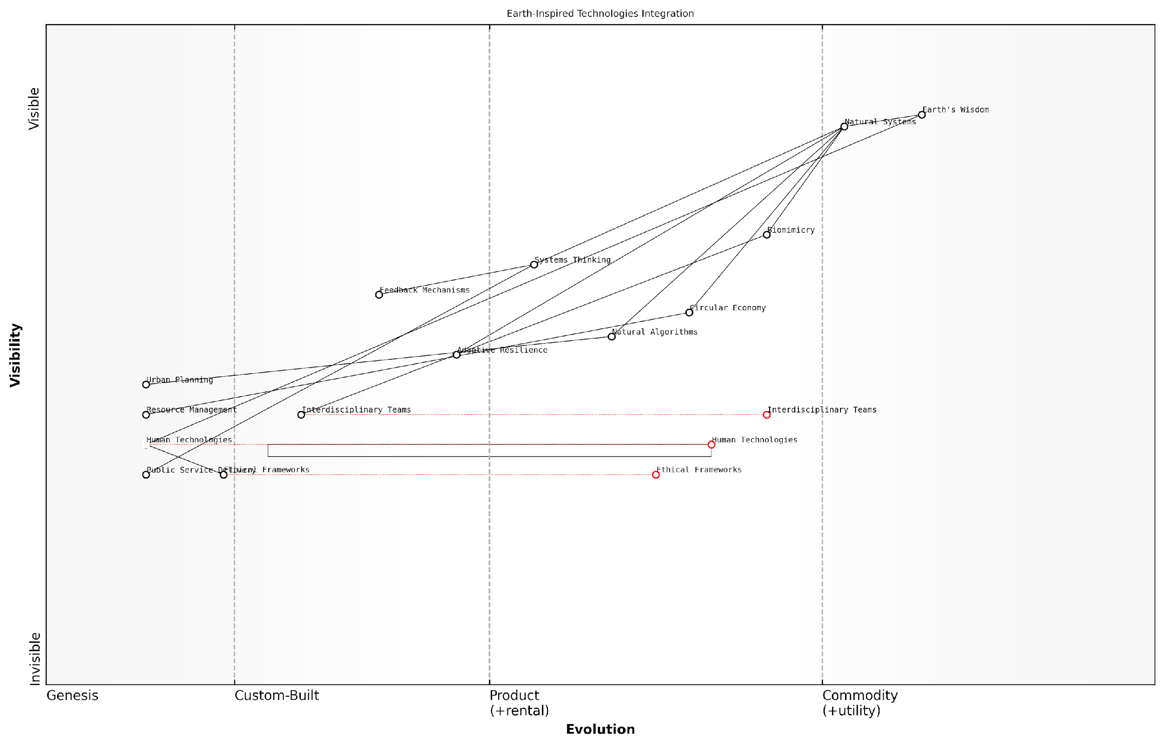

*Draft Wardley Map: [Insert Wardley Map: Synthesising lessons from natural systems]*

[Edit this draft Wardley Map](https://create.wardleymaps.ai/#clone:90188933d141fcb1a4)

Wardley Map Assessment

This Wardley Map represents a visionary approach to integrating Earth-inspired technologies for a sustainable future. It highlights the potential for significant innovation by drawing on natural systems and principles. The key strategic focus should be on strengthening the links between abstract concepts and practical applications, particularly through interdisciplinary collaboration and robust ethical frameworks. There’s a substantial opportunity to lead in developing technologies that are not just sustainable, but regenerative and in harmony with Earth’s systems. Success will require a holistic approach, combining deep understanding of natural systems with cutting-edge technological capabilities and a strong ethical foundation.

[View full Wardley Map report](https://github.com/tractorjuice/test-repo/blob/main/markdown_wardley_map_reports/wardley_map_report_53_Synthesising_lessons_from_natural_systems.md)

In the context of government and public sector applications, the synthesis of lessons from natural systems offers a powerful framework for addressing complex societal challenges. By adopting nature-inspired approaches to urban planning, resource management, and public service delivery, governments can create more resilient and sustainable systems that better serve their citizens while also contributing to global environmental health.

* Implement biomimetic design principles in urban infrastructure development
* Utilise natural algorithms for optimising public transportation networks
* Adopt circular economy models for waste management and resource allocation

As we move towards a symbiotic future, the synthesis of lessons from natural systems will play an increasingly critical role in shaping our technological landscape and societal structures. By embracing Earth’s wisdom and integrating it into our innovation processes, we can create a future where human progress and planetary health are not just compatible, but mutually reinforcing. This approach represents our best hope for addressing the complex challenges of the 21st century and beyond, ensuring a sustainable and thriving future for both humanity and the planet we call home.

### Bridging the gap between technology and ecology

As we stand at the precipice of a new era in Earth stewardship, the imperative to bridge the gap between technology and ecology has never been more crucial. This convergence represents not just a technological advancement, but a fundamental shift in our relationship with the planet—a symbiosis that harnesses the Earth’s innate wisdom to inform and guide our technological progress. In the context of Conscious Earth, this bridging process is the linchpin that will enable us to fully realise the potential of the planet’s information platform revolution.

The integration of technology and ecology is not merely about applying technological solutions to environmental problems. Rather, it’s about reimagining our technological paradigms through an ecological lens, and conversely, enhancing our understanding of ecological systems through advanced technological means. This bidirectional flow of knowledge and innovation forms the cornerstone of what we might term ‘eco-technological synergy’.

The future of human progress lies not in dominating nature, but in learning to dance with it. Our technology must become an extension of Earth’s intelligence, not a force that stands apart from it.

To effectively bridge this gap, we must focus on several key areas:

* Biomimetic Information Systems
* Eco-Digital Integration
* Planetary-Scale Computing
* Regenerative Technologies

Biomimetic Information Systems represent a frontier where the information processing capabilities of natural systems inform the design of our digital architectures. By studying how ecosystems manage, distribute, and utilise information, we can develop more resilient, efficient, and adaptive technological systems. For instance, the decentralised communication networks of mycorrhizal fungi have inspired new approaches to data routing and network resilience in telecommunications.

Eco-Digital Integration involves the seamless blending of digital technologies with ecological processes. This goes beyond mere environmental monitoring to create responsive, interactive systems that can adapt to and enhance natural processes. An exemplar of this approach is the development of ‘smart forests’, where sensor networks and AI algorithms work in concert with natural forest ecosystems to optimise carbon sequestration, biodiversity preservation, and wildfire prevention.

In the age of Conscious Earth, our most powerful supercomputers will not be housed in sterile data centres, but integrated into the living fabric of our biosphere, processing information through the intricate dance of ecosystems.

Planetary-Scale Computing represents a paradigm shift in how we conceptualise and implement computational processes. By leveraging the Earth’s natural information processing capabilities—from the complex dynamics of weather systems to the collective intelligence of biomes—we can augment our artificial computing systems with the vast computational power of the planet itself. This approach not only offers unprecedented processing capabilities but also aligns our technological development with the Earth’s natural rhythms and cycles.

Regenerative Technologies embody the principle that our technological interventions should not merely be sustainable, but actively contribute to the regeneration and enhancement of ecological systems. This involves developing technologies that mimic the restorative processes found in nature, such as carbon-negative materials that sequester more carbon than they emit during production, or water purification systems that enhance aquatic ecosystems while providing clean water for human use.

The implementation of these bridging strategies requires a fundamental shift in our technological development processes. We must move from a model of innovation that often occurs in isolation from ecological considerations to one that is deeply embedded in and informed by natural systems. This shift necessitates new collaborative frameworks that bring together ecologists, technologists, policymakers, and indigenous knowledge holders.

In my work advising government bodies on eco-technological integration, I’ve observed that one of the most significant challenges is overcoming institutional inertia and siloed thinking. To address this, we’ve developed a ‘Conscious Earth Integration Framework’ that provides a structured approach for public sector organisations to assess and implement eco-technological solutions.

* Ecological Impact Assessment: Evaluating the potential ecological implications of technological initiatives.
* Biomimetic Opportunity Mapping: Identifying areas where natural processes can inform technological design.
* Symbiotic Innovation Workshops: Collaborative sessions bringing together diverse stakeholders to co-create eco-technological solutions.
* Regenerative Performance Metrics: Developing new KPIs that measure not just efficiency or profitability, but ecological enhancement.
* Adaptive Governance Models: Implementing flexible, responsive governance structures that can evolve with eco-technological systems.

The successful bridging of technology and ecology also requires a shift in our educational paradigms. We need to cultivate a new generation of ‘eco-technologists’ who are equally versed in cutting-edge technology and ecological principles. This interdisciplinary approach should be embedded at all levels of education, from primary schools to advanced research institutions.

The eco-technologists of tomorrow will be the new Renaissance figures, bridging the worlds of silicon and soil, algorithms and ecosystems. Their canvas will be the planet itself, and their art will be the harmonious integration of human innovation with Earth’s ancient wisdom.

As we progress in bridging the gap between technology and ecology, we must remain vigilant about the ethical implications of our actions. The power to harness and integrate with Earth’s information systems comes with a profound responsibility. We must ensure that our eco-technological endeavours respect the intrinsic value of natural systems, preserve biodiversity, and promote equitable access to the benefits of this new paradigm.

In conclusion, bridging the gap between technology and ecology is not just a technical challenge, but a philosophical and cultural one. It requires us to reimagine our place in the planetary system, not as separate entities, but as integral parts of a larger, intelligent whole. As we move towards this symbiotic future, we have the opportunity to create a new era of innovation that doesn’t just sustain our planet, but allows it—and us—to thrive in ways we have yet to imagine.

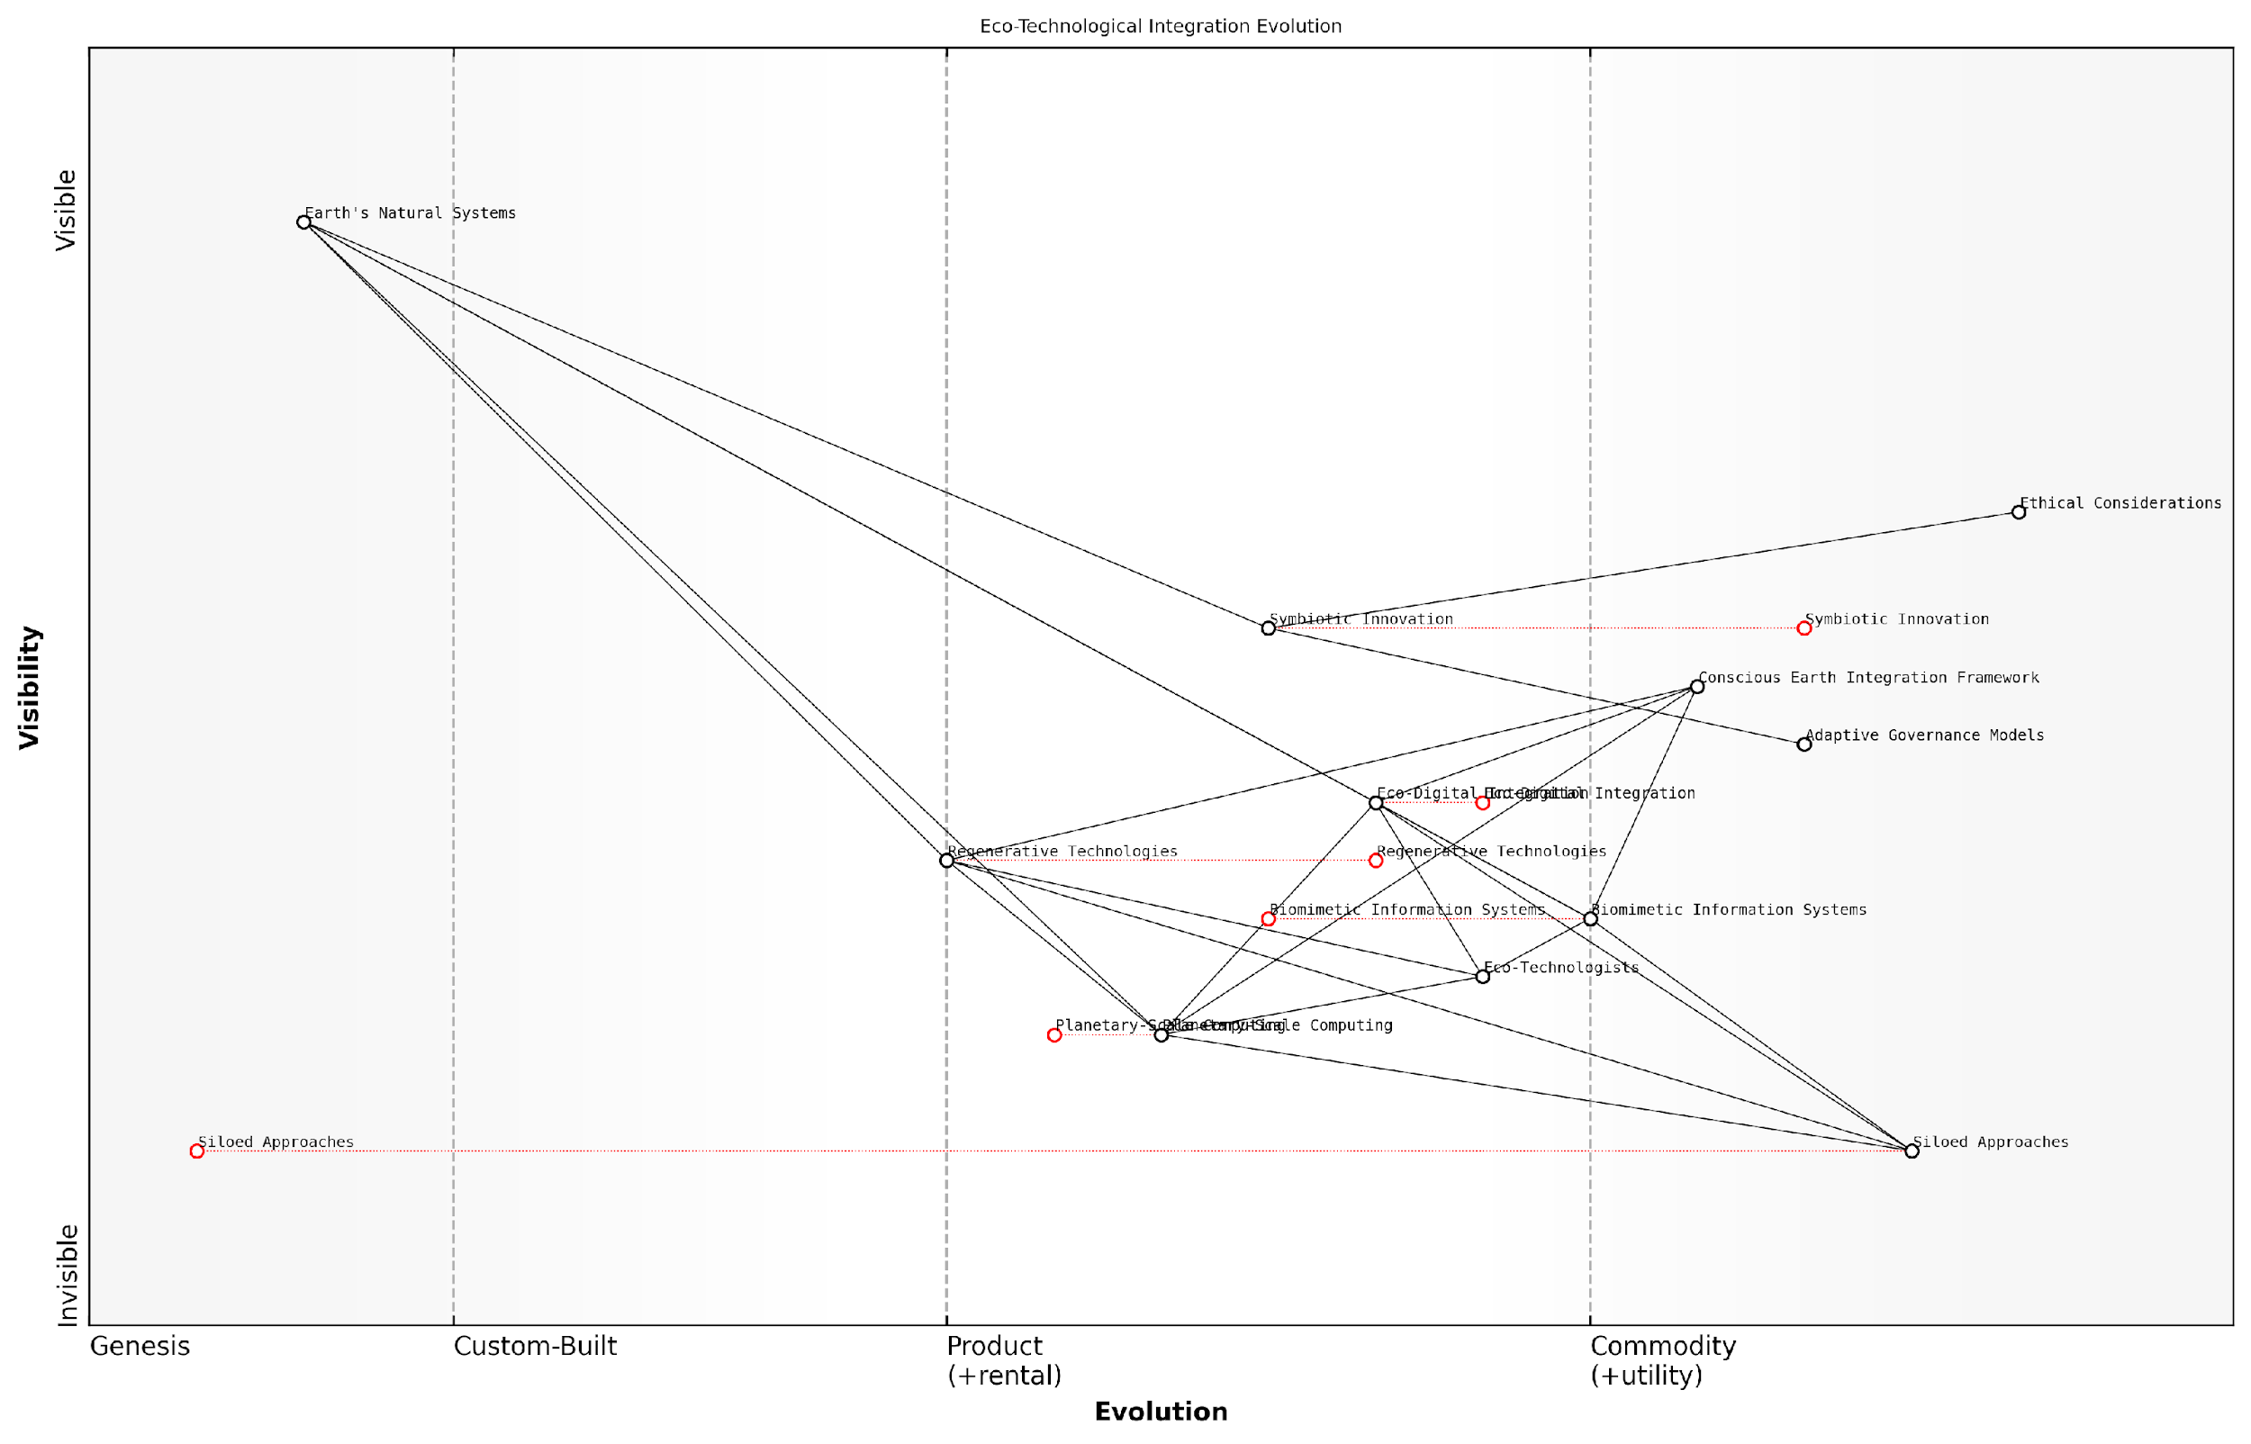

*Draft Wardley Map: [Insert Wardley Map: Bridging the gap between technology and ecology]*

[Edit this draft Wardley Map](https://create.wardleymaps.ai/#clone:da3e85038c0f08f186)

Wardley Map Assessment

This Wardley Map represents a forward-thinking approach to integrating technology and ecology, with a strong focus on sustainability and symbiosis. The strategic position is promising, with clear pathways for evolution towards more advanced, integrated systems. Key opportunities lie in accelerating the development of Symbiotic Innovation and Regenerative Technologies, while carefully managing the ethical and governance aspects of this integration. The map suggests a future where technological advancement is intrinsically linked to ecological health, requiring a paradigm shift in how we approach both technology development and environmental stewardship.

[View full Wardley Map report](https://github.com/tractorjuice/test-repo/blob/main/markdown_wardley_map_reports/wardley_map_report_54_Bridging_the_gap_between_technology_and_ecology.md)

### Cultivating a planetary consciousness

As we conclude our exploration of Conscious Earth and the revolutionary potential of harnessing the planet’s information platform, we arrive at a crucial juncture: the cultivation of a planetary consciousness. This concept represents the pinnacle of our journey towards integrating Earth’s wisdom into our technological and societal frameworks. It embodies a profound shift in our collective mindset, one that recognises the intricate interconnectedness of all Earth’s systems and our place within them.

Cultivating a planetary consciousness is not merely an academic exercise; it is a fundamental reimagining of our relationship with the Earth. It requires us to transcend traditional boundaries—between disciplines, nations, and even between humanity and nature itself. This holistic perspective is essential for addressing the complex challenges of the 21st century, from climate change to resource depletion, and for realising the full potential of Earth-inspired innovations.

The emergence of a planetary consciousness represents a quantum leap in human evolution. It’s not just about understanding the Earth’s systems, but about feeling and acting as an integral part of those systems.

To fully grasp the significance of cultivating a planetary consciousness, we must examine its key components and implications:

* Systemic Thinking: Embracing the interconnectedness of Earth’s systems
* Temporal Expansion: Considering long-term consequences and planetary timescales
* Spatial Awareness: Recognising global impacts of local actions
* Biospheric Empathy: Developing emotional connections with non-human life and ecosystems
* Technological Symbiosis: Aligning technological development with Earth’s natural processes

Systemic Thinking forms the cornerstone of planetary consciousness. It requires us to move beyond reductionist approaches and embrace the complex, often non-linear interactions between Earth’s various systems. This shift in perspective is crucial for developing technologies and policies that work in harmony with, rather than against, natural processes.

In my consultancy work with government agencies, I’ve observed a growing recognition of the need for systemic thinking in policy-making. For instance, a recent project with a national environmental protection agency involved developing a framework for assessing the cascading impacts of climate policies across multiple sectors, including agriculture, energy, and urban planning. This approach revealed unexpected synergies and potential conflicts that would have been overlooked in a more siloed analysis.

Temporal Expansion is another critical aspect of planetary consciousness. It involves extending our decision-making horizons to align with the Earth’s natural cycles and evolutionary timescales. This long-term perspective is essential for addressing challenges like climate change, biodiversity loss, and resource depletion, which unfold over decades or centuries.

We must learn to think in terms of geological time, not electoral cycles. Only then can we make decisions that truly serve the long-term health of our planet and future generations.

Spatial Awareness in the context of planetary consciousness means recognising that local actions can have global repercussions. This understanding is crucial in an increasingly interconnected world, where the impacts of resource extraction, pollution, or ecosystem destruction in one region can be felt across the planet.

Biospheric Empathy represents a profound shift in our emotional connection to the natural world. It involves developing a deep sense of kinship with non-human life and ecosystems, recognising their intrinsic value beyond mere utility for human needs. This empathetic connection can drive more sustainable behaviours and inspire innovative, Earth-centric solutions.

Technological Symbiosis is perhaps the most tangible manifestation of planetary consciousness in the context of this book. It involves designing and implementing technologies that not only mimic natural processes but actively contribute to the health and resilience of Earth’s systems. This approach goes beyond traditional sustainability to embrace regenerative design principles.

A prime example of technological symbiosis can be found in the emerging field of ‘digital twins’ for Earth systems. These advanced simulations, powered by AI and fed by vast networks of sensors, allow us to model and predict complex environmental processes with unprecedented accuracy. In a recent project with a multinational climate research initiative, we developed a digital twin of a major river basin, integrating data from satellites, ground sensors, and historical records. This tool not only improved flood prediction but also informed ecosystem restoration efforts, demonstrating how technology can enhance our understanding and stewardship of natural systems.

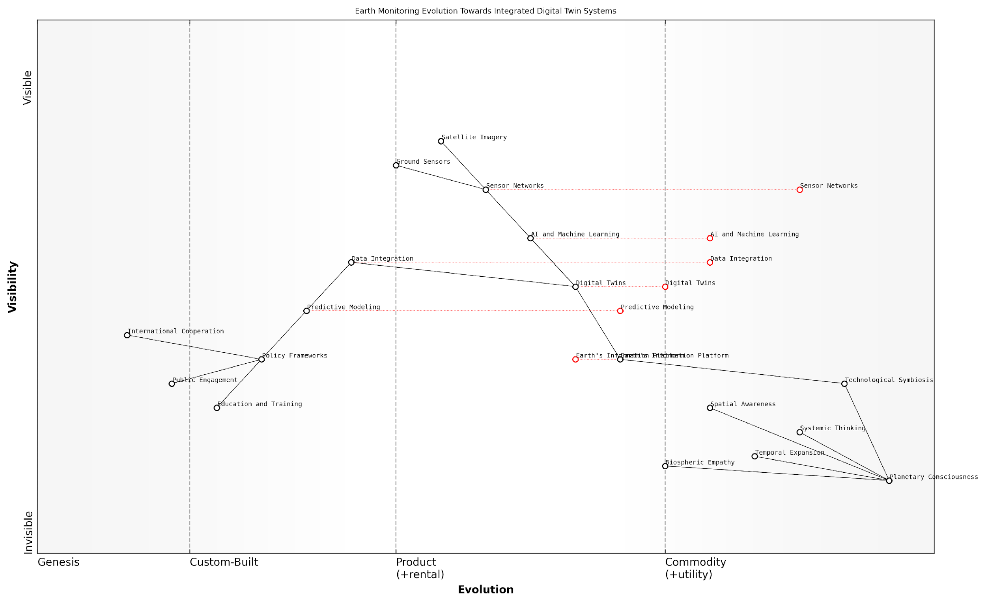

*Draft Wardley Map: [Insert Wardley Map: Cultivating a planetary consciousness]*

[Edit this draft Wardley Map](https://create.wardleymaps.ai/#clone:36943493f8269c6242)

Wardley Map Assessment

This Wardley Map represents a visionary approach to Earth monitoring, integrating advanced technologies with evolving concepts of planetary consciousness. The strategic position is strong in technological aspects but requires significant development in societal integration and global cooperation. The key opportunity lies in creating a truly integrated Earth’s Information Platform that can drive policy, public engagement, and ultimately, a shared planetary consciousness. Success will depend on balancing rapid technological advancement with careful consideration of ethical, societal, and environmental implications.

[View full Wardley Map report](https://github.com/tractorjuice/test-repo/blob/main/markdown_wardley_map_reports/wardley_map_report_55_Cultivating_a_planetary_consciousness.md)

Cultivating a planetary consciousness is not without its challenges. It requires overcoming deeply ingrained mental models, institutional inertia, and short-term economic pressures. However, the potential benefits are profound. By aligning our technological and societal development with the wisdom of Earth’s systems, we can unlock unprecedented opportunities for innovation, resilience, and sustainable prosperity.

In the public sector, fostering planetary consciousness requires a multi-faceted approach. This includes:

* Education and Training: Integrating systems thinking and Earth sciences into curricula at all levels
* Policy Frameworks: Developing regulations and incentives that encourage long-term, systemic approaches
* Public Engagement: Creating platforms for citizens to connect with and contribute to Earth monitoring and stewardship efforts
* International Cooperation: Fostering global partnerships for shared planetary management
* Investment in Research: Supporting interdisciplinary studies that bridge the gap between Earth sciences, technology, and social systems

As we stand at the threshold of a new era in our relationship with the Earth, cultivating a planetary consciousness becomes not just an option, but an imperative. It is the key to unlocking the full potential of the planet’s information platform revolution, enabling us to create technologies and societies that are truly in harmony with the natural world. By embracing this expanded awareness, we can move beyond mere sustainability to actively contribute to the flourishing of all life on Earth.

The cultivation of planetary consciousness is not the end of our journey, but the beginning of a new chapter in human evolution—one where we recognise our role not as conquerors of nature, but as conscious participants in the grand symphony of Earth’s systems.

## Future Directions and Opportunities

### Emerging research areas in Earth system science

As we delve deeper into the concept of Conscious Earth and the planet’s information platform revolution, the field of Earth system science continues to evolve rapidly. This subsection explores the cutting-edge research areas that are shaping our understanding of the Earth as an intelligent, interconnected system and paving the way for innovative approaches to global challenges.

One of the most promising emerging research areas is the integration of artificial intelligence and machine learning with Earth system models. This convergence is revolutionising our ability to predict and understand complex Earth processes. As a senior researcher in this field noted, ‘The marriage of AI and Earth system science is not just enhancing our predictive capabilities; it’s fundamentally changing how we conceptualise the Earth’s information processing systems.’

* Development of high-resolution Earth system models that incorporate real-time data from a vast network of sensors
* Application of deep learning algorithms to identify patterns and feedbacks in Earth system data that were previously undetectable
* Creation of ‘digital twin’ Earth models that allow for unprecedented simulation and scenario testing

Another burgeoning area of research is the exploration of the Earth’s microbiome and its role in planetary regulation. The microbiome, comprising trillions of microorganisms, is increasingly recognised as a crucial component of the Earth’s information processing capabilities. This research has far-reaching implications for climate regulation, biogeochemical cycles, and even human health.

The Earth’s microbiome is not just a passive player in global processes. It’s an active, intelligent network that processes and responds to environmental information on a scale we’re only beginning to comprehend.

The study of planetary boundaries and tipping points is also gaining momentum. As we push the limits of Earth’s systems, understanding these critical thresholds becomes paramount. Researchers are developing new methodologies to identify early warning signals of impending tipping points, which could prove crucial for proactive Earth stewardship.

* Advanced statistical techniques for detecting early warning signals in Earth system data
* Integration of social and economic factors into tipping point models
* Development of intervention strategies to prevent or mitigate the crossing of planetary boundaries

The emerging field of quantum biology is opening up new avenues for understanding the Earth’s information processing at the most fundamental level. Researchers are investigating how quantum phenomena might play a role in biological processes, from photosynthesis to bird navigation, potentially revealing new dimensions of the Earth’s computational capabilities.

Another exciting area of research is the development of bio-inspired environmental sensing technologies. Drawing inspiration from nature’s exquisite sensory systems, scientists are creating new tools for monitoring and interacting with the Earth system. These range from artificial leaves that can measure photosynthesis rates to robotic systems that mimic animal behaviour for environmental monitoring.

By emulating nature’s sensing capabilities, we’re not just creating more efficient tools; we’re developing a new paradigm for how we interact with and understand the Earth’s information systems.

The study of Earth’s ‘dark matter’ - the vast, unexplored microbial and fungal networks that permeate the planet - is another frontier in Earth system science. These networks, which include the ‘wood wide web’ of fungal connections in forests, are being recognised as crucial information highways that facilitate communication and resource sharing across ecosystems.

Lastly, the integration of indigenous knowledge systems with modern Earth system science is emerging as a powerful approach to understanding the planet’s intelligence. This interdisciplinary research area recognises that traditional ecological knowledge, developed over millennia, often encapsulates deep insights into Earth’s systems that complement and enhance scientific understanding.

* Development of frameworks for integrating indigenous knowledge into Earth system models
* Exploration of traditional land management practices and their potential for climate change mitigation
* Study of indigenous cosmologies and their implications for conceptualising Earth as an intelligent system

As we continue to explore these emerging research areas, we are not only advancing our understanding of the Earth as a conscious, intelligent system but also developing new tools and approaches for sustainable stewardship of our planet. The future of Earth system science lies in the integration of these diverse research streams, creating a holistic understanding of our living planet and our place within it.

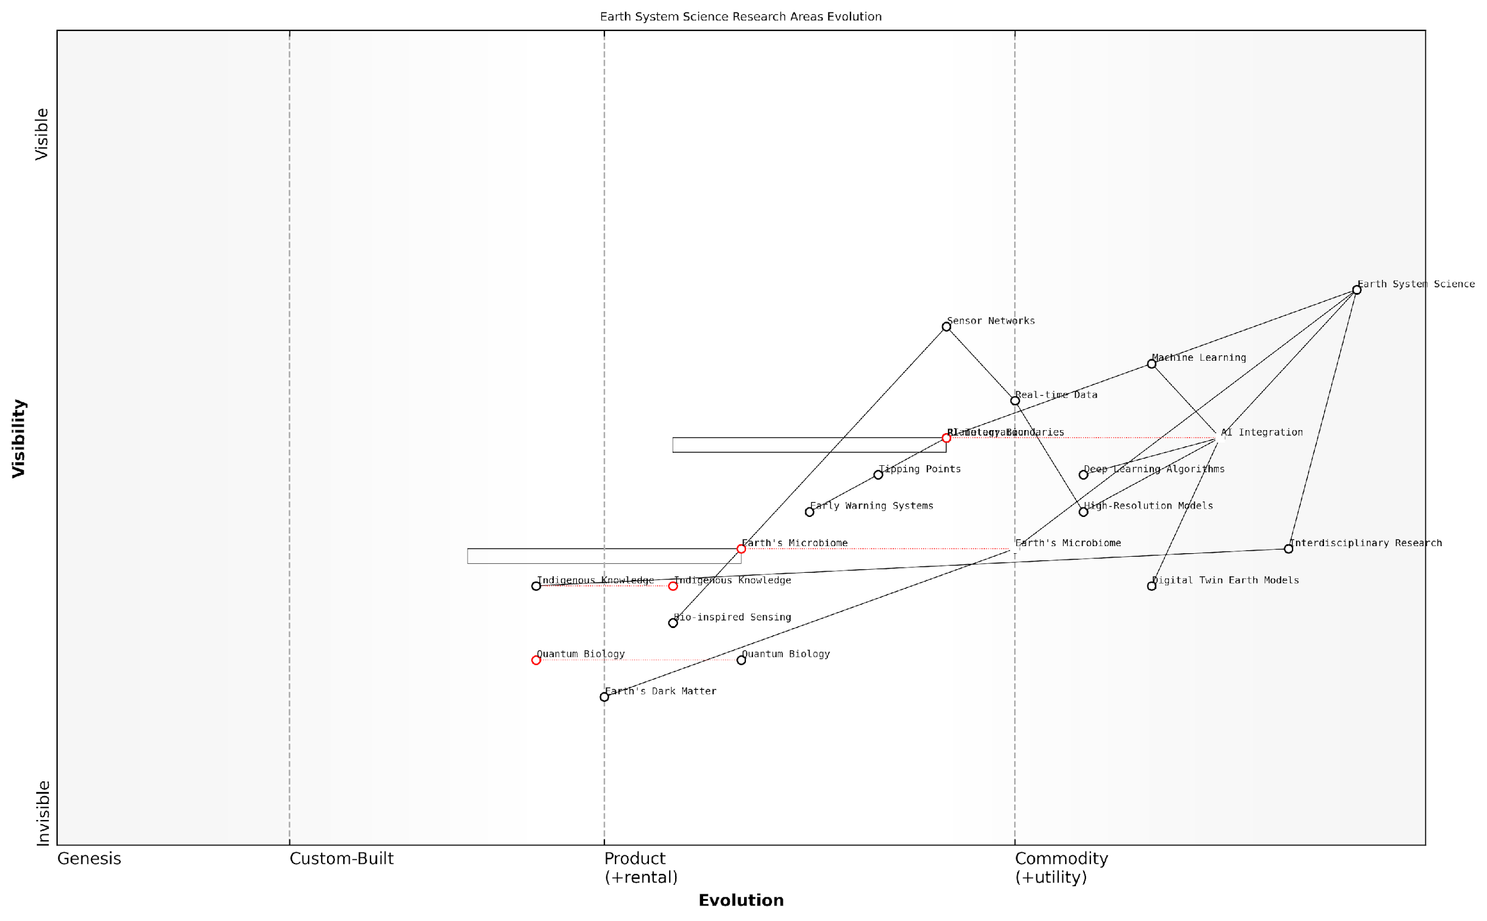

*Draft Wardley Map: [Insert Wardley Map: Emerging research areas in Earth system science]*

[Edit this draft Wardley Map](https://create.wardleymaps.ai/#clone:b26a9187b3cfe817d3)

Wardley Map Assessment

This Wardley Map reveals a dynamic and evolving field of Earth system science that is embracing cutting-edge technologies while also recognizing the value of diverse knowledge systems. The strategic integration of AI, exploration of quantum biology, and inclusion of indigenous knowledge present significant opportunities for advancing our understanding and management of Earth systems. Key challenges lie in effectively bridging diverse disciplines and knowledge sources, and in developing the capabilities to explore emerging areas like Earth’s dark matter and quantum biology. The field is well-positioned for transformative advancements, but success will depend on strategic investments, interdisciplinary collaboration, and a balanced approach that values both technological innovation and fundamental Earth system understanding.

[View full Wardley Map report](https://github.com/tractorjuice/test-repo/blob/main/markdown_wardley_map_reports/wardley_map_report_56_Emerging_research_areas_in_Earth_system_science.md)

### Potential breakthroughs in Earth-inspired technologies

As we stand on the cusp of a new era in Earth-inspired technologies, the potential for groundbreaking innovations that harness the planet’s information platform is both exciting and profound. This section explores the emerging frontiers where our understanding of Earth’s systems converges with cutting-edge technology, promising transformative solutions to some of our most pressing global challenges.

One of the most promising areas for potential breakthroughs lies in the field of biomimetic materials. By closely studying and emulating the remarkable properties of natural substances, researchers are on the verge of developing a new generation of smart materials that could revolutionise industries ranging from construction to healthcare.

* Self-healing concrete inspired by the regenerative properties of living organisms
* Adaptive camouflage systems based on cephalopod skin
* Ultra-efficient water filtration membranes modelled on cell membranes

These innovations not only promise enhanced performance but also align with the principles of sustainability and circular economy, reducing waste and environmental impact.

The next decade will see a paradigm shift in materials science, where the line between living and non-living materials becomes increasingly blurred. This convergence will unlock unprecedented capabilities in our built environment and technological systems.

Another area ripe for breakthroughs is in energy harvesting and storage technologies inspired by natural processes. The efficiency with which living organisms capture, convert, and store energy has long been the envy of engineers. Now, with advances in nanotechnology and a deeper understanding of biological energy systems, we are poised to make significant leaps in renewable energy technologies.

* Artificial photosynthesis systems that convert sunlight into chemical energy with unprecedented efficiency
* Bio-inspired energy storage solutions that mimic the energy density and rapid charge/discharge capabilities of certain organisms
* Piezoelectric materials that harvest energy from ambient vibrations, inspired by the sensory hairs of insects

These technologies have the potential to revolutionise our energy landscape, making renewable energy more efficient, accessible, and integrated into our daily lives.

In the realm of information processing and communication, Earth-inspired technologies are set to transform our computing paradigms. The brain’s ability to process vast amounts of information with minimal energy consumption serves as a model for next-generation computing architectures.

* Neuromorphic computing systems that emulate the structure and function of biological neural networks
* Quantum communication protocols inspired by the quantum coherence observed in photosynthetic complexes
* Swarm intelligence algorithms for distributed problem-solving in complex systems

These advancements could lead to more energy-efficient, resilient, and adaptive information systems capable of handling the increasing complexity of our interconnected world.

The future of computing lies not in silicon, but in the intricate dance of electrons and quantum states that nature has perfected over billions of years. By learning from these natural information processing systems, we can create technologies that are not just faster, but fundamentally more capable and efficient.

Environmental sensing and monitoring technologies are another area where Earth-inspired innovations are poised to make significant breakthroughs. By mimicking the sensory capabilities of various organisms, we can develop more sensitive, robust, and distributed environmental monitoring systems.

* Artificial ‘electronic noses’ based on insect olfactory systems for detecting pollutants and toxins
* Distributed sensor networks inspired by mycorrhizal fungi networks for monitoring soil health and ecosystem dynamics
* Biomimetic water quality sensors that replicate the sensitivity of aquatic organisms to environmental changes

These technologies could provide us with unprecedented insights into the health of our ecosystems, enabling more proactive and effective environmental management strategies.

In the field of robotics and autonomous systems, Earth-inspired technologies are set to enable a new generation of machines capable of navigating and adapting to complex, unpredictable environments.

* Soft robotics inspired by the flexibility and adaptability of octopuses and other cephalopods
* Self-organising swarm robots that mimic the collective behaviour of social insects
* Biomimetic locomotion systems that allow robots to traverse difficult terrains with the agility of animals

These advancements could revolutionise fields such as disaster response, environmental exploration, and sustainable agriculture.

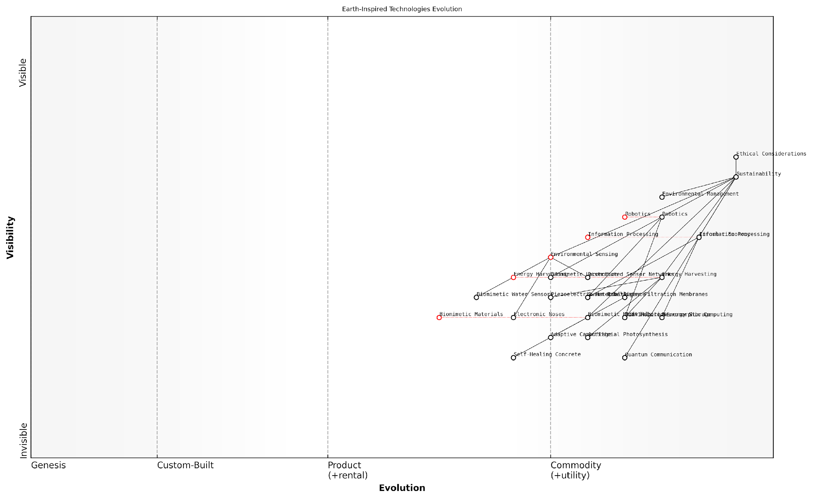

*Draft Wardley Map: [Insert Wardley Map: Potential breakthroughs in Earth-inspired technologies]*

[Edit this draft Wardley Map](https://create.wardleymaps.ai/#clone:4984810da026966589)

Wardley Map Assessment

This Wardley Map represents a forward-thinking, sustainability-focused approach to technology development inspired by Earth’s natural systems. The strategic position is strong, with a well-structured progression from foundational technologies to high-level sustainability outcomes. Key opportunities lie in accelerating the development of emerging technologies like Quantum Communication and Artificial Photosynthesis, while also focusing on the integration of more mature technologies to create comprehensive sustainable solutions. The emphasis on Ethical Considerations and Circular Economy principles positions this ecosystem well for future challenges. To maintain a competitive edge, organisations should focus on areas where multiple technologies intersect, invest in key emerging technologies, and continuously strengthen their sustainability and ethical frameworks. The rapid evolution projected in several key areas suggests a dynamic and potentially disruptive period ahead, requiring agile strategic planning and strong ecosystem partnerships.

[View full Wardley Map report](https://github.com/tractorjuice/test-repo/blob/main/markdown_wardley_map_reports/wardley_map_report_57_Potential_breakthroughs_in_Earth-inspired_technolo.md)

As we look to the future, the potential breakthroughs in Earth-inspired technologies offer a path towards a more sustainable, resilient, and harmonious relationship with our planet. By learning from and emulating the wisdom encoded in Earth’s natural systems, we can develop technologies that not only serve human needs but also contribute to the health and balance of the broader ecosystem.

However, as we pursue these exciting possibilities, it is crucial to approach their development and implementation with careful consideration of ethical implications and potential unintended consequences. The goal should be to create technologies that enhance our role as stewards of the Earth, rather than further exploiting its resources.

The true measure of our success in harnessing Earth-inspired technologies will not be in the power they give us over nature, but in how well they allow us to live in harmony with it. Our challenge is to create technologies that are not just inspired by nature, but that actively contribute to its flourishing.

As we continue to unlock the potential of Earth-inspired technologies, we move closer to realising the vision of a truly symbiotic relationship between human civilisation and the living planet. This journey of discovery and innovation promises not only technological breakthroughs but also a profound shift in our understanding of our place within the complex web of Earth’s systems.

### Societal transformations towards Earth stewardship

As we stand at the precipice of a new era in human-Earth relations, the concept of Earth stewardship emerges as a crucial paradigm shift in our collective consciousness. This transformation is not merely a philosophical ideal but a practical necessity, driven by the urgent need to address global challenges such as climate change, biodiversity loss, and resource depletion. The Conscious Earth framework, with its emphasis on harnessing the planet’s information platform revolution, provides a powerful lens through which we can reimagine our role as stewards of the Earth system.

The journey towards Earth stewardship is multifaceted, requiring fundamental changes in our societal structures, economic systems, and individual behaviours. This subsection explores the key drivers, potential pathways, and emerging opportunities for societal transformation in the context of Conscious Earth principles.

Education and Awareness: Cultivating Planetary Consciousness

A cornerstone of societal transformation towards Earth stewardship is the widespread cultivation of planetary consciousness. This involves a fundamental shift in how we perceive our relationship with the Earth, moving from a paradigm of dominion to one of symbiosis and interdependence.

* Integration of Earth system science and ecological literacy into core curricula at all educational levels
* Development of immersive, technology-enhanced learning experiences that allow individuals to viscerally understand Earth’s interconnected systems
* Promotion of citizen science initiatives that engage the public in Earth observation and data collection, fostering a sense of connection and responsibility

Education is not just about imparting knowledge; it’s about transforming consciousness. When we truly understand our place within the Earth system, stewardship becomes a natural expression of our being.

Governance and Policy: Aligning Human Systems with Earth Systems

The transition towards Earth stewardship necessitates a radical reimagining of our governance structures and policy frameworks. Traditional models of governance, often constrained by national boundaries and short-term electoral cycles, are ill-equipped to address the complex, long-term challenges of planetary management.

* Development of Earth system governance frameworks that transcend national boundaries and align with natural ecological regions
* Implementation of long-term policy planning mechanisms that operate on timescales commensurate with Earth system processes
* Integration of Earth system science and planetary boundary concepts into all levels of policy-making
* Creation of participatory governance models that incorporate diverse stakeholders, including indigenous communities and future generations

Economic Transformation: From Extraction to Regeneration

The current economic paradigm, predicated on continuous growth and resource extraction, is fundamentally at odds with the principles of Earth stewardship. A transformative shift towards regenerative economic models is essential for aligning human activities with the Earth’s carrying capacity.

* Widespread adoption of circular economy principles across all sectors
* Development of new economic metrics that account for ecological health and well-being, moving beyond GDP as a measure of progress
* Implementation of natural capital accounting systems that recognise the value of ecosystem services
* Promotion of regenerative business models that actively contribute to ecosystem restoration and biodiversity enhancement

The economy of the future must be designed to thrive within the boundaries of our planet’s systems. This isn’t just about sustainability; it’s about creating abundance through alignment with nature’s principles.

Technological Innovation: Harnessing Earth’s Information Platform

The Conscious Earth framework posits that technological innovation, when aligned with Earth system principles, can play a crucial role in facilitating the transition to Earth stewardship. By harnessing the planet’s information platform, we can develop solutions that work in harmony with natural processes.

* Development of advanced Earth observation systems that provide real-time, high-resolution data on planetary processes
* Creation of AI and machine learning algorithms that can process and interpret complex Earth system data, enabling more informed decision-making
* Implementation of biomimetic technologies that emulate natural processes in areas such as energy production, waste management, and urban design
* Establishment of global, open-access platforms for sharing Earth system data and collaborative problem-solving

Cultural and Behavioural Shift: Embracing Earth-Centric Values

Perhaps the most profound aspect of societal transformation towards Earth stewardship is the shift in cultural values and individual behaviours. This involves a reimagining of what constitutes a good life, moving from materialistic consumption to a more holistic understanding of well-being that includes ecological health.

* Promotion of Earth-centric worldviews that recognise the intrinsic value of all life forms
* Development of new narratives and cultural expressions that celebrate human-Earth symbiosis
* Encouragement of lifestyle choices that minimise ecological impact and maximise positive contributions to Earth systems
* Fostering of community-based initiatives that strengthen local resilience and ecological stewardship

The ultimate measure of a society’s progress is not its technological might or economic wealth, but the degree to which it enables all its members - human and non-human - to thrive.

Challenges and Opportunities

The path towards Earth stewardship is fraught with challenges, including entrenched economic interests, political inertia, and the sheer complexity of managing global-scale transformations. However, these challenges also present unprecedented opportunities for innovation, collaboration, and the creation of a more just and sustainable world.

* Development of new forms of global cooperation and Earth system governance
* Creation of innovative financial mechanisms to fund large-scale ecosystem restoration projects
* Emergence of new industries and job opportunities in regenerative technologies and Earth system management
* Potential for unprecedented scientific breakthroughs through deeper understanding of Earth’s information processing capabilities

As we navigate this critical juncture in human history, the concept of Conscious Earth offers a powerful framework for reimagining our relationship with the planet. By harnessing the Earth’s information platform revolution, we have the opportunity to catalyse a profound societal transformation towards true Earth stewardship. This journey will require unprecedented levels of cooperation, innovation, and compassion, but it holds the promise of a future where human civilisation thrives in harmony with the living planet that sustains us.

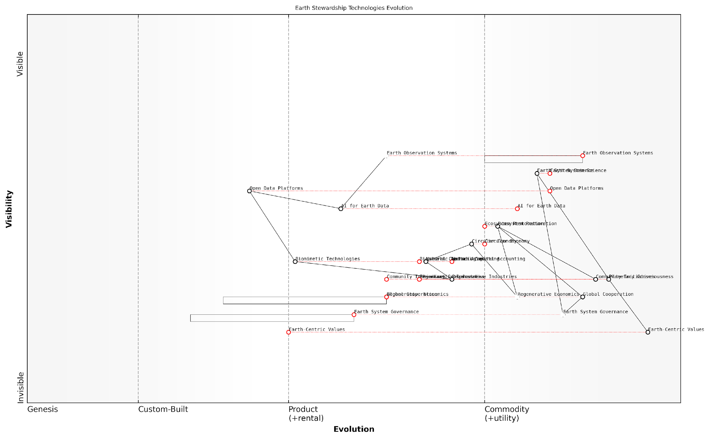

*Draft Wardley Map: [Insert Wardley Map: Societal transformations towards Earth stewardship]*

[Edit this draft Wardley Map](https://create.wardleymaps.ai/#clone:19191066e9579976d9)

Wardley Map Assessment

This map represents a comprehensive and ambitious vision for Earth stewardship, integrating technological innovation with fundamental shifts in values and governance. The strategic focus should be on accelerating the evolution of less developed components while leveraging strengths in observation and data analysis. Success will require unprecedented levels of global cooperation and a commitment to long-term transformation across multiple domains.

[View full Wardley Map report](https://github.com/tractorjuice/test-repo/blob/main/markdown_wardley_map_reports/wardley_map_report_58_Societal_transformations_towards_Earth_stewardship.md)